Health Star Rating system
Calculator and Style Guide
October 2023
Version 8

Legal Considerations and Disclaimer
Use of the Health Star Rating (HSR) system does not negate any legal obligations imposed by the Australia New Zealand Food Standards Code (the Code) or other relevant legislation at the Commonwealth or state or territory level in Australia, or in New Zealand. Businesses should ensure they are fully aware of the labelling requirements of the Code and other legislation and seek legal advice.
This Guide and its provisions are intended as a guide only, to provide industry best practice and consistency in utilising the HSR system and meeting the relevant requirements of the Code.
The information in this Guide should not be relied upon as legal advice or used as a substitute for legal advice. Businesses need to apply their own skills and knowledge in determining compliance with the labelling requirements of the Code. Businesses should consider obtaining independent legal advice, or undertaking appropriate training in labelling requirements.
Additional regulatory requirements relating to the Nutrition Information Panel (NIP) may be triggered, such as a requirement to display a NIP on, or in association with, the food product.
Businesses should specifically refer to Standard 1.1.2 Definitions throughout the Code, Standard 1.2.1 Requirements to have labels or otherwise provide information, Standard 1.2.7 Nutrition, Health and Related Claims, Standard 1.2.8 Nutrition Information Requirements and Standard 1.3.2 Vitamins and Minerals of the Code. Other standards may also be relevant.
In using this Guide Businesses acknowledge that neither the Commonwealth of Australia or the Government of New Zealand, its employees or agents are responsible for any action taken on the basis of information provided, or any errors or omissions, and expressly disclaim all liability in this regard, including any liability for any loss, injury or damage as a result of product being labelled according to this Guide.
Any brand representation in this Guide is for illustration purposes only.

Contact Information
Any questions relating to the use of the HSR system, including interpretation of this Guide, should be directed to the Front-of-Pack Labelling (FoPL) Secretariat.
FoPL Secretariat
Nutrition Policy Section
MDP 570, Department of Health and Aged Care
GPO Box 9848
CANBERRA ACT 2601

Email: frontofpack@health.gov.au
Phone: 1800 099 658

Contents
Legal Considerations and Disclaimer 2
Contact Information 2
References to the Food Standards Code 8
Purpose of this Guide 9
Section 1. Overview 9
1a Principles of Use 9
Section 2. Application of the Health Star Rating system 10
2a Products that must not use the Health Star Rating system 10
2b. Products intended to use the Health Star Rating system 11
2c. Imported Food Products 11
Section 3. The Health Star Rating Calculator 12
3a. How the Health Star Rating Calculator works 12
Section 4. Steps to assess the Health Star Rating of a Product 14
Step 1: Determine whether the product is eligible for an automatic Health Star Rating 14
Step 2: Determine the Health Star Rating category of the product 15
Step 3: Determine the form of the product for the HSR 18
Step 4: Calculate Health Star Rating baseline points 18
Step 5: Calculate Health Star Rating modifying points 21
Step 6: Calculate the final Health Star Rating score 24
Step 7: Assignment of a Health Star Rating to the product 24
Section 5. On Pack presentation of the Health Star Rating system 25
5.1 HSR system graphic Elements 25
5.2 Design principles 26
5.3 Scaling and Minimum Size 26
5.4 Health Star Rating graphic 26
5.5 Energy and Nutrient Icons 26
5.6 Nominated Reference Measure 29
5.7 Industry Agreed Standardised Serve Sizes 30
5.8 Multipacks 30
Section 6. Hierarchy of Health Star Rating system presentation 31
Section 7. Display of further Health Star Rating Information 33
Section 8. The Daily Intake Guide, Health Logos and Certification Schemes 33
Appendix 1: Health Star Rating calculation steps - All products (excluding dairy) 34
Appendix 2: Health Star Rating calculation steps - Dairy products and their alternatives 35
Appendix 3: Calculation examples 36
Appendix 4: Products not eligible to score Health Star Rating V points 54
Appendix 5: Possible configurations of the Health Star Rating system graphic 55
Appendix 6: Calculating Percentage Daily Intake values for the energy Icon 56
Appendix 7: Document Changes 57

Glossary and Definition of Terms
Term | Definition
AGHE | The Australian Guide to Healthy Eating, included in Eat for Health: Australian Dietary Guidelines, NHMRC 2013.
As prepared | The food as prepared including foods that are required to be prepared according to directions prior to consumption. Only to be calculated on this basis for products which must be rehydrated, diluted or mixed with water, or drained of water or brine.
As sold | A food as sold - such that it can be prepared with other food or consumed as sold.
Baseline points  (in Schedule 5) | In Schedule 5 of the Australia New Zealand Food Standards Code (the Code), baseline points are calculated as part of the nutrient profiling score. Baseline points are allocated for the energy, saturated fat, total sugar and sodium present in foods.
Businesses | All businesses involved in the production and sale of food and beverages – e.g. companies, retailers, manufactures, exporters, sole traders, producers
Category 1 | HSR category that captures beverages (other than dairy beverages and alcoholic beverages), jellies and water-based ice confections.
Category 1D | HSR category that captures dairy beverages that contain sufficient calcium to meet the requirements for a ‘source of calcium’ claim under Standard 1.2.7 of the Code. Category 1D may include milk and dairy beverage alternatives derived from legumes, cereals, nuts or seeds, providing they contain at least 100mg calcium per 100ml.
Category 2 | HSR category that captures all foods other than those in Category 1, 1D, 2D, 3 or 3D.
Category 2D | HSR category that captures dairy and permitted dairy alternative foods derived from legumes (not including those included in Category 1D or 3D).
Category 3 | HSR category that captures oils and spreads, defined as follows:  - edible oil as defined in Standard 2.4.1 of the Code  - edible oil spreads as defined in Standard 2.4.2 of the Code  - margarine as defined in Standard 2.4.2 of the Code  - butter as defined in Standard 2.5.5 of the Code
Category 3D | HSR category that captures cheese and processed cheese as defined in Standard 2.5.4 of the Code (with calcium content >320mg/100g). Category 3D may include cheese alternatives derived from legumes providing they meet the criterion for 3D foods for calcium content.
Cheese | Cheese, as defined in Standard 2.5.4 of the Code means:  The ripened or unripened solid or semi-solid milk product, whether coated or not, that is obtained by one or both of the following processes:  - wholly or partly coagulating milk, or materials obtained from milk, or both, through the action of rennet or other suitable coagulating agents, and partially draining the whey which results from such coagulation;  - processing techniques involving concentration or coagulation of milk, or materials obtained from milk, or both, which give an end-product with similar physical, chemical and organoleptic characteristics as the product described in subparagraph (a)(i); or  such a product with any of the following additional ingredients added during production:  - water; lactic acid producing microorganisms; flavour producing microorganisms; gelatine; starch; vinegar; salt; tall oil phytosterol esters added in accordance with this Standard.  Processed cheese means a product manufactured from cheese and products obtained from milk, which is heated and melted, with or without added emulsifying salts, to form a homogeneous mass.
The Code | Australia New Zealand Food Standards Code.
Dairy beverages  (including dairy beverage alternatives) | Beverages that:  - are made from milk (but do not meet the compositional criteria for ‘milk’ in Standard 2.5.1 of the Code), or  - are made from a permitted ‘milk’ alternative,  and  contain ≥75% milk or permitted milk-alternative ingredients and contain the required calcium (calcium requirements are detailed in Step 2 below),  are termed ‘dairy beverages’ or ‘dairy beverage alternatives’.
Dairy beverage alternative | A ‘dairy beverage’ analogue:  - derived from legumes and containing no less than 3% m/m protein derived from legumes, or  - derived from cereals, nuts, seeds, or a combination of those ingredients and containing no less than 0.3% m/m protein derived from cereals, nuts, seeds, or a combination of those ingredients,  and contains a minimum of 100mg of calcium per 100ml product.
Dairy foods  (including dairy food alternatives) | Cheese and dairy foods produced from milking animals (for example: cow, goat, buffalo), or permitted dairy alternatives.  Must contain >75% dairy or permitted dairy-alternative ingredients and the required calcium content.
Dairy food alternative | A ‘dairy food’ analogue derived from legumes that contains:  - no less than 3.1% m/m protein derived from legumes if presented as a ‘yoghurt or a dairy dessert analogue’, or  - no less than 15% m/m protein derived from legumes if presented as a ‘cheese analogue’.
FoPL | Front-of-Pack Labelling
fvnl | fruits, vegetables, nuts and legumes  Defined in Schedule 5 of the Code and includes coconut, spices, herbs, fungi, seeds and algae.
General purpose foods | All foods - except Special Purpose Foods in Part 2.9 of the Code.  Note: General purpose foods are subject to the requirements for nutrition content claims and general level health claims set out in Standard 1.2.7, Schedule 4 and Schedule 5 of the Code.
HSR | Health Star Rating
HSR Advisory Committee (HSRAC) | A group of representatives from Government (Australian Commonwealth, State and New Zealand), industry, public health and consumer sectors responsible for governance support to the continued implementation of the HSR system across Australia and New Zealand.  The Terms of Reference for the HSR Advisory Committee are available on the HSR website.
HSR baseline points | Points allocated to baseline components (energy, saturated fat, total sugars and sodium) in the HSR Calculator.
HSR F points | HSR fibre points (applicable to Categories: 2, 2D and 3D)  May be referred to as ‘F points’
HSR modifying points | Points allocated to modifying components (protein, fibre and fvnl) in the HSR Calculator.
HSR P points | HSR protein points (applicable to Categories: 1D, 2, 2D and 3D)  May be referred to as ‘P points’
HSR V points | HSR V points  Products score V points for the proportion of their ingredients comprising of fvnl (fruits, vegetables, nuts and legumes including coconut, spices, herbs, fungi, seeds and algae). See Step 4 below and Schedule 5 of the Code for the rules relating to scoring these points, noting that the HSR Calculator V points table has been expanded from that in Schedule 5 of the Code.  May be referred to as ‘V points’
HSR score | The HSR score for a product.  (Note: the HSR score helps to determine final rating and is calculated by subtracting the HSR modifying points (HSR V, P and F points) from the HSR baseline points).
HSR system | HSR system – a FoPL system that rates the overall nutritional profile of packaged foods and beverages and assigns an interpretive rating from 0.5 to 5 stars. This rating, and in some instances energy and nutrient information is depicted via application of a HSR graphic.
HSR system graphic | The part of a product label which provides information in accordance with this HSR system Calculator and Style Guide. The specific elements included in the HSR system graphic may vary, in accordance with the hierarchy of elements outlined in this Guide.
Milk | Milk, as defined in Standard 2.5.1 of the Code means:  (a) the mammary secretion of milking animals, obtained from one or more milkings for consumption as liquid milk or for further processing, but excluding colostrums; or  (b) such a product with phytosterols, phytostanols and their esters added.
Fresh (unprocessed) and minimally processed fruit and vegetables | All whole fresh fruit (except coconut) and vegetables, fungi and legumes (except peanuts) as sold with no processing, plus these same products that have only been peeled, cut and/or surface treated and/or blanched and/or frozen (not dried), or canned without the addition of fat, sugars/sweeteners or salt.
Modifying points  (in Schedule 5) | In Schedule 5 of the Code, modifying points are calculated as part of the nutrient profiling score. Modifying points are allocated for the percentage of fvnl, and in some instances, the amount of protein and dietary fibre, present in foods and beverages.
Multipack | Packs that contain individual pre-portioned units intended for consumption as single portions and not intended for individual sale (e.g. a pack containing individually wrapped mini chocolate bars; individual packets of potato crisps in a family multipack; individual packs of yoghurt in a 4-serve multipack; individual bottles (under 600mL) in a 6-pack of soft drinks).
NIP | Nutrition Information Panel referred to in Standard 1.2.8 of the Code.
NPSC | Nutrient Profiling Scoring Criterion, referred to in Standard 1.2.7 of the Code and detailed in Schedule 5 of the Code.
Optional nutrient | A single positive nutrient that may be displayed as a part of the HSR system graphic, in addition to the prescribed nutrients.  Optional nutrients are defined as properties of food in Schedule 4 of the Code.
Pre-portioned unit | An individual packaged portion contained within a multiple portion pack (i.e. multipack) where the individual portion packs are not intended for individual sale.
Prescribed nutrient | Prescribed nutrients for inclusion in the HSR system are:  - Saturated fat  - Sugar  - Sodium
Product | Food or beverage product.
Rating | The HSR for a product.
Policy Decision | A decision made by the Forum, informed by research and evidence, which pertains to a specific food or groups of foods under the HSR system.
Serve size | In certain circumstances there may be an official industry agreed serve size. These are listed in Table 8 (refer to Section 5.7).
Share pack | A pack of food products intended for sharing (e.g. a pack of lollies (either wrapped or unwrapped)).
Single serve | A product intended for consumption in a single sitting.
Special Purpose Foods | Part 2.9 of the Code regulates Special Purpose Foods (e.g. foods for infants). In most cases, special purpose foods are not permitted to use the HSR system.  The exception is for formulated meal replacements and formulated supplementary foods standardised in Divisions 2 and 3 of Standard 2.9.3 of the Code - such products may use the HSR system as Category 1, 1D or 2, 2D foods.
Unsweetened flavoured water | Packaged beverages similar in nutritional profile to water that may contain only:  - carbon dioxide, whether added or naturally occurring;  - permitted flavouring substances (as defined by Standard 1.1.2-2 of the Code)  - mineral salts at Good Manufacturing Practice (GMP) (Schedule 16 of the Code)  - additives that provide a specific safety or stability function at GMP (Schedule 16 of the Code)  and must not contain:  - added sugars, sweeteners, colours, sodium, caffeine, quinine, or any other ingredient that contains energy and is not expressly permitted above (e.g. protein).
Yoghurt | Yoghurt, as defined in Standard 2.5.3 of the Code means:  A fermented milk where the fermentation has been carried out with lactic acid producing microorganisms.
%DI | Percentage daily intake

References to the Food Standards Code

Throughout this Guide, the below Standards and Schedules within the Australia New Zealand Food Standards Code (the Code) are referred to. Online access to current versions of these Standards and Schedules in the Code is at: www.foodstandards.gov.au/code
Standards - General
- 1.1.2 Definitions used throughout the Code
- 1.2.1 Requirements to have labels or otherwise provide information
- 1.2.7 Nutrition, health and related claims
- 1.2.8 Nutrition information requirements
- 1.2.10 Information requirements - characterising ingredients and components of food
- 1.3.2 Vitamins and minerals
- 1.4.2 Agvet chemicals (applies to Australia Only)

Standards - General Purpose Foods
- 2.4.1 Edible oils
- 2.4.2 Edible oil spreads
- 2.5.1 Milk
- 2.5.4 Cheese
- 2.5.5 Butter
- 2.6.1 Fruit juice and vegetable juice
- 2.6.2 Non-alcoholic beverages and brewed soft drinks

Standards - Special Purpose Foods
- 2.9.1 Infant formula products
- 2.9.2 Foods for infants
- 2.9.3 Formulated meal replacements and formulated supplementary foods
- 2.9.4 Formulated supplementary sports foods
- 2.9.5 Foods for special medical purposes

Schedules
- Schedule 1 RDIs and ESADDIs
- Schedule 4 Nutrition, health and related claims
- Schedule 5 Nutrient profile scoring method
- Schedule 11 Calculation of values for nutrition information panel
- Schedule 16 Types of substances that may be used as food additives
- Schedule 17 Vitamins and minerals
- Schedule 22 Foods and classes of foods

Purpose of this Guide
This Guide is intended to provide clarity on the full and correct use of the Health Star Rating (HSR) system and has been designed for use by those within the food industry.
It outlines overarching principles of the HSR system, steps required to determine a HSR score and assign a Rating to a food or beverage product (Product), and the presentation of the HSR system graphic on the product packages.

Section 1. Overview
The fundamental purpose of the HSR system is:
‘To provide convenient, relevant and readily understood nutrition information and/or guidance on food packs to assist consumers to make informed food purchases and healthier eating choices.’
Standard 1.2.8 of the the Code already requires most packaged food to display a Nutrition Information Panel (NIP), which provides mandatory nutrition information on the average quantity per serve and per 100g (or 100mL), of energy, protein, total fat, saturated fat, carbohydrate, total sugars and sodium. The NIP may also include information on additional nutrients or biologically active substances, as well as information relating to percentage daily intake (%DI) for energy, protein, fat, saturated fat, carbohydrate, sodium, sugars, and dietary fibre, and percentage RDI (recommended dietary intake) or percentage ESADDI (estimated safe and adequate daily dietary intake) for the vitamins and minerals listed in Schedule 1 of the Code.
The HSR system complements the NIP by providing interpretive information on the front-of-packaged products. The HSR system is based on an algorithm that awards a Rating based on the quantity of specific components within the product. These components can include energy, saturated fat, total sugars, sodium, protein, dietary fibre, and ‘fruit, vegetable, nut and legume (fvnl) content’, depending on some criteria. Detailed information on the algorithm is provided in Section 4.
Use of the HSR system is voluntary; however, Businesses that choose to adopt the HSR system are encouraged to do so consistently across their full product range, and within all (eligible) product categories.
The HSR system artwork is trademarked and therefore use of the artwork requires compliance with this guidance.

1a Principles of Use
While there is some flexibility in relation to the final design and the main elements used on the label, any design should conform to the following principles:
- The HSR system graphic should provide convenient, relevant and readily understood nutrition information and/or guidance on packs to help consumers make informed food purchases and healthier eating choices;
- The HSR system graphic is placed on the front facing of the pack;
- Businesses are encouraged to use as many elements of the HSR system graphic as possible consistent with the hierarchy of elements (see Section 6); and
- The HSR system graphic needs to be consistent with all relevant provisions of the Code.

Section 2. Application of the Health Star Rating system
The HSR system has been optimised for application to packaged products presented for retail sale through supermarkets and similar retail outlets.
If the product carries a NIP, the use of the HSR system should be considered.
Some packaged products are exempt from NIP labelling under Standard 1.2.8 of the Code, and generally the HSR is not appropriate for use on these products. Examples include products with inherently low nutritional contribution in the context of an overall diet, such as herbs, spices, vinegar, salt, pepper, tea, coffee, herbal infusions, gelatine and setting compounds.
Small packages (less than 100cm²) are exempt from NIP labelling, and may not have space to carry HSR labelling.
Standard 1.2.1 of the Code exempts certain ‘Fresh value-added products’, such as packaged fruits, vegetables, meat, poultry and fish, and pre-packaged rolls and sandwiches from NIP labelling. While the HSR may be displayed in relation to such foods, there is no expectation they do so unless the products are of standardised composition and label space permits (e.g. bulk-produced pre-packaged sandwiches or wraps).
HSR optional nutrient icons are considered a nutrient content claim. Where nutrient icons are displayed as part of the HSR system graphic, these are considered a nutrition content claim under Standard 1.2.7 of the Code. This means use of HSR system nutrient icons may trigger the need to include NIP labelling if it is used in relation to a food that otherwise would be exempt from NIP requirements, or require the inclusion of additional information in the NIP.

2a Products that must not use the Health Star Rating system
Specific products that must not display the HSR system graphic include:
- Certain Special Purpose Foods in Part 2.9 of the Code where there are required compositional formulations, namely:
- Infant formula products – Standard 2.9.1 of the Code;
- Food for infants – Standard 2.9.2 of the Code;
- Formulated Supplementary Foods for young children – Standard 2.9.3 Division 4 of the Code (including toddler milks and formulated supplementary foods intended for young children);
- Formulated Supplementary Sports Foods – Standard 2.9.4 of the Code; and
- Foods for Special Medical Purposes – Standard 2.9.5 of the Code.
- Beverages containing more than 0.5% alcohol by volume.
- Beverages that contain less than or equal to 0.5% alcohol by volume that resemble an alcoholic beverage (e.g. in look and/or taste) and are marketed as a non-alcoholic variant or brand extension of an alcoholic beverage. This includes, but is not limited to, beverages labelled and advertised as ‘alcohol-free’, ‘non-alcoholic’, ‘zero alcohol’, ‘de-alcoholised’ and ‘alcohol removed’.
- Alcohol kits.
- Kava.
Note: Foods that fall under Division 2 and Division 3 of Standard 2.9.3 of the Code (Formulated meal replacements and Formulated supplementary foods) are eligible to use the HSR system.

In addition, the HSR system graphic should not be displayed on products that are not eligible to carry nutrition content claims and health claims, as listed in Standard 1.2.7 of the Code, which includes products:
- that are intended for further processing or labelled prior to retail sale
- delivered to a vulnerable person by a delivered meal organisation
- provided as an institutional meal.
If in doubt about the application of the HSR system, Businesses can seek guidance prior to label changes from the FoPL Secretariat (see page 2 for contact details).

2b. Products intended to use the Health Star Rating system
Products intended to carry the HSR system are foods and beverages:
- that do not meet the criteria under Section 2a - Products that must not use the HSR system; and
- that are required to have a NIP; and
- that can vary in nutrient composition.
This includes products for which composition can be altered (multi-ingredient processed packaged foods) or similar foods which can vary in composition (for example single ingredient foods such as flours, milks, edible oils and canned fruits and vegetables).
While the HSR system is not intended to be used on some foods (i.e. unpackaged foods, foods not required to bear a NIP etc.) they are not excluded from using the system. Only those foods listed in Section 2a are not permitted to use the HSR system.

2c Imported Food Products
The intent of the HSR system is that it applies equally to domestically manufactured and imported products. Importers of packaged products into Australia and/or New Zealand are strongly encouraged to adopt the HSR system.

Section 3. The Health Star Rating Calculator
The HSR Calculator was developed for use by Businesses to determine a Rating for Products.
For most products the HSR Calculator is based on the nutrient content and ingredient information used for the Nutrient Profiling Scoring Criterion (NPSC) developed by Food Standards Australia New Zealand (FSANZ) for the regulation of health claims in Australia and New Zealand. The NPSC is prescribed in Schedule 5 of the Code.
The selection of nutrients and ingredients in the nutrient profiling system used in the HSR Calculator are consistent with the 2013 Australian Dietary Guidelines and 2015 New Zealand Eating and Activity Guidelines for Healthy Adults.
For Category - 1 Non-dairy beverages, jellies and water-based ice confections, not all the components used for other categories are relevant. A separate calculator has been developed for this category, using only energy, total sugars and fruit, vegetable, nut and legume content (fvnl), based on the French Nutri-Score system.
The HSR system is not designed to give information on the quantity of each product to be consumed in a healthy diet. This information is provided in the Australian Guide to Healthy Eating and the New Zealand Eating and Activity Guidelines for New Zealand Adults.
The HSR Calculator can be found on the HSR website (as an Excel document and web form).

3a. How the Health Star Rating Calculator works
There are six categories of products, further details are given on page 13, these are:
1. Non- dairy beverages, jellies and water-based ice confections
1D. Milk and Dairy beverages (and alternatives)
2. Foods
2D. Dairy foods (and alternatives)
3. Oils and Spreads
3D Cheese
In all categories (except Category 1 Non-dairy beverages, jellies and water-based ice confections) the HSR Calculator takes into account four components of the product associated with increasing the risk factors for chronic diseases;
- energy,
- saturated fat,
- sodium,
- total sugars
It also considers certain ‘positive’ components of a product such as fvnl content, and in some instances, dietary fibre and protein content. Taking these components into account, points are allocated based on the composition per 100 g or 100 mL of the product.
For these categories ‘HSR baseline points’ are identified for the energy, saturated fat, total sugars and sodium content of the product. ‘HSR modifying points’ can then be calculated for the percentage of the product that is fruits, vegetables, nuts and legumes, (including coconut, spices, herbs, fungi, seeds and algae) (fvnl) and/or concentrated fruits and vegetables. These are known as ‘HSR V points’. Some foods are able to score further HSR modifying points for the protein and dietary fibre content in the product. These are known as ‘protein’ or ‘HSR P points’ and ‘fibre’ or ‘HSR F points’, respectively.

For Category 1 Non-dairy beverages, jellies and water-based ice confections, the system calculates HSR baseline points using only;
- energy, total sugars and HSR modifying points using only content of:
- fvnl.
A final HSR score is calculated by subtracting the HSR modifying points (HSR V, P and F points) from the HSR baseline points. The HSR score is then assigned a Rating.

Section 4. Steps to assess the Health Star Rating of a Product
There are several steps that must be completed in order to obtain a Rating for a product using the HSR Calculator. An outline of these steps is provided in the flowcharts in Appendices 1 and 2 and in the summary below.
In summary, a six step process is used:

Step 1: Determine whether the product is eligible for an automatic Health Star Rating
There are some products for which an automatic Rating is applied, independent of the HSR Calculator. These products are outlined below:

- Plain water
Packaged water as defined in Standard 2.6.2 of the Code (which sets out composition and chemical limits for packaged water).
HSR of 5 applies

- Unsweetened flavoured water
Unsweetened flavoured waters, as per the following definition:
Packaged beverages similar in nutritional profile to water that may contain only:
  - carbon dioxide, whether added or naturally occurring;
  - permitted flavouring substances (as defined by Standard 1.1.2-2 of the Code)
  - mineral salts at Good Manufacturing Practice (GMP) (Schedule 16 of the Code)
  - additives that provide a specific safety or stability function at GMP (Schedule 16 of the Code)
and must not contain:
  - added sugars, sweeteners, colours, sodium, caffeine, quinine, or any other ingredient that contains energy and is not expressly permitted above (e.g. protein).

HSR of 4.5 applies

- Fresh and minimally processed fruit and vegetables
Fresh (unprocessed) and minimally processed fruit and vegetables, as per the following definition:
All whole fresh fruit (except coconut) and vegetables, fungi and legumes (except peanuts) as sold with no processing, plus these same products that have only been peeled, cut and/or surface treated and/or blanched and/or frozen (not dried), or canned without the addition of fat, sugars/sweeteners or salt.

HSR of 5 applies

The above definition excludes canned fruit and vegetables in juice and brine. The addition of these liquids provides an additional source of sugar and/or salt which should be reflected in its HSR and is not be permitted under the definition of minimally processed fruit and vegetables.
Fresh fruit and vegetables do not require packaging to be eligible for a HSR of 5, and businesses are encouraged to avoid packaging unprocessed fruit and vegetables unless it is necessary.
For fruit and vegetables not sold in packaging, businesses may choose to display the HSR as the 5-star icon and/or words to the effect that fresh fruit and vegetables a HSR of 5 stars.
For example, this could occur in any of the following ways:
  - Banners or floor stickers at the entry to or in the fresh food section.
  - HSR stickers or shelf wobblers near the price tags/stickers for individual fresh fruit or vegetables.
  - Statements on businesses websites.
  - Posters displayed at checkouts.
  - Posters on/in shopping trolleys and baskets.
  - Any further marketing activities that businesses deem suitable to promote the automatic HSR of 5 stars for fresh and minimally processed fruit and vegetables.

Businesses may choose to use the full HSR system graphic on these foods in accordance with the hierarchy of presentation described under Section 6.

Step 2: Determine the Health Star Rating category of the product
The Category of the product determines which steps are to be followed to determine its HSR.
The six categories of foods in the HSR Calculator are:
- Category 1 Non-dairy beverages, jellies and water-based ice confections (excluding Category 1D beverages)
- Category 1D Milk (defined in Standard 2.5.1 of the Code) and dairy beverages (including dairy alternative beverages) that meet specified dairy criteria
- Category 2 All foods (other than those included in Category 1, 1D, 2D, 3 or 3D)
- Category 2D Dairy foods (other than those included in Category 1D or 3D) with ≥75% dairy or permitted dairy alternative content.
- Category 3 Oils and spreads, defined as follows
    - edible oil as defined in Standard 2.4.1 of the Code
    - edible oil spreads as defined in Standard 2.4.2 of the Code
    - margarine as defined in Standard 2.4.2 of the Code
    - butter as defined in Standard 2.5.5 of the Code
- Category 3D Cheese (including surface ripened cheese) and processed cheese as defined in Standard 2.5.4 of the Code (with calcium content >320 mg/100 g).

Figure 1: Categories of products in the HSR Calculator

Dairy (D) foods
A dairy food is defined as a milk, dairy beverage, cheese or yoghurt produced from milking animals (for example from cow, goat or buffalo), including fermented milk products, that meets the relevant calcium criterion for dairy foods outlined below.
Standard 2.5.1 of the Code defines compositional requirements for the minimum milk fat and protein content of cow’s milk. Beverages made from milk that do not meet these compositional criteria are termed ‘dairy beverages’ in this guide.
For the purposes of the HSR Calculator, milk and dairy beverage alternatives derived from legumes, cereals, nuts or seeds may be considered to belong to Category 1D providing they meet the relevant calcium criterion and protein requirements outlined below.
Dairy food alternatives derived from legumes may be considered in the dairy food categories (2D or 3D) for the purposes of assigning a HSR, providing they meet the relevant calcium criterion and protein requirements for dairy foods outlined below.
The criteria below are used to determine the HSR category.

Category 1D includes:
- milk and dairy beverages with ≥ 80 mg calcium/serve (this equates to sufficient calcium to meet the requirements for a ‘source of calcium’ claim under Standard 1.2.7 of the Code. A reference serve of 200mL is given in Schedule 17).
- milk and dairy beverage alternatives derived from legumes that contain no less than 3% m/m protein derived from legumes and have ≥100mg calcium per 100mL.
- milk and dairy beverage alternatives derived from cereals, nuts, seeds, or a combination of those ingredients that contain no less than 0.3% m/m protein derived from cereals, nuts, seeds, or a combination of those ingredients, and have ≥100mg calcium per 100mL.
- milk, dairy beverages, and milk and dairy beverage alternatives, must contain ≥75% dairy or permitted dairy-alternative ingredients (refer example below).

Category 2D includes:
- all dairy foods not included in HSR Categories 1D or 3D, including cheeses with a calcium level ≤320 mg/100 g (e.g. ricotta, cottage cheese, cream cheese), yoghurt, fermented milk products, cream, dairy desserts and other chilled (but not frozen) dairy products.
- cheese alternatives derived from legumes that contain no less than 15% m/m protein derived from legumes and have a calcium level of ≤320 mg/100 g.
- yoghurt dairy dessert alternatives derived from legumes that contain no less than 3.1% m/m protein derived from legumes.
- dairy foods and alternatives must contain ≥75% dairy or permitted dairy-alternative ingredients (refer example below).
This category does not include ice cream or alternatives derived from cereals, nuts or seeds. These products fall in Category 2.

Category 3D includes:
- cheese (including surface ripened cheeses) and processed cheese, as defined in Standard 2.5.4 of the Code, with a calcium content > 320 mg/100 g. Must consist of >75% dairy ingredients.
- cheese alternatives derived from legumes that contain no less than 15% m/m protein derived from legumes and have a calcium content > 320 mg/100 g and contain >75% permitted dairy-alternative ingredients (refer example below).
Dairy-alternative ingredients
For the purposes of Categories 1D, 2D and 3D ‘permitted dairy-alternative ingredients’ are those that are permitted by the Code and would otherwise be expected to be found as an ingredient in a ‘dairy-alternative’ product.
E.g. 1
A soy milk could reasonably be expected to be contain the following ingredients - Water, Soy Protein, Maltodextrin, Vegetable Oil, Sugar, Acidity Regulators, Emulsifiers, Thickeners, Stabilisers, Natural Flavours, Calcium, Vitamins.
A chocolate flavoured soy milk with any of the above ingredients and 3.5% cocoa would be considered a dairy alternative beverage that contained 96.5% ‘permitted dairy-alternative ingredients’ and 3.5% ‘other ingredients. The beverage contains ≥75% permitted dairy-alternative ingredients and would therefore fall in Category 1D.

E.g. 2
A natural soy yogurt could reasonably be expected to be contain the following ingredients - Water, Soybeans, Canola Oil, Sugar, Thickeners, Preservatives, Flavour, Yoghurt Cultures.
An Apple and Cinnamon flavoured soy yogurt with any of the above ingredients and 6% apple and cinnamon blend would be considered a dairy alternative food that contained 94% ‘permitted dairy-alternative ingredients’ and 6% ‘other ingredients. The food contains ≥75% permitted dairy-alternative ingredients and would therefore fall in Category 2D.

Step 3: Determine the form of the product for the HSR
In most cases the HSR should be calculated and displayed on the basis of the product as it appears on the shelf (i.e. as sold). Specific exemptions apply for products which must be rehydrated, diluted or mixed with water, or drained of water or brine. The HSR for these products can be calculated on the basis of the product ‘as prepared’. If the HSR is based on product ‘as prepared’ according to one of these specific exemptions, the label should clearly specify the directions for that preparation.
Examples, but not an exhaustive list of these exemptions are:
- Rehydrated - dehydrated peas
- Diluted - condensed soups, cordial
- Mixed with water - powdered stock, powdered gravy, powdered soups, jelly crystals
- Drained of water - canned tuna
- Drained of brine - canned tuna, canned beans, canned vegetables

For products that say on the label it should be drained before consumption (for example drained of oil or syrup), and do not meet the above exemption to be labelled ‘as prepared’, HSRs should be calculated based on the product as it appears on the shelf (i.e. as sold). For products with these label directions the NIP is calculated ‘as prepared’ (for example drained of oil or syrup) as required by Standard 1.2.8 of the Code. In these cases, the HSR would not be calculated using the the information in the NIP. For these products only Figure 5.4 (the HSR icon without nutrient icons) should be displayed. A statement to the effect of ‘HSR calculated undrained’ should be included on packaging where space allows.

The HSR website at www.healthstarrating.gov.au or www.mpi.gov.nz/healthstars has an online HSR Calculator and downloadable excel calculator. Once Steps 1-3 have been completed, this information along with the values from the NIP and recipe information (for fvnl content) can be used to automatically calculate steps 4-7 to produce a HSR for the food. The information in Steps 4-7 in this guide is provided to show how the calculation is done within both the online and excel versions of the HSR Calculator.

Step 4: Calculate Health Star Rating baseline points
The appropriate method to determine the HSR baseline points is subject to the category of the product determined in Step 2 above; the nutrient content of the product scored is determined by the form of the product in Step 3.
HSR baseline points are calculated for the prescribed nutrients plus energy, in 100g or 100mL of the product except for Category 1 where HSR baseline points are calculated for energy and total sugars only.

Category 1 (non-dairy beverages)
- energy
- total sugars

Categories 1D, 2, 2D, 3, 3D
- energy
- saturated fat
- total sugars
- sodium
HSR baseline points for each are shown in the Tables below.
Note: the maximum number of points varies across the categories.

Table 1: HSR baseline points for Category 1D, 2 and 2D products
Baseline points | Energy (kJ)  per 100 g or 100 mL | Saturated fat (g)  per 100 g or 100 mL | Total sugars (g)  per 100 g or 100 mL | Sodium (mg)  per 100 g or 100 mL
0 | ≤335 | ≤1.0 | ≤5.0 | ≤90
1 | >335 | >1.0 | >5.0 | >90
2 | >670 | >2.0 | >8.9 | >180
3 | >1005 | >3.0 | >12.8 | >270
4 | >1340 | >4.0 | >16.8 | >360
5 | >1675 | >5.0 | >20.7 | >450
6 | >2010 | >6.0 | >24.6 | >540
7 | >2345 | >7.0 | >28.5 | >630
8 | >2680 | >8.0 | >32.4 | >720
9 | >3015 | >9.0 | >36.3 | >810
10 | >3350 | >10.0 | >40.3 | >900
11 | >3685 | >11.2 | >44.2 | >990
12 |  | >12.5 | >48.1 | >1080
13 |  | >13.9 | >52.0 | >1170
14 |  | >15.5 | >55.9 | >1260
15 |  | >17.3 | >59.8 | >1350
16 |  | >19.3 | >63.8 | >1440
17 |  | >21.6 | >67.7 | >1530
18 |  | >24.1 | >71.6 | >1620
19 |  | >26.9 | >75.5 | >1710
20 |  | >30.0 | >79.4 | >1800
21 |  | >33.5 | >83.3 | >1890
22 |  | >37.4 | >87.3 | >1980
23 |  | >41.7 | >91.2 | >2070
24 |  | >46.6 | >95.1 | >2160
25 |  | >52.0 | >99.0 | >2250
26 |  | >58.0 |  | >2340
27 |  | >64.7 |  | >2430
28 |  | >72.3 |  | >2520
29 |  | >80.6 |  | >2610
30 |  | >90 |  | >2700

Table 2: HSR baseline points for Category 3 and 3D Foods
Baseline points | Energy (kJ)  per 100 g or 100 mL | Saturated fat (g)  per 100 g or 100 mL | Total sugars (g) per 100 g or 100 mL | Sodium (mg)  per 100 g or 100 mL
0 | ≤ 335 | ≤1.0 | ≤ 5.0 | ≤ 90
1 | >335 | >1.0 | >5.0 | >90
2 | >670 | >2.0 | >9.0 | >180
3 | >1005 | >3.0 | >13.5 | >270
4 | >1340 | >4.0 | >18.0 | >360
5 | >1675 | >5.0 | >22.5 | >450
6 | >2010 | >6.0 | >27.0 | >540
7 | >2345 | >7.0 | >31.0 | >630
8 | >2680 | >8.0 | >36.0 | >720
9 | >3015 | >9.0 | >40.0 | >810
10 | >3350 | >10.0 | >45.0 | >900
11 | >3685 | >11.0 |  | >990
12 |  | >12.0 |  | >1080
13 |  | >13.0 |  | >1170
14 |  | >14.0 |  | >1260
15 |  | >15.0 |  | >1350
16 |  | >16.0 |  | >1440
17 |  | >17.0 |  | >1530
18 |  | >18.0 |  | >1620
19 |  | >19.0 |  | >1710
20 |  | >20.0 |  | >1800
21 |  | >21.0 |  | >1890
22 |  | >22.0 |  | >1980
23 |  | >23.0 |  | >2070
24 |  | >24.0 |  | >2160
25 |  | >25.0 |  | >2250
26 |  | >26.0 |  | >2340
27 |  | >27.0 |  | >2430
28 |  | >28.0 |  | >2520
29 |  | >29.0 |  | >2610
30 |  | >30.0 |  | >2700

Table 3: HSR baseline points for Category 1
Baseline points | Energy (kJ)  per 100mL | Total sugars (g)  per 100mL
0 | - | ≤ 0.1
1 | ≤31 | > 0.1
2 | > 31 | > 1.6
3 | > 61 | > 3.1
4 | > 91 | > 4.6
5 | > 121 | > 6.1
6 | > 151 | > 7.6
7 | > 181 | > 9.1
8 | > 211 | > 10.6
9 | > 241 | > 12.1
10 | > 271 | > 13.6

Step 5: Calculate Health Star Rating modifying points
HSR modifying points may be scored for the amount of fruits, vegetables, nuts and legumes (fvnl) (HSR V points) in a product. In some cases HSR modifying points may also be scored for the amount of protein and dietary fibre. Businesses are encouraged to list FVNL content as a percentage in the ingredients list or to keep records to substantiate FVNL claims to support transparency in the HSR system.

If you are familiar with the NPSC (for purposes of health claims as set out in Schedule 5 of the Code), you will notice the point scales for fvnl (HSR V points) are expanded and those for HSR protein and dietary fibre are extended (compared to the NPSC).

HSR fvnl (V) points
Products must contain either non-concentrated fvnl sources or concentrated fruits or vegetables, or a mixture of both to be eligible for points.
Category 1 can score up to 10 points
Categories 1D, 2, 2D, 3 and 3D can score up to 8 points
HSR Protein (P) points
Category 1 not eligible for HSR P points
Category 1D, 2, 2D, 3 or 3D if HSR baseline points are < 13, can score up to 15 points
if HSR baseline points are ≥ 13, can score P points only if the HSR V points are ≥ 5
HSR Fibre (F) points
Category 1 and 1D not eligible for HSR F points
Category 2, 2D, 3 and 3D can score up to 15 points

Step 5.1 Determining the HSR V points
The method for determining the HSR V points is the same as that detailed in Schedule 5, however for the purposes of the HSR system the HSR V points allocated have been expanded.
HSR V points can be scored for fruits, vegetables, nuts and legumes (fvnl) including coconut, spices, herbs, fungi, seeds and algae content including:
- fvnl that are fresh, cooked, frozen, canned, pickled or preserved; and
- fvnl that have been peeled, diced or cut (or otherwise reduced in size), puréed or dried.
- fruit juice or vegetable juice as standardised in Standard 2.6.1 of the Code including concentrated juices and purées;
- coconut flesh (which is to be scored as a nut), whether juiced, dried or desiccated, but not processed coconut products such as coconut milk, coconut cream or coconut oil; and
- the water in the centre of the coconut.
Note: sweet corn is eligible to score V points although not defined as fruits, vegetables, nuts and legumes under Schedule 5 of the Code.

HSR V points cannot be scored for:
- a constituent, extract or isolate of a food e.g. peanut oil, fruit pectin and de-ionised juice; or
- cereal grains mentioned as a class of food in Schedule 22 (other than sweet corn).

HSR V points may be scored for:
Flours derived from vegetables and legumes are eligible to score HSR V points as per the HSR V points scoring criteria above. Vegetable flours score V points as concentrated fruit or vegetable and legume flours score HSR V points as a non-concentrated fvnl source.
For products that may be considered a cereal grain, but are not listed under Schedule 22 of the Code, and/or for products where it is not clear whether or not they would be classed as a fruit, vegetable, nut or legume for the purposes of scoring HSR V points, advice can be sought from the HSR Advisory Committee (through the FoPL Secretariat).
For previous determinations made by the HSR Advisory Committee please refer to Appendix 4.
Calculating HSR V points for ‘As sold’ versus ‘As consumed’ needs to consider:
The percentage of fvnl (including concentrated sources) in a product should be calculated in accordance with the appropriate method in Standard 1.2.10 of the Code - Characterising Ingredients and Components of Food - in the product as sold. The exception is when determining HSR V points for canned vegetables and legumes, where the percentage of fvnl should be calculated based on the products as it would be consumed (i.e. drained) and not the product as sold.
As a result of the above, the form of the fvnl in the product used to determine the percentage of non-concentrated fvnl / percentage concentrated fruits or vegetables will not always be the same as the form of the final product to which the HSR applies.
Establish the HSR V points (to a maximum of 8) in accordance with Table 4.

Table 4: HSR V points for Categories 1D, 2, 2D, 3 and 3D
Points | Column 1  % concentrated fruits or vegetables | Column 2  % non-concentrated fvnl
0 | <25 | ≤40
1 | ≥25 | >40
2 | ≥43 | >60
3 | ≥52 | >67
4 | ≥63 | >75
5 | ≥67 | >80
6 | ≥80 | >90
7 | ≥90 | >95
8 | =100 | =100

Notes to Table 4
  - Column 1 only applies if a product contains solely concentrated fruits or vegetables. Nuts and legumes are specifically excluded from the definition of fruit and vegetables and should be scored under Column 2 in all forms (fresh, dried, roasted etc.).
- Use Column 1 of Table 4 if the fruits or vegetables in the product are all concentrated (including dried), for example dried fruit or tomato paste.
- Use Column 2 of Table 4 if:
    - There are no concentrated (or dried) fruits or vegetables in the product; or
    - The percentages of all concentrated ingredients are calculated based on the ingredient when reconstituted (according to Standard 1.2.10-4(3) and 1.2.10-4(4) of the Code); or
    - The product contains a mixture of concentrated fruits or vegetables and non-concentrated fvnl sources (after following the formula given below); or
    - The product is potato crisps or similar low moisture vegetable product.
Products that score ≥13 HSR baseline points are not permitted to score points for protein unless they score five or more HSR V points in Table 4 above.

If the food product contains a mixture of concentrated fruits or vegetables and non-concentrated fvnl sources, the percentage of total fvnl must be worked out as follows:

$\frac{(\% non\text{-}concentrated fvnl) + (2 x \% concentrated fruits or vegetables)}{(\% non\text{-}concentrated fvnl) + (2 x \% concentrated fruits or vegetables) +( \% non fvnl ingredient)} ×100/1$

where:
%non-concentrated fvnl/concentrated fruits or vegetables means the percentage of fvnl in the food determined using the appropriate calculation methods.
For the formula above, potato crisps and similar low moisture vegetable products are taken to be non-concentrated.
Table 5: HSR V Points for Category 1
Points | Fruit and vegetable content (%)
0 | < 25
1 | ≥ 25
2 | ≥ 33
3 | ≥ 41
4 | ≥ 49
5 | ≥ 57
6 | ≥ 65
7 | ≥ 73
8 | ≥ 81
9 | ≥ 89
10 | ≥ 96

Notes to Table 5
- For the purpose of the HSR Calculator a product that is >99.5% fvnl counts as 100% fvnl where food additives or fortificants have been added e.g. pure fruit juice with added vitamin C.

Step 5.2 Determining Health Star Rating P & F points
Table 6 gives HSR protein and fibre points, a maximum of 15 points can be awarded for each. The extension of points for protein and fibre is non-linear beyond the original 5 point cap of the NPSC to account for the wide range of these nutrient values and so that the points assigned are not distorted by very high protein and fibre values found in only a few products.
The prescribed methods of analysis to determine total dietary fibre are outlined in Schedule 11 of the Code.
Table 6: HSR Protein (P) and Fibre (F) Points
Points | Protein (g)  per 100 g or 100 mL | Dietary fibre (g)  per 100 g or 100 mL
0 | ≤1.6 | ≤0.9
1 | >1.6 | >0.9
2 | ≥3.2 | >1.9
3 | >4.8 | >2.8
4 | >6.4 | >3.7
5 | >8.0 | >4.7
6 | >9.6 | >5.4
7 | >11.6 | >6.3
8 | >13.9 | >7.3
9 | >16.7 | >8.4
10 | >20.0 | >9.7
11 | >24.0 | >11.2
12 | >28.9 | >13.0
13 | >34.7 | >15.0
14 | >41.6 | >17.3
15 | >50.0 | >20.0

Step 6: Calculate the final Health Star Rating score
The final HSR score is calculated by subtracting the HSR modifying points (HSR V, P and/or F points) from the HSR baseline points (see Tables 1 - 6 above).
Calculate the final HSR score using the following formula:
Final HSR score
= HSR baseline points – (HSR V points) – (HSR P points if eligible) – (HSR F points if eligible)

Step 7: Assignment of a Health Star Rating to the product
The HSR score is assigned a rating according to Table 7.
Note – ratings differ across the 6 categories
In this table find the HSR score in the correct category for the product, and identify the HSR shown in the left hand column:
Table 7: HSR scores by category, with final Heath Star Rating
HSR rating | Cat. 1 | Cat. 1D | Cat. 2 | Cat. 2D | Cat. 3 | Cat. 3D
5 | Water | ≤-2 | Eligible fruits and vegetables  ≤-11 | ≤-2 | ≤13 | ≤24
4.5 | Unsweetened  Flavoured water | -1 | -10 – -7 | -1 – 0 | 14 – 16 | 25 – 26
4 | ≤0 | 0 | -6 – -2 | 1 – 2 | 17 – 20 | 27 – 28
3.5 | 1 | 1 | -1 – 2 | 3 | 21 – 23 | 29 – 30
3 | 2 – 3 | 2 | 3 – 6 | 4 – 5 | 24 – 27 | 31
2.5 | 4 – 5 | 3 | 7 – 11 | 6 – 7 | 28 – 30 | 32 – 33
2 | 6 – 7 | 4 | 12 – 15 | 8 | 31 – 34 | 34 – 35
1.5 | 8 – 9 | 5 | 16 – 20 | 9 – 10 | 35 – 37 | 36 – 37
1 | 10 – 11 | 6 | 21 – 24 | 11 – 12 | 38 – 41 | 38 – 39
0.5 | ≥12 | ≥7 | ≥25 | ≥13 | ≥42 | ≥40

Section 5. On Pack presentation of the Health Star Rating system
The following information is provided to aid your choice of display options. If the online Calculator is used to calculate the HSR, the artwork file in the format of a layered vector file will be generated, including all options described below. This file can be edited to show your choice of display options. The artwork file will not be populated with the details of the individual product. The details of the product will need to be manually entered.

5.1 HSR system graphic Elements
The HSR system graphic comprises three main elements:
- Health Star Rating (stars element)
An overall evaluation of the product based on its nutrient profile (per 100g or 100mL), presented as a star rating graphic and numerically;
- Energy Declaration (energy element)
The average energy content of the product on a per 100g or 100mL basis, or per pack when presented as a single portion intended for consumption in a single sitting, or per [reference portion] when presented as part of a multipack (refer to Section 5.8), or per serve when presented in the context of any industry agreed standardised serve sizes; and
- Nutrient Content Declarations (nutrients element)
Individual icons indicating the average quantity of prescribed nutrients (saturated fat, sugars and sodium) per 100g or 100mL, or per pack when presented as a single portion or per [reference portion] when presented as part of a multipack (refer to Section 5.8), or per serve when presented in the context of any industry agreed standardised serve sizes. A single ‘positive’ nutrient may also be included alongside these nutrients, where eligible, but not alone.

Displaying as many elements of the HSR system graphic as possible is encouraged in order to help consumers make the most informed choice.

Figure 2: The HSR system graphic – main elements
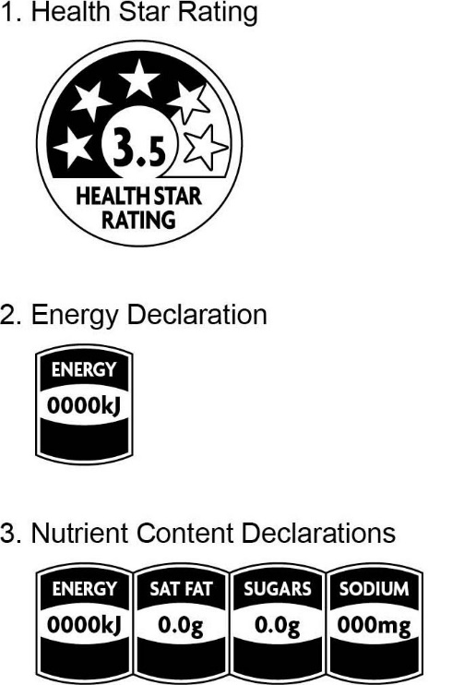

5.2 Design principles
- The HSR system is designed as a front-of-pack labelling tool, however where products are generally displayed with an alternative visible facing side (such as some products displayed in a chest freezer where a side facing may be visible to the shopper), the HSR system graphic may be placed on the commonly visible facing side.
- If the HSR system graphic is duplicated on a secondary facing, the rating must be the same as the product and not an example of a lower or higher HSR.
- For products in cylindrical packaging the HSR system graphic should be placed on the part of the container most likely to be considered the front-of-pack (i.e. showing a prominent brand and net weight/volume). There is no requirement to duplicate the HSR system graphic on a secondary facing.
- All HSR elements must be presented exactly as shown in Figure 2. All stars must be visible, with shading behind the appropriate number of stars to indicate the rating of the product. The style of the energy and nutrient icon elements must be as per Figure 2, noting the energy icon is not permitted in isolation (i.e. without the stars element of the HSR system graphic).
- The stars element of the HSR system graphic should be larger than the energy and nutrient elements (when they are used within the HSR system graphic).
- The HSR system graphic should be presented in a colour that meets legibility requirements and provides good contrast to the background to maximise legibility (legibility requirements are detailed in Standard 1.2.1 in the Code) . Where the HSR system graphic may not be legible due to background images or colour, a white or contrasting colour panel can be used behind the HSR system graphic to further aid legibility.

5.3 Scaling and Minimum Size
The HSR system graphic can be scaled according to the package size, provided that it remains legible.

5.4 Health Star Rating graphic
As illustrated in Figure 2, the HSR system graphic comprises:
- A rating from ½ to 5 stars (in ½ star increments) represented by shading behind the stars with all stars displayed clearly on the graphic;
- The same rating displayed numerically; and
- The words “Health Star Rating” displayed prominently below the stars.
The stars element of the HSR system graphic is designed to be more prominent than the energy and nutrient elements. The stars element of the HSR system graphic must be used on all products using the HSR system.

5.5 Energy and Nutrient Icons
The nutrition information icons, when they are used, should include:
- ‘Energy’;
- The nutrient name;
- The average energy content or average quantity of nutrients in the nominated reference measure with appropriate units i.e. kilojoules (kJ) for energy, grams (g) or milligrams (mg) or millilitres (mL) for nutrients;
The order of the icons in the HSR system graphic should reflect their order in the NIP, i.e. reading from left to right: energy, prescribed nutrients (saturated fat, sugars, sodium), optional nutrient.
Sufficient space has been provided in the preferred design to accommodate nutrient names and values in a clear and legible way. For the declaration of ‘saturated fat’ content in the nutrient icon, ‘sat fat’ is permitted. If it is necessary to use an abbreviation for positive nutrients with long names in order to maintain legibility please seek advice from the FoPL Secretariat.

Figure 3: Elements of the Energy and Nutrient icons
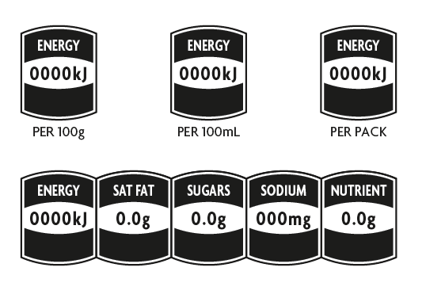
Individual values within each icon should:
- be consistent with values shown in the NIP;
- in the case of energy, be reported as a whole number of kilojoules to three significant figures (e.g. 452.4 presented as 452kJ);
- be reported to one decimal place if the units are grams (e.g. 4.5g); and
- be reported as a whole number if the units are milligrams (e.g. 450mg).
The energy and nutrient icons cannot be used in isolation. They must be displayed in conjunction with the HSR stars graphic.
The energy and nutrient composition of product ingredients can vary significantly. Businesses need to be aware of this variation, and its potential magnitude, when estimating average values. Energy and nutrient values should reflect those stated in the NIP (i.e. if values in the NIP change, the energy and nutrient values displayed as part of the HSR system graphic should be updated).

Australian and New Zealand consumer law legislation is also relevant and requires that claims and representations are not false or misleading. It may therefore be inappropriate to round a number that reflects the presence of a number to zero (e.g. rounding 0.021mg to zero), as this would imply an absence of the nutrient. In this instance rounding to two decimal places is permitted.

5.5.1 Energy icon
The energy icon may be used in conjunction with other HSR system graphic elements. If the energy icon is used with only the stars element of the HSR system graphic, the energy icon should be placed to the right-hand side of HSR system graphic (as illustrated in Figure 5.3). If required, the energy icon may be placed below the HSR system graphic, (see options for configuration at Appendix 5, Figure 6).
A %DI value may be included within the energy icon for ‘per pack’ values (i.e. when presented as a single serve pack intended for consumption in a single sitting) or ‘per [serve size]’ values (when displayed in accordance with Section 5 of this Guide). %DI cannot be used for reference measurements of per 100g/100mL (example is at Figure 5.1).
The %DI value should be:
- based on the energy content per pack (for single serve packs intended for consumption in a single sitting) or per [serve size] (when displayed in accordance with Section 5.6 of this Guide);
- expressed as a percentage of the total DI reference value for energy as listed in Standard 1.2.8 of the Code;
- expressed as a whole number through standard rounding (unless < 1). Values above 1 with a following decimal below 0.5 should be rounded down and values above 1 with a following decimal of 0.5 or above should be rounded up to the next whole number; and
- presented as %DI*, with the asterisk (*) to refer to a back of pack message about the average daily adult kilojoule intake.
When %DI is used on the energy icon, it triggers the full use of %DI column in the NIP, i.e. energy plus 6 nutrients and a statement about the average daily adult kilojoule intake (refer to 1.2.8-8 of Standard 1.2.8 of the Code).
Where the labelled value for energy is ‘0’, statement of a %DI is at the discretion of the Business.
Details on calculating %DI values are provided in Appendix 6.

5.5.2 Nutrient Icons
If the prescribed nutrient icons are displayed (saturated fat, sugars, sodium) they should all be displayed, in conjunction with the energy icon.
A single optional nutrient may be presented, in addition to the prescribed nutrient icons, and the energy icon. Businesses may choose, with consideration of the following, which (single) optional nutrient to present within the HSR system graphic:
- Optional nutrients are defined as properties of products in Schedule 4.
- The nutrient must be present at a level consistent with the requirements of Schedule 4 and be included in the NIP in accordance with the requirements of Standard 1.2.8 of the Code.
- The purpose of the nutrient icons is to provide nutritional information only. They are not to be used to provide advice on the levels of food components which may have other health implications - for example gluten content, lactose content, glycaemic index, etc.
The words ‘low’ and ‘high’ may be used within the nutrient icons (except for the energy icon) to highlight the content of individual nutrients in the food product (example is at Figure 5).
In the case of the prescribed nutrients (saturated fat, sugars and sodium), the word low may only be used when the nutrient is present at levels consistent with the requirements of Schedule 4 for making a low saturated fat/sugar/ sodium nutrition content claim.
In the case of the optional positive nutrient, the word high may only be used when the nutrient is present at levels consistent with the requirements of Schedule 4 for making nutrition content claims for ‘good source’ or ‘excellent source’.

The use of the HSR system optional positive nutrient icon will constitute a nutrition content claim under Standard 1.2.7 of the Code, and must comply with the requirements of the Standard.

Figure 4: Use of %DI, ‘low’ and ‘high’
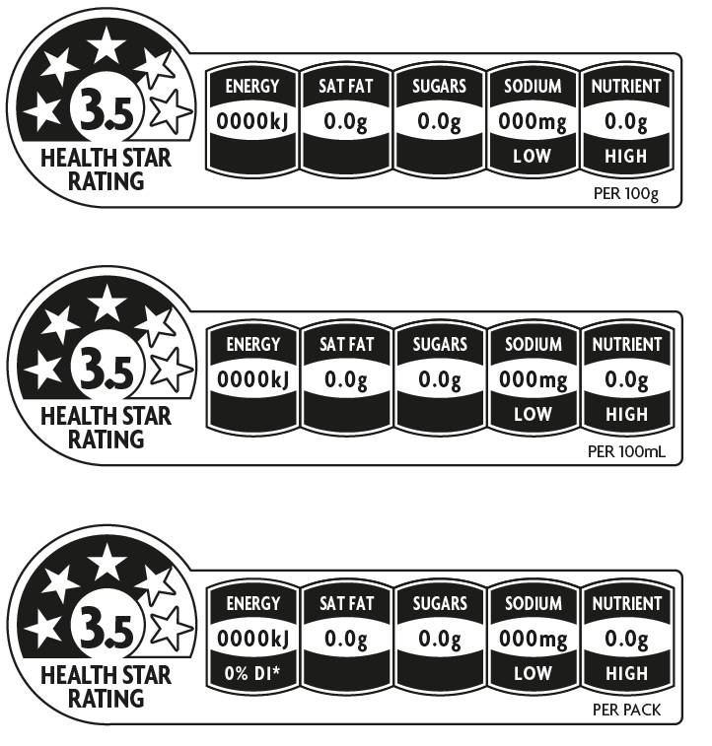

5.6 Nominated Reference Measure
Energy and nutrient information may be presented on a ‘per 100g or 100mL’ basis, ‘per pack’ (when presented as a single portion), or ‘per [reference portion]’ (when presented as a multipack with individual pre-portioned units intended for consumption in a single sitting), or ‘per [serve size]’ according to the following guidance.
- All products may use the ‘per 100g’ or ‘per 100mL’ reference, which should be placed to the right hand side of the graphic.
- Products presented in single serve packages (e.g. an individual lasagne intended for consumption in a single sitting by a single person) may use the:
- ‘per 100g’ or ‘per 100mL’ reference; or
- ‘per pack’ reference.
The nominated reference measure should be placed to the bottom right hand side of the graphic, as shown in Figure 4.
- Products presented as multipacks with multiple individually pre-packaged units (Section 5.8) may use the:
- ‘per 100g or 100mL’ reference; or
- ‘per [reference portion]’ reference.
- Products for which an industry agreed standardised serve size applies (Section 5.7) may use the ‘per [serve size]’ reference (see Table 8).
In order to be consistent with the Code, the serve size should also be specified in the NIP.
- Products for which the energy and nutrient information is calculated ‘as prepared’, reference weight should include the text ‘as prepared’ after the nominated reference measure.

Percentage daily intake (%DI) information can only be used on the energy icon of a ‘per pack’ or ‘per [serve size]’ representation. To comply with Standard 1.2.8 of the Code, %DI should not appear on products when nutrient information is presented on a ‘per 100g or 100mL’ basis. See Section 5.7 for confectionary packs displayed on a per ‘reference portion’ reference.

5.7 Industry Agreed Standardised Serve Sizes
Where there is an industry agreed standardised serve size for products it is appropriate to use this as the nominated reference value on packs and with corresponding nutrient values in the nutrient information elements of the HSR system graphic. The star rating element will still be calculated per 100g/100mL. Current industry agreed standardised serve sizes are listed in Table 8 below. Only those categories listed in Table 8 should use the standardised serve size as the nominated reference measure.
Other industry agreed standardised serve sizes will be considered by the HSR Advisory Committee for inclusion in Table 8 and use in the HSR system once they have been agreed by industry through formal processes.

Table 8: Current industry agreed standardised serve size
Category | Standardised serve size | Notes
Beverages | Product less than or equal to 600mL – serve size is the entire product  Products greater than 600mL – serve size is 250mL
Chocolate / Sugar confectionery | 25g +/- 5g  The nominated reference measure (e.g. per row for share pack of chocolate / per 3 snakes etc.) can be used when the nominated reference amount equals 25g +/-5g | Pack should specify what the actual confectionery serve size is, e.g. 23g

5.8 Multipacks
Multipacks are packs that contain individual pre-portioned units intended for consumption as single portions and not intended for individual sale. Examples include individual packets of potato crisps in a family multipack; individual packs of yoghurt in a 4-serve multipack; individual bottles (under 600 mL) in a 6-pack of soft drinks.
For multipacks with individually pre-portioned units, ‘per [reference portion]’ may be used on the HSR system graphic. The reference portion may be presented as appropriate (e.g. ‘per inner pack’ or ‘per single pack’ or ‘per bottle’) and should be clearly visible to the shopper at the point of sale.
For confectionery products only, the %DI can be shown on the energy icon for individual packs in a multipack, even when the pre-portioned piece size is not the industry agreed standardised serve size (see Section 5.7). However, in order to be consistent with the Code, the pre-portioned piece size should be specified in the NIP.
For multipacks that display more than one NIP on the outer pack, the preferred display option for the HSR system is one HSR system graphic to represent each NIP or product in the pack.
Where Businesses choose to display only one HSR system graphic, then an average HSR which represents the average nutrient content of all of the products within the outer pack (rather than an average of all HSRs) should be displayed. Alternatively, Businesses may choose to display the lowest HSR and indicate that the products within the multipack are either equivalent to the displayed HSR or higher. In either case the company should include a statement on how the HSR was derived (e.g. ‘average of nutrient content of all varieties’ or ‘minimum star rating of varieties’).

Section 6 Hierarchy of Health Star Rating system presentation
It is expected consumers will benefit most when the full (including optional) elements of the HSR system graphic are displayed. This includes:
- the Health Star Rating,
- energy icon,
- three (3) prescribed nutrient icons
- an optional nutrient icon (if appropriate),
together with the further optional interpretive terms ‘high’ and ‘low’ with respect of the nutrient icons, and the %DI of energy (for the ‘per pack’ or ‘per [serve size]’ presentation) (Figure 5).
Therefore, Businesses are encouraged to use as many elements of the HSR system graphic as possible, consistent with the below hierarchy. Some products may not be able to display all the elements of the full HSR system graphic due to pack or label size or other considerations. In these cases there is a hierarchy of options for the elements to be displayed:
- Health Star Rating + energy icon + 3 prescribed nutrient icons + 1 optional nutrient icon.
- Health Star Rating + energy icon + 3 prescribed nutrient icons.
- Health Star Rating + energy icon.
- Health Star Rating (e.g. when pack size does not accommodate more complete versions).
It is the responsibility of Businesses to determine which presentation format is most suitable for their products, based on the above hierarchy, available pack size and label space.
The different options for displaying the HSR system graphic are shown below (Figure 5).

Figure 5 – all options for HSR display
Figure 5.1: Health Star Rating + energy icon + 3 prescribed nutrient icons + 1 optional nutrient icon (plus the two optional elements: use of the terms High / Low and %DI)

Figure 5.2: Health Star Rating + energy icon + 3 prescribed nutrient icons
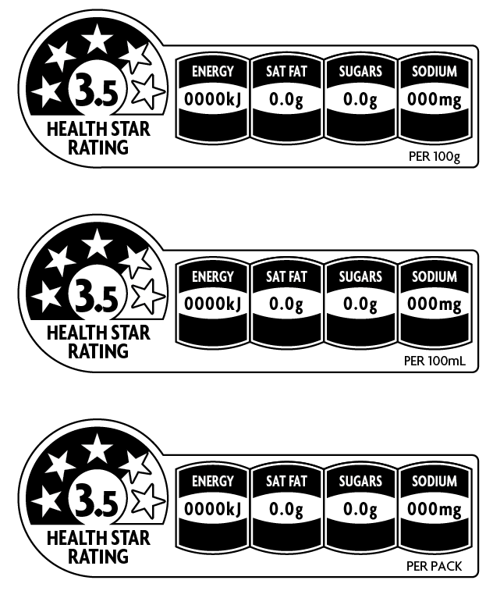

Figure 5.3: Health Star Rating + energy icon
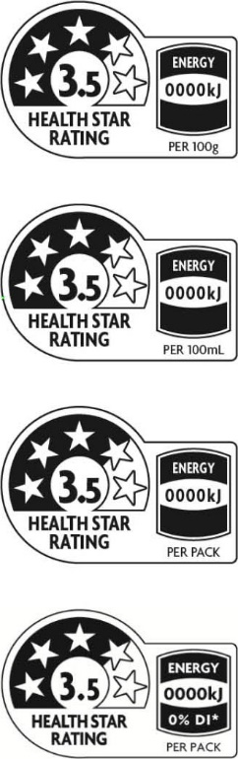

Figure 5.4: Health Star Rating
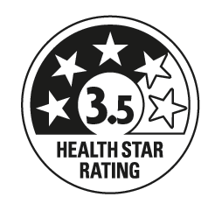

Figure 5.5: Standard Design for the Health Star Rating system (full graphic without optional elements of High / Low or %DI)
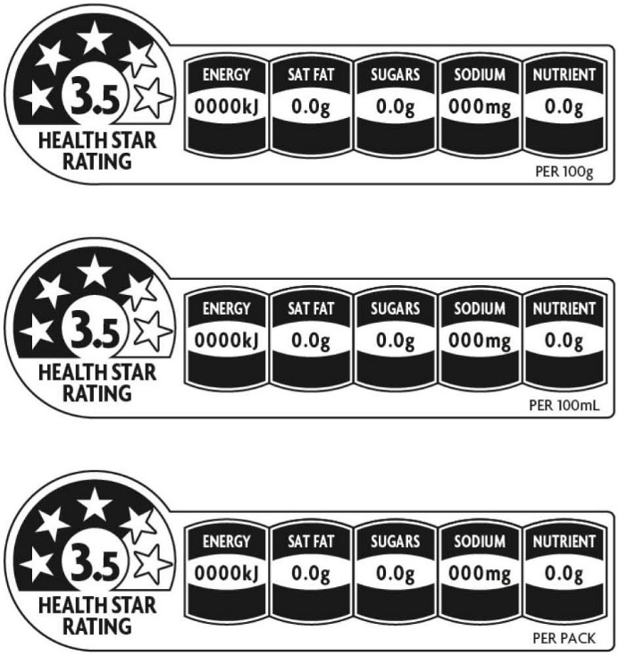

Section 7 Display of further Health Star Rating Information
Where Businesses choose to display further information on the HSR system on their product packages, any HSR system graphic displayed in this context should be a duplicate of the HSR system graphic displayed on the front of the pack i.e. if a product displays a HSR of 3.5, any additional information given on the label must be consistent with this rating.
Where additional information is displayed and if space permits, Businesses are encouraged to display an HSR Quick Response (QR) Code that directs consumers to the HSR website when scanned. A QR Code is available for download on the HSR website.

Section 8 The Daily Intake Guide, Health Logos and Certification Schemes
The Daily Intake Guide (DIG) and health logos and certification schemes that provide nutritional guidance to consumers are used widely in Australia and New Zealand. The DIG, health logos, other industry initiatives and certification schemes may co-exist with the HSR system graphic.
Where the HSR system graphic and DIG are used on the same pack care should be taken to ensure they do not lead consumers to believe they are linked or are two parts of a single system.

Section 9 Digital and other off-pack use of the HSR system
The display of the HSR on the Front-of-physical packaging is encouraged in all circumstances in line with this guidance on HSR eligible products, as appropriate.

The digital and other off-pack display of the HSR system is permitted, for example display on online shopping platforms, consumer facing phone applications, statements on businesses websites, in-store signage and through advertising and/or marketing.

Digital and off-pack application alone, or without the use on labels will not be counted towards HSR uptake figures.

Retailers, brand owners, manufacturers and other users may choose to digitally or otherwise display the HSR for a product that does not display the HSR on its physical label, or to complement the physical label. When the HSR is displayed by a third party, express permission must be granted by the manufacturer/brand owner to display the rating and the rating must be confirmed by the brand owner/manufacturer prior to display. Calculation details are not required for confirmation. It is recommended a record is kept of this confirmation.

Although it is best practice, the requirement to confirm the rating with the brand owner/manufacturer is not required where the HSR is not associated with commercial use, for example (including but not limited to) government, public health, research, database or similar use. Best efforts should be made to ensure the accuracy of the HSR calculation and there should be pathways in place for brand owners/manufacturers to query the HSR rating or inform of changes to the HSR.

All displays of the HSR system must be aligned with the design principles for on pack display where applicable. It is the responsibility of the third party to amend and regularly update any Health Star Rating. Should a rating be queried by the brand owner/manufacturer, the third party must cease all off-pack use of the HSR for the product in question until the rating can be confirmed by the brand owner/manufacturer. If the matter cannot be resolved between the brand owner/manufacturer and third party, the dispute resolution process for the HSR system should be enacted.

The off-pack display of an HSR does not trigger the requirement for a nutrition information panel to be displayed.

Appendix 1: Health Star Rating calculation steps - All products excluding dairy & alternatives (categories 1, 2 and 3)
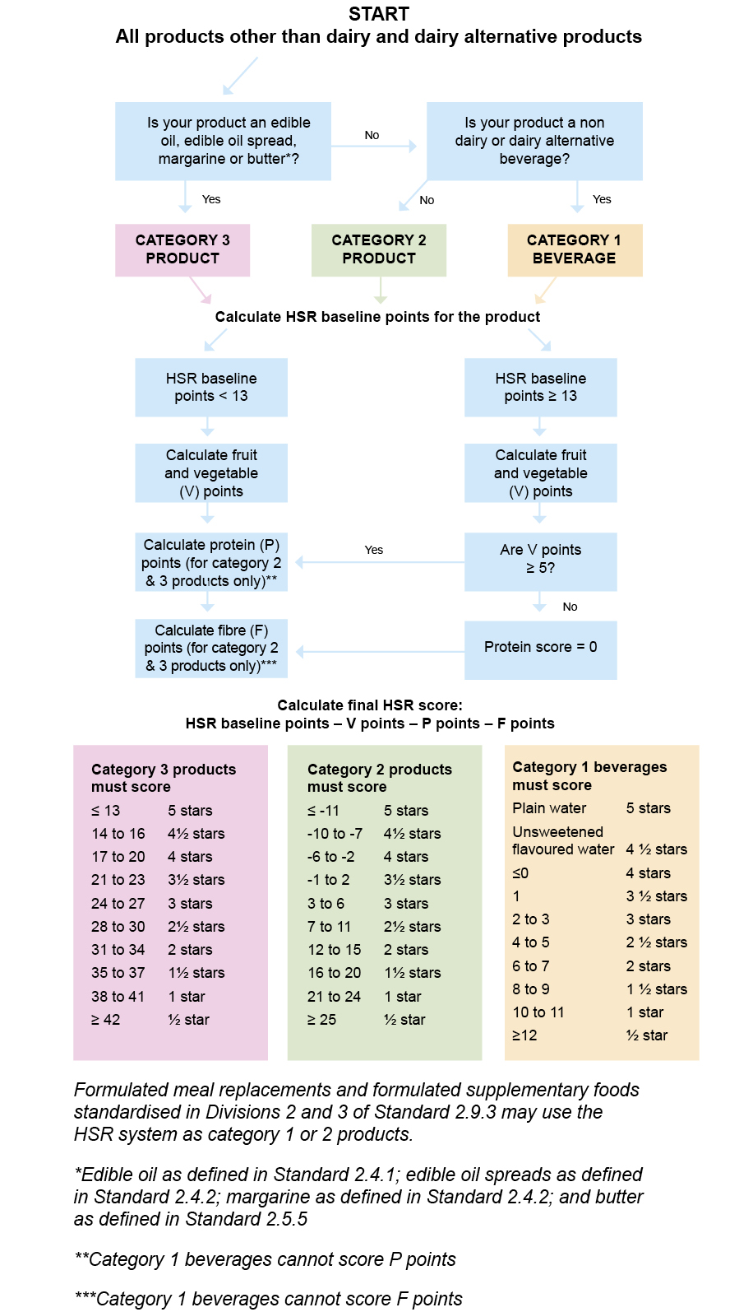

Appendix 2: Health Star Rating calculation steps - Dairy products and their alternatives (categories 1D, 2D and 3D) 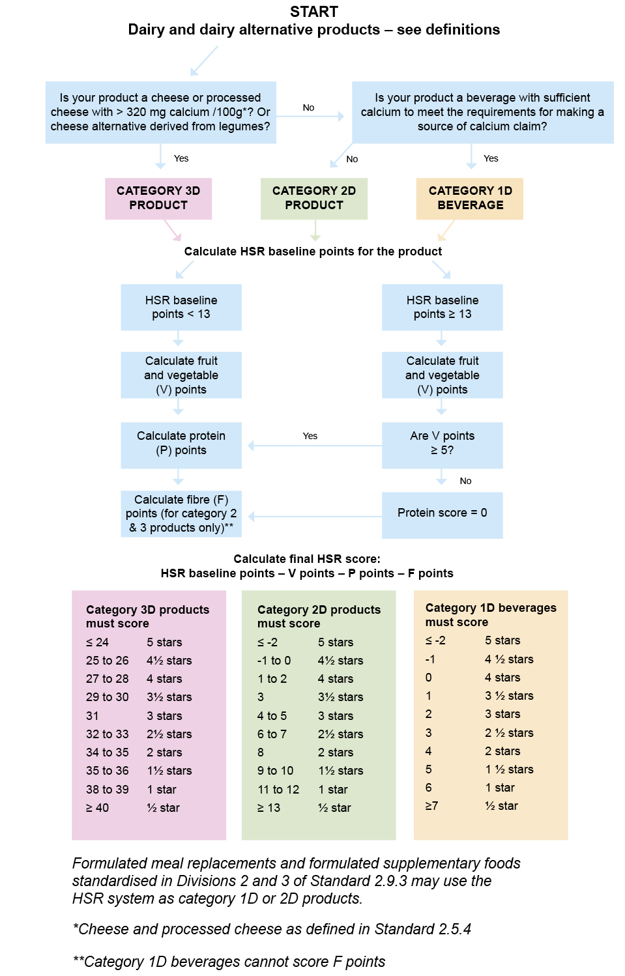

Appendix 3: Calculation examples – using case studies
The following examples are provided to demonstrate the calculations in the HSR Calculator. The nutrition information provided in these examples is intended to be fictional and is not based on any specific product existing in the market.
The rating given to these examples may differ to other similar products in the market as it is dependent on each product’s nutrient and ingredient profile.
In the following examples, the reference to any relevant policy decisions means to consider whether the product is permitted or not permitted to carry a HSR, and if permitted, would it qualify for an automatic HSR score.
Example 1 Chocolate milk
Example 2 Dairy spread
Example 3 Fruit and nut muesli bar
Example 4 Pizza Supreme
Example 5 Raspberry soft drink
Example 6 Vanilla dairy food
Example 7 Camembert cheese
Example 8 Instant chicken soup

Example 1 – Chocolate milk
Nutrition Information – chocolate milk (Defined serve for regulatory purposes - 200mL)
Component | Per 100 mL
Energy | 380 kJ
Protein | 3.2 g
Saturated fat | 1.2 g
Total sugars | 9.5 g
Dietary fibre | 0
Sodium | 45 mg
Calcium | - mg

Determine the HSR Calculator category of the product
The chocolate milk is a Category 1D dairy beverage because it:
- is a beverage
- contains ≥75% dairy
  - Ingredients list: Whole milk, Sugar, Cocoa powder, Natural flavours, Vegetable Gum (407), Colours (155, 133).
- has ≥ 80 mg of calcium per serve.

Determine whether there are any relevant policy decisions
No relevant policy decisions.

Determine form of product
As sold.

Calculate HSR baseline points
Based on the nutrition information for the chocolate milk example, the baseline points obtained are highlighted below.
HSR baseline points for Category 1D Beverages, 2 or 2D Foods*
Baseline points | Energy (kJ)  per 100 g or 100 mL | Saturated fat (g)  per 100 g or 100 mL | Total sugars (g)  per 100 g or 100 mL | Sodium (mg)  per 100 g or 100 mL
0 | ≤335 | ≤1.0 | ≤5.0 | ≤90
1 | >335 | >1.0 | >5.0 | >90
2 | >670 | >2.0 | >8.9 | >180
3 | >1005 | >3.0 | >12.8 | >270
4 | >1340 | >4.0 | >16.8 | >360
5 | >1675 | >5.0 | >20.7 | >450
6* | >2010 | >6.0 | >24.6 | >540
*This table is a shortened version of Table 1 provided in the HSR Calculator Guide above
Total HSR baseline points = (1) + (1) + (2) + (0) = 4

Calculate HSR modifying points
HSR V points
The chocolate milk in this example does not contain any fvnl.
V points = 0
HSR Protein (P) and Fibre (F) points
Category 1D products cannot score F points.
Based on the nutrition information for the chocolate milk example, the protein (P) points obtained are highlighted below:
HSR Protein (P) and Fibre (F) Points
Points | Protein (g)  per 100 g or 100 mL | Dietary fibre (g)  per 100 g or 100 mL
0 | ≤1.6 | ≤0.9
1 | >1.6 | >0.9
2 | ≥3.2 | >1.9
3 | >4.8 | >2.8
4 | >6.4 | >3.7
5 | >8.0 | >4.7
6 | >9.6 | >5.4
7 | >11.6 | >6.3
8* | >13.9 | >7.3
*This table is a shortened version of Table 6 provided in the HSR Calculator Guide above

The product in this example contains 3.2 g of protein per 100 mL and therefore scores 2 protein (P) points.
P points = 2 F points = 0

Calculate the final HSR score
Final HSR score = HSR baseline points – (V points) – (P points) – (F points)

Final HSR score = (4) – (0) – (2) – (0) = 2

Assessment of the final HSR score to a rating
The final HSR score for the chocolate dairy milk example (Category 1D product) is 2.
Therefore this example product would be assigned a rating of 3 stars.

Example 2 – Dairy spread
Nutrition Information – Dairy spread
Component | Per 100 mL
Energy | 2420 kJ
Protein | 0.0 g
Saturated fat | 16.5 g
Total sugars | 0.0 g
Dietary fibre | 0.0 g
Sodium | 640 mg

Determine the HSR Calculator category of the product
This dairy spread meets the definition of edible oil spread as defined in Standard 2.4.2 of the Code.

Determine whether there are any relevant policy decisions
No relevant policy decisions.

Determine form of product
As sold.

Calculate HSR baseline points
Based on the nutrition information for this example, the HSR baseline points obtained are adjacent to the highlighted boxes in the table below.
HSR baseline points for Category 3 and 3D products
Baseline points | Energy (kJ)  per 100 g or 100 mL | Saturated fat (g)  per 100 g or 100 mL | Total sugars (g)  per 100 g or 100 mL | Sodium (mg)  per 100 g or 100 mL
0 | ≤ 335 | ≤1.0 | ≤ 5.0 | ≤90
1 | >335 | >1.0 | >5.0 | >90
2 | >670 | >2.0 | >9.0 | >180
3 | >1005 | >3.0 | >13.5 | >270
4 | >1340 | >4.0 | >18.0 | >360
5 | >1675 | >5.0 | >22.5 | >450
6 | >2010 | >6.0 | >27.0 | >540
7 | >2345 | >7.0 | >31.0 | >630
8 | >2680 | >8.0 | >36.0 | >720
9 | >3015 | >9.0 | >40.0 | >810
10 | >3350 | >10.0 | >45.0 | >900
11 | >3685 | >11.0 |  | >990
12 |  | >12.0 |  | >1080
13 |  | >13.0 |  | >1170
14 |  | >14.0 |  | >1260
15 |  | >15.0 |  | >1350
16 |  | >16.0 |  | >1440
17 |  | >17.0 |  | >1530
*This table is a shortened version of Table 2 provided in the HSR Calculator Guide above

Total HSR baseline points = (7) + (16) + (0) + (7) = 30

Calculate HSR modifying points
HSR V points
As oil is an extract of a fruit, the food in this example cannot score V points for fvnl content.
V points = 0

HSR Protein points (P points)
The product in this example does not contain any protein and scores zero protein (P) points.
Further, products that score 13 or more HSR baseline points are not permitted to score points for protein unless they score at least 5 V points. If the product in this example contained protein, it would not be permitted to score points for protein as it scored 30 HSR baseline points and does not score any V points.
P points = 0

HSR Fibre points (F points)
The product in this example does not contain any dietary fibre.
F points = 0

Calculate the final HSR score
Final HSR score = HSR baseline points – (V points) – (P points) – (F points)

Final HSR score = (30) – (0) – (0) – (0) = 30

Assessment of the final HSR score to a rating
The final HSR score for the Dairy spread (Category 3 food) is 30.
Therefore, this example product would be assigned a rating of 2½ stars.

Example 3 – Fruit and nut muesli bar
Nutrition Information – Fruit and nut muesli bar
Component | Per 100 g
Energy | 1735 kJ
Protein | 12.5 g
Saturated fat | 4.5 g
Total sugars | 36.4 g
Sodium | 30 mg
Dietary fibre | 5.0 g

Determine the HSR Calculator category of the product
This bar is not a dairy food, it is not a Category 1 (non-dairy beverage) or 3 (oils and spreads) product so is a Category 2 product (i.e. all products other than those included in Category 1, 1D, 2D, 3 or 3D).

Determine whether there are any relevant policy decisions
No relevant policy decisions.

Determine form of product
As sold.

Calculate HSR baseline points
Based on the nutrition information for this example, the HSR baseline points obtained are adjacent to the highlighted boxes in the table below.
HSR baseline points for Category 1D Beverages, 2 or 2D Foods
Baseline points | Energy (kJ)  per 100 g or 100 mL | Saturated fat (g)  per 100 g or 100 mL | Total sugars (g) per 100 g or 100 mL | Sodium (mg)  per 100 g or 100 mL
0 | ≤335 | ≤1.0 | ≤5.0 | ≤90
1 | >335 | >1.0 | >5.0 | >90
2 | >670 | >2.0 | >8.9 | >180
3 | >1005 | >3.0 | >12.8 | >270
4 | >1340 | >4.0 | >16.8 | >360
5 | >1675 | >5.0 | >20.7 | >450
6 | >2010 | >6.0 | >24.6 | >540
7 | >2345 | >7.0 | >28.5 | >630
8 | >2680 | >8.0 | >32.4 | >720
9 | >3015 | >9.0 | >36.3 | >810
10 | >3350 | >10.0 | >40.3 | >900
11 | >3686 | >11.2 | >44.2 | >990
12 |  | >12.5 | >48.1 | >1080
13 |  | >13.9 | >52.0 | >1170
*This table is a shortened version of Table 1 provided in the HSR Calculator Guide above
Total HSR baseline points = (5) + (4) + (9) + (0) = 18

Calculate HSR modifying points
HSR V points
In this example, the bar contains 43% peanuts and 27% sultanas.
Schedule 5 contains the following formula to derive V points from a mixture of concentrated (dried) fruit or vegetables and non-concentrated fvnl ingredients:
$$\frac{(\% non\text{-}concentrated fvnl) + (2 x \% concentrated fruits or vegetables)}{(\% non\text{-}concentrated fvnl) + (2 x \% concentrated fruits or vegetables) +( \% non fvnl ingredient)} ×100/1$$
where:
%non-concentrated fvnl/concentrated fruits or vegetables means
the percentage of fvnl in the food determined using the appropriate calculation methods outlined in Standard 1.2.10 of the Code.
= 43 + (2 x 27) / 43 + (2x 27) + 30
= 97/127 x 100
= 76% fvnl, including a mixture of concentrated fruit and non-concentrated nuts; therefore Column 2 in the table below is used to determine the V points.
HSR V Points
Points | Column 1  % concentrated fruits or vegetables | Column 2  % non-concentrated fvnl
0 | <25 | ≤40
1 | ≥25 | >40
2 | ≥43 | >60
3 | ≥52 | >67
4 | ≥63 | >75
5 | ≥67 | >80
6 | ≥80 | >90
7 | ≥90 | >95
8* | =100 | =100
*For the purposes of HSR Calculator a food that is >99.5% fvnl counts as 100% where food additives or fortificants have been added, e.g. pure fruit juice with added vitamin C
V points = 4

HSR Protein points (P points)
Foods that score 13 or more HSR baseline points are not permitted to score points for protein unless they score at least 5 V points.
The product in this example scored 18 HSR baseline points and 4 V points (it did not score at least 5 V points) and is therefore not permitted to score points for protein.
P points = 0
HSR Protein (P) and Fibre (F) Points
Points | Protein (g)  per 100 g or 100 mL | Dietary fibre (g)  per 100 g or 100 mL
0 | ≤1.6 | ≤0.9
1 | >1.6 | >0.9
2 | ≥3.2 | >1.9
3 | >4.8 | >2.8
4 | >6.4 | >3.7
5 | >8.0 | >4.7
6 | >9.6 | >5.4
7 | >11.6 | >6.3
8 | >13.9 | >7.3
9 | >16.7 | >8.4
10 | >20.0 | >9.7
11 | >24.0 | >11.2
12 | >28.9 | >13.0
13 | >34.7 | >15.0
14 | >41.6 | >17.3
15 | >50.0 | >20.0

F points = 5

Calculate the HSR final score
Final HSR score = HSR baseline points – (V points) – (P points) – (F points)

Final HSR score = (18) – (4) – (0) – (5) = 9

Assessment of the final HSR score to a rating
The final HSR score for the fruit and nut muesli bar (Category 2 food) is 9.
Therefore, this example product would be assigned a rating of 2½ stars.

Example 4 – Pizza Supreme
Nutrition Information – Pizza supreme
Component | Per 100 g
Energy | 1125 kJ
Protein | 13.9 g
Saturated fat | 5.2 g
Total sugars | 0.9 g
Sodium | 743 mg
Dietary fibre | 3.3 g

Determine the HSR Calculator category of the product
This pizza is not a dairy food, it is not a Category 1 (non-dairy beverage) or 3 (oils and spreads) food so is a Category 2 product (i.e. all products other than those included in Category 1, 1D, 2D, 3 or 3D).

Determine whether there are any relevant policy decisions
No relevant policy decisions.

Determine form of product
As sold

Calculate HSR baseline points
Based on the nutrition information for this example, the HSR baseline points obtained are adjacent to the highlighted boxes in the table below.

HSR baseline points for Category 1D Beverages, 2 or 2D Foods
Baseline points | Energy content (kJ)  per 100 g or 100 mL | Saturated fat (g)  per 100 g or 100 mL | Total sugars (g) per 100 g or 100 mL | Sodium (mg)  per 100 g or 100 mL
0 | ≤335 | ≤1.0 | ≤5.0 | ≤90
1 | >335 | >1.0 | >5.0 | >90
2 | >670 | >2.0 | >8.9 | >180
3 | >1005 | >3.0 | >12.8 | >270
4 | >1340 | >4.0 | >16.8 | >360
5 | >1675 | >5.0 | >20.7 | >450
6 | >2010 | >6.0 | >24.6 | >540
7 | >2345 | >7.0 | >28.5 | >630
8 | >2680 | >8.0 | >32.4 | >720
9 | >3015 | >9.0 | >36.3 | >810
10 | >3350 | >10.0 | >40.3 | >900
11 | >3686 | >11.2 | >44.2 | >990
12 |  | >12.5 | >48.1 | >1080
*This table is a shortened version of Table 1 provided in the HSR Calculator Guide above
Total HSR baseline points = (3) + (5) + (0) + (8) = 16

Calculate HSR modifying points
HSR V points
In this example, the pizza contains:
- 4% concentrated vegetables
- 23% non-concentrated vegetables.
Schedule 5 of the Code contains the following formula to use to derive V points from a mixture of concentrated (dried) fruits or vegetables and non-concentrated fvnl ingredients:
$$\frac{(\% non\text{-}concentrated fvnl) + (2 x \% concentrated fruits or vegetables)}{(\% non\text{-}concentrated fvnl) + (2 x \% concentrated fruits or vegetables) +( \% non fvnl ingredient)}×100/1$$
where:
%non-concentrated fvnl/concentrated fruits or vegetables means
the percentage of fvnl in the food determined using the appropriate calculation methods outlined in Standard 1.2.10 of the Code.
= 23 + (2 x 4) / 23 + (2x 4) + 73
= 31/104 x 100
= 30% fvnl, including a mixture of concentrated fruits and non-concentrated nuts; therefore Column 2 in the table below is used to determine the V points.
HSR V Points
Points | Column 1  % concentrated fruits or vegetables | Column 2  % non-concentrated fvnl
0 | <25 | ≤40
1 | ≥25 | >40
2 | ≥43 | >60
3 | ≥52 | >67
4 | ≥63 | >75
5* | ≥67 | >80
*This table is a shortened version of Table 5 provided in the HSR Calculator Guide above

V points = 0

HSR Protein points (P points)
Products that score 13 or more HSR baseline points are not permitted to score points for protein unless they score at least 5 V points.
The products in this example scored 16 HSR baseline points and zero V points (it did not score at least 5 V points) and is therefore not permitted to score points for protein.

P points = 0

HSR Protein (P) and Fibre (F) Points
Points | Protein (g)  per 100 g or 100 mL | Dietary fibre (g)  per 100 g or 100 mL
0 | ≤1.6 | ≤0.9
1 | >1.6 | >0.9
2 | ≥3.2 | >1.9
3 | >4.8 | >2.8
4 | >6.4 | >3.7
5 | >8.0 | >4.7
6 | >9.6 | >5.4
7 | >11.6 | >6.3
8* | >13.9 | >7.3
*This table is a shortened version of Table 6 provided in the HSR Calculator Guide above

F points = 3

Calculate the HSR final score
Final HSR score = HSR baseline points – (V points) – (P points) – (F points)

Final HSR score = (16) – (0) – (0) – (3) = 13

Assessment of the final HSR score to a rating
The final HSR score for the Pizza supreme (Category 2 food) is 13.
Therefore this example product would be assigned a rating of 2 stars.

Example 5 – Raspberry Soft Drink
Nutrition Information – Raspberry Soft Drink
Component | Per 100 mL
Energy | 235 kJ
Protein | 1 g
Saturated fat | 0 g
Total sugars | 13.3 g
Sodium | 5 mg
Dietary fibre | 0 g

Determine the HSR Calculator category of the product
The soft drink is a Category 1 Non-dairy beverage.

Determine whether there are any relevant policy decisions
No relevant policy decisions.

Determine form of product
As sold

Calculate HSR baseline points
Based on the nutrition information for this example, the HSR baseline points obtained are adjacent to the highlighted boxes in the table below.
HSR baseline points for Category 1 Non-dairy beverages
Baseline points | Energy (kJ)  per 100 mL | Total sugars (g)  per 100 mL
0 | ≤1.1 | ≤ 0.1
1 | > 1.1 | > 0.1
2 | > 31 | > 1.6
3 | > 61 | > 3.1
4 | > 91 | > 4.6
5 | > 121 | > 6.1
6 | > 151 | > 7.6
7 | > 181 | > 9.1
8 | > 211 | > 10.6
9 | > 241 | > 12.1
10 | > 271 | > 13.6

Total baseline points = (8) + (9) = 17

Calculate HSR modifying points
HSR V points
In this example the drink contains 6.3% raspberry juice from concentrate.
HSR V Points for Category 1 Non-dairy beverages
Points | % fvnl
0 | < 25
1 | ≥ 25
2 | ≥ 33
3 | ≥ 41
4 | ≥ 49
5 | ≥ 57
6* | ≥ 65
*This table is a shortened version of Table 4 provided in the HSR Calculator Guide above

V points = 0

HSR Protein (P points) and Fibre points (F points)
Category 1 beverages cannot score P or F points

Calculate the HSR final score
Final HSR score = HSR baseline points – (V points) – (P points) – (F points)

Final HSR score = (17) – (0) – (0) – (0) = 17

Assessment of the final HSR score to a rating
The final HSR score for the Raspberry Soft Drink (Category 1 beverage) is 17.
Therefore this example product would be assigned a rating of 0.5 star.

Example 6 – Vanilla dairy food
Nutrition Information – Vanilla dairy food
Component | Per 100 g
Energy | 345 kJ
Protein | 3.5 g
Saturated fat | 0.5 g
Total sugars | 11.0 g
Dietary fibre | 0 g
Sodium | 45 mg
Calcium | 218 mg

Determine the HSR Calculator category of the product
The vanilla dairy food is a Category 2D dairy food because it is a ‘spoonable’ dairy foods that contains > 75% dairy ingredients.
Ingredients list: skim milk, milk solids, water, cream, sugar, natural flavour, acidity regulator (Citric Acid, Sodium Citrate), stabilisers (dextrose, agar), mineral (Calcium), vanilla bean seed (0.01%), natural colour (Carotene).

Determine whether there are any relevant policy decisions
No relevant policy decisions.

Determine form of product
As sold.

Calculate HSR baseline points
Based on the nutrition information for the vanilla dairy food example, the HSR baseline points obtained are highlighted below.
HSR baseline points for Category 1D beverages, 2 or 2D Foods*
Baseline points | Energy (kJ)  per 100 g or 100 mL | Saturated fat (g)  per 100 g or 100 mL | Total sugars (g) per 100 g or 100 mL | Sodium (mg)  per 100 g or 100 mL
0 | ≤335 | ≤1.0 | ≤5.0 | ≤90
1 | >335 | >1.0 | >5.0 | >90
2 | >670 | >2.0 | >8.9 | >180
3 | >1005 | >3.0 | >12.8 | >270
4 | >1340 | >4.0 | >16.8 | >360
5* | >1675 | >5.0 | >20.7 | >450
*This table is a shortened version of Table 1 provided in the HSR Calculator Guide above

Total HSR baseline points = (1) + (0) + (2) + (0) = 3

Calculate HSR modifying points
HSR V points
The vanilla dairy food in this example does not contain any fvnl.
V points = 0

HSR Protein (P) and Fibre (F) points
Based on the nutrition information for the vanilla dairy food example, the protein and fibre points obtained are highlighted below:
HSR Protein (P) and Fibre (F) Points
Points | Protein (g)  per 100 g or 100 mL | Dietary fibre (g)  per 100 g or 100 mL
0 | ≤1.6 | ≤0.9
1 | >1.6 | >0.9
2 | ≥3.2 | >1.9
3 | >4.8 | >2.8
4 | >6.4 | >3.7
5 | >8.0 | >4.7
6 | >9.6 | >5.4
7 | >11.6 | >6.3
8* | >13.9 | >7.3
*This table is a shortened version of Table 6 provided in the HSR Calculator Guide above

The product in this example contains 3.5g of protein per 100g and therefore scores 2 protein (P) points.
P points = 2 F points = 0

Calculate the final HSR score
Final HSR score = HSR baseline points – (V points) – (P points) – (F points)

Final HSR score = (3) – (0) – (2) – (0) = 1

Assessment of the final HSR score to a rating
The final HSR score for the vanilla dairy food example (Category 2D food) is 1.
Therefore this example product would be assigned a rating of 4 stars.

Example 7 – Camembert cheese
Nutrition Information – camembert cheese
Component | Per 100 g
Energy | 1750 kJ
Protein | 16.4 g
Saturated fat | 22.5 g
Total sugars | <1 g
Dietary fibre | 0 g
Sodium | 652 mg
Calcium | 430 mg

Determine the HSR Calculator category of the product
The camembert cheese is a Category 3 D cheese because it meets the definition of cheese as defined in Standard 2.5.4 of the Code and has a calcium content > 320 mg/100 g.

Determine whether there are any relevant policy decisions
No relevant policy decisions.

Determine form of product
As sold.

Calculate HSR baseline points
Based on the nutrition information for the camembert cheese example, the HSR baseline points obtained are highlighted below.
HSR baseline points for Category 3 or 3 D Foods*
Baseline points | Energy (kJ)  per 100 g or 100 mL | Saturated fat (g)  per 100 g or 100 mL | Total sugars (g) per 100 g or 100 mL | Sodium (mg)  per 100 g or 100 mL
0 | ≤335 | ≤1.0 | ≤5.0 | ≤90
1 | >335 | >1.0 | >5.0 | >90
2 | >670 | >2.0 | >9.0 | >180
3 | >1005 | >3.0 | >13.5 | >270
4 | >1340 | >4.0 | >18.0 | >360
5 | >1675 | >5.0 | >22.5 | >450
6 | >2010 | >6.0 | >27.0 | >540
7 | >2345 | >7.0 | >31.0 | >630
8 | >2680 | >8.0 | >36.0 | >720
9 | >3015 | >9.0 | >40.0 | >810
10 | >3350 | >10.0 | >45.0 | >900
11 | >3685 | >11.0 |  | >990
12 |  | >12.0 |  | >1080
13 |  | >13.0 |  | >1170
14 |  | >14.0 |  | >1260
15 |  | >15.0 |  | >1350
16 |  | >16.0 |  | >1440
17 |  | >17.0 |  | >1530
18 |  | >18.0 |  | >1620
19 |  | >19.0 |  | >1710
20 |  | >20.0 |  | >1800
21 |  | >21.0 |  | >1890
22 |  | >22.0 |  | >1980
23* |  | >23.0 |  | >2070
*This table is a shortened version of Table 2 provided in the HSR Calculator Guide above

Total baseline points = (5) + (22) + (0) + (7) = 34

Calculate HSR modifying points
HSR V points
The camembert cheese in this example does not contain any fvnl.

V points = 0

HSR Protein (P) and Fibre (F) points
Products that score 13 or more HSR baseline points are not permitted to score points for protein unless they score at least 5 V points.
The product in this example scored 34 HSR baseline points and zero V points (it did not score at least 5 V points) and is therefore not permitted to score points for protein.

P points = 0

HSR Protein (P) and Fibre (F) Points
Points | Protein (g)  per 100 g or 100 mL | Dietary fibre (g)  per 100 g or 100 mL
0 | ≤1.6 | ≤0.9
1 | >1.6 | >0.9
2 | ≥3.2 | >1.9
3 | >4.8 | >2.8
4 | >6.4 | >3.7
5 | >8.0 | >4.7
6* | >9.6 | >5.4
*This table is a shortened version of Table 6 provided in the HSR Calculator Guide above

F points = 0

Calculate the final HSR score
Final HSR score =HSR baseline points – (V points) – (P points) – (F points)

Final HSR score = (34) – (0) – (0) – (0) = 34

Assessment of the final HSR score to a rating
The final HSR score for the camembert cheese example (Category 3D food) is 34.
Therefore this example product would be assigned a rating of 2 stars.

Example 8 – Instant chicken soup
Nutrition Information – Instant chicken soup
Component | Per 100 mL (as prepared)
Energy | 65 kJ
Protein | 0.3 g
Saturated fat | 0.1 g
Total sugars | 0.5 g
Sodium | 290 mg
Dietary fibre | 0.5 g
As prepared instructions: Add contents of sachet to 200mL of boiling water

Determine the HSR Calculator category of the food
This soup is not a dairy food, it is not a Category 1 (non-dairy beverage) or 3 (oils and spreads) food so is a Category 2 food (i.e. all foods other than those included in Category 1, 1D, 2D, 3 or 3D).

Determine whether there are any relevant policy decisions
No relevant policy decisions.

Determine form of product
As prepared. This product needs to be rehydrated with water prior to consumption.

Calculate HSR baseline points
Based on the nutrition information for this example, the HSR baseline points obtained are adjacent to the highlighted boxes in the table below.
HSR baseline points for Category 1D Beverages, 2 or 2D Foods
Baseline points | Energy (kJ)  per 100 g or 100 mL | Saturated fat (g)  per 100 g or 100 mL | Total sugars (g) per 100 g or 100 mL | Sodium (mg)  per 100 g or 100 mL
0 | ≤335 | ≤1.0 | ≤5.0 | ≤90
1 | >335 | >1.0 | >5.0 | >90
2 | >670 | >2.0 | >8.9 | >180
3 | >1005 | >3.0 | >12.8 | >270
4 | >1340 | >4.0 | >16.8 | >360
5 | >1675 | >5.0 | >20.7 | >450
6 | >2010 | >6.0 | >24.6 | >540
7 | >2345 | >7.0 | >28.5 | >630
*This table is a shortened version of Table 1 provided in the HSR Calculator Guide above

Total HSR baseline points = (0) + (0) + (0) + (3) = 3

Calculate HSR modifying points
HSR V points
The chicken soup in this example does not contain any fvnl.
V points = 0
HSR Protein points (P points)
Based on the nutrition information, the protein and fibre points obtained are highlighted below:
HSR Protein (P) and Fibre (F) Points
Points | Protein (g)  per 100 g or 100 mL | Dietary fibre (g)  per 100 g or 100 mL
0 | ≤1.6 | ≤0.9
1 | >1.6 | >0.9
2 | ≥3.2 | >1.9
3 | >4.8 | >2.8
4 | >6.4 | >3.7
5 | >8.0 | >4.7
6* | >9.6 | >5.4
*This table is a shortened version of Table 6 provided in the HSR Calculator Guide above

P points = 0 F points = 0

Calculate the HSR final score
Final HSR score = HSR baseline points – (V points) – (P points) – (F points)

Final HSR score = (3) – (0) – (0) – (0) = 3

Assessment of the final HSR score to a rating
The final HSR score for the instant chicken soup (Category 2 product) is 3.
Therefore, this example product would be assigned a rating of 3 stars.

Appendix 4: Products not eligible to score Health Star Rating V points
These are as determined by the HSR Advisory Committee

HSR V points can be scored for products that contain either non-concentrated fruit, vegetable, nut, legume (fvnl) sources, or concentrated fruits or vegetables, or a mixture of both.
The method for determining the HSR V points of a product are the same as those in Schedule 5.
Where it is not clear whether or not an ingredient would be classed as a fruit, vegetable, nut or legume for the purposes of scoring HSR V points, seek advice from the FoPL Secretariat.
Previous determinations made by the HSR Advisory Committee are detailed below.

Ingredient | Determination | Reason
Quinoa | Does not qualify to score HSR V points | Quinoa contains a similar nutritional profile to and is consumed in the same way as products defined as cereal grains. To align with the provision in Schedule 5 that excludes cereal grains from scoring V points, the HSR Advisory Committee has determined that Quinoa cannot contribute to a product’s fvnl content for the purpose of scoring HSR V points.
Cacao/Cocoa beans | Does not qualify to score HSR V points | Fruits, vegetables, nuts and legumes are awarded V points in recognition of the nutritive benefits that they provide (i.e. vitamins, minerals, fibre and other micronutrients). HSR Advisory Committee Members noted that within the Food Standards Code these beans are defined as a seed intended for use in beverages and sweets. This sub group of seeds are not referred to in any Australian Guide to Healthy Eating category for daily consumption as they do not contain equivalent levels of nutrients as the other seed sub categories (i.e. tree nuts and oil nuts). The HSR Advisory Committee has therefore determined that cacao/cocoa beans cannot contribute to a product’s fvnl content for the purpose of scoring HSR V points.
Coffee beans | Does not qualify to score HSR V points | As per cacao/cocoa beans.
Carob | Does not qualify to score HSR V points | Carob is used in confectionery and in other ways similar to cacao and does not provide sufficient nutritive value to justify scoring HSR V points. The HSR Advisory Committee has determined that carob should be treated in the same way as cacao and is therefore not eligible to score HSR V points in the HSR system.

Appendix 5: Possible configurations of the Health Star Rating system graphic
Note: Images shown here as left facing may be presented as right facing, retaining the order of the nutrients as displayed below.

Figure 6: Configuration options for display of the HSR system graphic on pack

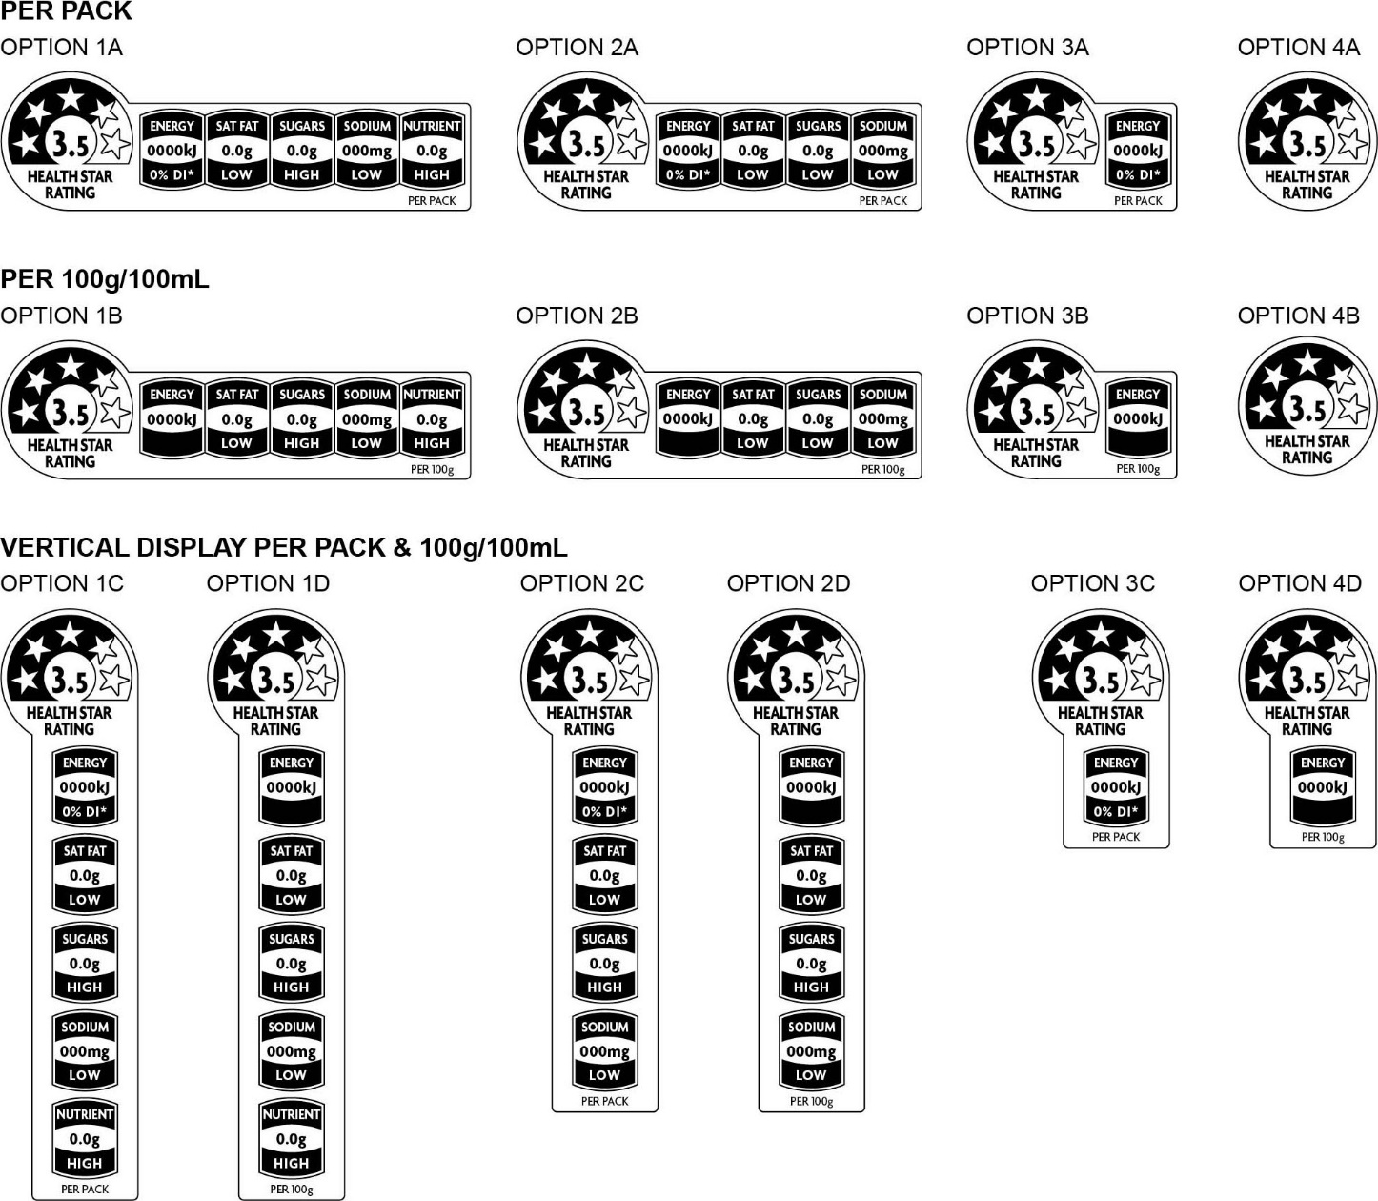

Appendix 6: Calculating Percentage Daily Intake values for the energy Icon
For ‘per pack’ (when presented as a single portion package) or ‘per [serve size]’ (when displayed as described in Section 5.6 of this Guide) representation of the energy icon, %DI values should be calculated as follows:

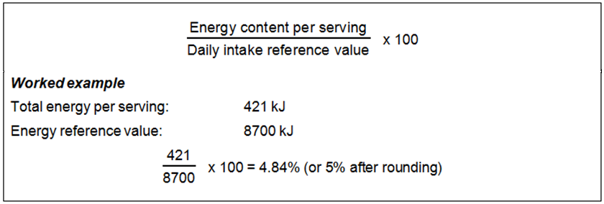

As per requirements of Standard 1.2.8 of the Code, the Daily Intake reference value for Energy is 8700kJ.
When %DI is used on the energy icon, the following is required:
- The %DI for energy must also be included in the NIP
- Under Standard 1.2.8 of the Code the percentage daily intake (%DI) for fat, saturated fat, carbohydrate, sugars, protein and sodium (per serving) must also be included in the NIP
- either of the following statements must be included under the NIP
‘*based on an average adult diet of 8700 kJ’; or
‘Percentage daily intakes are based on an average adult diet of 8700 kJ’.

Appendix 7: Document Changes
Version | Location | Change | Date
2 | Glossary and page 14 | Definition for ‘unsweetened flavoured water’ updated. | 15 November 2020
3 | Glossary and page 14 | Definition for ‘fresh and minimally processed fruits and vegetables’ updated. | 27 November 2020
4 | Section 2 and page 10 | Definition of a small package corrected ‘less than 100cm^{2’.} | 29 June 2021
4 | Section 4, Step 4 and page 20 | Table 3 (the first two rows of values the Energy column only) have been updated to reflect the changes in values in the NDB Calculator, and therefore allow for a maximum rating of 3.5 stars for diet soft drinks when using the guide to manually calculate the rating. | 29 June 2021
4 | Section 5.6 and page 29 | Reference to ‘Table 8’ has changed to ‘Section 5.7’ to correct an error made in the previous version. | 29 June 2021
5 | Section 4, Step 3 and page 18 | Additional guidance on form of the food for products drained of substances other than water or brine added. | 19 October 2021
6 | Section 2, 2a and page 10 | Additional guidance that non-alcoholic variants or brand extensions of alcoholic beverages must not use the HSR system added. | 1 July 2022
7 | Section 2, 2a and page 10 | Additional guidance that all beverages with above 0.5% alcohol by volume are excluded from applying the HSR system added. | 15 March 2023
8 | Section 4, step 5.1, page 21  Page 33, new Section 9 | Clarification on sweet corns being eligible for FVNL points subsequent to their reclassication in Schedule 22 of the Australia New Zealand Food Standards Code  New section added on digital and other off-pack use of the HSR | 21 September 2023

Front-of-Pack Labelling (FoPL) Project Committee: Objectives and principles for the development of a FoPL scheme. 2012.
Nutri-Score is a voluntary French front-of-pack labelling system based on colours and letters from green/A to red/E, allowing consumers to see and compare at a glance the nutritional value for pre-packaged food.
Dairy foods (including milk/yoghurt/cheese alternatives) are classified in separate categories 1D, 2D and 3D as the HSR score they achieve is treated slightly differently when assigned a star rating than Category 1, 2 or 3 foods. Dairy foods is the one food category with a very narrow range of HSR scores due to their derivation from a single food source (milk) and giving them a slightly wider range of star ratings allows for more informed consumer choice in this product range. The star ratings for dairy foods have been designed to support the Australian Dietary Guidelines which include dairy foods (no added sugars) in their Foundation Diets. For example, dairy products based on reduced fat milks are assigned a higher star rating than full fat milk counterparts and products with added sugar are assigned a lower star rating than those with no added sugar.
The requirement for dairy beverage alternatives to contain a ≥100mg calcium per 100mL aligns with the recommendation of the Australian Dietary Guidelines to select milk and dairy beverages alternatives with at least 100mg of added calcium per 100ml.
The types of products permitted to be considered ‘dairy alternatives’ align with those that are considered analogues and are permitted to be fortified with calcium in accordance with Schedule 17 of the Code, e.g. The Code does not provide for fortification of analogues of cheese derived from nuts and consequently these types of products are treated as a Category 2 – food and not a Category 2D - dairy food.

