Health Star Rating

Stakeholder Kit

2019

Introduction
This kit is designed to help you promote the Health Star Rating system through your programs and campaigns.

The kit contains:

- The Health Star Rating System Background
- The Facts
- The Campaign
- FAQs
- Social media content
- Website content
- Campaign resources

The kit is also located on the campaign website at:

www.healthstarrating.gov.au/stakeholder

The Health Star Rating System Background

The Health Star Rating system is a food labelling system that can help take some of the guess work out of shopping, and help consumers to make healthier choices when it comes to buying packaged food. It allows consumers to quickly compare the nutritional profile of packaged and processed foods within the same category. For example, compare one breakfast cereal with another, or one muesli bar with another. And it’s simple to understand and use. Basically, the more stars on the front of pack, the healthier the choice, when compared to similar products.

The system uses stars, ranging from a half to five stars, to provide an at-a-glance nutrition rating of packaged and processed food. The system is voluntary and is being implemented over five years, starting June 2014. Over 10,300 products have displayed the stars since the system began.

Many healthy foods, such as fresh fruit and vegetables and lean meats, are not packaged and won’t have a Health Star Rating. However these are a vital part of a nutritious and balanced diet.

Six different food categories are covered by the system. Because the calculations used to determine each product’s rating are specific to each of the six food categories, the system is not designed, for example, to compare yoghurt with frozen lasagne or margarine with cereal. Rather, it can be used to compare similar foods. The calculation is complex and takes into account the amount of certain ingredients in each product that are linked to an increased risk of developing chronic diseases, as well as some other healthier ingredients.

The Health Star Rating System is based on:
- Total energy (kilojoules) of the product.
- The saturated fat, sodium (salt) and sugar content.
- The fibre, protein, fruit, vegetable, nut and legume content.

Points are allocated based on the above ingredients per 100g or 100mL. The points are converted to a star rating (from half to five stars), which are scaled specifically to each of six Health Star Rating food categories. Details are provided in the Guide for Industry to the Health Star Rating Calculator.

The calculations for each food category and each product do not take into account ingredients such as preservatives, colours and flavours. Information on these additives can be found in the ingredients list on the pack. Those aiming to reduce their intake of these additives should review the ingredient list of each product.

A high Health Star Rating does not necessarily mean that the particular packaged food provides all of the essential nutrients required for a balanced and healthy diet. The Australian Dietary Guidelines recommend eating a balanced diet that includes a variety of nutritious foods every day. Fresh fruit and vegetables and lean meat are generally healthier choices than processed food. Frozen and canned fruit and vegetables are also great choices.

More information on the nutrition profile of a packaged food can be found in the Nutrition Information Panel and ingredients list. General dietary advice can be found in the Australian Dietary Guidelines and the Australian Guide to Healthy Eating.

Five year formal review

Australian and New Zealand Food Ministers agreed that an independent review would be held during the fifth year of implementation of the Health Star Rating system. The review is under way with views from a diverse and comprehensive range of stakeholders being sought through an open public submissions process and public consultation.

Findings and recommendations are being developed and a draft report is scheduled to be released for public comment as of February 2019. Anyone with an interest in the Health Star Rating system is encouraged to make a submission. All input and suggestions are valued. The final report will be provided to Food Ministers in mid-2019 for consideration and a response in late 2019.

Any enhancements that are likely to occur following the review will be not implemented until after a transition period has occurred. With the number of products displaying star ratings increasing, it is important to continue to increase consumer understanding of how to best use the system within a balanced diet. The key messages of the campaign remain important and relevant. These include that ratings are calculated using a strict calculation, the ratings of similar products should be compared, and carefully selected packaged foods can be incorporated into a balanced diet.

The Facts

The Australian Institute of Health and Welfare (AIHW) ‘Australia’s Health 2018’ report found that diet-related chronic diseases, such as cardiovascular disease, diabetes and some cancers, are a major cause of death and disability in Australia, and that their prevalence is steadily increasing.

The AIHW estimated that poor diets and their related health impacts cost Australia $5 billion each year, which includes direct health care costs of $3 billion. In addition, overweight and obesity (of which poor diet and physical inactivity are causal factors) cost a further $11.6 billion per year.

The burden of disease due to poor diet is often associated with large intakes of energy-dense foods with high saturated fat, sugar and/or salt content, and low intakes of nutrient-dense foods such as vegetables, fruit and wholegrain cereals.

The Australian Bureau of Statistics National Australian Health Survey 2014–2015 and some early 2017–18 results found the following:

- Australia has one of the highest rates of obesity in the world. The proportion of Australians aged 18 years and over who are overweight or obese has steadily increased, from 56.3% in 1995, to 61.2% in 2007–08, to 62.8% in 2011–12, and to 63.4% in 2014–15. In 2017–18, 67.0% of Australians were either overweight or obese.
- Around one in four (27.4%) children aged 5-17 years were overweight or obese, similar to 2011–12 (25.7%).
- In 2017–18, a greater proportion of men aged 18 years and over were overweight or obese than women (74.5% and 59.7% respectively).
- In 2014–15, 49.8% of Australians aged 18 years and over met the guidelines for recommended daily serves of fruit (2 or more serves), while only 7% met the guidelines for serves of vegetables (5-6 or more serves for men depending on age, and 5 or more for women).
- Only one in 20 (5.1%) adults met both guidelines. These rates were similar to 2011–12 (48.5%, 6.1% and 4.2% respectively).

The Campaign

The campaign will continue to support the implementation of the Health Star Rating system, through activities designed to educate and encourage consumers to use the system and to encourage increased industry participation.

Since first launching in December 2014, the campaign has focused on raising awareness of the system and educating consumers on how to use it. The new phase of activity aims to inform consumers that the ratings are calculated using a strict calculation; that the ratings of similar products should be compared; and that packaged foods can be incorporated into a balanced diet.

The key findings from the evaluation of the last phase of the campaign in 2017 are:

- Awareness of the Health Star Rating has significantly increased from 59% in June 2016 to 75% in April 2017, equating to three in four Australians being aware of the system.
- The campaign has performed well with one in five of the sample (20%) reporting having seen some aspect of the Health Star Rating campaign.
- The influence of the system on fostering positive behaviour change continues to grow, with 20% of consumers reporting that they had bought a product with a higher rating than their usual product (up from 18% in 2016), with this number increasing to 46% in consumers who had seen phase four of the campaign.

Evaluation results from each campaign phase are available at: http://healthstarrating.gov.au/internet/healthstarrating/publishing.nsf/Content/formative-research

A full suite of campaign materials including videos, images and resources can be downloaded at: http://healthstarrating.gov.au/internet/healthstarrating/publishing.nsf/Content/health-star-rating-campaign

Frequently asked questions

What are Health Star Ratings?
Health Star Ratings help you compare similar packaged products at a glance. The Health Star Rating system provides a rating from a half to five stars on the front of product packaging – the more stars, the healthier the choice. The system is voluntary but star ratings are appearing on a growing number of products.

How do I use Health Star Ratings?
When looking for the stars, remember to compare similar packaged products only. For example, compare one breakfast cereal with another, not cereal with yoghurt. The more stars, the healthier the choice.

Where will you see Health Star Ratings?
Health Star Ratings are displayed on the front of packaged foods and can be displayed in two ways. The first (circle only) shows the star rating of the product; the second includes the star rating plus additional specific nutrition information.
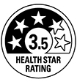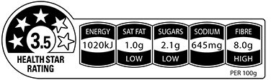
Many healthy foods, like fresh fruit and vegetables and lean meats, are not generally packaged and may not have a star rating.

What are the stars based on?
Packaged products are given a rating based on their nutritional profile, according to a strict calculation (the Health Star Rating Calculator). This includes: energy (kilojoules); risk nutrients – saturated fat, sodium (salt) and sugars; and positive components – dietary fibre, protein and the proportion of fruit, vegetable, nut and legume content.

Star ratings for all products are calculated based on 100g or 100mL, meaning you can easily compare the star ratings of similar products.

How do I know if the stars on a product are accurate?
The National Heart Foundation of Australia is currently responsible for monitoring the Health Star Rating system in Australia, including the accuracy of the star rating on a random sample of products, on behalf of the Australian and state and territory governments.

The Health Star Rating Advisory Committee addresses concerns relating to the Health Star Rating system. It is responsible for overseeing the implementation of the system and assessing and resolving disputes. Queries or disputes can be sent to frontofpack@health.gov.au

Choosing a healthy diet
Health Star Ratings are one tool to assist you in following a healthy diet and many healthy, fresh foods won’t display ratings. The Australian Dietary Guidelines provide advice on the amounts and kinds of foods that we need to eat for health and wellbeing. The guidelines recommend eating a wide variety of nutritious foods every day and drinking plenty of water. See the Australian Guide to Healthy Eating for further information.

Social Media Content

The Health Star Rating Campaign uses the Twitter and Pinterest handle @healthstarsau

All social media posts about the health stars should link back to the above Twitter/Pinterest handle. Retweeting posts from the campaign account and use of the hashtags #healthstarrating and #healthstars in social media posts is also encouraged.

The Twitter character limit is 280 characters per tweet (including all hashtags and URLs.)

Example Twitter and Facebook posts

- Health Star Ratings help you to make healthier choices between similar packaged foods as part of a balanced diet. For more info visit www.healthstarrating.gov.au

- The Health Star Rating is the easy way to compare similar packaged food - for example, one cereal with another. Compare the #HealthStars on packaged foods at a glance so you can find the healthier option.

- Manufacturers use a strict calculation to determine the Health Star Rating, making the #HeathStars an easy way to compare similar packaged food. The more stars, the healthier.

- More than 10,300 packaged foods have featured a Health Star Rating that lets you compare the healthiness of similar packaged products. For more information visit the #HealthStarRating website.

- Want an easy way to tell the difference between similar packaged foods? Find the healthier option by comparing the #HealthStars. The more stars, the healthier. Look for the #HealthStars next time you're out shopping.

- Fresh produce is a great choice, and canned and frozen fruit and veg are good too. To find the healthier option on packaged foods, make sure you compare the #HealthStars. The more stars, the healthier.

- The Health Star Rating system can be used in conjunction with other nutrition information on packaged foods to help make healthier food choices. For more information, visit www.healthstarrating.gov.au

- The Health Star Rating system considers certain aspects of packaged food, including energy, saturated fat, sodium and total sugar content. For more information about how the stars are calculated, visit www.healthstarrating.gov.au

Generic website content for your use

The Health Star Rating System
The Health Star Rating is a front-of-pack labelling system that rates the overall nutritional profile of packaged food and assigns a rating from half to five stars. It provides a quick, easy, standard way to compare similar packaged foods, for example one breakfast cereal with another breakfast cereal or one pasta sauce with another. The more stars, the healthier the choice.
Maintaining a healthy weight is important for everyone. A healthy weight can help us to live longer, get more out of life and reduce our chances of developing chronic diseases such as heart disease, type 2 diabetes and some cancers.

Supermarkets provide many food options, but as shoppers we don’t always have the time to fully understand and compare these choices. Most products carry a Nutrition Information Panel which provides important information about the contents of the food. The Health Star Rating simplifies this information. It’s perfect for our on-the-go lifestyle.
Choosing foods that are higher in positive nutrients and lower in risk nutrients that are linked to obesity and diet-related chronic diseases (such as saturated fat, sodium (salt), sugars and energy) contributes to a balanced diet and can lead to better health.

How to use the Health Star Rating System
We can make healthier choices by using the Health Star Rating to compare the overall nutritional profile of packaged food products at-a-glance. When we go shopping we should:
- Look for the Health Star Ratings on the front of packaged food products.
- Use the Health Star Ratings to compare similar food products. Remember, the more stars, the healthier the choice.
- Use the nutrient information to choose products that contain less sodium, saturated fat and/or sugars.
The Health Star Rating is one tool to assist us in following a healthy diet. However, for better health and wellbeing, we need to eat a wide variety of nutritious foods, many of which may not be packaged.
For information about what foods contribute to a healthy diet, and how much of each food should be consumed, visit the Eat for Health website.

What do the stars look like?
Health Star Ratings can appear on packs in two general ways. The first shows just the star rating of the product; the second can show the star rating plus additional specific nutrient content of the product.

What are the stars based on?
Under the system, packaged foods are given a star rating based on their nutritional profile. This includes:
- Energy (kilojoules).
- Risk nutrients - saturated fat, sodium (salt) and sugars.
- Positive nutrients - dietary fibre, protein and the proportion of fruit, vegetable, nut and legume content.
Health Star Ratings for products within a food category can vary significantly depending on the individual nutrient profile of each product. For more information on how nutrient content determines the Health Star Rating visit the consumer FAQs.

Who developed the Health Star Rating system?
The Health Star Rating system was developed by the Australian, state and territory governments in collaboration with industry, public health and consumer groups. The development of the Health Star Rating system has been jointly funded by Australian, state and territory governments. It has been implemented from June 2014 on a voluntary basis by the food industry over five years, with a review of progress after two years and a formal review at five years.

Resources

Health Star Rating videos on YouTube
The Department of Health’s YouTube channel has a “HSR playlist” with informational videos explaining the system and how to use it. These videos can be linked to from other social media accounts. These videos can be found at https://www.youtube.com/playlist?list=PLKFDUMupjXqiN3dGhgai2o3tzNO8CbeNg

Facts Sheets
A variety of fact sheets for consumers, families, health professionals and industry are available on the website at: www.healthstarrating.gov.au/stakeholder

Images
A variety of images are available on the stakeholder page of the website which you can use across social media, your website and other promotional collateral of the system.

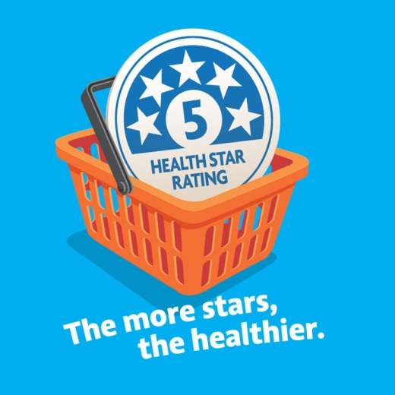
Health Star Rating Image 1

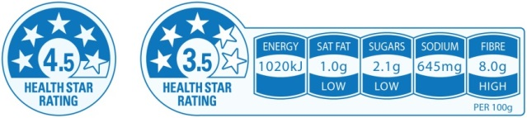Health Star Rating label and icon

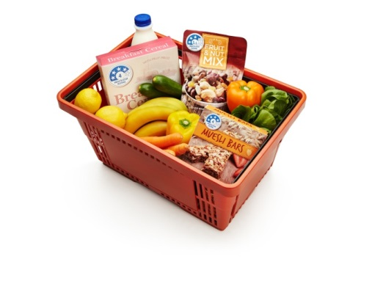
Grocery basket

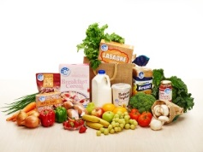
HSR with fresh produce

Compare similar packaged foods

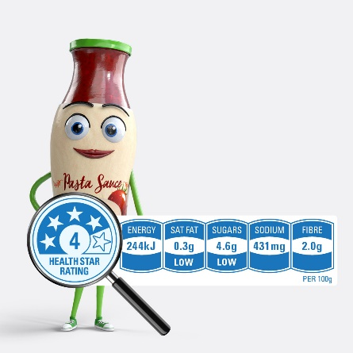
Ratings use a strict calculation

Australian Institute of Health and Welfare (2018) Australia’s health 2018. Australia’s health series no.16. Cat. no. AUS 221. Canberra: AIHW. p 9
Australian Institute of Health and Welfare. Australia’s food & nutrition 2012. Cat. no. PHE 163. Canberra, p 195. Canberra.
Australian Institute of Health and Welfare (2016) Australia’s health 2016. Australia’s health series no.15. Cat. no. AUS 199. Canberra: AIHW. p 9
Australian Health Survey: Updated Results, 2014-2015 and National Health Survey: First Results, 2017-18

