HEALTH STAR RATING STAKEHOLDER WORKSHOP

Auckland, New Zealand, 12 October 2016

(Attendees 36)

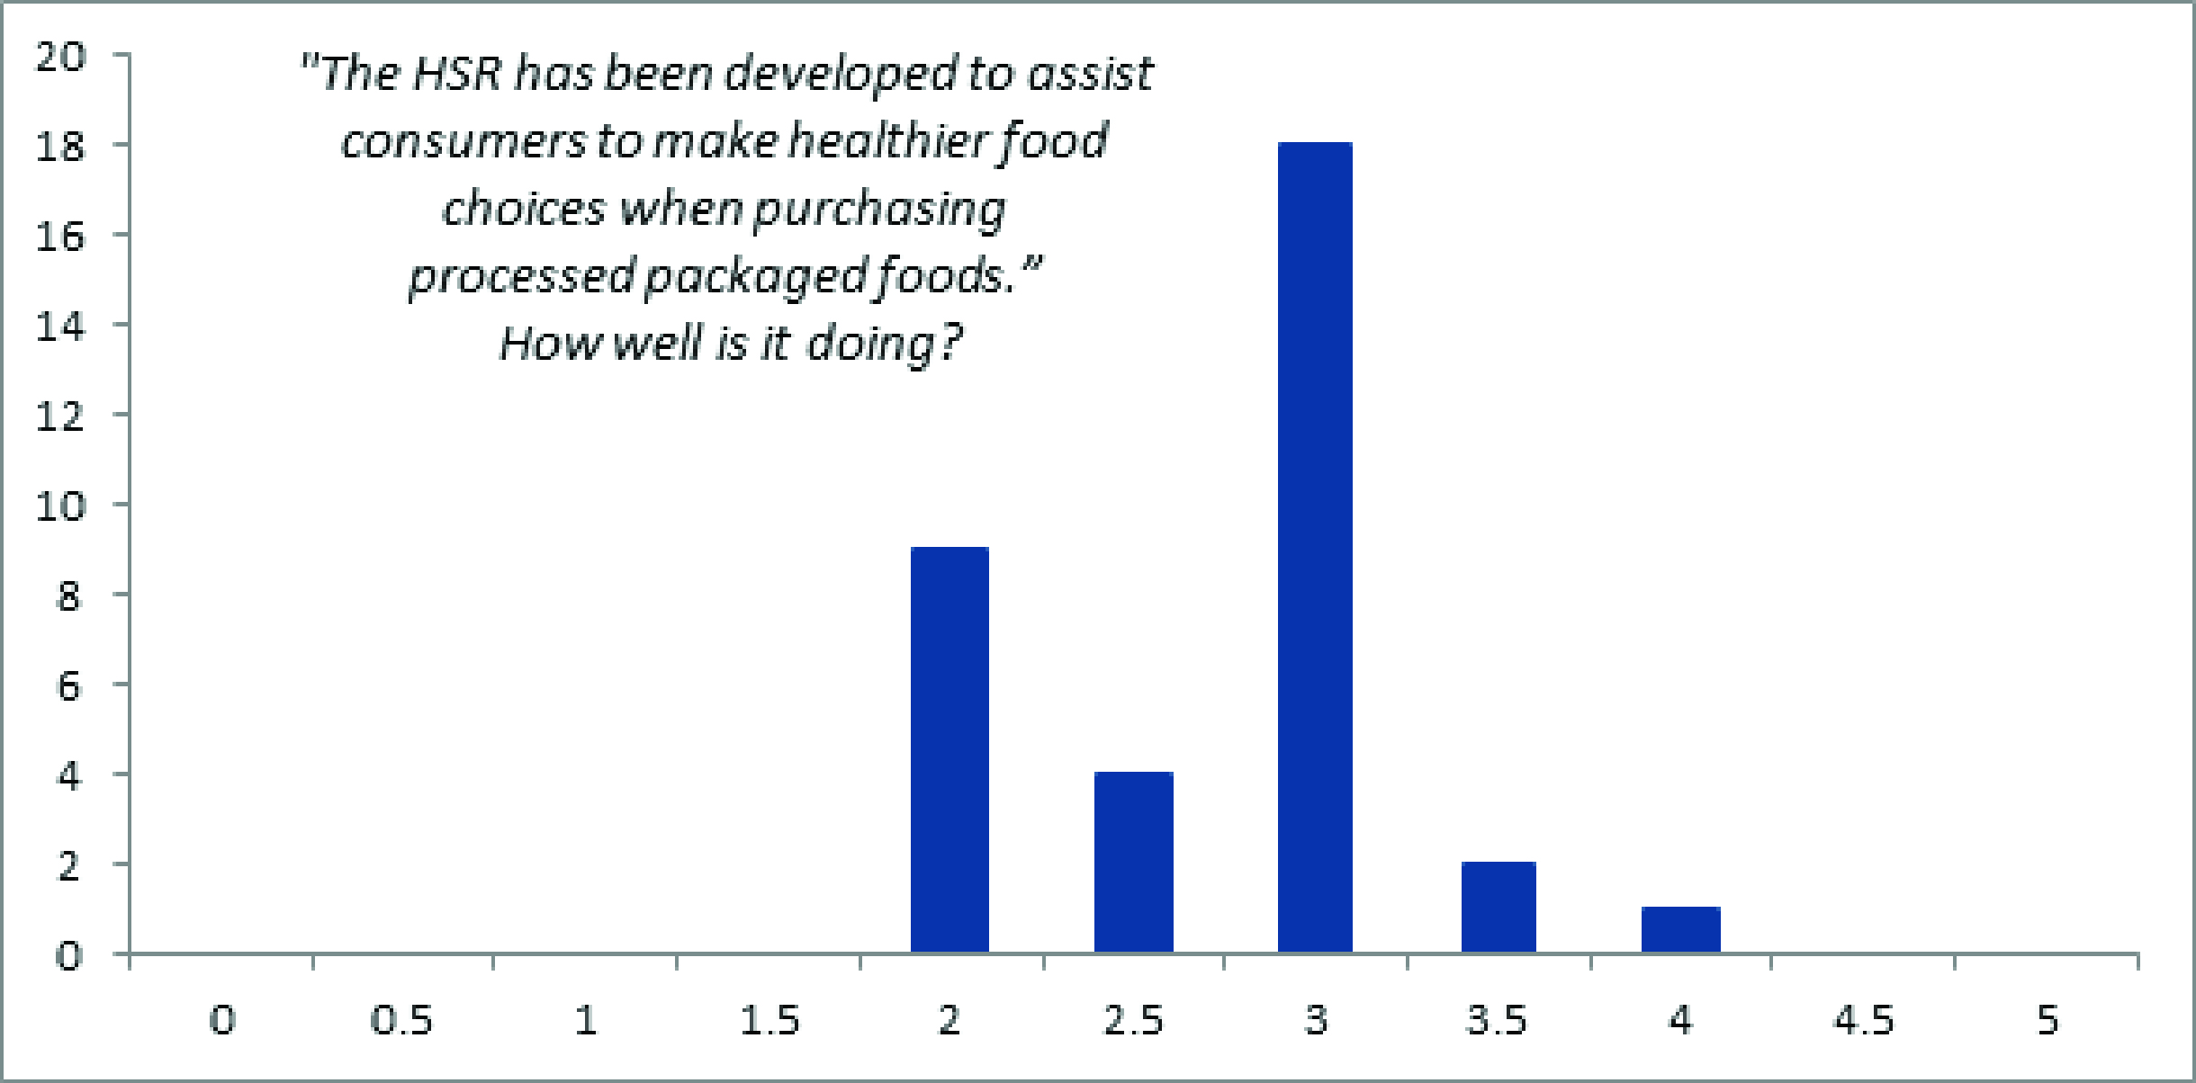

Key messages for consideration by the Health Star Rating (HSR) Advisory Committee
The outcomes of the workshop are not a consensus statement. The ‘messages’ described below reflect the main themes and views of attendees in general.

- The HSR system has demonstrated good intentions, uses a simple easy to understand concept which is impacting on consumer behaviour and encouraging industry to reformulate products.
- It is essential the education campaign is developed to address current confusion, to promote wider nutrition messages and establish and build consumer trust. This campaign must be extended and involve more community engagement with target groups and be designed to respond quickly and more effectively to media attention.
- The algorithm should be reviewed to ensure that the weighting of all nutrients are appropriate to promote dietary guidelines. Special concern should be given to sugar, whole grains and the treatment of whole foods.
- This workshop has worked well at bringing the stakeholders together. Further workshops should be held in the lead up to the formal review of the system.

Main areas of discussion
The HSR system has enabled, through a simple easy to interpret system, consumers to receive nutritional messages and open the conversation about healthy eating.

The education campaign should be targeted to ensure that both wider nutrition messages and some specifics are clearly communicated to consumers including comparisons within / between categories and the ‘as prepared’ rules. In addition to the current campaign, new tools plus better use of existing educational networks should be used to extend the reach of the campaign, especially to target groups.

Because of the rules / exclusions and exceptions to the system the education campaign needs to be comprehensive. An alternative could be to consider simplifying the system so that this education is not needed in such detail.

Significant negative media has the power to undermine consumer trust and understanding. Response to the media needs to be timelier and be part of a proactive program using a range of mechanisms including champions of the system.

It is important that we understand what consumers actually think and not just the media commentators. For example, is there a ‘halo effect’ of the stars?

A strong call for a review of the algorithm was requested. Generally, the review should ensure that the weighting of nutrients is appropriate to distinguish between healthy and less healthy foods and also between good and great foods. Consideration should be given to adding in whole grains into the algorithm and consider ways in which whole foods can be more effectively promoted by the Calculator. An understanding of sugar and how it influences the stars is also essential.

Portion size plays a big part in nutritional concerns, although outside the scope of the system, it would be good if this could be built into the system as many anomalies / concerns occur as a result of this.

