HEALTH STAR RATING STAKEHOLDER WORKSHOP

Sydney - 4 August 2016

Combined afternoon session including food industry stakeholders and public health stakeholders (Attendees: 26)

Summary report
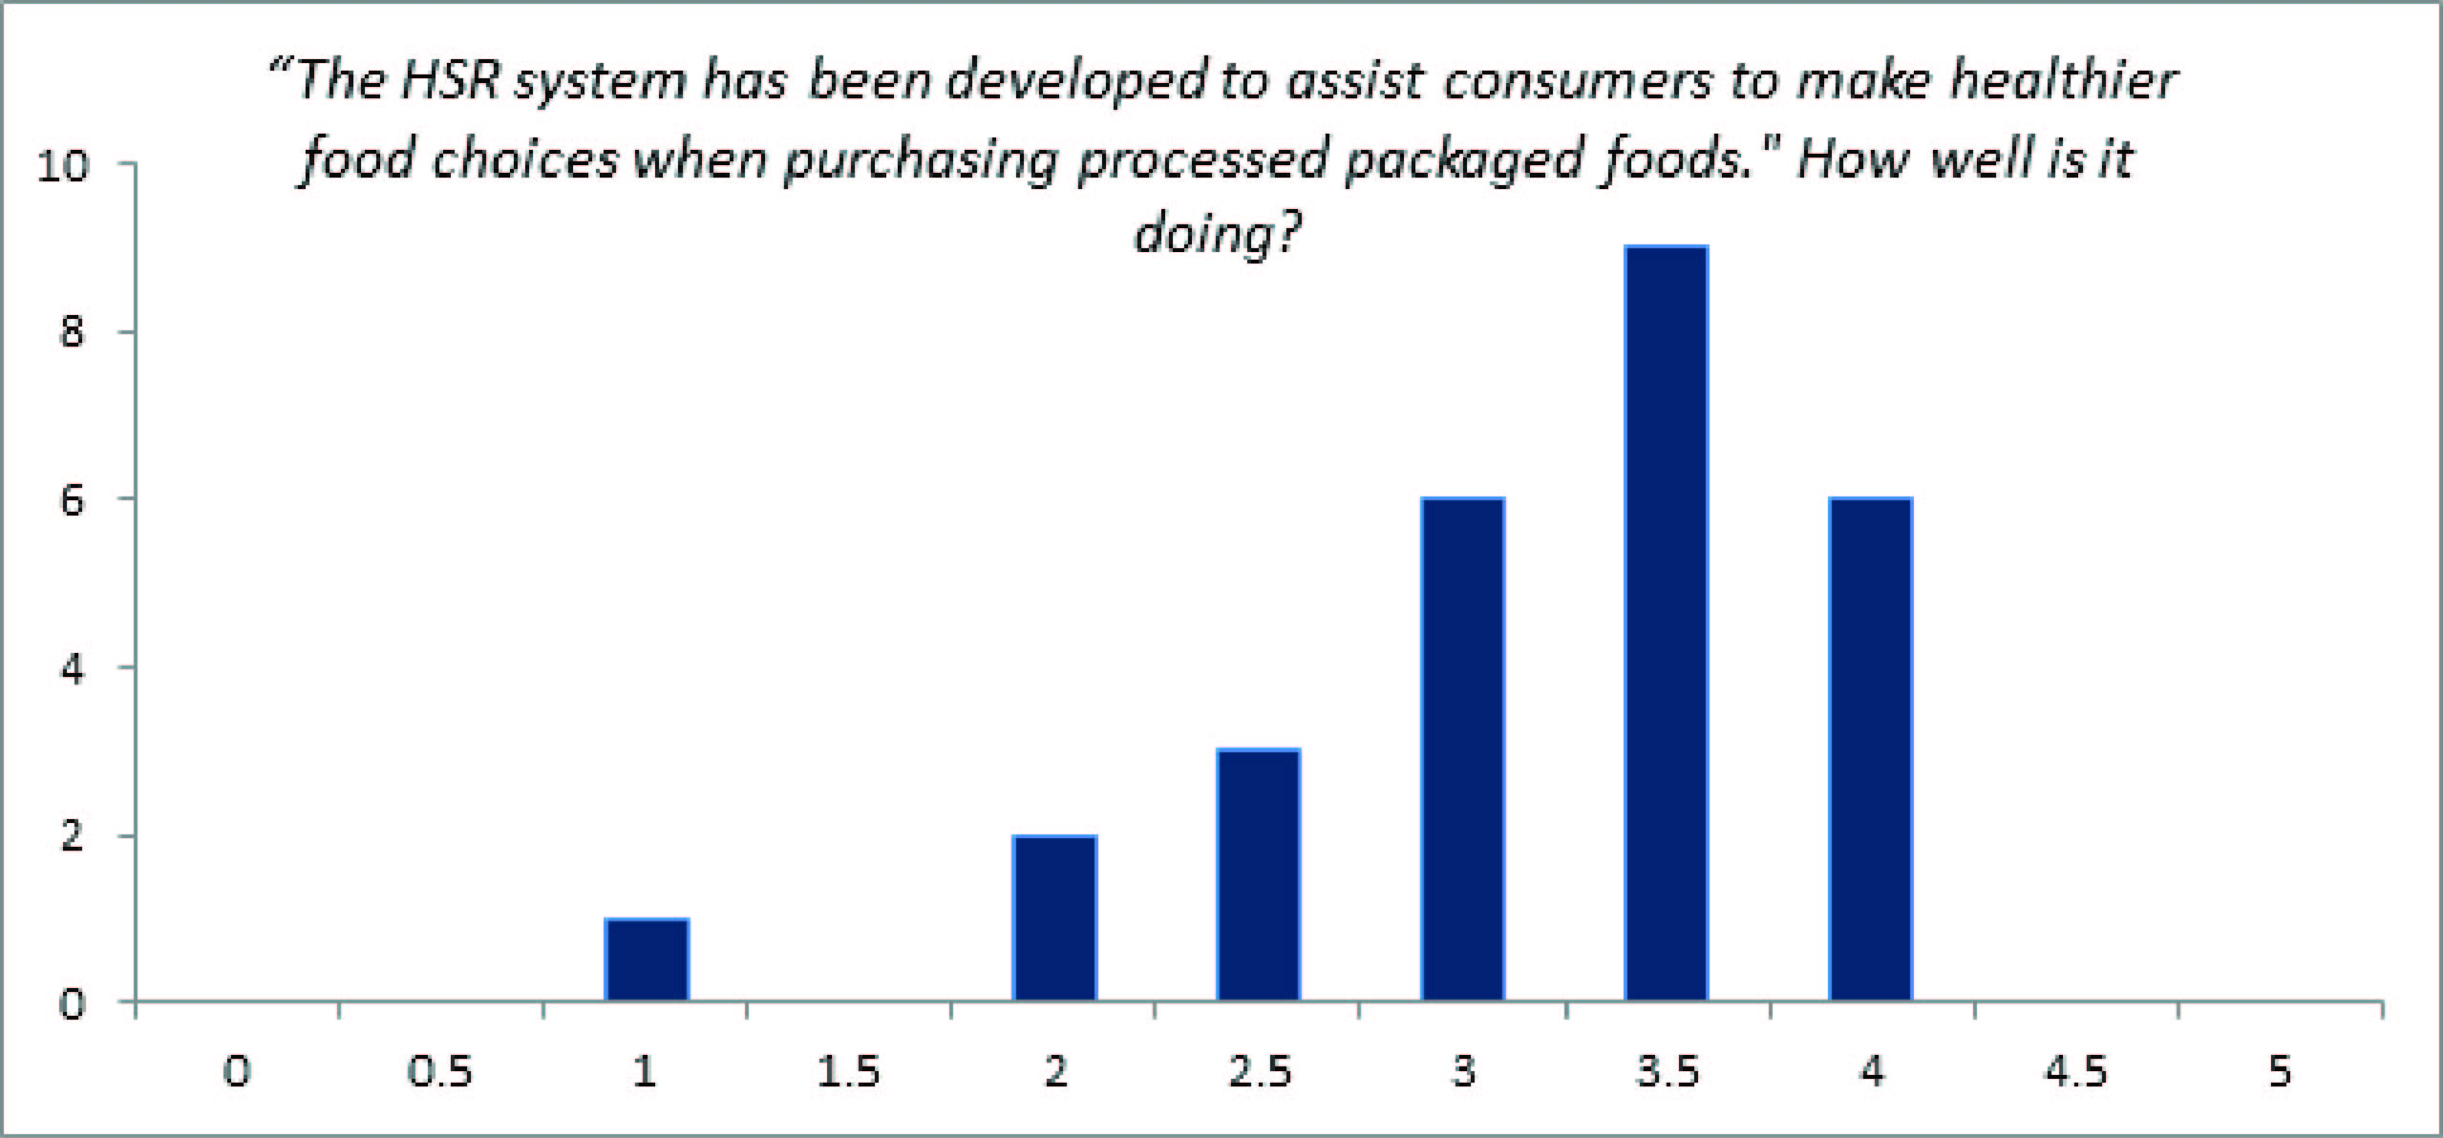

Key messages for consideration by the Health Star Rating (HSR) Advisory Committee
The outcomes of the workshop are not a consensus statement. The ‘messages’ described below reflect the main themes and views of attendees in general.

- Industry uptake is good, it has driven reformulation and behavioural changes by consumers.
- It is essential the education campaign is developed to address current confusion, to promote wider nutrition messages, and establish and build consumer trust.
- The algorithm should be reviewed to ensure it better aligns with dietary guideline messages and specifically to address consumer expectations regarding core foods, added sugar and wholegrains.
- This workshop has worked well at bringing stakeholders together, and should remain in place during the lead up to the formal review of the system.
- This format should remain transparent and open with information provided to stakeholders in a timely manner and on a regular basis.

Main areas of discussion
The HSR system has enabled, through a simple, easy to interpret system, consumers to receive nutritional messages which broadly support the Australian Dietary Guidelines (ADG). These messages may need to be further developed to ensure that areas of confusion are reduced, however, merely having this system in place is a huge step from which to build on.

The education campaign needs to be targeted to ensure that both wider messages and some specific messages are clearly communicated to consumers including comparisons within / between categories and the ‘as prepared’ rules.

Industry uptake of the system has been good, but better in some categories compared to other sections of the supermarket. This inconsistent adoption has raised consumer confusion and promoted the discussion on the system being mandatory.

The good level of uptake has meant that consumers are beginning to use this system to make lasting positive behavioural changes. There is also evidence of product reformulation, which on the whole is seen as positive.

A government endorsed / backed, Australia and New Zealand system is seen as a strength, however, there are many more opportunities to build consumer trust by more clearly communicating who manages the system.

A strong call for a review of the algorithm was requested. Generally, the review should ensure that the HSR more strongly aligns with the messages of the ADG, and more specific issues would include consideration of wholegrains, added sugar and the building in of the concept of ‘intactness’.

Comments relating to the treatment of core foods within the HSR were polarised, indicating the complexity of the issue. Some claimed for wider communication of the current status quo, others called for core foods to be excluded, some called for five stars for core foods, whilst others wanted core foods to be star rated above the current five star cap.

