HEALTH STAR RATING SYSTEM: CAMPAIGN EVALUATION REPORT
By
Garrett Parker and Rebecca Frith
June 2016
Report prepared by:
Pollinate Research
Level 6, 8 Hill Street
Surry Hills, NSW 2010
www.pollinate.com.au

CONTENTS
CONTENTS 2
EXECUTIVE SUMMARY 3
KEY FINDINGS AND RESULTS - OVERVIEW 6
The Health Star Rating System 6
The Campaign 6
RESEARCH BACKGROUND & OBJECTIVES 7
Background 7
Objectives 7
METHODOLOGY 7
Survey 7
Fieldwork dates 7
Sample 7
AWARENESS AND UNDERSTANDING 10
Current awareness and understanding of the Health Star Rating system 10
Awareness 10
Other influences on purchase choice 14
CAMPAIGN PERFORMANCE 17
Campaign elements 20
Pre-roll Videos 20
Out of Home (OOH) / Print advertisements 21
Online advertising 23
Campaign Message 24
Call to Action 26
Areas for improvement 27
Key Next Step 29
CAMPAIGN IMPACT ON KEY METRICS 30
Health Star Rating Awareness 30
Understanding of the Health Star Rating 30
Use of the Health Star Rating 31
Evaluation of the Health Star Rating - sentiment 34
Key Next Step 36
CONCLUSION 37

EXECUTIVE SUMMARY
The Australian Government Department of Health, in collaboration with the State and Territory Governments, food industry, public health and consumer groups, has developed the Health Star Rating (HSR) system. The HSR system is voluntary and is being rolled out across various packaged food products over a five-year period.
Research background and methodology
This report is part of ongoing evaluation of the HSR campaign activity, which will form part of the overall monitoring and evaluation of the implementation of HSR in Australia.
This survey was designed to track awareness and understanding of the HSR and evaluate the performance of Phase 3 of the HSR campaign, including campaign performance in terms of recognition, messaging and diagnostics; and what impact the campaign has had on key metrics relating to the success of the HSR system.
Fieldwork was conducted in June 2016, with the survey including questions in common with the prior waves of HSR campaign evaluation survey (conducted in September 2014 and 2015), and the HSR Consumer Use and Understanding survey (April 2015 and March 2016). Where relevant, results from the surveys have been compared.
The results are based on a nationally and population representative sample of 1000 main/joint grocery buyers aged 18 years and older.
HSR system evaluation
Awareness of the HSR has increased slightly since March 2016 from 57% to 59% in June 2016 (noting the smaller than usual interval since the previous survey). Likelihood to use the HSR has also increased, with 50% of the sample stating they would be likely to use the HSR on a regular basis, an increase from 39% in March 2016.
There is a desire among the public to see the HSR in store: when asked how many products people would like to see the HSR on, 65% stated they would like the HSR on more products than is currently the case. This is consistent with the previous waves of research with 66% agreement in March 2016 and 62% in September 2015.
The results suggest that the HSR is creating positive behaviour change among Australian grocery buyers. As awareness of HSR and how to use HSR when shopping both increase, HSR is also increasingly being used to make healthier food choices: among those aware of the HSR, 33% recalled buying a product they do not usually buy – rather than their habitual choice – because the new product had a higher HSR than their usual product. This equates to 16% of the total sample, or approximately one in six people changing their shopping behaviour based on the HSR.
The strength of the HSR remains the clarity of the system, with high levels of agreement that HSR, ‘makes it easier to identify the healthier option’ (68% agree) and that it is ‘easy to understand’ (69% agree).
In addition, the HSR appears to be delivering lasting behaviour change, which is the ultimate objective. Among those grocery shoppers who said they have purchased a new product because it had a higher HSR than their habitual purchase, 79% have continued to buy this new product with a higher rating. This equates to around one in ten people (12% of the total sample) who are effecting lasting behaviour change through use of the HSR when grocery shopping.
When it comes to understanding how to use the HSR within the supermarket, approximately two thirds (70%) of those surveyed state the HSR makes it easier to compare products that are in the same section of the supermarket. However, there remains confusion regarding using the HSR to compare products in different sections of the supermarket: 50% of those surveyed agree the HSR makes it easier to compare products that are in different sections of the supermarket. This issue of how the HSR should be used has not yet been comprehensively addressed in campaign messaging, and will need to be addressed to ensure credibility of the system.
HSR campaign evaluation
The HSR campaign consisted of the following:
- five online pre-roll videos (played in full before YouTube videos, within catch-up TV etc.)
- six out of home (OOH) advertisements
- six culturally and linguistically diverse (CALD) translated advertisements;
- in-store shelf-fin and trolley advertisements; and
- a six-panel online ad (square and ‘sky-scraper’ formats)
The campaign has performed well in terms of cut-through and message delivery – particularly given the relatively small spend compared to other government campaigns and the disrupted media placement. One in four respondents recalled having seen some part of the campaign, and all campaign advertisements were perceived as clear and easy to understand. Overall campaign impact is positive, driving awareness and having a strong call to action – resulting in 77% of those who saw the campaign carrying out at least one of the behavioural objectives of the campaign (only 23% selected ‘none of these’ in response to this question), with the strongest outcomes for ‘using the HSR in store’ (38%), and trying ‘to eat healthier’ (28%).
The campaign had a broad target audience of Australian grocery shoppers aged over 18, and in line with this, recognition of the campaign was broadly similar across most population groups. Demographic breakdown of the results showed that 55-64 year olds, and regional respondents were less likely to be campaign recognisers (possibly reflecting less ‘opportunity to see’ in regional areas).
When asked what the message of the campaign is, most people accurately understand the objective of the advertising, which is to communicate that the HSR helps shoppers make healthier choices. However there are some who believe the campaign is advocating for purchasing of packaged food. Specifically, 15% agree that ads in this campaign communicate that you should buy packaged foods instead of unpackaged foods.
Overall, those who are campaign recognisers are significantly more engaged with and positive toward the HSR system than those who are not campaign recognisers: those who are campaign recognisers have significantly higher awareness of the HSR system (78% vs 59%). However, campaign recognition has no significant effect on likelihood to describe accurate usage of the HSR system (68% for campaign recognisers vs 70% for the total sample).
Campaign recognisers are also considerably more likely to agree that the HSR is ‘easy to understand’ (81% vs 69%), a ‘system (I) trust’ (60% vs 44%) and that the HSR is ‘believable’ (66% vs 52%). These higher levels of awareness, understanding, and trust amongst people who recognise the campaign than those who do not, are likely impacting on the higher levels of action when it comes to buying healthier food. This is reflected in the significantly higher levels of agreement regarding usage statements about the HSR:
- ‘makes choosing foods easier’ (73% vs 61%),
- ‘helps me make decisions about which foods to buy’ (71% vs 60%), and
- ‘makes it easier for me to identify the healthier option’ (77% vs 68%).

KEY FINDINGS AND RESULTS - OVERVIEW

The Health Star Rating System
Awareness of the Health Star Rating (HSR) has significantly increased since September 2015 and likelihood to use the HSR on a regular basis has increased
Awareness has reached 59% (up from 42% after the previous burst of campaign activity) and likelihood to ‘use HSR on a regular basis’ has shifted from 47% in September 2015 to 50% in June 2016.
The majority of people want to see the HSR on packaged foods
When asked about how many products they would like to see HSR on, 65% stated they would like the HSR on more products.
The HSR is creating positive behaviour change.
Of those aware of the HSR, 33% have bought a new product because it had a higher HSR than their usual product (16% among the total sample). This is even higher among those who saw the campaign and are aware of the HSR, at 42% (8% of the total sample) buying a new product because it had a higher HSR than their usual product.
This appears to be lasting behaviour change, which is the ultimate objective.
Of those who have bought a new product because it had a higher HSR than their usual product, 79% have continued to buy this new product with a higher HSR rating (12% of the total sample).

The Campaign
1 in 4 Australians (25%) have seen the Government’s HSR campaign, and the campaign has helped drive awareness, understanding and trust in the HSR system.
Awareness levels are relatively even across the population. The campaign advertisements are considered clear, easy to understand and informative.
Overall impact of the campaign is very positive.
Those who are campaign recognisers have a significantly higher awareness of and positivity toward of HSR.
There has been a very strong response to the campaign call to action.
77% of people who are campaign recognisers have carried out at least one of the behavioural objectives of the campaign: using the HSR in store and trying to eat healthier are the strongest outcomes.

RESEARCH BACKGROUND & OBJECTIVES

Background
The HSR system was developed by the Australian Government Department of Health in collaboration with the State and Territory Governments, food industry, and public health and consumer groups. The purpose of the HSR system is to provide clear, simple interpretive nutrition information on the front of food packaging – with the potential to greatly assist in making healthier food purchases.
HSR campaign launched in December 2014. It is a voluntary system and is being rolled out across packaged food products over a five-year period.

Objectives
This research evaluates the 2016 HSR campaign activity as part of ongoing evaluation of the HSR campaign which contributes to the broader implementation of the HSR system.
This report addresses:
- Current awareness and understanding of the HSR system
- How the campaign has performed in terms of recognition, messaging and diagnostic metrics
- What impact the campaign has had on key metrics relating to the success of the HSR system.

METHODOLOGY
This wave of research was conducted in June 2016. The survey aligns with prior HSR campaign evaluation surveys (conducted in September 2014 (benchmark) and September 2015), and shares common metrics with HSR Consumer Use and Understanding survey (April 2015 and March 2016). Where relevant, results from these surveys have been compared.

Survey
The research was conducted using a 15-minute online survey, developed by Pollinate in conjunction with the Department of Health.

Fieldwork dates
Survey conducted: 3rd of June to 15th of June 2016.

Sample
The results are based on a nationally representative sample of 1007 main/joint grocery buyers aged 18 years and older across Australia with representation of Aboriginal and Torres Strait Islander people, Culturally and Linguistically Diverse (CALD) groups, and those of low socio-economic status (low SES). Where base sizes allow, results have been analysed by sub groups.
Table 1 provides details of the sample.
Table 1 - Demographic information
 | Gender
 | Male |  |  | 33%
 | Female |  |  | 67%
Age
 | 18 - 24 |  |  | 15%
 | 25 - 34 |  |  | 20%
 | 35 - 44 |  |  | 21%
 | 45 - 54 |  |  | 18%
 | 55- 64 |  |  | 12%
 | 65 or over |  |  | 15%
 | Grocery buyer
 | Main grocery buyer |  |  | 73%
 | Joint grocery buyer |  |  | 27%
 | Language spoken
 | Only English |  |  | 77%
 | Mainly English |  |  | 16%
 | Mainly Language other than English (LOTE) |  |  | 7%
 | Location
 | Sydney metro |  |  | 21%
 | NSW (Not Sydney) |  |  | 12%
 | Melbourne metro |  |  | 19%
 | VIC (Not Melbourne) |  |  | 7%
 | Brisbane metro |  |  | 9%
 | QLD (Not Brisbane) |  |  | 10%
 | Adelaide metro |  |  | 6%
 | SA (Not Adelaide) |  |  | 2%
 | Perth metro |  |  | 7%
 | WA (Not Perth) |  |  | 2%
 | NT |  |  | 1%
 | TAS |  |  | 2%
 | ACT |  |  | 2%

Reporting:
Statistical significance is defined as a significant difference at a 95% confidence level throughout the report.
Research team:
Pollinate is an independent market research consultancy with expertise across a variety of government, not for profit and corporate clients.

AWARENESS AND UNDERSTANDING

Current awareness and understanding of the Health Star Rating system

Awareness
Overall awareness of the HSR has increased by 17% since September 2015. Fifty-nine percent of Australians now recognise the HSR.
Total spontaneous (unprompted) awareness of HSR is 26% - notably, this is higher than that of the mandatory Nutrition Information Panel, and all other nutrition logos or labelling except for the longstanding Heart Foundation Tick. This has increased from 6% in April 2015 to 26% in June 2016. The majority of these mentions are ‘top of mind’ (first mention) by the respondent, as shown in Figure 1 below.

Figure 1 - Awareness of nutrition logos and labelling,
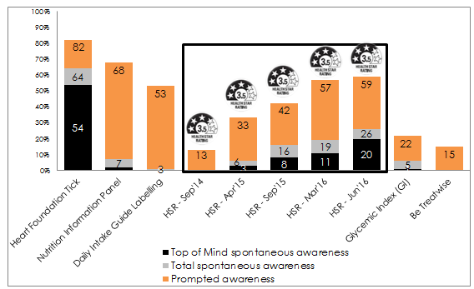
Base: All respondents (n=1007).
Awareness of the HSR is highest among young people (86% for 18-24 year olds) and lowest among older people (39% for 65 and over), which is a typical trend for new products/brands, however the increase among young people is notable and worthy of further investigation.
There has been a significant increase in prompted awareness from the benchmark measure across every age group. However, in this wave there is a decline in awareness for those in the age groups of 35-44 and 55-64. Perhaps influenced by the shorter interval between surveys, there is also a tapering of the increase in awareness seen previously.
Figure 2 - Awareness of HSR by age
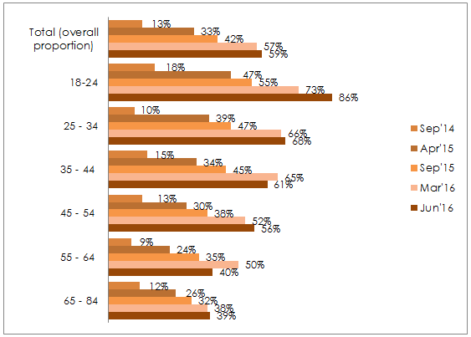
Base: All respondents Jun’16 {18-24 (n=112), 25 - 34 (n=173), 35 - 44 (n=226), 45 - 54 (n=203), 55 - 64 (n=146), 65 and over (n=147)}
Differences in prompted awareness can also be seen by Body Mass Index (BMI) groups, with slight declines for some of these groups since the previous survey. Declines in awareness can be seen for Obese Class I respondents, and, after a significant gain in the prior wave of research, those of Obese Class II+III. Awareness is highest among people within the healthy BMI range (67%) and lowest among the obese Class I (46%), as shown in Figure 3.

Figure 3 – Prompted Awareness of HSR by Body Mass Index (BMI) groups
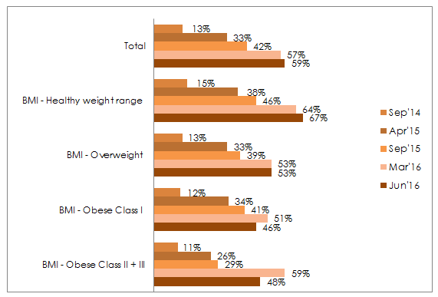
Base: All respondents {BMI: Healthy weight range (n=339), BMI - Overweight (n=262), BMI - Obese Class I (n=119), BMI - Obese Class II + III (n=47)}

Other groups showing differing levels of awareness of the HSR are:
- those who speak a language other than English at home compared to the total sample (66% vs 59%),
- females compared to males (66% vs. 46%) and
- Melbourne metropolitan respondents compared to the total sample (66% vs 59%).

Awareness of the HSR is driven mostly by seeing it ‘on pack’ (70%) and ‘in a TV ad’ (23%). It should be noted that there has been television advertising around HSR from food brands, and HSR campaign ‘pre-roll’ videos played during ‘catch-up TV’ programs. Other common sources are ‘on the news’ (16%), ‘store catalogue’ (15%), ‘in-store promotion’ (12% - which may have been influenced by out of home (OOH) advertisements with digilites and shop-a-lites placed outside of shopping centres and supermarkets) and, ‘food brand or supermarket website’ (9%).
Word of mouth/social media sources, as well as (other) advertising media were also mentioned, as described in Figure 4.

Figure 4 – Where have you seen, heard or read about the Health Star Rating?
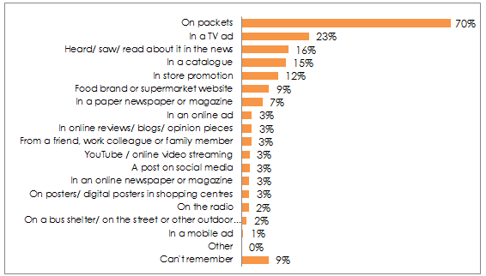
Base: Those aware of HSR (n=581)
Among the 59% of people who are aware of the HSR, over three quarters (77%, representing 44% of total sample) say they have bought a product with the HSR displayed, reflecting both the growing awareness and availability of HSR.
Since September 2015 there has been an increase in recognition that the HSR is on more products. Only one third (31%) say the HSR is on no products that they regularly buy compared to September 2015 when 2 in 5 stated this (43%). In this wave of research, over half (56%) of Australians report that ‘some’ products that they regularly buy have the HSR, and 13% believe ‘most’ products that they regularly buy display the rating.

Figure 5 - How many products that you regularly buy have the Health Star Rating?
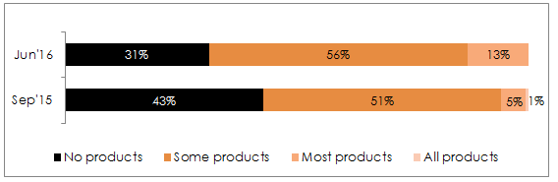
Base: All respondents Sep’15 (n=1000); Jun’16 (n=1007).

When asked about how many products they would like to see HSR on, around two thirds (65%) would like the HSR on more products. Australians either want to see it on ‘more’ products (28%) or ‘all’ products (37%); or they ‘don’t mind either way’ (30%). Importantly, there is very little negativity toward the HSR in this measure, with just 6% indicating that they would prefer to see HSR on ‘less’ or ‘no’ products, a result consistent with September 2015 findings.
Figure 6 – How many products would you like to see the Health Star Rating on?
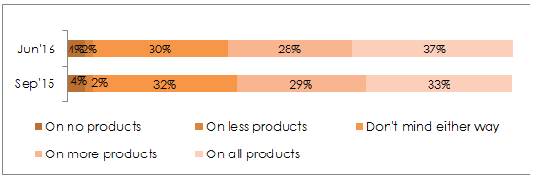Base: All respondents Sep’15 (n=1000); Jun’16 (n=1007).

Other influences on purchase choice
The research also aimed to quantify an aspect of shopping behaviour which will overlay consideration of HSR in choosing packaged foods, and should be noted. Each survey to date has consistently identified that around 3 in 10 respondents shop with specific dietary requirements/allergies in mind. For these shoppers, consideration of HSR in purchase decision may be limited, or even invalidated, by these requirements.

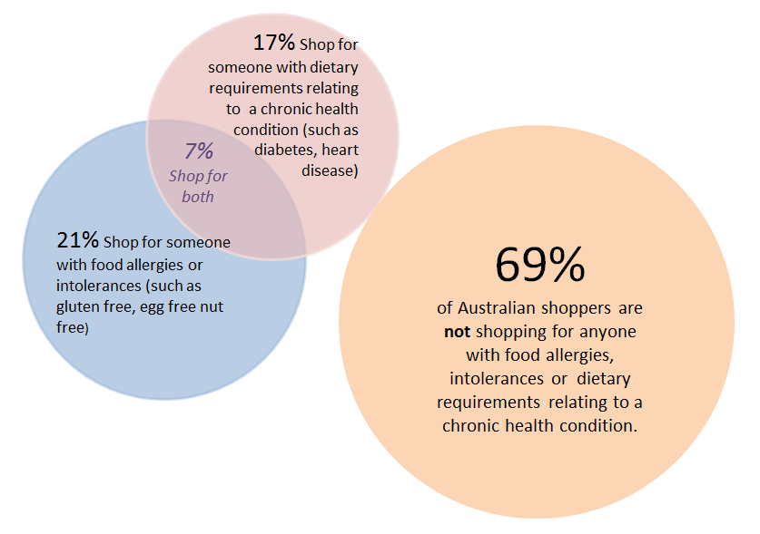
Understanding of the Health Star Rating
Figure 7 - Images used in the survey
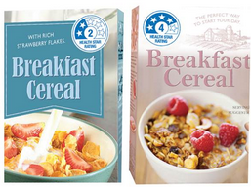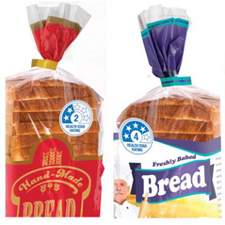
When shown images of HSR on mock products (as above in Figure 7) and asked “how would you use the Health Star Rating?” nearly three quarters (70%) of the respondents accurately understand the HSR, with correct responses regarding accurate understanding increasing from 64% in September 2015 to 70% in June 2016. The proportion of Australians who say that they ‘don’t know how they would use the HSR’ has increased since September 2015, from 20% to 28%. This increase may be due to the Health Star Rating now reaching a wider audience – with some consumers who are newly aware of the HSR not yet accurately understanding how to use the system.
Table 3 – Coded responses to “How would you use the Health Star Rating?”
Responses | September 2015 | June  2016
NET accurate understanding of the HSR | 64% | 70%
The more stars the better/healthier | 29% | 20%
Buy/choose products with more/the most stars | 11% | 15%
To know what is healthier/better for me | 8% | 11%
Comparing the number of stars | 4% | 10%
As a general guide | 1% | 4%
To choose between similar products | 4% | 3%
I'd use it for quick reference | 3% | 3%
I would use it/would consider it/great idea | 3% | 3%
I wouldn't use it + would have to know more | 8% | 11%
I would have to consider other nutritional information too | 5% | 5%
Other | 5% | 7%
Don't Know | 20% | 28%
All respondents Sep’15 (n=1000); Jun’16 (n=1007).
Verbatim comments about how people say they use / would use the HSR included:
‘To gauge what are the healthy products and the star system tells me at a glance what are the healthy ones and its easier to read’
‘I always use this rating as it is quick and easy to understand and make your choice easier’
‘To see at a quick glance if it's worth checking the nutrition panel and ingredients before deciding whether to buy or not.’

CAMPAIGN PERFORMANCE
Campaign recognition, branding and performance
The Health Star Rating Campaign Elements
The HSR campaign consisted of 5 online pre-roll videos, six print/OOH ads, one in store trolley/basket ad, one online ad and CALD ads in Greek, Vietnamese, Italian, Arabic, Cantonese and Mandarin. Media buy and spend for this campaign was relatively modest when compared with other recent government and private media and marketing campaigns. All respondents were shown the campaign advertisements in the survey, with this being the first time the majority (75%) had seen any of the campaign advertisements.
Snapshots of these advertisements are shown below:
Figure 8 – Health Star Rating campaign advertising showing 5 online pre-roll (videos) still, 6 OOH/ print advertisements, an online ad, an in-store ad and 6 CALD ads

Video ads (screenshot of each ad)

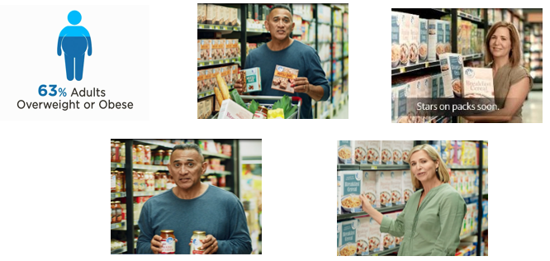

Print/OOH ads
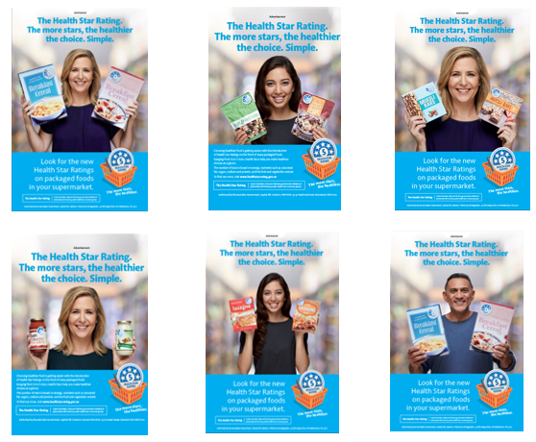
Online ad
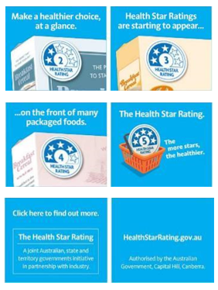
Culturally and Linguistically Diverse audiences (CALD) ads
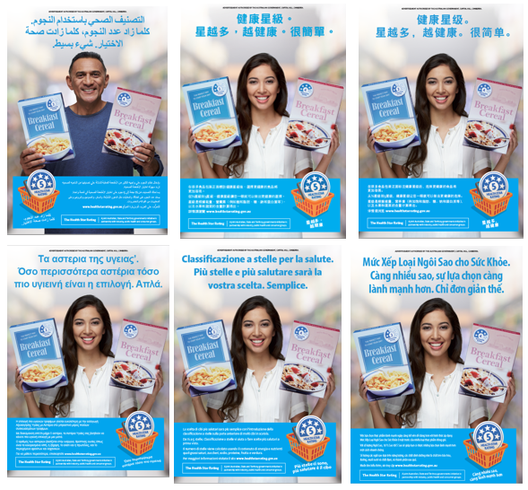
One in four (25%) of those surveyed recalled seeing at least one element of the HSR campaign. The few significant differences regarding campaign awareness were:
- Those aged 25-34 were more likely to recall seeing the campaign than those aged 55-64 (30% vs 16%)
- Those with healthy range BMI were more likely to recall seeing the campaign than those in Obese class I, II and III combined (31% vs ~16%)
- Metro respondents were slightly more likely to recall seeing the campaign than regional respondents (26% vs 23%) and,
- People who speak a language other than English at home were more likely to recall seeing the campaign than those who speak only English (34% vs 22%).

Campaign elements

Pre-roll Videos
Of all of the campaign elements, the pre-roll videos had the highest level of recall; with almost one in five overall (17%) stating they have seen at least one of the HSR pre-roll videos. The figure for having seen a pre-roll video was significantly higher among Melbourne metropolitan respondents (24%), CALD respondents (22%), and people aged 25-34 (20%). It was significantly lower among obese class I, II and III (11%), people in regional Victoria and the Adelaide metropolitan area (12%) and those aged 55-64 (9%).
Despite no TV presence, there is some misattribution with 2 in 5 (38%) saying they saw the ads on TV. This confusion is likely due to the ads being video, so there is some assumption they must have been aired on TV, rather than online only. This may also be explained by these advertisements looking similar to the pre-roll, and/or that people may have seen the HSR advertised on TV by product brands in commercial advertising.
The pre-roll videos were generally perceived as ‘easy to understand’ and ‘making (its) point in a simple way’, although they were not as strong at ‘grabbing (people’s) attention’. Those who had seen the ad prior to it being shown during the survey believed the ad more (52% vs 37%) and thought the ad made its point in a clever way (47% vs 31%). They also rated the ads higher than other respondents for the role HSR plays in helping to make healthy decisions, specifically ‘helps me make decisions about which food to buy’ (51% vs 41%).
Although a smaller proportion agreed that the pre-roll ads were ‘attention grabbing’ (30%), encouragingly, agreement with negative statements ‘it is boring’ (13%) and ‘it is irritating’ (10%) were very low.

Figure 9 - Which of these statements describe how you feel about the advertising? Pre-roll (video) Ad
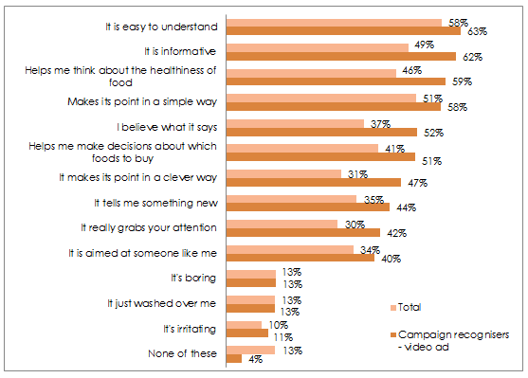
Base: All respondents (Total sample n=1007; Campaign recognisers – video ad n=156).

Out of Home (OOH) / Print advertisements
One in ten (10%) respondents stated that they had seen at least one of the OOH/print advertisements, with the blonde female talent being the most recalled (6% for cereal and muesli and 5% for pasta sauce), followed by the brunette female talent (5% for lasagne and fruit and nut), then the male talent (5% for cereal). This reflects the media buy, as the execution with the blonde female talent occupied more media.

Figure 10 – Response to the question: “Have you seen any of these ads before?”
10% had seen at least one OOH/print advertising
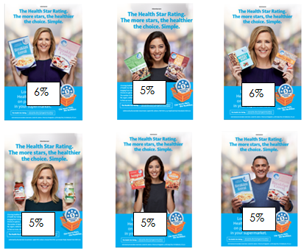
Base: All respondents (n=1007).
The main location reported for seeing these advertisements is ‘In store promotion’ (39%). As the media buy included no in-store promotion, it is possible that some respondents are recalling the OOH advertising that was placed outside supermarkets in shopping centres.
Similar to the performance of the pre-roll videos, diagnostically these advertisements are perceived as easy to understand, simple advertising, but not strong for grabbing people’s attention. Those who saw at least one of the ads prior to exposure in the survey have a higher level of agreement with the messaging of the ads, especially for ‘makes me think about the healthiness of food’ than the total sample (43% vs 37%), as well as being more likely to believe the message and feel that it is informative, when compared to the total sample.
Figure 11 - Which of these statements describe how you feel about the advertising? (Select all that apply) OOH/Print Advertisements
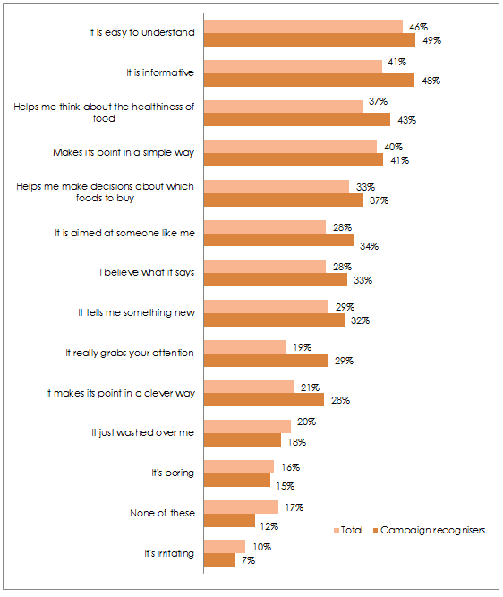
Base: All respondents (n=1007).

Online advertising
Few recall the online advertising, with recognition of the ad at 8%. However, this is not a key concern, as the goal of online advertising is driving interest and research in a product/brand or system, rather than driving campaign recall. Similarly, most respondents could not remember where they saw the ad – perhaps due to the multiple online platforms used for ad placement and seeing it across multiple websites.

Table 4 – Coded responses to “On what website did you see these ads?
Coded Response | Proportion of campaign recognisers
Don’t know | 59%
Facebook | 16%
Supermarket website | 14%
Don't know/can't remember | 14%
News website | 9%
Government website | 6%
Google | 6%
Culinary/food website | 3%
Yahoo | 3%
Other | 29%

Base: Campaign recognisers (n=66). NOTE: Small base size (less than n=100)

Campaign Message
When asked what the campaign communicates you should do, 82% of respondents agreed the campaign communicates ‘you should look for the HSR if you are buying packaged foods’; 83% agreed you should ‘compare the HSR on similar products’; and 32% agreed ‘Only purchase food with a Health Star Rating’.

There was a small level of confusion regarding the campaign message; with 15% agreeing the campaign communicates you should ‘buy packaged foods instead of unpackaged foods’, and 14% agreeing you should ‘buy more packaged foods’. Profiling of these groups shows these people are more likely to be aged 25-34, CALD, or live in the Sydney Metropolitan area.

At a spontaneous level, the campaign message is generally on target; around a quarter (27%) provided a correct and specific message take-out that the more stars the healthier the product. Overall, 94% provided a ‘correct’ message about the HSR (depending on which advertisements they saw).

Table 5 – Responses to the question, “What do you think these ads are trying to tell you? What is the message?” (Free text responses coded for analysis)
Responses | Total Sample | Campaign recognisers
Eat/choose/buy healthier foods/foods with more stars | 19% | 31%
The more stars the healthier/better | 27% | 23%
It is an easy/easier/quick way to compare the healthiness of food/choose the healthier foods | 12% | 11%
Use/check the system to help pick/choose healthier foods/the products with more stars | 12% | 9%
There are healthier choices/products/think healthier - it is good for you | 7% | 8%
People need to start eating healthier/helping people start/address health problems | 1% | 3%
Promote HSR as a new way to choose healthier options/to inform shoppers of the system | 3% | 3%
To look for the Health Star Rating | 2% | 3%
How healthy a product is/which is the healthier | 6% | 2%
How to choose healthier foods | 3% | 1%
Other | 4% | 3%
Don't know | 25% | 19%

Base: All respondents (n=1007), Campaign recognisers (n=235).

Verbatim responses included:
‘The ratings tell you how healthy a product is, allows you to compare one product against another.’

‘Choose foods that have a higher star rating as these should be more nutritious and assist with a healthy food intake to help control weight.’

‘That the healthy star rating is trying to make shopping and healthier choices easier. The more stars the healthier the food.’

‘You have a chance to improve your health by being informed of the products healthiness to consume.’

Call to Action
The campaign has had a very impressive call to action result, with 77% of campaign recognisers agreeing that they have done at least one of the actions suggested by the campaign. With only 23% of campaign recognisers stating they have done ‘none of these’, the majority have engaged in activities such as ‘used the HSR in store’ (38%), ‘tried to eat healthier’ (28%) and/or ‘used the HSR to compare products at the supermarket’ (30%) (Note that respondents could select more than one statement).
Figure 12 - After seeing this advertising, which of the below did you do? (Select all that apply)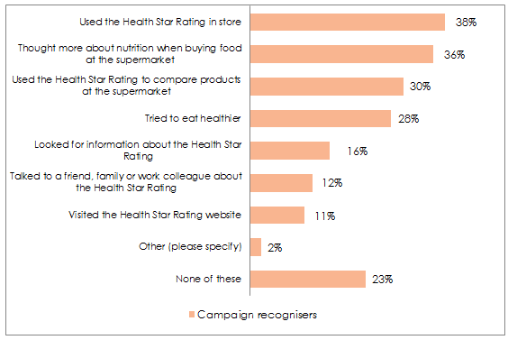Base: Campaign recognisers (n=235).

The different elements of the campaign are driving different behaviours relating to the campaign:
- The pre roll videos have been the primary driver of campaign recall
- The OOH/ print advertising has helped to drive overall usage of the system, with people who had seen these ads being more likely to have used the HSR in store (43% among those who saw OOH/print vs 35% of people who saw any campaign element)
- Online has played a role in driving information seeking and understanding. Those who had seen the online ad were more likely to have tried to eat more healthily (43% vs 21% at the campaign level), talked to a friend, family or work colleague about the HSR (20% vs 9% at the campaign level), looked for information about the HSR (33% vs 8% at the campaign level) and visited the HSR website (28% vs 3% at the campaign level).

Areas for improvement
There is some level of confusion among respondents regarding who is behind this campaign, which may be affecting the perception of the overall role and message of the campaign.

Interestingly, when asked ‘who is this advertising from?’ (the advertisements were not on screen at the time), 61% of campaign recognisers said Government/ Health Star/ Health Department, while among the total sample 74% state the campaign is from Government/ Health Star/ Health Department: those who had not seen the campaign before the survey were more likely to guess who was behind the campaign, while those who had seen the campaign were less certain.
The HSR is branded as “A joint Australian, state and territory Government initiative in partnership with industry”, which is a complex statement (and concept) to recall accurately, and may have led some respondents to select ‘don’t know’ in response to this question. In addition, the campaign elements each carried Federal Government advertising authorisation statements and the website with a “.gov.au” domain name, which may explain attribution solely to ‘Government’. Reassuringly, the level of misattribution to brands or other organisations is very low, as seen in Table 6 below.
Table 6 - Thinking of all of the ads you’ve just seen, who is this advertising from? (Free text responses coded for analysis)
Responses | Total sample  (%) | Campaign recognisers (%)
NET Government/Health Star/Health Department | 74 | 61
The Government | 40 | 33
Health Star | 29 | 23
Health Department | 5 | 5
Food manufacturers | 2 | 5
Woolworths/ Coles/ Supermarkets | 2 | 4
Health group | 3 | 3
Heart Foundation | 2 | 2
Specific brand/company | 1 | 2
Bread &/or cereal producers | 1 | 0
Other | 8 | 12
Don't know | 8 | 11

Base: All respondents (n=1007).

After being exposed to the advertisements in the survey, respondents were asked if this campaign communicates to you that ‘the HSR is a joint initiative of Governments and others’. At this later point 48% agree yes, which suggests that exposure to the campaign does go some way to clarifying ownership of HSR (52% of all respondents answer ‘no’ or ‘not sure’). Those who had seen the advertising before the survey were even more likely to agree, with 68% answering ‘yes’ the HSR is a joint initiative of Governments and others.
There is some confusion around campaign messaging as 32% agree the campaign communicates you should ‘only purchase food with a Health Star Rating’ and 14% agree with the statement that this campaign communicates ‘you should buy more packaged foods’.
There is also some confusion regarding the HSR system itself, with 41% agreeing the campaign communicates that ‘food is healthy if it displays a Health Star Rating’ (i.e., that food has ‘earned’ the HSR for its nutritional value).
Confusion around messaging may be due in part to current lack of awareness, noting that 2 in 5 respondents (41%) had been introduced to the HSR for the first time in the survey. It is reasonable to suggest that more exposure to HSR, through advertising, press or first-hand experience in store is likely to reduce this confusion.
Table 7 shows that while exposure to the campaign does increase awareness of the HSR being a joint initiative, it is also perceived as promoting purchasing of food displaying a HSR. This result will continue to be monitored.

Table 7 – Significant differences found between campaign recognisers and total sample for agreement with statements when asked: ‘Do the ads in this campaign communicate to you / that you should…?’:
Agreement with statements: | Campaign recognisers  (% Yes) | Total sample  (% Yes)
When buying packaged food, Health Star Rating can help guide healthier choices | 83% | 90%
Look for the Health Star Rating if you are buying packaged foods | 82% | 86%
Compare the Health Star Rating on similar products | 83% | 84%
The Health Star Rating is a joint initiative of Governments and others | 48% | 68%
Food is healthy if it displays a Health Star Rating | 41% | 55%
Only purchase food with a Health Star Rating | 32% | 41%
Buy packaged foods instead of unpackaged foods | 15% | 25%
Buy more packaged foods | 14% | 23%
Base: All respondents (n=1007).

Key Next Step
One in six people who saw the campaign agreed that it communicated they should buy packaged foods instead of unpackaged foods. This indicates a need to ensure that ongoing marketing efforts and public relations address the fact that HSR is for packaged foods only, and does not imply packaged foods are healthier than fresh foods.

CAMPAIGN IMPACT ON KEY METRICS

Health Star Rating Awareness
The campaign appears to have significantly driven awareness of the HSR. Prompted awareness significantly increases among those who are campaign recognisers to 78% (from 68% in September 2015), which is 19% above the total sample. Although it must be noted that commercial advertising from foods carrying the HSR may be contributing, this research repeatedly finds significant differences in understanding and awareness of HSR among campaign recognisers compared to the total sample.
Figure 13 examines this comparison.
Figure 13 – Comparison of awareness of HSR between those total sample and campaign recognisers)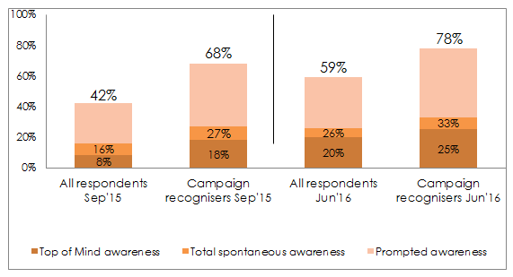Base: All respondents (n=1007).

Understanding of the Health Star Rating
Those who are campaign recognisers demonstrate a similar level of understanding of accurate usage of HSR to the total sample. However, they are half as likely (15%, compared to 28% overall) to say that they don’t know how to use HSR.

Table 8 - How would you use this system?
Coded responses | Jun’16 total sample | Jun’16 campaign recognisers
NET accurate understanding of the HSR  (bullet points below) | 70% | 68%
The more stars the better/healthier | 20% | 20%
Buy/choose products with more/the most stars | 15% | 18%
To know what is healthier/better for me | 11% | 13%
Comparing the number of stars | 10% | 6%
As a general guide | 4% | 2%
To choose between similar products | 3% | 2%
I'd use it for quick reference | 3% | 2%
I would use it/would consider it/great idea | 3% | 3%
I wouldn't use it + would have to know more | 11% | 7%
I would have to consider other nutritional information too | 5% | 6%
Other | 7% | 12%
Don't Know | 28% | 15%
Base: All respondents (n=1007); campaign recognisers (n=235).

Use of the Health Star Rating
Those who are campaign recognisers are also significantly more likely to have bought a product with the HSR displayed (81% vs 54%), talked about the HSR (40% vs 19%) or sought out information about the HSR (29% vs 13%).
Thirty-eight percent of respondents claimed to have compared the HSR to other nutritional information on pack and among those who are campaign recognisers it is 59%. This finding indicates that HSR has prompted consideration of the nutritional profile of food products, and potentially higher engagement with nutrition through comparing the rating with the nutritional information on pack.
These findings are detailed in Figure 14 below.

Figure 14 - Thinking about the Health Star Rating, have you:
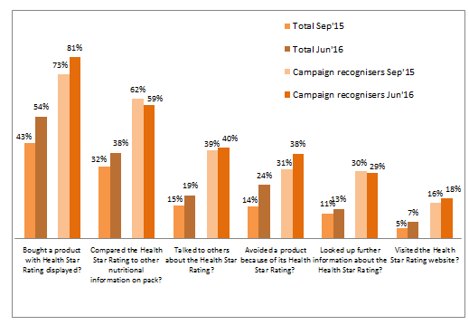
Base: Jun’16 (Total n=1007, Campaign recognisers n=235); Sep’15 (Total n=1000, Campaign recognisers n=419)
Noting that it is not possible to know from this research what level of prior use, attitudes or exposure to commercial advertising may have primed a response to the campaign, the results among those who are campaign recognisers are very positive.
Among those who have bought a product with the HSR displayed (44% n=443), one third (33%, n=164 or 16% of all respondents) stated they were influenced to buy the product due to the product having a higher HSR than their usual product. Among those who are campaign recognisers, this result is even higher, with 42% (n=76, or 8% of all respondents) stating they bought a different product because it had a higher HSR rating. This shows that the HSR is likely to be driving positive behaviour change when it comes to making healthy food choices, and exposure to the campaign may be reinforcing this behaviour change.
As described above, there is a clear relationship between exposure to the HSR campaign and holding a more positive perception of the HSR, however, this research cannot confirm causality or the direction of this relationship. While it is likely the HSR campaign has contributed to the positive perceptions, it is also possible that people with positive perceptions of the HSR have been more likely to notice the HSR campaign.
Figure 15 – Influence of Health Star Rating on purchase decision: “Did the Health Star Rating influence your choice to purchase this [new] product?”
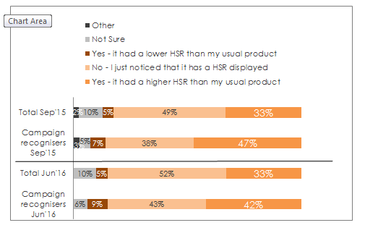
Base: Those who bought a product with HSR Jun’16 (n=534); Sep’15 (n=419)
Not only is this behaviour change occurring among a third (33%, n=164) of those who have bought a product with the HSR displayed, the HSR appears to be having a lasting impact, with most of those who have bought a product due to it having a higher HSR continuing to buy this product (79%, n=125). This equates to around one in ten people (12%) continuing to buy the healthier product at the total respondent level. This is evidence to show the HSR is not only helping to bring about positive behaviour change, but is also driving lasting behaviour change.
Reported likelihood to use the HSR has remained similar to that seen in September 2015 (evaluation of phase 2 campaign activity), up 3% from 47% to 50%. Those who are campaign recognisers are even more likely to use the HSR, 11% higher at 61% among this group (57% in September 2015). Among both those who are campaign recognisers and the total sample, there are very low levels of negativity toward the HSR; people are generally either positive or ambivalent toward the new system. These results are detailed in Figure 16.

Figure 16 – Likelihood to use the HSR on a regular basis: “If the Health Star Rating was on most packaged foods in your supermarket, how likely would you be to use it on a regular basis?”
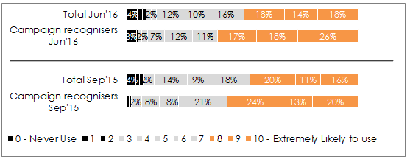

Base: Jun’16 (Total n=1007, Campaign recognisers n=235); Sep’15 (Total n=1000, Campaign recognisers n=419)

Evaluation of the Health Star Rating - sentiment
The campaign has helped drive perceptions of the HSR system as a straight-forward source of information, with 82% of those who are campaign recognisers believing it is easy to understand, compared to 71% overall.
Similarly, those who are campaign recognisers are significantly more likely to say that the HSR ‘Is informative’, at 75% compared to 65% overall.
The campaign may also be helping to make grocery shopping easier. Those who are campaign recognisers are more likely to agree the HSR ‘helps me make decisions about which foods to buy’ (71% vs 60%) and ‘makes choosing foods easier’ (73% vs 61%).
The campaign appears to be driving credibility of HSR, with those who had seen the campaign prior to the survey considerably more likely to agree the HSR system is believable (66% vs 52%).
Although it is reasonable to expect that those who are exposed to HSR for the first time in the survey are not likely to give high ratings for trust or independence without more opportunity to interact with or find out about HSR, trust in, and independence of the HSR are still areas to work on, as shown in Table 9.
There also remains an issue around the number of people who state the HSR makes it easier for them to compare products that are in different sections of the supermarket (63% for those who are campaign recognisers and 50% total sample). More communication is needed to explain the most appropriate use of the HSR, to ensure there is no loss in credibility, which could occur when used across categories.

Table 9 – Perception of the HSR: agreement with statements
The Health Star Rating | Total | Campaign recognisers
Is easy to use | 71% | 82%
Is easy to understand | 69% | 81%
Is informative | 65% | 75%
It stands out on the pack | 58% | 71%
It tells me something new | 59% | 68%
It really grabs my attention | 44% | 63%
Is confusing | 14% | 15%
Using the Health Star Rating | Total | Campaign recognisers
Makes it easier for me to identify the healthier option | 68% | 77%
Makes it easier for me to compare products that are in the same section of the supermarket | 70% | 81%
Is easy to use | 71% | 82%
Helps me make decisions about which foods to buy | 60% | 71%
Makes choosing foods easier | 61% | 73%
Makes it easier for me to compare products that are in different sections of the supermarket | 50% | 63%
It's just another thing on a pack that makes shopping more confusing | 19% | 18%
Is irritating | 12% | 16%
Influence of the Health Star Rating | Total | Campaign recognisers
Helps me think about the healthiness of food | 68% | 81%
Makes me want to buy healthier products | 58% | 67%
It is aimed at someone like me | 54% | 66%
It is believable | 52% | 66%
Is a system I trust | 44% | 60%
Is independent | 36% | 53%
It is not relevant to me | 19% | 22%

Base: All respondents (n=1007).

Key Next Step
The expectation that HSR can be used for cross-category comparisons will need to be monitored and addressed to ensure continuing credibility of the HSR. As awareness and understanding of HSR increases, it will be necessary to communicate and reinforce the correct way to use the system to build confidence and trust through optimal channels for more nuanced information, such as public relations, social media and social marketing.

CONCLUSION
Results in this report are from the HSR campaign evaluation survey conducted in June 2016. The survey included questions in common with earlier surveys. Where relevant, results from the surveys have been compared.

- 1 in 4 (25%) Australians have seen the HSR campaign, a strong result noting that the campaign ran in a highly competitive commercial environment with a modest budget and no television advertising.

- Overall impact of the campaign has been positive with significantly higher awareness, understanding and trust of the system among campaign recognisers.
- The campaign advertisements are clear, easy to understand and informative, yet lacked a real hook to grab people’s attention. With this and modest media placements in mind, an enduring and multifaceted approach is required to not only cement awareness of the HSR, but also to ensure understanding and trust of the HSR.
- It will be important that future communications re-iterate that the HSR is endorsed by Government as this will help build trust; however, it is equally important the public is made aware the HSR is a joint initiative.
- There appears to be some confusion around correct usage of HSR which should be addressed in future marketing and public relations activities to ensure the HSR is being used as intended.

- The campaign has helped drive positive lasting behaviour change, with 42% of those who saw the campaign buying a product with a higher HSR than their usual product, and 86% of these people continuing to buy this new product. Given the HSR is not on all items in supermarkets, this level of uptake strongly suggests the HSR is creating positive behaviour change among Australian grocery buyers.

- Future campaign activity could broaden the focus from awareness to understanding, to give people a better idea of how it is calculated and how best to use the HSR.

The campaign was suspended in accordance with Caretaker Conventions when the 2016 election was called, but reinstated with bipartisan support around 1 week later.
“Top of mind” means that HSR was the ‘first mention’ of a respondent.” “Other spontaneous” means other unprompted mention. “Total spontaneous” mentions is top of mind and other spontaneous mentions combined
Respondents were asked: Apart from brand names, can you think of any nutrition logos or labelling that you have seen on food packaging to help you decide how healthy it is? If so, what was it that you saw? The following question was; which of the following nutrition logos or labelling on food packaging have you heard of? with a bank of images/logos to select from.
Pollinate research- multiple studies across categories- beverage, digital media, appliances, fashion.
Body Mass Index is a person's weight in kilograms divided by the square of height in meters. BMI can be used as a screening tool for weight categories that may indicate higher risk of some health conditions, but is not diagnostic of the health of an individual.
Obesity classes defined as: Class 1 - BMI 30.0 - 34.9, Class 2 BMI 35.0 - 39.9, Class 3 equal to or greater than 40.0
Note that the advertising materials were not on screen when this question was asked, but respondents had viewed the materials in the question prior.

