Report 2: Modelling a stronger approach to total sugars and sodium
July 2020

Contents

Summary 3
1. Introduction 5
1.1 Changes to the HSR calculator recommended by the Review 5
1.2 Forum request for additional modelling and advice 5
1.3 TAG Dataset and Calculator 6
2. HSR System Review Recommendation 4b – Total Sugars 7
2.1 Total Sugars Scenario modelled 8
2.2 Outcomes of Total Sugars Scenario modelling 9
2.3 Conclusion 17
3. HSR System Review Recommendation 4c - Sodium 17
3.1 Sodium Scenarios modelled 17
3.2 Outcomes of Sodium Scenarios modelling 18
3.3 Conclusion 28
4. Combined impact of Review Recommendation 4b and 4c Scenarios 29
4.1 Combined Scenario modelled. 29
4.2 Outcomes of Combined Scenario modelling 29
4.3 Conclusion 33
APPENDIX 1 Total Sugars Scenario Tables 35
APPENDIX 2 Sodium Scenarios Tables 43
APPENDIX 3 Combined Scenario Tables 55
APPENDIX 4 Glossary and Definition of Terms 74
Glossary and Definition of HSR System Terms 75

Summary
Subsequent to the mpconsulting independent Five Year Review of the Health Star Rating System (the Review), the Forum requested that Food Standards Australia New Zealand (FSANZ) undertake further modelling and provide advice on the combined impact of specific recommendations when considered in the context of all recommended HSR calculator changes proposed to be implemented.

This report addresses the request for additional modelling under Recommendation 4 in the Forum’s response to the Review, relating to a proposed package of changes to the way the HSR is calculated to better align foods with dietary guidelines, specifically 4b and 4c, which refer to the impact of using alternative sodium and sugars points tables in the HSR calculator. In doing so, this report also takes into consideration the recommendations 4d (re-scaling dairy categories) and 4e (re-categorising water-based ice confections and jellies) by ensuring that these changes are incorporated into a revised HSR calculator and that additional modelling reflects the impact of all proposed changes to the HSR calculator.

The database of foods used by the HSR Technical Advisory Group (TAG) for modelling proposed changes during the HSR Five Year review, (the TAG database) was used to assess the impact of the additional modelling undertaken by FSANZ.

During its consideration of the Review Report’s findings the Forum noted that the modelling relied upon for mpconsulting to recommend a 25, rather than 30 HSR baseline points scale for total sugars, was undertaken in isolation of other HSR system changes and without due consideration of the products impacted. Therefore, the Forum requested that FSANZ undertake additional modelling on the combined impact of all proposed changes to the HSR calculator on both the recommended 25 baseline point scale (Recommended) and a 30 point scale (Scenario) for total sugars which was also previously considered by the TAG.

The FSANZ analysis of the impact of a revised 30 HSR baseline point total sugars scale indicates that approximately 9% of products in HSR Categories 1D, 2 and 2D would be affected by reductions in HSR only, with the proportion of five food group (FFG) (5%) and discretionary (5%) products impacted being approximately equal. Product categories impacted tend to be those previously indicated by stakeholders to be of most concern, with the greatest impact on FFG products seen in the Processed fruit (20%), Breakfast cereals (19%) and Yoghurt/soft cheese (17%) categories and for discretionary foods in the Ice cream and Confectionery (22% respectively), Bakery/cake mixes (20%) and Custard/desserts (18%) categories. The majority of affected products received a 1 star point (0.5 HSR) reduction with a small proportion of products receiving a 2 star point reduction in the Breakfast cereals, Cream, Custards/desserts, and Snacks Australian Guide to Healthy Eating (AGHE) food categories.

The Forum was concerned that the changes to the sodium HSR baseline points table recommended by the Review to improve the sensitivity of the HSR calculator to foods with high sodium content would only impact a small subset of discretionary foods that are high in sodium (those HSR Category 1D, 2 and 2D foods with >900 mg sodium/100 g), providing little incentive for food reformulation. The Forum therefore requested that FSANZ undertake additional modelling on the combined impact of all proposed changes on both the recommended approach (application of intervals of 90 mg of sodium content to a maximum of 30 HSR baseline points at a lower sodium content of 2700 mg/100g instead of the original value of 8106 mg/100g) and the alternative (scenario) approach considered in the Review’s draft Report. This alternative approach considered applying HSR baseline points at intervals of 75 mg/100 g of sodium content, rather than 90 mg/100 g across the point scale recommended in the Review.

The FSANZ analysis of the impact of a revised sodium HSR baseline points table using 75 mg sodium /100 g increments indicates that approximately 14% of products in HSR Categories 1D, 2 and 2D would be affected by reductions in HSR only, with the proportion of FFG (7%) and discretionary (8%) products being approximately equally impacted. Product categories impacted include those of most concern with the greatest impact on FFG products seen in the Bread (22%), Plant protein (18%), Biscuits (16%), Breakfast cereals (15%) and Meals/meal bases and Nuts (14% respectively) categories and for discretionary foods in the Dressings (44%), Dips (32%), Sauces/condiments and Yeast spread (25% respectively) and Biscuits (20%).The majority of affected products received a 1 star point (0.5 HSR) reduction but with a small proportion of products receiving a 2 or 3 star point reduction. Given that there are relatively few products with sodium concentrations >900 mg/100 g in the TAG database the majority of products receiving a reduction in star points had a sodium concentration of ≤900 mg/100 g sodium. The effect of the recommended changes to the sodium baseline points table on HSR Category 3 and 3D foods was also assessed. Amending this baseline points table appeared to create a greater misalignment with Dietary Guideline recommendations than the Recommended HSR calculator. A broad range of FFG foods would be affected with a greater reduction in HSRs for lower fat foods, which is not in line with the Dietary Guidelines recommendation to eat dairy products, preferably reduced fat products.

In order to assess the impact of both the Total Sugars and Sodium Scenarios compared to the Recommended HSR, a Combined Scenario was modelled. For this Combined Scenario the total sugars points table was adjusted from a 25 point to a 30 HSR baseline point scale and the sodium table was adjusted from a 30 HSR baseline point scale with 90 mg/100 g sodium increments for each point to 75 mg/100 g increments for each point.

The FSANZ analysis of a Combined Scenario indicates that approximately 23% of products in the TAG database would be affected by a reduction in HSR, with the proportion of FFG (11%) and discretionary (12%) products impacted being approximately equal. Of those products affected in the Combined Scenario, 10% where affected by both total sugars and sodium HSR baseline point adjustments. Product categories impacted in the Combined Scenario reflected those impacted in the separate Total sugars Scenario and the Sodium Scenario. The greatest impact on FFG products is seen in the Breakfast cereals (33%) Bread (23%), Processed Fruit and Nuts (21% respectively) and Yoghurt, soft cheese (20%) categories, and for discretionary foods in the Dressings (53%), Bakery/cake mixes (34%), Sauces/condiments (33%), Dips (32%), and Snacks (29%). More than 90% of products in the TAG database affected by the Combined Scenario received a 1 star point (0.5 HSR) reduction with a small proportion of products receiving a 2 or 3 star point reduction. The Combined Scenario changes to the HSR calculator aligns more closely with the dietary guidelines, with fewer discretionary products receiving a HSR of ≥3. While the majority of FFG products in the TAG database receive a HSR of ≥3, the Combined Scenario also resulted in an increase in the number of FFG products receiving a HSR of <3 (3%).

The reductions of HSRs due to a stronger approach to total sugars or sodium or both combined are in addition to those impacts arising from implementing amendments to the HSR calculator as recommended in the Review. FSANZ Report 1 assessed the impact of all changes recommended in the Review and estimated that approximately 8% of products in the TAG database would be affected by a reduction in HSRs.

Introduction
The Heath Star Rating (HSR) system was implemented as a voluntary food product front of pack labelling program in Australia in June 2014 following agreement by the Australia New Zealand Forum on Food Regulation (the Forum). The Forum also requested that a formal, independent review of the HSR system should be carried out after five years of implementation. To action this request mpconsulting were engaged from 2017-19 to undertake an independent review of the HSR system (the Review).

The Review considered if, and how well, the HSR system has met its objectives, including by reference to the impact of the HSR system, and presented ten recommendations for enhancements to the HSR system for consideration by the Forum. Overall the Forum was supportive of the recommendations outlined in the Review Report. However, the Forum also requested additional information and consideration of Recommendation 4, relating to a package of proposed changes to the way the HSR is calculated to: better align foods with dietary guidelines, reflect emerging evidence, address consumer concerns and encourage positive reformulation.

The Forum requested that FSANZ undertake further modelling and provide advice on the impact of specific recommendations when considered in the context of all recommended HSR calculator changes proposed to be implemented.

Changes to the HSR calculator recommended by the Review
Recommendation 4 of the Review proposed a package of changes to the HSR calculator to:

4a allow fresh, frozen or canned fruit and vegetables (with no added salt, sugars or fat) to automatically receive a HSR of 5
4b more strongly penalise total sugars
4c improve sodium sensitivity to reduce the HSR of products with sodium in excess of 900 mg/100 g
4d redefine and rescale dairy categories to better differentiate and improve comparability between four/five food group (FFG) and dairy dessert type products
4e re-categorise water-based ice confections and jellies, and calculate HSRs for these products on an ‘as prepared’ basis

In addition, recommendation 5 of the Review proposed a policy change to increase the HSRs of flavoured waters to 4.5 stars where they are nutritionally similar to plain packaged water, which is assigned an automatic 5 stars. An alternative method for calculating HSRs for all other non-dairy beverages was also proposed, based on the French Nutri-Score system that focusses only on energy, total sugars and fruit and vegetable content. These recommendations were intended to better discern water and flavoured waters from high energy drinks.

Forum request for additional modelling and advice
Following detailed consideration of the Review report, the Forum requested that FSANZ provide additional modelling and advice in relation to:

- Recommendation 4b – provide further modelling and advice on the combined impact of both the recommended 25 baseline point and the stronger 30 baseline point table for total sugars.
- Recommendation 4c - provide further modelling and advice on the combined impact of both the recommended sodium baseline points table and an alternative baseline points table which takes a stronger approach to products with <900 mg/100 g sodium previously considered in the draft HSR review report.
- Recommendation 4d – provide further modelling and advice on the combined impact of re-categorisation and rescaling of dairy products.
- Recommendation 4e – include the re-categorisation of jellies and water-based ice confections in modelling of combined impacts of recommended changes to the HSR calculator.
- Recommendation 5 – provide advice on a suitable definition for drinks similar in nutritional profile to water that would be eligible to receive an automatic HSR of 4.5 stars.
- A peer review of the modelling that informed the HSR five year review report recommendations and advice on combined impacts.

The Forum also requested that FRSC determine a suitable definition for minimally processed fruits and vegetables that would be eligible to receive an automatic HSR of 5 stars (Recommendation 4a).

This report (Report 2) specifically addresses the request for additional modelling under recommendations 4b and 4c relating to the impact of alternative sodium and sugars HSR baseline points tables. In doing so, this report also takes into consideration the recommendations of 4a, 4d, 4e and 5 by ensuring that these changes are incorporated into the HSR calculator and that additional modelling reflects the impact of all proposed changes to the HSR calculator.

The Forum also requested that FSANZ undertake a peer review of modelling in the Review Report and provide advice on the combined impact of all recommended changes, which is provided in a separate report (Report 1). This peer review also incorporates additional analysis on dairy (recommendation 4d) and jelly and ice confectionery (recommendation 4e).

TAG Dataset and Calculator
The database of foods used by the HSR Technical Advisory Group (TAG) for modelling proposed changes during the HSR 5 year review, (the TAG database) was used to assess the impact of the additional modelling undertaken by FSANZ. While noting that there are some limitations relating to the TAG database, it was used in its current form for consistency and to allow comparability in results with previous work undertaken in the Review and for modelling of additional scenarios.

This database includes product data for 5,885 packaged and unpackaged foods and drinks sold in Australia and New Zealand, provided by the food industry. The vast majority of products are in HSR Categories 1,1D, 2 and 2D. Data cover the range of HSR components including energy, saturated fat, total sugar, sodium, protein and fruit, vegetable, nut and legume (FVNL) and fibre content data for all foods where applicable.

Each food was assigned four different classifications for analysis and reporting purposes. These include a:
- HSR category
- food category based on the Australian Guide to Healthy Eating (AGHE), such as fats and oils, breakfast cereals, dairy beverages, fruits and vegetables. These were further grouped as ‘core’ or ‘non-core’, generally based on the proportion of five food group or discretionary foods within the category (described further below). Refer to Appendix 4 Table 26 for a summary of AGHE categories in the TAG database
- 5-digit classification based on the classification system developed for reporting food and nutrient intakes from the 2011-13 Australian Health Survey (AHS)
- ‘Five Food Group’ (FFG) or ‘Discretionary’ food classification based on the criteria used to develop the Australian Health Survey 2011-13 Discretionary Food List, which were based on the 2013 Australian Dietary Guidelines (ADGs).

The classification of a food in a core or non-core AGHE category does not necessarily match with the FFG or discretionary food classification in all cases (see section 2.2.2). Individual products within a 5-digit AHS classification may be split across one or more AGHE categories. In addition, in some instances, a 5-digit AHS classification may contain a mix of FFG and discretionary foods (e.g. Breakfast cereals and Snacks).

The TAG database was not updated for the purposes of undertaking this additional modelling in order to allow comparability in results with previous work.

All HSR categories and nutrient points tables in the HSR calculator and food classifications in the TAG dataset were adjusted to reflect all of the recommendations of the HSR Review. This in effect creates a new ‘baseline’ of HSR star points and HSR star ratings for foods in the TAG database against which further modelling undertaken in this report has been compared.

To avoid confusion, the HSR calculator and TAG database used by the TAG during the Review are referred to as the ‘Original’ HSR calculator and TAG database, and the updated HSR calculator and TAG database reflecting all recommended changes are referred to as the ‘Recommended’ HSR calculator. Adjustments made to the Recommended HSR calculator for the purposes of this modelling are referred to as ‘scenarios’.

For further information on the TAG Database, refer to Report 1 - Peer Review of Modelling.

HSR System Review Recommendation 4b – Total Sugars
During its consideration of the Review Report’s findings the Forum noted that the modelling relied upon for mpconsulting to recommend a 25, rather than 30 HSR baseline points scale for sugars, was undertaken in isolation of other HSR system changes and without due consideration of the products impacted. Therefore, the Forum requested that FSANZ undertake additional modelling on the combined impact of all proposed changes to the HSR calculator on both the recommended 25 point scale and a 30 point scale for sugars which was also previously considered by the TAG.

The scope of this additional analysis is limited to consideration of the impacts of a 25 and 30 point scale for total sugars in the context of all other recommended HSR calculator changes and does not consider issues raised in submissions relating to use of an added sugar rather than total sugars content, which is discussed in the Review Report.

The analysis of the impact of a 30 point sugars scale is limited to HSR food categories 1D, 2 and 2D only as the Review recommended a new approach for the calculation of HSRs for non-dairy beverages (HSR category 1), based on a policy decision and use of the French Nutri-Score system which defines a separate points table limited to energy, total sugars and FVNL content only. The AGHE categories Jelly and Ice confectionery were also excluded as the Review recommended that these products should be classified as HSR Category 1 non-dairy beverages due to their similar nutritional profile. The Review also recommended that Unprocessed fruit and Unprocessed vegetables should receive an automatic HSR of 5. These AGHE categories, with HSRs amended as recommended, have been included in the analysis. HSR category 3 and 3D foods were not included in the analysis as a separate total sugars baseline points scale is applied to Category 3 products and it is unlikely that total sugars for these products would ever exceed 45%, so would be minimally affected by extensions to the HSR baseline points scale.

Total Sugars Scenario modelled
As a new approach was recommended for the calculation of HSRs for non-dairy beverages, these HSR Category 1 products (429 products) were excluded from the TAG dataset for total sugars modelling purposes and not further considered in this analysis. Exclusion of HSR Category 1 products excludes the following AGHE categories:
- Flavoured water
- Whole juices
- Other juices
- Dry beverage mixes
- Carbonated beverages
- Lifestyle drinks
- Cordial
- Ice confectionery
- Jelly

Ice confectionery and Jelly were included in HSR Category 1 for HSR calculation purposes, as recommended in the Review Report.

As described in Section 1.3 above, the HSR calculator has been updated to include all recommended changes arising from the review (Recommended HSR). This new baseline incorporates the 25 point total sugars table in addition to all other changes. In addition to the Recommended HSR calculator, one other Scenario was considered; applying a 30 point scale for total sugars. Points scales used for the Recommended and Scenario modelling are provided in Table 1 below for comparison purposes.

Table 1 Total sugars concentration (g/100 g) and allocated HSR points for foods in HSR categories 1D, 2 and 2D, as applied for Recommended and Scenario HSR calculator models
HSR baseline points for total sugars | RECOMMENDED  25 point total sugars table  (grams total sugars/100 g) | SCENARIO  30 point total sugars table  (grams total sugars/100 g)
0 | 0 | 0
1 | 5.01 | 5.01
2 | 8.91 | 8.31
3 | 12.81 | 11.51
4 | 16.81 | 14.71
5 | 20.71 | 18.01
6 | 24.61 | 21.21
7 | 28.51 | 24.51
8 | 32.41 | 27.71
9 | 36.31 | 30.91
10 | 40.31 | 34.21
11 | 44.21 | 37.41
12 | 48.11 | 40.71
13 | 52.01 | 43.91
14 | 55.91 | 47.11
15 | 59.81 | 50.41
16 | 63.81 | 53.61
17 | 67.71 | 56.91
18 | 71.61 | 60.11
19 | 75.51 | 63.41
20 | 79.41 | 66.61
21 | 83.31 | 69.81
22 | 87.31 | 73.11
23 | 91.21 | 76.31
24 | 95.11 | 79.61
25 | 99.01 | 82.81
26 |  | 86.01
27 |  | 89.31
28 |  | 92.51
29 |  | 95.81
30 |  | 99.01
The HSR calculator algorithm is based on that used for the Nutrient Profiling Scoring Criterion (NPSC) for nutrition and health claims, dark blue shading indicates the NPSC cut-off

Outcomes of Total Sugars Scenario modelling

Impact of Scenario by AHGE categories
Increasing the number of HSR baseline points for total sugars means that products incur more baseline points at lower total sugars concentrations and the maximum baseline points available is increased. There is less impact for products with lower sugars concentrations (e.g. currently a product with 10 g total sugars/100 g receives 2 HSR baseline points for the Original, Recommended and Scenario points scale) but the impact increases for products with higher sugars concentrations (e.g. a product with 30 g total sugars/100 g would receive 6, 7 and 8 HSR baseline points respectively). The impact of total sugars within the algorithm is therefore increased for both the Recommended and Scenario models, relative to other nutrients/components, the impact being greater for the Scenario model.

Overall, the Scenario (30 point scale) affected a total of 466 (~9%) of the 4919 products in HSR categories 1D, 2 and 2D, compared to the Recommended HSR calculator (25 point scale) encompassing 30 AGHE categories in the TAG database. All affected products had a reduction in HSR.

There were no changes to any HSR for products in 12 AGHE categories:
- Beverages dry mix/milk powder
- Cream cheese
- Dairy alternative beverages
- Dips
- Meats/fish
- Pasta/grains/flour
- Pizza
- Plant proteins
- Soups/stocks
- Unprocessed fruit
- Unprocessed vegetables
- Yeast spread

For the remaining 18 AGHE categories in this analysis, the proportion of affected products in non-core AGHE categories was generally higher (range of 1-32%, with most affected products in Custard/desserts, and Miscellaneous), than for core AGHE categories (<1-26%), with Processed fruit being the most affected (26% of products) followed by Breakfast cereals (21%). Refer to Figure 1 and Appendix 1, Table 7.

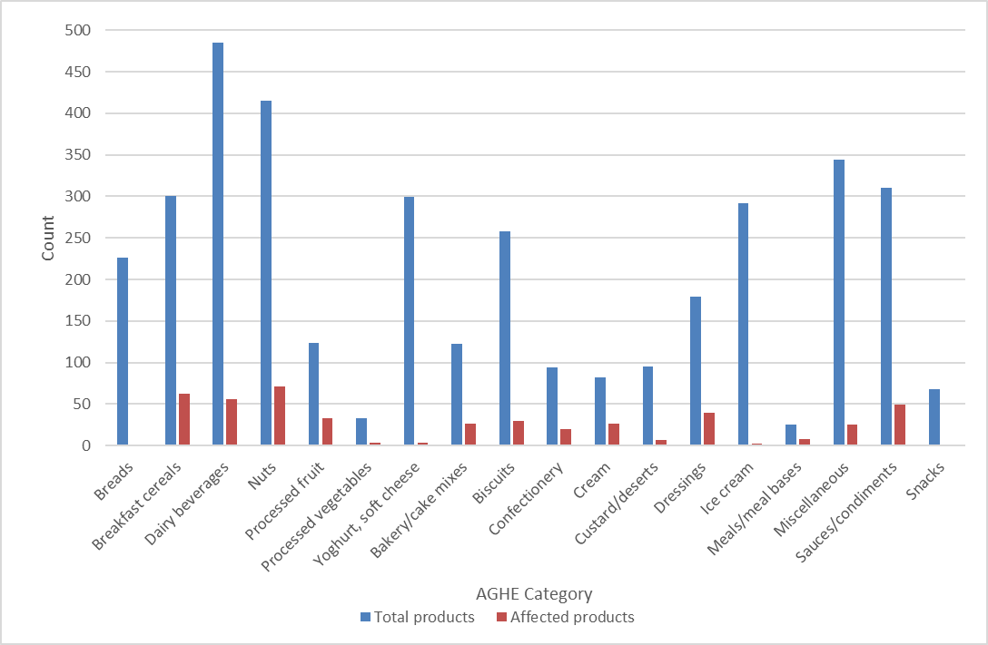
Figure 1 Total number of TAG database products for each affected AGHE category and number in each category affected by scenario adjustment to Total sugars points table compared with Recommended HSR calculator.
Figure 2 below summarises the overall distribution of HSR Star Points for products in the TAG database for all AGHE categories affected by the Total Sugars Scenario. For the vast majority of affected foods, there was a maximum reduction of 1 star point (0.5 stars), with a total of 23 products having a reduction of 2 star points (1 star) in only four AGHE categories: Breakfast cereals, Cream, Custards/desserts, and Snacks.

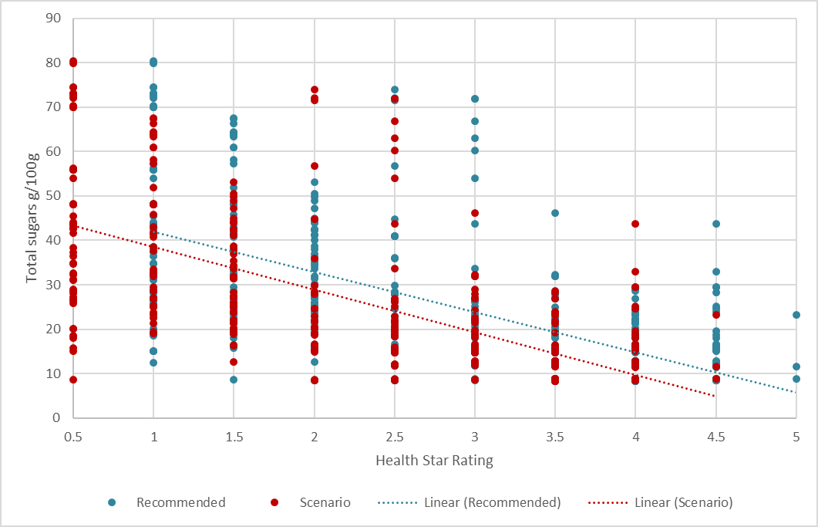
Figure 2 Distribution of Health Star Rating of TAG database products affected by scenario adjustment to Total Sugars HSR baseline points table compared to the Recommended HSR calculator

Impact of Scenario on FFG and discretionary products
As each product in the TAG database was assigned a FFG/discretionary food flag, the impact of the Scenario can be assessed by its effect on FFG and discretionary foods. This can give an indication of the overall impact of the Scenario in relation to consistency with dietary guidelines. If there is to be greater consistency with dietary guidelines, FFG foods would generally score higher HSRs and discretionary foods lower.

Overall, of the 4919 products in HSR categories 1D, 2 and 2D in the TAG database, 2985 (61%) were flagged as FFG and 1934 (39%) were flagged as discretionary.

Of the 466 foods affected by the Total Sugars Scenario, 236 (51%) were FFG and 230 (49%) were discretionary. This equates to approximately 5% of FFG and 5% of discretionary foods, as a proportion of all products in HSR Categories 1D, 2 and 2D in the TAG database. Refer to Appendix 1 Table 8 for a detailed breakdown of the impact on FFG and discretionary products by AGHE category.

Another general indicator of alignment with the dietary guidelines is the number of potential ‘outliers’, that is, the number of FFG foods that may be scoring relatively low HSRs and discretionary foods scoring relatively high HSRs. In order to be consistent with previous work on alignment with dietary guidelines carried out by the TAG, a HSR of <3 is used to identify potential FFG outliers, and a HSR of ≥3 is used to identify potential discretionary food outliers.

When the impact on FFG and discretionary products in the TAG database is broken down by HSR, generally HSRs are similar or there is a small decrease in HSRs for discretionary products at the lower end of the HSR scale. Of foods affected, approximately 8% of all FFG foods and 12% of all discretionary foods had a reduction of 1 or 2 star points. As shown in Figure 3, the number of discretionary outliers reduced as a result of the total sugars scenario, but the number of FFG outliers increased slightly.

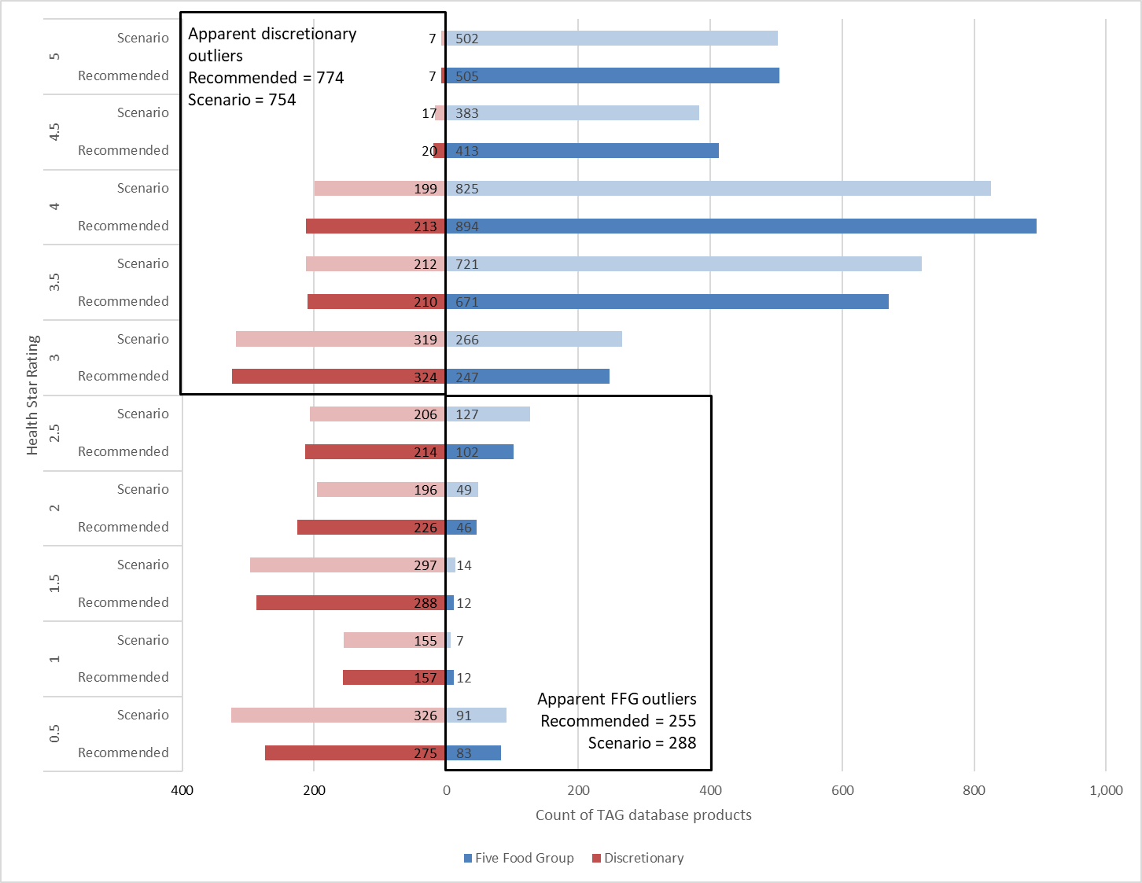
Figure 3 Impact of Total sugars scenario on FFG and discretionary foods broken down by Health Star Rating.

Types of products affected by Scenario
In order to provide a better indication of the types of products that were affected by the Scenario adjustment to the total sugars HSR baseline points table, AGHE categories were broken down into their allocated 5-digit AHS classification. Details of affected 5-digit classifications for core AGHE categories are provided in Appendix 1, Table 10 and for non-core AGHE categories in Table 11.

For core AGHE categories, the 5-digit classifications with the greatest number of affected products included:

- Yoghurt, flavoured or added fruit, full fat (26 products affected)
- Milk, coffee/chocolate flavoured and milk-based drinks, full fat (25)
- Milk, other flavoured and milk-based drinks, full fat (16)
- Yoghurt, flavoured or added fruit and/or cereal, high fat (>4 g/100g fat) (15)
- Yoghurt, added nutrients or other substances (14)
- Yoghurt, flavoured or added fruit, reduced fat (12)
- Other dried fruit including mixed dried fruit (12)
- Breakfast cereal, mixed grain, with fruit and/or nuts (12)
- Breakfast cereal, mixed grain, fortified, >20 g total sugars/100g (11, products affected, 4 of which were flagged as discretionary)
- Breakfast cereal, wheat based, with fruit and/or nuts, fortified, ≤25 g total sugars/100g (11).

A total of 16 individual products affected in the Total Sugars Scenario were flagged as discretionary within their FFG 5-digit AHS classification. This included 5 of 63 affected products in Breakfast cereals, and 7 of 29 affected products in Processed fruit.

For non-core AGHE categories, the most affected 5-digit AHS classifications were:

- Lollies and other confectionery, sugar sweetened (17 products affected).
- Muesli and cereal style bars, added coatings or confectionery (15)
- Dairy desserts, smooth or gelatine-based dairy desserts (14)
- Ice cream, tub varieties, >10 g saturated fat/100 g (14)
- Muesli and cereal style bars, with fruit and/or nuts(14).

A total of 19 individual products affected by the Total Sugars Scenario were flagged as FFG within their discretionary 5-digit AHS classification. This included 11 of 26 affected Custard/desserts products and 5 of 8 affected Miscellaneous products.

Effect of Scenario on key food products
The Review Report noted a number of key product types that were of concern to stakeholders in respect to the perceived inappropriately high HSRs of some products with relatively high levels of added sugars when using the original HSR calculator. These included some breakfast cereals, ready to eat muesli and cereal bars, sweetened and flavoured milks and yoghurts. Recommendations in the Review Report, particularly Recommendation 4 sought to address these concerns.

Noting that products within a 5-digit AHS classification could be mapped to different AHGE categories and include both FFG and discretionary foods, the impact of the 30 point scale Scenario compared to the recommended 25 point scale on the product types is:

- Breakfast cereals (previously identified as an issue as certain breakfast cereals with relatively high levels of added sugars were obtaining an HSR ≥3.5 using the original HSR calculator).

Of the 300 products in the TAG database that are included in the relevant 5-digit classifications, 63 products (21%) had a reduction of 1-2 HSR star points, 52 with a reduction of 1 star point (0.5 star) and 11 with a reduction of 2 star points (1.0 star), refer to Table 2. Five of the affected products were flagged as discretionary. Total sugars content of affected products ranged from 8.6-41.3 g/100g with 21 products containing > 25 g/100g. Of those products affected by the adjustment to the points table, Recommended HSR star points ranged from 3-10, with an average of 7.4 (3.5-4 stars). This was reduced to a range of 2-9 and an average of 6.2 HSR star points (3-3.5 stars) in the Scenario model, with the largest reduction of 1-2 star points (0.5-1.0 stars) from the Recommended model being for products with 9 HSR star points (4.5 stars), refer to Figure 4. The intention of a 30 point total sugars baseline points table is to more strongly penalise products with higher concentrations of total sugars. The Scenario model affected breakfast cereals with total sugar contents of ≤ 25 g/100g as well as those with >25 g/100g total sugars so may not provide the desired assistance in discriminating between these two groups of breakfast cereal products (Table 2). In fact, a higher proportion of products with ≤ 25 g total sugars /100g (21%) would have a reduction of 2 HSR star points (1 star) than the products with >25 g total sugars /100g (10%).

Table 2 Summary of number of affected breakfast cereal products above and at or below 25 g Total Sugars /100 g content by reduction in HSR star points.
Reduction in HSR star points | Number affected products | Total sugars ≤ 25 g/100g | Total sugars >25 g/100g
1 | 52 | 33 (79%) | 19 (90%)
2 | 11 | 9 (21%) | 2 (10%)
Total | 63 | 42 | 21
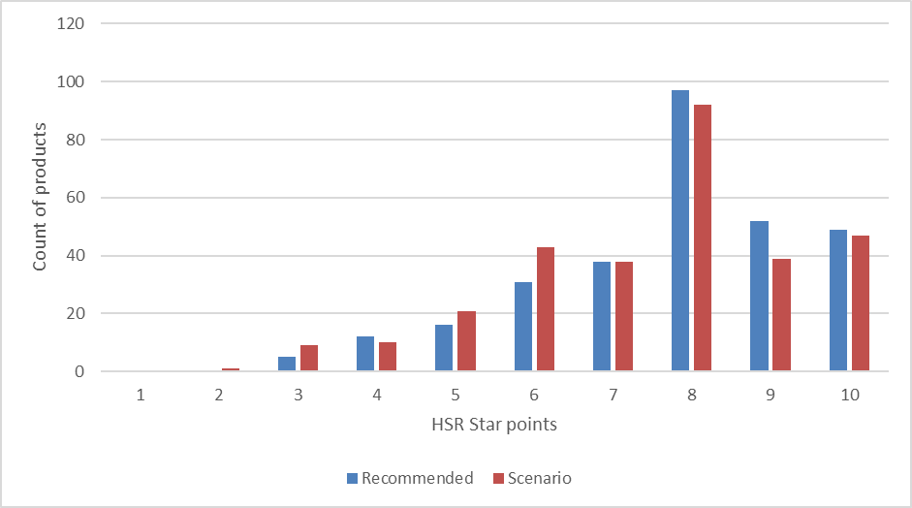
Figure 4 Distribution of HSR Star Points for all Breakfast cereals in TAG Database affected by Scenario adjustment to Total Sugars HSR baseline points table compared to the Recommended HSR calculator

- Muesli and cereal bars

All Muesli and cereal bar products are flagged as discretionary. Of the 125 muesli and cereal bar products in the TAG database that are included in the relevant 5-digit classifications, 41 were affected in the Scenario model; of these 34 had a reduction of 1 HSR star point and 7 had a reduction in 2 HSR star points, with 4 of these in Muesli and cereal style bars, added coatings or confectionery 5-digit classification. Of those products affected by Scenario, total sugars content ranged between 12.1-41 g/100 g. Recommended HSR star points for affected products ranged from 2-9 star points with an average of 5.7 (2.5-3 stars) and in the Scenario model this was reduced to a range of 1-8 star points with an average of 4.5 (2-2.5 stars), with the largest reduction from the Recommended HSR calculator being for products with 8 HSR start points (4 stars) by 1-2 star points (0.5-1.0 stars), refer to Figure 5.

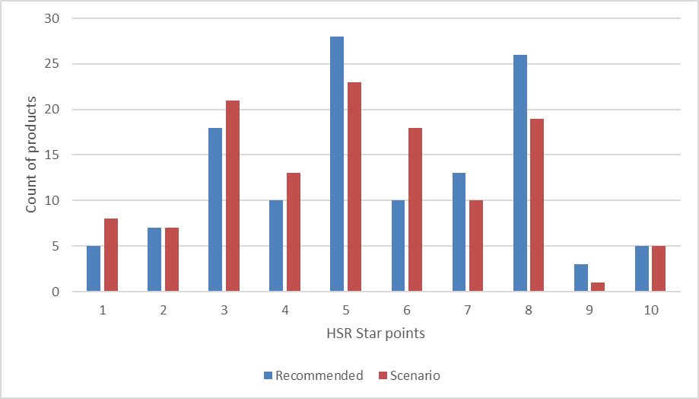
Figure 5 Distribution of HSR Star Points for all Muesli & Cereal Bars in TAG Database affected by Scenario adjustment to Total Sugars HSR baseline points table compared to the Recommended HSR calculator

- Flavoured milks

All flavoured milk-based drinks are flagged as FFG. Of the 226 products in the TAG database that are included in the relevant 5-digit classifications a total of 46 were impacted by a reduction of 1 star point. Figure 6, shows the distribution for all flavoured milks in the TAG database. Recommended HSR star points for just those products affected by the Scenario model ranged from 6-9 points, (average 7.8, approximately 4 stars) and in the Scenario model this reduced to a range of 5-8 HSR star points (average 6.8, approximately 3.5 stars). The greatest number of products affected had 8 star points in the Recommended HSR calculator (4 stars), reducing to 7 star points. Total sugars content for the affected products ranged from 8.4-12.8 g/100g.

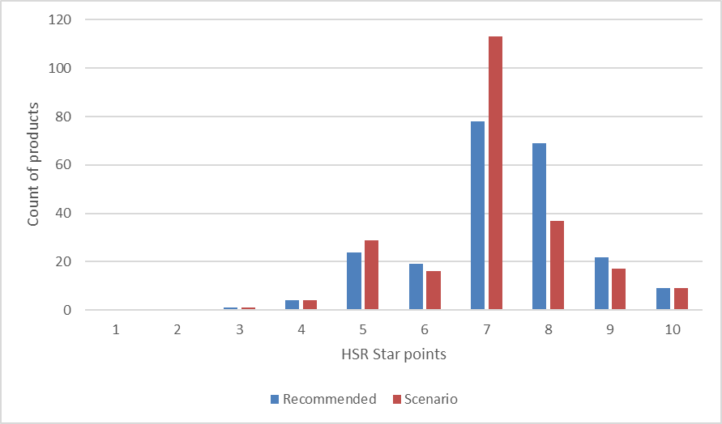
Figure 6 Distribution of HSR Star Points for all Flavoured Milks in TAG Database affected by Scenario adjustment to Total Sugars HSR baseline points table compared to the Recommended HSR calculator

- Yoghurts

All yoghurts in the TAG database are flagged as FFG foods. Of the 381 products in the TAG database that are included in the relevant 5-digit classifications, 70 products had a reduction of 1 star point, with 26 (37%) of these being Yoghurt, flavoured or added fruit, full fat. Recommended HSR star points for affected products ranged from 5-10 points with an average of 7.6 (3.5-4 stars) and in the Scenario model reduced to a range of 4-9 points with an average of 6.6 (3-3.5 stars), refer to Figure 7. The greatest number of products affected were those with 8 star points (4 stars) in the Recommended HSR calculator, reducing to 7 star points (3.5 stars) with total sugars ranging between 8.4-16.3 g/100 g.

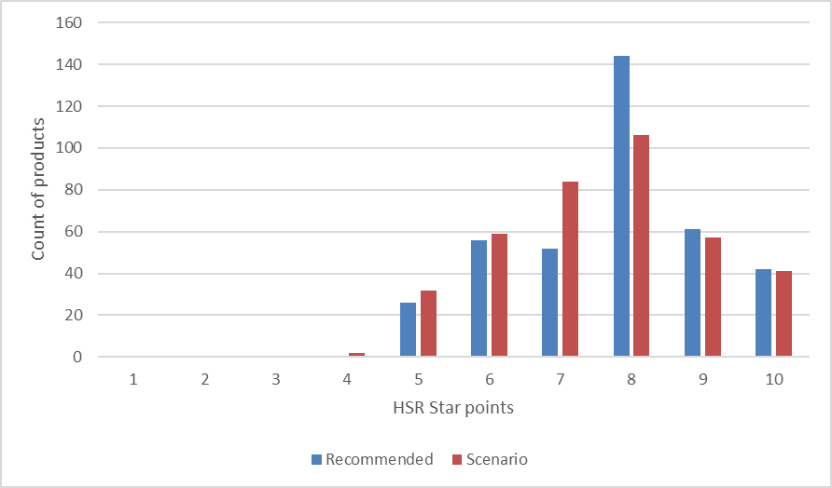
Figure 7 Distribution of HSR Star Points for all Yoghurts in TAG Database affected by Scenario adjustment to Total Sugars points table compared to the Recommended HSR calculator

Conclusion
The total sugars Scenario model indicates changes that would be in addition to any changes to HSRs as a result of all other recommended changes to the HSR calculator (Recommended model).

Analysis of the impact of using a revised 30 HSR baseline point total sugars scale indicates that:

- Approximately 9% of products in the TAG database would be affected by a reduction in HSR, with the proportion of FFG (5%) and discretionary (5%) products impacted being approximately equal.
- Product categories impacted tend to be those indicated as being of most concern to stakeholders with the greatest impact on FFG products seen in the Processed fruit (20%), Breakfast cereals (19%) and Yoghurt/soft cheese (17%) categories and for discretionary foods in the Ice cream and Confectionery (22% respectively), Bakery/cake mixes (20%) and Custard/desserts (18%) categories.
- The majority of affected products in the TAG database received a 1 star point (0.5 star) reduction with a small proportion of products receiving a 2 star point (1 star) reduction in only four AGHE categories: – Breakfast cereals, Cream, Custards/desserts, and Snacks.

HSR System Review Recommendation 4c - Sodium
The Forum was concerned that the changes to sodium HSR baseline points table recommended by the Review to improve the sensitivity of the HSR calculator to foods with high sodium content would only impact a small subset of discretionary foods that are high in sodium (those HSR Category 1D and 2 foods with >900 mg sodium/100 g), providing little incentive for food reformulation. The Forum therefore requested that FSANZ undertake additional modelling on the combined impact of all proposed changes on both the recommended approach and the alternative approach considered in the Review’s draft Report. This alternative approach considered applying HSR baseline points at 75 mg/100 g of sodium intervals across all sodium baseline points, rather than the 90 mg/100 g across all baseline points recommended in the Review.

Sodium Scenarios modelled
As was the case for total sugars modelling, all products in HSR Category 1 (429 products) were excluded from the dataset for sodium modelling purposes and not further considered in this analysis as a new approach is recommended for the calculation of HSRs for non-dairy beverages which is based on energy, total sugars and FVNL only. Also as was the case in the total sugars analysis, Unprocessed fruit and Unprocessed vegetables, with HSRs amended as recommended, have been included in the analysis.

In addition to the Recommended HSR calculator, two Sodium Scenarios were modelled by adjustments to the HSR baseline points tables for Category 1D, 2 and 2D foods only (Scenario 1) and 1D, 2, 2D, 3 and 3D (Scenario 2). For the Recommended model HSR baseline point allocations were at 90 mg/100 g increments, consistent with the NPSC algorithm on which the HSR algorithm is based, which has allocations up to 900 mg sodium/100 g. In the Scenarios, the adjusted points were allocated per 75 mg/100 g increment starting from 0 mg/100 g up to 30 points (maximum of 2250 mg sodium/100g compared to a maximum of 2700 mg/100g for the Recommended model). The sodium concentration cut-offs and HSR points allocated for the Recommended and each Scenario models are provided in Table 3.

Table 3: Sodium concentration (mg/100 g) and allocated HSR baseline points for foods in HSR categories 1D, 2, 2D, 3 and 3D for Recommended and two scenario models.
 | Recommended |  | Scenario 1 |  | Scenario 2
HSR baseline points for sodium | Category 1D, 2 & 2D Foods  90 mg sodium/100g intervals | Category 3 & 3D Foods  90 mg sodium/100g intervals | Category 1D, 2 & 2D Foods  75 mg sodium/100g intervals | Category 3 & 3D Foods  90 mg sodium/100g intervals | Category 1D, 2 & 2D Foods  75 mg sodium/100g intervals | Category 3 & 3D Foods  75 mg sodium/100g intervals
0 | 0 | 0 | 0.00 | 0 | 0.00 | 0.00
1 | 90.01 | 90.01 | 75.01 | 90.01 | 75.01 | 75.01
2 | 180.01 | 180.01 | 150.01 | 180.01 | 150.01 | 150.01
3 | 270.01 | 270.01 | 225.01 | 270.01 | 225.01 | 225.01
4 | 360.01 | 360.01 | 300.01 | 360.01 | 300.01 | 300.01
5 | 450.01 | 450.01 | 375.01 | 450.01 | 375.01 | 375.01
6 | 540.01 | 540.01 | 450.01 | 540.01 | 450.01 | 450.01
7 | 630.01 | 630.01 | 525.01 | 630.01 | 525.01 | 525.01
8 | 720.01 | 720.01 | 600.01 | 720.01 | 600.01 | 600.01
9 | 810.01 | 810.01 | 675.01 | 810.01 | 675.01 | 675.01
10 | 900.01 | 900.01 | 750.01 | 900.01 | 750.01 | 750.01
11 | 990.01 | 990.01 | 825.01 | 990.01 | 825.01 | 825.01
12 | 1080.01 | 1080.01 | 900.01 | 1080.01 | 900.01 | 900.01
13 | 1170.01 | 1170.01 | 975.01 | 1170.01 | 975.01 | 975.01
14 | 1260.01 | 1260.01 | 1050.01 | 1260.01 | 1050.01 | 1050.01
15 | 1350.01 | 1350.01 | 1125.01 | 1350.01 | 1125.01 | 1125.01
16 | 1440.01 | 1440.01 | 1200.01 | 1440.01 | 1200.01 | 1200.01
17 | 1530.01 | 1530.01 | 1275.01 | 1530.01 | 1275.01 | 1275.01
18 | 1620.01 | 1620.01 | 1350.01 | 1620.01 | 1350.01 | 1350.01
19 | 1710.01 | 1710.01 | 1425.01 | 1710.01 | 1425.01 | 1425.01
20 | 1800.01 | 1800.01 | 1500.01 | 1800.01 | 1500.01 | 1500.01
21 | 1890.01 | 1890.01 | 1575.01 | 1890.01 | 1575.01 | 1575.01
22 | 1980.01 | 1980.01 | 1650.01 | 1980.01 | 1650.01 | 1650.01
23 | 2070.01 | 2070.01 | 1725.01 | 2070.01 | 1725.01 | 1725.01
24 | 2160.01 | 2160.01 | 1800.01 | 2160.01 | 1800.01 | 1800.01
25 | 2250.01 | 2250.01 | 1875.01 | 2250.01 | 1875.01 | 1875.01
26 | 2340.01 | 2340.01 | 1950.01 | 2340.01 | 1950.01 | 1950.01
27 | 2430.01 | 2430.01 | 2025.01 | 2430.01 | 2025.01 | 2025.01
28 | 2520.01 | 2520.01 | 2100.01 | 2520.01 | 2100.01 | 2100.01
29 | 2610.01 | 2610.01 | 2175.01 | 2610.01 | 2175.01 | 2175.01
30 | 2700.01 | 2700.01 | 2250.01 | 2700.01 | 2250.01 | 2250.01
The HSR calculator algorithm is based on that used for the Nutrient Profiling Scoring Criterion (NPSC) for nutrition and health claims, dark blue shading indicates the NPSC cut-off

Outcomes of Sodium Scenarios modelling

Impact of Scenarios on HSR Category 3 and 3D products
Outcomes of modelling were identical for both Scenario 1 and Scenario 2 for the HSR categories 1D, 2 and 2D. HSR Category 3 Fats, oils & oil based spreads and 3D Cheese, were impacted by Scenario 2 (refer to Appendix 2 Table 12).

Within HSR Category 3 and 3D, the AGHE category most impacted by the changes to sodium points table was Cheese, with 345 foods (78%) receiving lower star points, an average reduction in star points of 1.2 (approximately ½ star) and a maximum of 3 star points (1.5 stars).

The AGHE Cheese category includes products such as ripened cheddar and processed cheeses and their reduced fat counterparts as well as surface ripened styles of cheese and is made up of a number of AHS 5-digit food classifications, all of which are flagged as FFG, as set out in Appendix 2 Table 13.

Reduced fat processed cheeses were more strongly affected by the proposed sodium changes to the points tables than other classifications. Four Cheese products in total in the TAG database had a reduction of 3 HSR star points (1.5 stars), all of which were in the reduced fat processed cheese classification. The 5-digit classification Cheese, camembert, brie and other surface ripened cheeses made up less than one fifth of all of the Cheese AGHE category in the TAG database and proportions of products affected and average reductions in HSR star scores were similar to other cheese classifications.

The AGHE category Fats, oils & oil based spreads, was minimally affected by the proposed changes to the sodium points table, with a total of 12 of the 93 products in the TAG database affected by a reduction in HSR star points of 1 (0.5 stars). Details of this category, broken down by AHS 5-digit classification is also set out in Appendix 2 Table 13.

Overall, the effect of the proposed additional changes to the sodium points table on HSR Category 3 and 3D foods would create a greater misalignment with Dietary Guidelines recommendations than the Recommended HSR calculator. A broad range of FFG foods would be affected with a greater reduction in HSRs for lower fat foods, which is not in line with the Dietary Guidelines recommendation to eat dairy products, preferably reduced fat products.

Further analysis is restricted to Scenario 1, affecting HSR categories 1D, 2 and 2D only.

Impact of Scenario 1 on HSR Category 1D, 2 and 2D products, by AHGE category
Following exclusion of HSR categories 1, 3 and 3D, there were a total of 4919 Category 1D, 2 and 2D products remaining in the TAG database. Of these a total of 701 (14%) were affected by a reduction in HSR as a result of Scenario 1 adjustments to the sodium HSR baseline points table, refer to Figure 8. This 14% of affected products is in addition to the products affected by the adjustments to the sodium HSR baseline points table recommended in the Review Report (Recommended model).

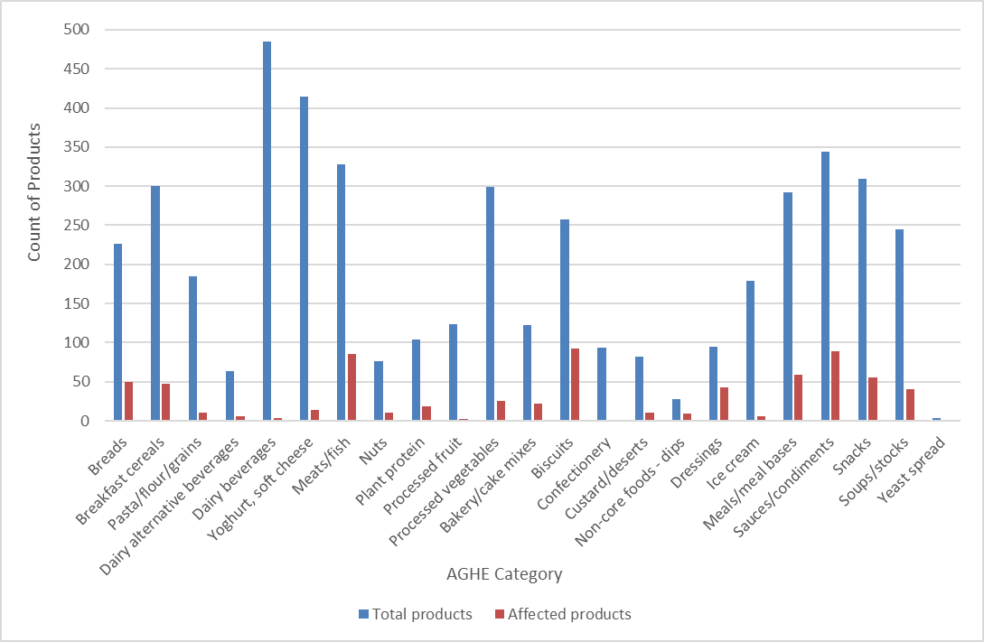
Figure 8 Total number of TAG database products for each affected AGHE category and number in each category affected by Scenario 1 adjustment to Sodium HSR baseline points table compared with the Recommended HSR calculator

Of the 30 AGHE categories considered, seven categories were not impacted by Scenario 1, with no reductions in star points for any products in:
- Dairy beverage dry mix
- Cream
- Cream cheese
- Miscellaneous foods
- Pizza
- Unprocessed fruit
- Unprocessed vegetables.

A number of AGHE categories were minimally impacted, with only 1-3% of products in each category affected by a reduction of 1 star point (0.5 stars):
- Dairy beverages, 3 of 485 products, 1%
- Yoghurt, soft cheese, 14 of 415 products, 3%
- Processed fruit, 2 of 124 products, 2%
- Confectionery, 1 of 94 products, 1%
- Ice cream, 6 of 179 products 3%.

Sodium concentrations in AGHE categories with no or a low proportion of affected products (as identified above) were at the lower end of the range of sodium concentrations captured in the TAG database with average concentrations ranging from 2-53 mg/100 g, except for Miscellaneous foods, Pizza and Cream cheese (average of 9,410, 603 and 446 mg sodium/100 g, respectively), noting that Pizza was under-represented in the TAG database.

For other AHGE categories, the proportion of products affected ranged from 6% for Pasta/flour/grains to 45% for Dressings. Reductions in HSR star points ranged from 1-3 points (0.5-1.5 stars). Figure 1 below summarises the overall distribution of HSR star points for all TAG products affect by Sodium Scenario 1. The majority (93%) of affected products had a reduction in 1 star point (0.5 stars), with 6% and 1% having a 2 and 3 star point reduction, respectively. Categories of specific interest are discussed in greater detail in section 3.2.5.

Figure 9 Distribution of Health Star Rating of TAG database products affected by Scenario 1 adjustment to Sodium points table compared to the Recommended HSR Calculator

Impact of Scenario 1 on FFG and discretionary products
Overall, of the 4,919 products in HSR categories 1D, 2 and 2D in the TAG database, 2985 (61%) were flagged as FFG and 1934 (39%) were flagged as discretionary. Of the 701 products that were affected by Scenario 1 compared to the Recommended model, 331 (47%) were flagged as FFG foods and 370 (53%) were flagged as discretionary foods. Outcomes are summarised in Figure 10 below with details provided in Appendix 2 Table 14 and Table 15.

AGHE categories with the greatest proportion of FFG products affected included Bread (22%), Plant protein (18%), Biscuits (16%), Breakfast cereals (15%) and Meals/meal bases and Nuts (14% respectively). AGHE categories with the greatest proportion of affected discretionary products included Dressings (44%), Dips (32%), Sauces/condiments and Yeast spread (25% respectively) and Biscuits (20%).

When the effect of the Sodium Scenario 1 was analysed against HSRs, generally there were more FFG and discretionary products affected in the mid-star ranges (HSRs of 2-3).

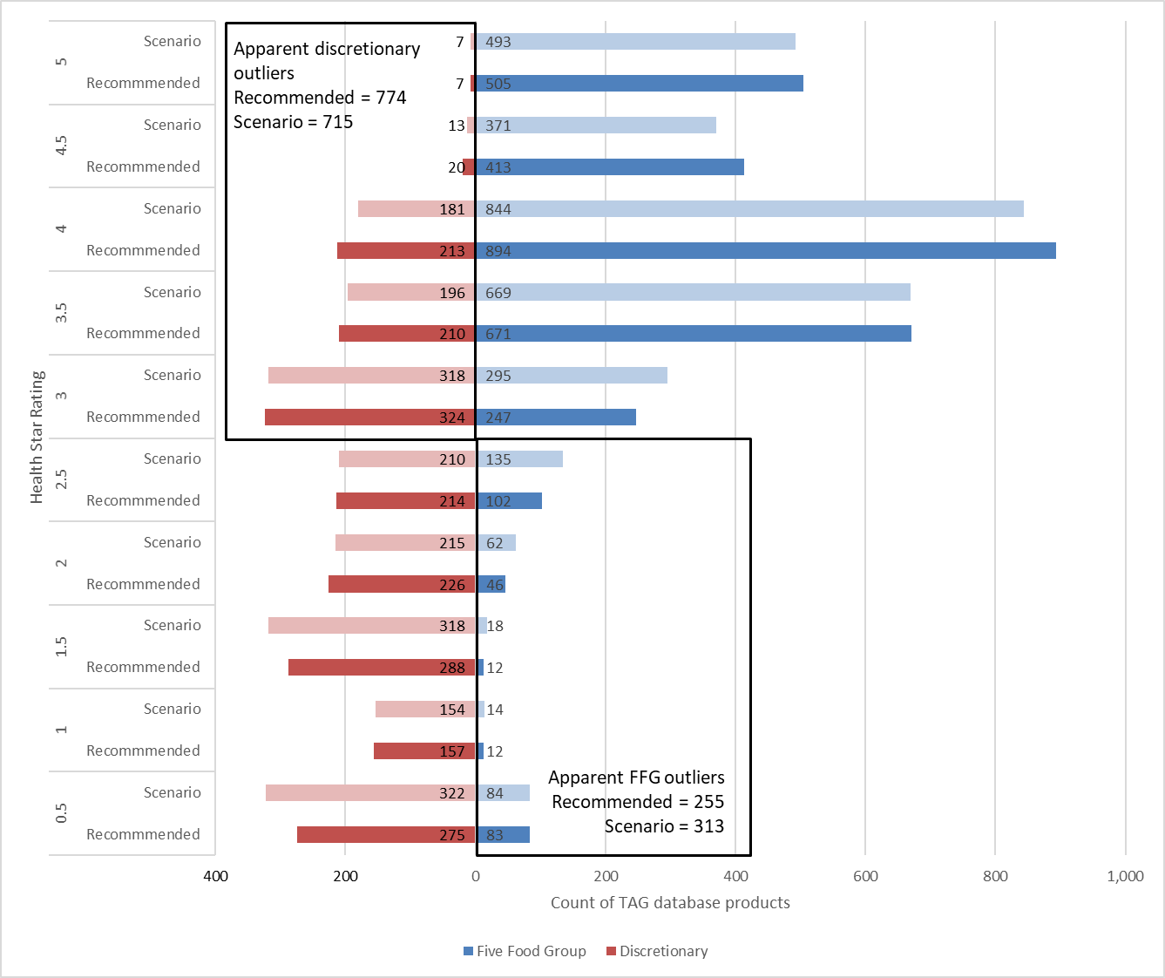
Figure 10 Impact of Sodium Scenario 1 on FFG and discretionary foods broken down by Health Star Rating.

Types of products affected by Scenario 1
When breaking each ‘core’ AGHE category down to its 5-digit AHS classification (refer to Appendix 2 Table 16), of the 273 affected products 64 were flagged as discretionary. Within the Meats/fish AGHE category, 44 of the 85 affected products were flagged as discretionary. However, the most affected 5-digit classification was Packed fin fish, with all 26 affected products (of 103 in category) flagged as FFG.

There were a number of 5-digit classifications in ‘core’ AGHE categories where all affected products were flagged as discretionary:

- Ham (18 affected out of 29),
- Vegetable-based pickles, chutneys and relishes (12 of 25).
- Fin fish, battered or crumbed (9 of 27)
- Fish and seafood products (5 of 20)
- Potato products (5 of 47)
- Processed delicatessen meat, mammalian (4 of 9)
- Processed delicatessen meat, poultry (4 of 6).

Other 5-digit classifications with higher numbers of affected FFG products included:

- Meat substitutes (15 affected out of 38 products)
- Breads, and bread rolls, mixed grain, mandatorily fortified (14 of 47)
- Breads, and bread rolls, wholemeal and brown, mandatorily fortified (11 of 37)
- Breakfast cereal, mixed grain, with fruit and/or nuts, fortified (11 of 39).

Also notable was Breakfast cereal, corn based, fortified where 7 of the 11 products (64%) in this 5-digit classification were affected by Sodium Scenario 1.

Within non-core AGHE categories (refer to Appendix 2 Table 17) 428 out of 1727 (25%) products were affected by Sodium Scenario 1. The majority of these affected foods were flagged as discretionary, however 122 were identified as FFG.

Five-digit classifications for which all affected foods were identified as FFG included:

- Savoury biscuits, wheat based, plain, energy ≤1800 kJ per 100 g (27 affected out of 39 products)
- Savoury pasta/noodle and sauce dishes, ≤5 g saturated fat/100 g (21 of 70)
- Soup, vegetable only (11 of 60)
- Savoury biscuits, rice based (includes rice cakes) (9 of 25)
- Stock, prepared (8 of 22)
- Soup containing meat, poultry or seafood (7 of 54).

Other non-core 5-digit categories with a large number of affected products included:

- Savoury biscuits, wheat based, plain, energy >1800 kJ per 100 g (33 affected out of 60 products)
- Savoury sauces, not tomato based, commercial (25 of 107)
- Savoury sauces, tomato based, commercial (20 of 89)
- Mayonnaise and cream-style dressings, full fat (19 of 40).

Effect of Scenario 1 on key food products
The sodium report prepared by the TAG during the HSR review noted a number of key product types that were noted to be of concern by respondents to the HSR review. These included Salty snacks, Gravy mixes, Recipe and sauce mixes, processed meat and Salted/unsalted products such as nuts.

Noting that products within a 5-digit AHS classification could be mapped to different AHGE categories and include both FFG and discretionary foods, effects of Sodium Scenario 1 on these product types is:

- Salty snacks –previously identified as an issue as some salty snacks were receiving higher than expected HSRs in the original HSR calculator because of the FVNL, fibre and/or protein content. Concerns were mainly around such products as Potato and other vegetable crisps, Corn chips, Extruded snacks, Popcorn and Other snacks.

Of the 131 products that are included in the relevant 5-digit classifications, 33 (25%) had a reduction of 1-3 HSR star points (0.5-1.5 stars). All of affected products had a sodium concentration in the range of 379-1980 mg/100 g. However, one product, an extruded snack, had a lower sodium concentration (84 mg/100 g). Figure 11 shows the distribution of all salty snack products in the TAG database. Of those products affected by the adjustment to the points table, star points for the Recommended HSR calculator ranged from 2-9, with an average of 4.7 (2-2.5 HSR stars). This was reduced in Scenario 1 to a range of 1-6 and an average of 3.5 HSR star points (1.5-2 stars) The number of products most affected by Scenario 1 were those with 7 HSR star points in the Recommended model (3.5 stars) with a reduction of 1-2 points (0.5-1 stars).

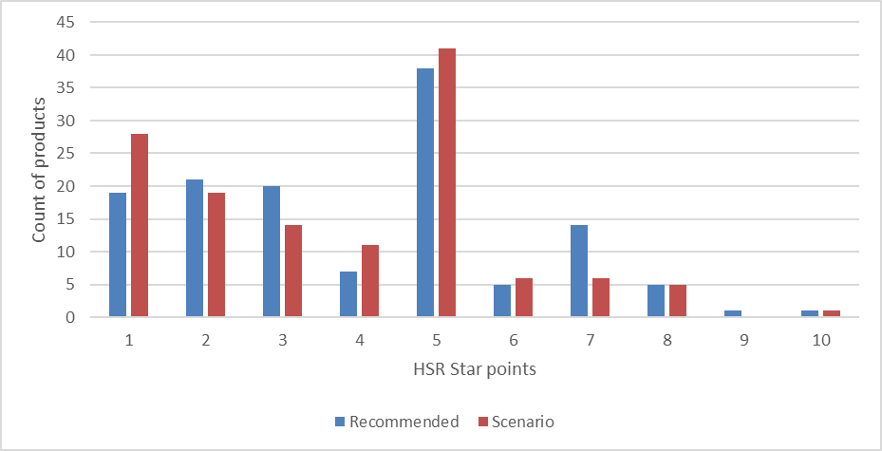
Figure 11 Distribution of HSR Star Points for all Salty Snacks in TAG Database using the Recommended HSR calculator compared to the Sodium Scenario 1 calculator

- Gravy mixes

Of the 38 products in the TAG database 15 were affected by a reduction of 1 star point. As shown in Figure 12, Recommended HSR calculator star points ranged from 6-7 points, (average 6.1, approx. 3 stars) and reduced to 5-6 star points (average 5.1, approx. 2.5 stars). Sodium concentrations for the affected products ranged from 260-613 mg/100 g. (AHS 5-digit code 23102 Dry gravy mixes).

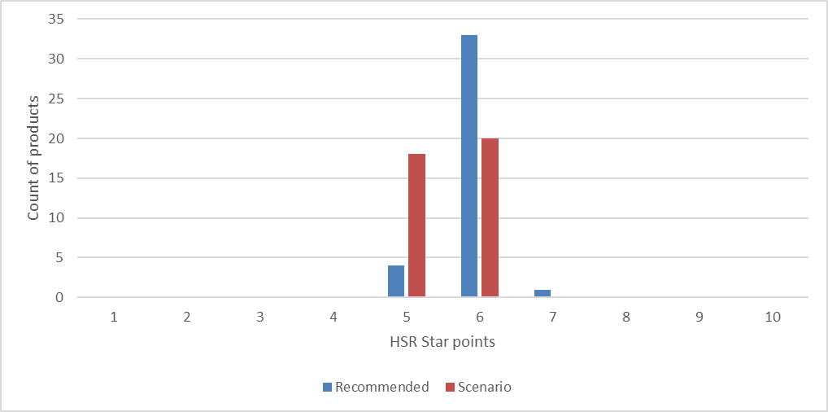
Figure 12 Distribution of HSR Star Points for all Gravy Mixes in TAG Database using the Recommended HSR calculator compared to the Sodium Scenario 1 calculator
- Recipe and sauce mixes

Of the 325 products in the AGHE non-core foods within relevant 5-digit meals/bases and sauces/condiments categories, 65 had a reduction in 1 star point (0.5 stars). Recommended HSR calculator star points for affected products ranged from 2-9 points (average 5.6, approximately 2.5 stars), and reduced to a range of 1-8 star points (average 4.6, approximately 2 stars), with the greatest number of products affected being those with 8 star points (4 stars) in the Recommended model, refer to Figure 13.

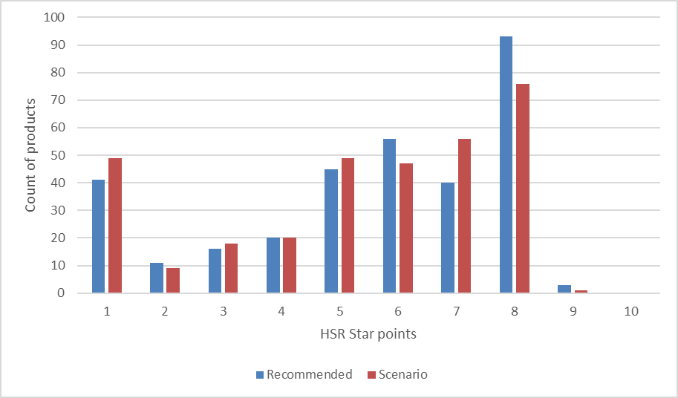
Figure 13 Distribution of HSR Star Points for all Recipe & Sauce Mixes in TAG Database using the Recommended HSR calculator compared to the Sodium Scenario 1 calculator

- Processed meat

Of the 30 products in the TAG database with relevant 5-digit classifications, 10 products had a reduction of 1 star point and 3 had a reduction of 2 star points. As shown in Figure 14 below, Recommended HSR calculator star points ranged from 4-8 points, (average 6.6, approx. 3.5 stars) and reduced to 3-7 star points (average 5.4, approx. 2.5 stars) in Scenario 1. Of the 19 products within the Protein meat/fish AGHE category, 9 were affected by the sodium scenario, all of which were flagged as discretionary. Eleven processed meat products were grouped in the non-core meals/meal bases AGHE category. Four of these were affected by Sodium Scenario 1, all of which were flagged as discretionary.

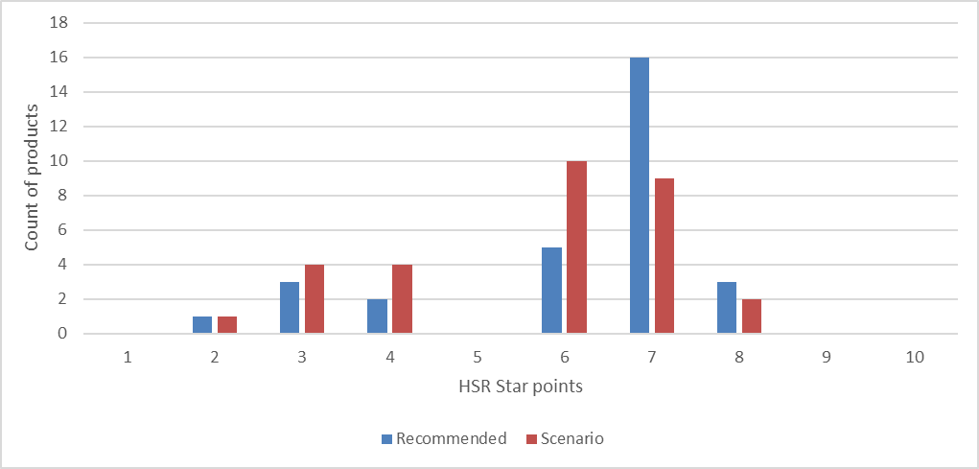
Figure 14 Distribution of HSR Star Points for all Processed meats in TAG Database using the Recommended HSR calculator compared to the Sodium Scenario 1 calculator

- Salted/unsalted nuts

All nuts and nut products are flagged as FFG. Of the 85 products in the TAG database (including relevant 5-digit classifications for nut products such as nut pastes and butters), 13 had a reduction of 1 star point, all of which had a sodium concentration of 380 mg/100 g or greater and three of which were described as salted in the product description (roasted salted nuts (680 mg/100 g), roasted salted peanuts (430 mg/100 g) and Nut, peanut, with skin, roasted, with oil, salted (380 mg/100 g). Figure 15 show the distribution of star points for all nut products in the TAG database. Of those products affected, Recommended HSR calculator star points ranged from 3-9 points, (average 6.1, approx. 3.0 stars) and reduced to 2-8 star points (average 5.1, approx. 2.5 stars) in Scenario 1. There was generally already a differentiation in star points in the Recommended HSR calculator between nuts with >25 mg sodium /100 g (41 products, range of 2-10 star points, average of 6.6 star points) and unsalted nuts with ≤25 mg sodium /100 g (44 products, range of 7-10 star points, average of 9.2 star points) A similar differentiation occurs between unsalted nut spreads and salted nut spreads (difference of 2-3 star points).

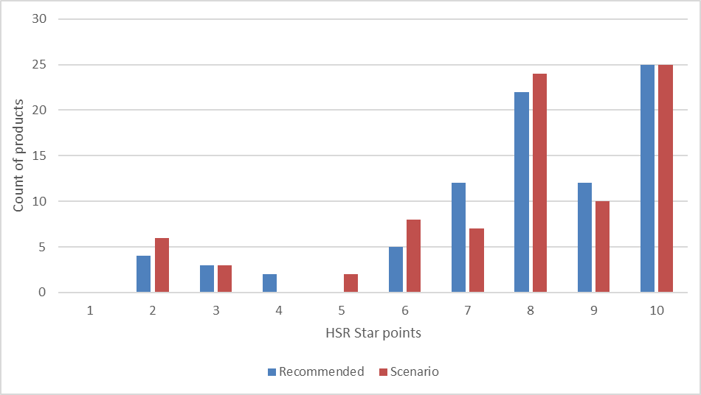
Figure 15 Distribution of HSR Star Points for all Salted/unsalted Nuts in TAG Database using the Recommended HSR calculator compared to the Sodium Scenario 1 calculator

Effect of Scenario 1 on products with ≤900 mg sodium /100 g
The sodium report prepared by the TAG noted that modelling undertaken by the TAG showed no change in HSRs for the vast majority of product categories, with <2% of products in the TAG database impacted by the scenarios modelled at that time. This was as a result of those scenarios not making any changes to the sodium points table for sodium concentrations of ≤900 mg/100 g. A small number of individual products in the TAG database were impacted in the TAG models as their sodium content was >900 mg/100 g, including processed meats, stock cubes and seasonings and savoury sauces, salty snacks and vegetable pickles. Consistent with the TAG modelling, the Review recommended adjustments to the sodium baseline points table for sodium concentrations >900 mg/100 g, incorporated in the Recommended HSR calculator.

As the sodium scenarios modelled for this report included adjustments to the sodium points table for all sodium concentrations, including for sodium concentrations ≤900 mg/100 g, a much higher proportion, 15%, of HSR categories 1D, 2 and 2D products in the TAG database were impacted (Scenario 1). This comprised a much broader range of food products across the majority of AGHE categories, including 7% of FFG products and 8% of discretionary products (see Table 14).

Of the 1934 products in the TAG database identified as discretionary, 370 were affected by Scenario 1, of which 92 (25%) had a sodium concentration of >900 mg/100 g, and 278 (75%) had a sodium concentration of ≤900 mg/100 g. All affected products with >900 mg sodium /100 g had a reduction of 1 star point (0.5 stars) except for 5 products which had a reduction of 2 star points (1 star). For affected products with ≤900 mg sodium /100 g, one product (an extruded snack, <100 mg sodium /100 g) had a reduction of 3 star points (1.5 stars) and 9 products had a reduction of 2 star points (1 star). All other products had a reduction of 1 star point (0.5 stars).

Of the 2985 foods identified as FFG in the TAG database in HSR categories 1D, 2 and 2D products, 331 were affected by Scenario 1, of which of which 11 (3%) had a sodium concentration of >900 mg/100 g. All of these products had a reduction in 1 star point (0.5 stars) except for two chicken products (approx. 920 mg sodium /100 g) which had a reduction of 3 star points (1.5 stars). Three hundred and twenty (97%) products had a sodium concentration of ≤900 mg/100 g. Thirty-one of these products had a reduction of 2 star points (1 star). Three products (two mixed grain breakfast cereals with fruit and or nuts, fortified and one meat substitute flavoured sausage) had a reduction of 3 star points. All other affected FFG had a reduction of 1 star point (0.5 stars).

Refer to Table 4 below for a summary of products affected above and below 900 mg sodium /100 g, and Appendix 2 Table 16 and Table 17 for details of the products with a 2 or 3 star point reduction.

Table 4 Summary of number of affected FFG and discretionary products above and below 900 mg sodium /100 g, in HSR category 1D, 2 and 2D in the TAG database (Sodium Scenario 1)
 | Total | Number affected products  (proportion of total) | Number of affected products with ≤900 mg sodium /100 g (proportion of affected products) | Number of affected products with >900 mg sodium /100 g (proportion of affected products)
FFG | 2985 | 331 (11%) | 320 (97%) | 11 (3%)
Discretionary | 1934 | 370 (19%) | 278 (75%) | 92 (25%)

Conclusion
The Sodium Scenario 1 model indicates changes that would be in addition to any changes to HSRs as a result of all other recommended changes to the HSR calculator (Recommended model). The analysis of a revised sodium points table with changes to the points scale ≤900 mg sodium/100 g indicates that:

- Proposed changes to the sodium baseline points table on HSR Category 3 and 3D foods potentially creates a greater misalignment with Dietary Guidelines recommendations than the Recommended HSR calculator. A broad range of FFG foods would be affected by a reduction in HSRs, with greater impacts for lower fat foods.
- Approximately 14% of products in HSR Categories 1D, 2 and 2D would be affected by a reduction in HSR, with the proportion of FFG (7%) and discretionary (8%) products impacted being approximately equal.
- Product categories impacted tend to be those indicated by stakeholders as being of most concern with the greatest impact on FFG products seen in the Bread (22%), Plant protein (18%), Biscuits (16%), Breakfast cereals (15%) and Meals/meal bases and Nuts (14% respectively) categories and for discretionary foods in the Dressings (44%), Dips (32%), Sauces/condiments and Yeast spread (25% respectively) and Biscuits (20%).
- The majority of affected products in HSR Categories 1D, 2 and 2D received a 1 star point (0.5 HSR) reduction with a small proportion of products receiving a 2 or 3 star point reduction.
- Given that there are relatively few products with sodium concentrations >900 mg/100 g, the majority of products receiving a reduction in star points had a sodium concentration of ≤900 mg sodium/100 g.
- Application of the scenario 75 mg/100 g increment to the sodium HSR baseline points table will introduce an inconsistency with the NPSC for nutrition and health claims, as set out in the Food Standards Code.

Combined impact of Review Recommendation 4b and 4c Scenarios

Combined Scenario modelled.
In order to assess the impact of both the Total Sugars and the Sodium Scenarios compared to the Recommended HSR calculator, a Combined Scenario was modelled. As per previous separate analysis of Total Sugars and the Sodium Scenarios, this combined analysis was limited to foods in HSR categories 1D, 2 and 2D only, so only Sodium Scenario 1 was included. Foods classified as categories 1, 3 and 3D were excluded from the analysis, but unprocessed fruit and vegetables included.

For this Combined Scenario the total sugars HSR baseline points table was adjusted from a 25 point to a 30 baseline point scale as per the description in Section 2.1. The sodium HSR baseline table was adjusted as per Scenario 1 as described in Section 3.1, from a 30 baseline point scale with 90 mg sodium /100 g increments for each point to 75 mg/100 g increments for each point.

Outcomes of Combined Scenario modelling

Impact of Combined Scenario by AHGE category
The Combined Scenario resulted in a total of 1134 (23%) of 4919 TAG database products in HSR categories 1D, 2 and 2D being affected by a reduction in HSR star points, refer to Figure 16. Products were affected either by a reduction in star points from the changes to the total sugars baseline points table or the sodium baseline points table or both. There were also a number of products that were affected by the Combined Scenario that were not affected by either the Total Sugars or Sodium Scenario. This occurred where there was an increase in Baseline points from both the Total Sugars or Sodium Scenario 1 which was not great enough to trigger a reduction in HSR star points, but where the combined, cumulative effect was sufficient to result in a change. Refer to Table 5, below and Appendix 3 Table 18.

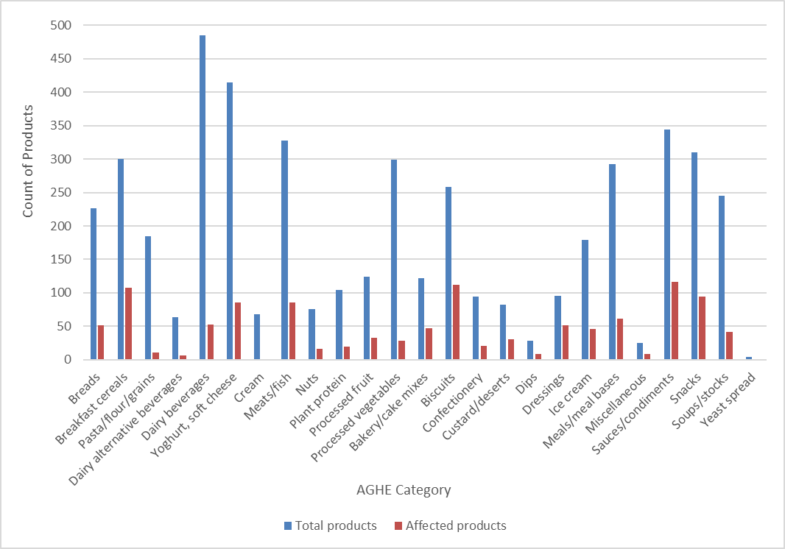
Figure 16 Total number of TAG database products in each affected AGHE category and number in each category affected by Combined Scenario adjustments to the HSR calculator
Five AGHE categories (Dairy beverage dry mix, Cream cheese, Pizza, Unprocessed fruit and Unprocessed vegetables) were not affected by the Combined Scenario while only 1 product was affected in two further categories (Cream and Yeast spread). However, total numbers of products in three of these categories were <4. (refer to Appendix 3 Table 19).

Non-core AGHE categories were the most affected by the Combined Scenario, with 54% of Dressings (51 of 95 products), 43% of Biscuits (112 of 258 products), 39% of Bakery/cake mixes (47 of 122 products) and 38% of Custard/desserts (31 of 82 products) being affected. Breakfast cereal was the most affected core AGHE category with 108 of 300 (36%) products affected, followed by Processed fruit, with 33 of 124 (27%) products affected.

Overall, 18% of products in AGHE categories identified as core were affected (495 of 2703 products) compared with 29% of products in AGHE categories identified as non-core (639 of 2216 products).

Of the 1134 products affected by the Combined Scenario, the majority (1058 products, 93%) had a reduction of 1 HSR star point (0.5 stars). Six percent had a reduction of 2 HSR star points (1 star) and 1% had a reduction of 3 HSR star points (1.5 stars).

Table 5 Summary of number of HSR category 1D, 2 and 2D TAG database products affected by Total Sugars Scenario, Sodium Scenario 1 and Combined Scenario
Scenario | Total number of products | Number of affected products (proportion of total) | Number of affected products  (proportion of affected products) | Number with 1 star point reduction (proportion of affected products) | Number with 2 star point reduction (proportion of affected products) | Number with 3 star point reduction (proportion of affected products)
Total Sugars Scenario | 4919 | 466 (9%) |  | 444 (95%) | 22 (5%) | -
Sodium Scenario 1 | 4919 | 701 (14%) |  | 650 (93%) | 45 (6%) | 6 (1%)
Combined Scenario  Affected by either Total Sugars or Sodium Scenario  Affected by both Total Sugars and Sodium Scenarios  Affected by Combined Scenario but not Total Sugars or Sodium Scenario | 4919 | 1134 (23%) | 943 (83%)  112 (10%)  79 (7%) | 1058 (93%) | 69 (6%) | 7 (1%)

Impact of Combined Scenario on FFG and discretionary products
Similar to the proportions of core and non-core AGHE categories affected, the proportion of FFG and discretionary products affected by the Combined Scenario were 19% and 30% respectively (refer to Table 6, below, and Appendix 3 Table 20 for additional details).

Table 6 Summary of FFG and discretionary TAG database products in HSR Categories 1D, 2 and 2D affected by the Total Sugars Scenario, Sodium Scenario 1 and Combined Scenario
 | Total number FFG  (proportion of all products) | Total number Discretionary (proportion of all products) | Number of FFG products affected  (proportion of all FFG products) | Number of discretionary products affected (proportion of all discretionary products)
Total Sugars Scenario | 2985 (61%) | 1934 (39%) | 236 (8%) | 230 (12%)
Sodium Scenario 1 | 2985 (61%) | 1934 (39%) | 331 (11%) | 370 (19%)
Combined Scenario | 2985 (61%) | 1934 (39%) | 553 (19%) | 581 (30%)

The greatest impact on FFG products in the Combined Scenario was seen for core AGHE categories. The highest proportion of affected FFG products (as a proportion of all category products) was in the Breakfast cereals category (33%) followed by Breads (23%) and Processed fruit and Nuts (21% respectively). FFG products were also affected in the Yoghurt, soft cheese and Miscellaneous (20% respectively) and Custards/desserts AGHE categories (17%).

Discretionary products were most impacted in the non-core AGHE classifications Dressings (53%, as a proportion of all category products), Bakery/cake mixes (34%), Sauces/condiments (33%), Dips (32%) and Snacks (29%).

The Combined Scenario changes to the HSR calculator aligns more closely with the dietary guidelines, with fewer discretionary products receiving a HSR of ≥3. While the majority of FFG products in the TAG database receive a HSR of ≥3, a combined stronger approach to the total sugars and sodium HSR baseline point tables also resulted in an increase in the number of FFG products receiving a HSR of <3, refer to Figure 17.

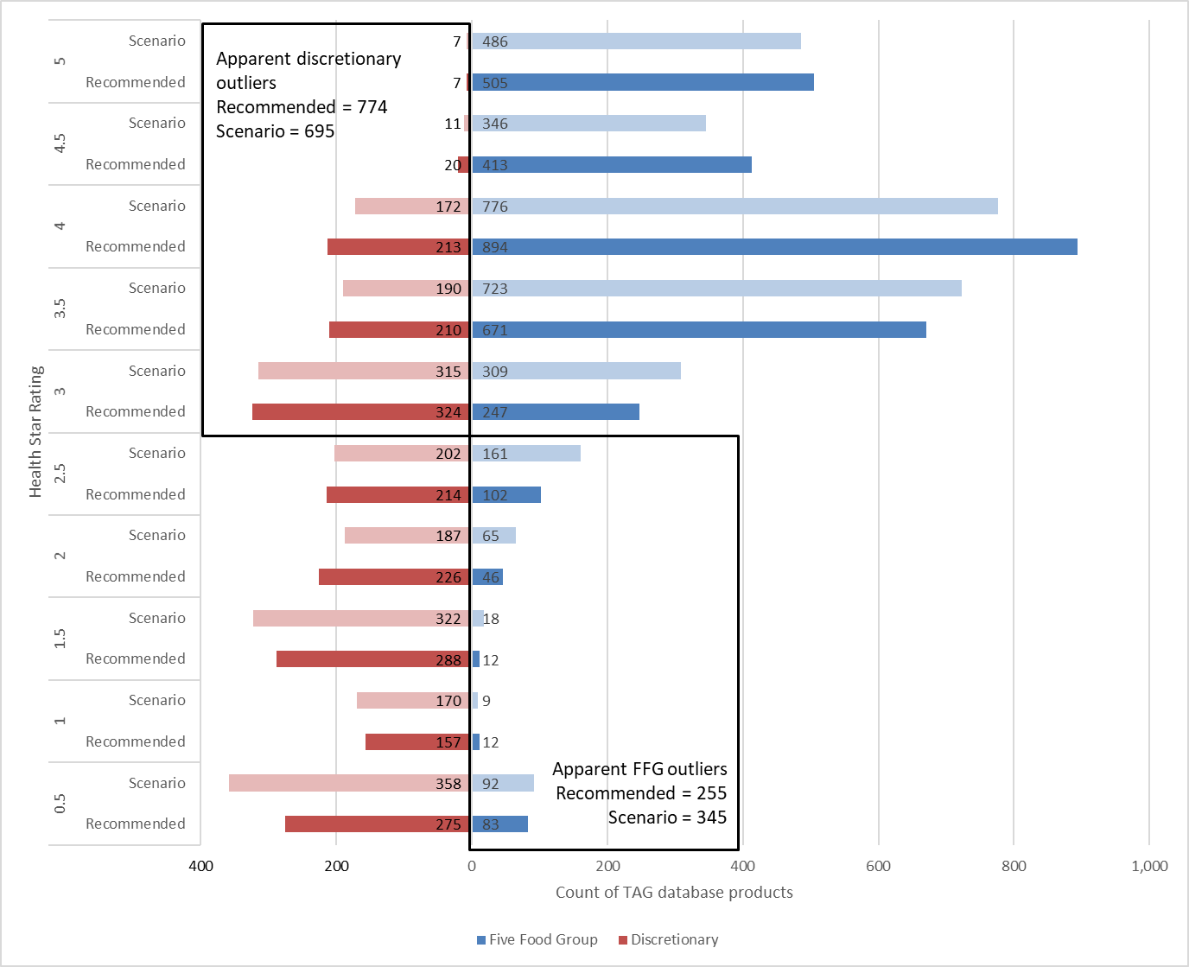
Figure 17 Impact of Combined scenario on FFG and discretionary foods broken down by Health Star Rating.

Types of products affected by the Combined Scenario
Details of types of products, at the 5-digit AHS classification level, that have been affect by the Combined Scenario are provided in Appendix 3 Table 22 for core AGHE classifications and Table 23 for non-core AGHE classifications. For those products affected by either Sodium Scenario 1 or the Total Sugars Scenario, 83% of all affected products, outcomes are as described in Sections 2 and 3.

As set out in Table 5 of Section 4.2.1, 112 products (10% of all affected products) were impacted by changes to both the total sugars and sodium HSR baseline points tables. Of these 112 products, 36 (32%, 31 of which were flagged as FFG and 5 as discretionary) were in core AGHE categories. The majority of affected products were in Breakfast cereals, across a number of 5-digit AHS classifications (24 products, three of which were flagged as discretionary). The most affected classification was Breakfast cereal, mixed grain, with fruit and/or nuts, fortified; where six of the seven products affected by Scenario changes to both the total sugars and sodium baseline points tables had a reduction of 2 HSR star points (1 star), with one product having a 3 HSR star point (1.5 stars) reduction. Total sugars and sodium concentrations ranged between 8.5-66.9 g/100 g and 76-1230 mg/100mg respectively. There were also seven affected products in the 5-digit classification Peanut products within the Nuts AGHE category, all flagged as FFG products and all with a reduction in 1 HSR star point (0.5 stars).

Seventy-six affected products were in non-core AGHE categories (68%), 72 of which were flagged as discretionary and 4 as FFG. The most affected non-core AGHE categories were Biscuits and Snacks, with 18 and 17 affected products respectively, closely followed by Sauces/condiments with 16 affected products. A the 5-digit classification level the most affected classifications were:

- Sweet biscuits, plain or flavoured including short bread varieties (10 products)
- Savoury sauces, not tomato based, commercial (9 products)
- Muesli and cereal style bars, with fruit and/or nuts (6 products)
- Savoury sauces, tomato based, commercial (5 products).

The majority of affected products had a reduction in 1 HSR star point (0.5 stars) although 5 products had a reduction of 2 star points (1 star), this latter group included all three affected products in the Dairy desserts, smooth or gelatine-based dairy desserts classification. Refer to Appendix 3, Table 24.

For the 79 (7%) of TAG database products that had been affected by the Combined Scenario but had not been affected by either Total Sugar Scenario or Sodium Scenario 1 individually, the most affected core AHGE categories were Breakfast cereals (22 products across eight 5-digit classifications). The most affected classification being Breakfast cereal, mixed grain, fortified, >20 g total sugars/100g, where total sugars and sodium concentrations ranged between 20-31.5 g/100 g and 240-398 mg/100mg respectively, with 3 of 5 products in this category flagged as discretionary. The most affected non-core AGHE category was Sauces/condiments (19 products across four 5-digit classifications), where total sugars and sodium concentrations ranged between 12.3-47.6 g/100 g and 166-1100 mg/100mg, respectively. These were followed by Snacks (9 products) and Bakery/cake mixes and Biscuits, both with 8 affected products. At the 5-digit classification level, most affected classifications were:

- Savoury sauces, not tomato based, commercial (9 products)
- Savoury sauces, tomato based, commercial (8 products)
- Mayonnaise and cream-style dressings, reduced or non-fat (5 products)
- Breakfast cereal, mixed grain, fortified, >20 g total sugars/100g (5 products)

All products had a reduction of 1 HSR star point (0.5 stars) except for four Breakfast cereal products that had a reduction of 2 HSR star points (1 star). Refer to Appendix 3, Table 25.

Conclusion
The Combined Scenario model indicates changes that would be in addition to any changes to HSRs as a result of all other recommended changes to the HSR calculator (Recommended model). The analysis of a Combined Scenario with revised total sugars HSR baseline points table adjusted from a 25 point to a 30 point scale and a revised sodium HSR baseline points table adjusted from a 30 point scale with 90 mg/100 g sodium increments for each point to 75 mg/100 g increments for each point indicates that:

- Approximately 23% of products in the TAG database would be affected by a reduction in HSR, with the proportion of FFG (11%) and discretionary (12%) products being impacted approximately equal.
- Product categories impacted in the Combined Scenario reflected those identified by stakeholders as being of most concern in the review. The greatest impact on FFG products was seen in the Breakfast cereals (33%) Bread (23%), Processed Fruit and Nuts (21% respectively) and Yoghurt and soft cheese (20%) categories, and for discretionary foods in the Dressings (53%), Bakery/cake mixes (34%), Sauces/condiments (33%), Dips (32%), and Snacks (29%).
- More than 90% of products in the TAG database affected by the Combined Scenario received a 1 star point (0.5 HSR) reduction with a small proportion of products receiving a 2 or 3 star point reduction.
- The Combined Scenario changes to the HSR calculator aligns with the dietary guidelines in that and fewer discretionary products in HSR Categories 1D, 2 and 2D receive a HSR of ≥3. However, more FFG products in those HSR Categories receive a HSR of <3.
- Adjustments to the total sugars and sodium baseline points tables will result in less consistency between the HSR system and the NPSC.

APPENDIX 1 Total Sugars Scenario Tables
Table 7 Summary of impact of Total Sugars Scenario on AGHE categories
AGHE category | RECOMMENDED Count of products | RECOMMENDED Average HSR star points | RECOMMENDED Max HSR star points | RECOMMENDED Min HSR star points | SCENARIO Count of products affected | SCENARIO Proportion of products affected (%) | SCENARIO Average HSR star points for all products | SCENARIO Average reduction in HSR star points for affected products | Average total sugars content (g/100g) | Max total sugars content (g/100g) | Min total sugars content (g/100g)
Bread | 226 | 7.7 | 10 | 5 | 1 | <1 | 7.7 | 1 | 2.7 | 20.8 | 0.1
Breakfast Cereal | 300 | 7.8 | 10 | 3 | 63 | 21 | 7.5 | 1.2 | 16.9 | 41.3 | 0
Pasta/flour/grains | 185 | 7.3 | 10 | 4 | 0 | 0 | 7.3 | 0 | 1.2 | 7.5 | 0
Dairy alternative beverages | 64 | 8.3 | 10 | 6 | 0 | 0 | 8.3 | 0 | 3.1 | 7.4 | 0
Dairy beverages | 485 | 8 | 10 | 3 | 50 | 10 | 7.9 | 1 | 7 | 17.3 | 1.8
Beverages dry mix/milk powder | 2 | 9 | 9 | 9 | 0 | 0 | 9 | 0 | 5.4 | 5.5 | 5.3
Yoghurt, soft cheese | 415 | 7.7 | 10 | 1 | 71 | 17 | 7.5 | 1 | 10 | 20.9 | 0
Cream | 68 | 1.4 | 8 | 1 | 1 | 1 | 1.4 | 2 | 3.7 | 8.6 | 0.9
Cream cheese | 67 | 1.3 | 8 | 1 | 0 | 0 | 1.3 | 0 | 6.2 | 16.3 | 1.9
Processed fruit | 124 | 6.4 | 10 | 3 | 32 | 26 | 6.1 | 1 | 29.8 | 72 | 4
Unprocessed fruit | 33 | 10 | 10 | 10 | 0 | 0 | 10 | 0 | 9.1 | 16.2 | 1.8
Bakery/cake mixes | 122 | 4 | 8 | 1 | 26 | 21 | 3.7 | 1 | 20.9 | 89.8 | 0.1
Biscuits | 258 | 3.5 | 9 | 1 | 30 | 12 | 3.4 | 1 | 19.1 | 52.5 | 0.1
Confectionery | 94 | 1.9 | 4 | 1 | 21 | 22 | 1.7 | 1 | 56.8 | 93.4 | 27.9
custard/desserts | 82 | 6 | 9 | 1 | 26 | 32 | 5.7 | 1.1 | 15.9 | 68.6 | 4.64
Dips | 28 | 5.2 | 8 | 3 | 0 | 0 | 5.2 | 0 | 5.1 | 10.5 | 0.3
Dressings | 95 | 3.3 | 6 | 2 | 7 | 7 | 3.2 | 1 | 12.6 | 27.2 | 1.1
Ice cream | 179 | 4.2 | 7 | 1 | 40 | 22 | 4 | 1 | 21.8 | 34.3 | 7.9
Meals/meal bases | 292 | 6.6 | 9 | 1 | 2 | 1 | 6.6 | 1 | 4 | 41.6 | 0
Miscellaneous | 25 | 3.6 | 10 | 1 | 8 | 32 | 3.3 | 1 | 22.6 | 72.1 | 0
Pizza | 3 | 4.7 | 6 | 4 | 0 | 0 | 4.7 | 0 | 2.1 | 2.9 | 0.9
Sauces/condiments | 344 | 5.4 | 10 | 1 | 25 | 7 | 5.4 | 1 | 10.3 | 63.4 | 0.1
Snacks | 310 | 4.9 | 10 | 1 | 47 | 15 | 4.7 | 1.1 | 15.6 | 73.9 | 0.1
Soups/stocks | 245 | 6.6 | 8 | 6 | 0 | 0 | 6.6 | 0 | 1.8 | 8.8 | 0
Yeast spread | 4 | 2 | 3 | 1 | 0 | 0 | 2 | 0 | 4.8 | 11.2 | 2
Meats/fish | 328 | 7.3 | 10 | 1 | 0 | 0 | 7.3 | 0 | 1.1 | 9.5 | 0
Nuts | 76 | 7.9 | 10 | 1 | 12 | 16 | 7.8 | 1 | 7.7 | 57.2 | 2.1
Plant proteins | 104 | 8.8 | 10 | 5 | 0 | 0 | 8.8 | 0 | 2.1 | 7.4 | 0
Processed vegetables | 299 | 8.6 | 10 | 1 | 4 | 1 | 8.6 | 1 | 3.3 | 40 | 0
Unprocessed vegetables | 62 | 10 | 10 | 10 | 0 | 0 | 10 | 0 | 2.5 | 7.7 | 0.3
Total | 4919 | 6.5 | 10 | 1 | 466 | 9 | 6.4 | 1.0 | 10.3 | 93.4 | 0

Table 8 Summary of impact of Total Sugars Scenario on AGHE categories by ‘FFG’ and ‘Discretionary’ foods flagged products
AGHE category | RECOMMENDED Count of products | RECOMMENDED Count of FFG products | RECOMMENDED Count of Discretionary  products | RECOMMENDED Average HSR points all products | SCENARIO Count FFG products affected | SCENARIO Proportion FFG products affected (%) | SCENARIO FFG Average reduction in HSR star points | SCENARIO Count Discretionary products affected | SCENARIO Proportion discretionary products affected (%) | SCENARIO Discretionary Average reduction in HSR star points
Bread | 226 | 217 | 9 | 7.7 | 1 | 0 | 1 | 0 | 0 | 0
Breakfast Cereal | 300 | 275 | 25 | 7.8 | 58 | 19 | 1.2 | 5 | 2 | 1
Pasta/flour/grains | 185 | 185 | 0 | 7.3 | 0 | 0 | 0 | 0 | 0 | 0
Dairy alternative beverages | 64 | 64 | 0 | 8.3 | 0 | 0 | 0 | 0 | 0 | 0
Dairy beverages | 485 | 461 | 24 | 8 | 50 | 11 | 1 | 0 | 0 | 0
Beverages dry mix/milk powder | 2 | 2 | 0 | 9 | 0 | 0 | 0 | 0 | 0 | 0
Yoghurt, soft cheese | 415 | 412 | 3 | 7.7 | 70 | 17 | 1 | 1 | 0 | 1
Cream | 68 | 4 | 64 | 1.4 | 0 | 0 | 0 | 1 | 1 | 2
Cream cheese | 67 | 67 | 0 | 1.3 | 0 | 0 | 0 | 0 | 0 | 0
Processed fruit | 124 | 94 | 30 | 6.4 | 25 | 20 | 1 | 7 | 6 | 1
Unprocessed fruit | 33 | 33 | 0 | 10 | 0 | 0 | 0 | 0 | 0 | 0
Bakery/cake mixes | 122 | 13 | 109 | 4 | 2 | 2 | 1 | 24 | 20 | 1
Biscuits | 258 | 70 | 188 | 3.5 | 0 | 0 | 0 | 30 | 12 | 1
Confectionery | 94 | 0 | 94 | 1.9 | 0 | 0 | 0 | 21 | 22 | 1
custard/desserts | 82 | 33 | 49 | 6 | 11 | 13 | 1 | 15 | 18 | 1.2
Dips | 28 | 0 | 28 | 5.2 | 0 | 0 | 0 | 0 | 0 | 0
Dressings | 95 | 4 | 91 | 3.3 | 0 | 0 | 0 | 7 | 7 | 1
Ice cream | 179 | 0 | 179 | 4.2 | 0 | 0 | 0 | 40 | 22 | 1
Meals/meal bases | 292 | 171 | 121 | 6.6 | 1 | 0 | 1 | 1 | 0 | 1
Miscellaneous | 25 | 13 | 12 | 3.6 | 5 | 20 | 1 | 3 | 12 | 1
Pizza | 3 | 1 | 2 | 4.7 | 0 | 0 | 0 | 0 | 0 | 0
Sauces/condiments | 344 | 11 | 333 | 5.4 | 0 | 0 | 0 | 25 | 7 | 1
Snacks | 310 | 34 | 276 | 4.9 | 0 | 0 | 0 | 47 | 15 | 1.1
Soups/stocks | 245 | 136 | 109 | 6.6 | 0 | 0 | 0 | 0 | 0 | 0
Yeast spread | 4 | 0 | 4 | 2 | 0 | 0 | 0 | 0 | 0 | 0
Meats/fish | 328 | 221 | 107 | 7.3 | 0 | 0 | 0 | 0 | 0 | 0
Nuts | 76 | 74 | 2 | 7.9 | 12 | 16 | 1 | 0 | 0 | 0
Plant proteins | 104 | 104 | 0 | 8.8 | 0 | 0 | 0 | 0 | 0 | 0
Processed vegetables | 299 | 224 | 75 | 8.6 | 1 | 0 | 1 | 3 | 1 | 1
Unprocessed vegetables | 62 | 62 | 0 | 10 | 0 | 0 | 0 | 0 | 0 | 0
Total | 4919 | 2985 | 1934 | 6.5 | 236 | 5 | 1 | 230 | 5 | 1

Table 9 Summary of Health Star Rating for ‘FFG’ and ‘discretionary’ flagged products for the Total Sugars Recommended and Scenario models
 | TOTAL SUGARS RECOMMENDED |  |  | TOTAL SUGARS SCENARIO
Health Star Rating | Count of FFG products | Count of Discretionary products | Total | Count of FFG products | Count of Discretionary products | Total
0.5 | 83 | 275 | 358 | 91 | 326 | 417
1 | 12 | 157 | 169 | 7 | 155 | 162
1.5 | 12 | 288 | 300 | 14 | 297 | 311
2 | 46 | 226 | 272 | 49 | 196 | 245
2.5 | 102 | 214 | 316 | 127 | 206 | 333
3 | 247 | 324 | 571 | 266 | 319 | 585
3.5 | 671 | 210 | 881 | 721 | 212 | 933
4 | 894 | 213 | 1107 | 825 | 199 | 1024
4.5 | 413 | 20 | 433 | 383 | 17 | 400
5 | 505 | 7 | 512 | 502 | 7 | 509
Total | 2985 | 1934 | 4919 | 2985 | 1934 | 4919

Table 10 Summary of AHS 5-digit food classifications affected by Total Sugars Scenario by AGHE ‘Core’ categories
AGHE Category | 5-digit classification name | RECOMMENDED Count of products | SCENARIO  Count of products affected  (flagged as a discretionary food) | SCENARIO Proportion of products affected (%) | RECOMMENDED Average HSR star points for all products | SCENARIO Average HSR star points for all products | SCENARIO Average reduction in HSR star points for affected products | SCENARIO Average total sugars content for affected products (g/100g) | SCENARIO Max total sugars content for affected products (g/100g) | SCENARIO Min total sugars content for affected products (g/100g)
Bread | Sweet breads, buns and scrolls, uniced, unfilled | 5 | 1 | 20 | 7.2 | 7 | 1 | 19 | 19 | 19
Breakfast Cereal | Breakfast cereal, corn based, fortified | 11 | 3 (1) | 27 | 5.9 | 5.6 | 1 | 27.2 | 41.3 | 12
 | Breakfast cereal, mixed grain | 6 | 1 | 17 | 8.7 | 8.5 | 1 | 15.7 | 15.7 | 15.7
 | Breakfast cereal, mixed grain, fortified, sugars >20 g/100g | 20 | 11 (4) | 55 | 5.4 | 4.9 | 1 | 30.4 | 38.6 | 25.1
 | Breakfast cereal, mixed grain, with fruit and/or nuts | 58 | 12 | 21 | 8.1 | 7.9 | 1.2 | 17.5 | 22.9 | 12
 | Breakfast cereal, mixed grain, with fruit and/or nuts, fortified | 39 | 9 | 23 | 7.4 | 7.1 | 1.4 | 21.6 | 27 | 16.5
 | Breakfast cereal, rice based, fortified | 16 | 2 | 13 | 4.9 | 4.8 | 1 | 8.6 | 8.6 | 8.6
 | Breakfast cereal, wheat based, fortified, sugars >20 g/100g | 1 | 1 | 100 | 7 | 6 | 1 | 21.5 | 21.5 | 21.5
 | Breakfast cereal, wheat based, fortified, sugars ≤20 g/100g | 18 | 1 | 6 | 9.6 | 9.6 | 1 | 11.6 | 11.6 | 11.6
 | Breakfast cereal, wheat based, with fruit and/or nuts, fortified, sugars >25 g/100g | 5 | 5 | 100 | 7.8 | 6.6 | 1.2 | 29.9 | 32.2 | 25.1
 | Breakfast cereal, wheat based, with fruit and/or nuts, fortified, sugars ≤25 g/100g | 31 | 11 | 35 | 7.5 | 7 | 1.3 | 20.5 | 24.7 | 12.1
 | Porridge style, oat based | 39 | 6 | 15 | 8.4 | 8.3 | 1.2 | 22.4 | 29 | 15.7
 | Porridge style, other cereals | 2 | 1 | 50 | 8 | 7.5 | 1 | 15.5 | 15.5 | 15.5
Dairy beverages | Fortified beverage flavourings prepared with water or milk | 6 | 3 | 50 | 8.2 | 7.7 | 1 | 8.6 | 8.8 | 8.4
 | Milk, coffee/chocolate flavoured and milk-based drinks, full fat | 133 | 25 | 19 | 7 | 6.8 | 1 | 8.7 | 8.9 | 8.4
 | Milk, coffee/chocolate flavoured and milk-based drinks, reduced fat | 29 | 3 | 10 | 9.1 | 9 | 1 | 8.9 | 8.9 | 8.9
 | Milk, other flavoured and milk-based drinks, full fat | 57 | 16 | 28 | 6.9 | 6.6 | 1 | 8.7 | 8.9 | 8.5
 | Milk, other flavoured and milk-based drinks, reduced fat | 4 | 1 | 25 | 8.3 | 8 | 1 | 8.4 | 8.4 | 8.4
 | Milk-based fruit drinks | 3 | 1 | 33 | 7 | 6.7 | 1 | 12.8 | 12.8 | 12.8
 | Unfortified beverage flavourings prepared with water or milk | 10 | 1 | 10 | 7.2 | 7.1 | 1 | 8.6 | 8.6 | 8.6
Yoghurt, soft cheese | Other beverages | 3 | 1 (1) | 33 | 7.7 | 7.3 | 1 | 15.6 | 15.6 | 15.6
 | Yoghurt, added nutrients or other substances | 38 | 14 | 37 | 8.4 | 8 | 1 | 11.8 | 12.4 | 8.832
 | Yoghurt, flavoured or added fruit and/or cereal, high fat (>4 g/100g fat) | 71 | 15 | 21 | 5.9 | 5.7 | 1 | 13.7 | 15.9 | 11.8
 | Yoghurt, flavoured or added fruit, full fat | 102 | 26 | 25 | 7.6 | 7.4 | 1 |  | 12.8 | 8.6
 | Yoghurt, flavoured or added fruit, reduced fat | 93 | 12 | 13 | 8.4 | 8.3 | 1 | 13.6 | 16.3 | 8.5
 | Yoghurt, natural, reduced fat | 28 | 1 | 4 | 9 | 9 | 1 | 8.9 | 8.9 | 8.9
 | Yoghurt, natural, regular fat and high fat (>4 g/100g fat) | 24 | 2 | 8 | 6.4 | 6.3 | 1 | 10.5 | 12.65 | 8.4
Processed fruit | Dried vine fruit | 5 | 4 | 80 | 5.4 | 4.6 | 1 | 64.5 | 72 | 54
 | Fruit bar and fruit-based confectionery | 6 | 4 (4) | 67 | 6.5 | 5.8 | 1 | 26.5 | 26.8 | 26.2
 | Fruit-based pickles, chutneys and relishes | 3 | 1 (1) | 33 | 4.3 | 4 | 1 | 48 | 48 | 48
 | Jams and conserves, sugar sweetened | 20 | 2 (2) | 10 | 3.1 | 3 | 1 | 65.4 | 66.3 | 64.4
 | Mixtures of two or more groups of fruit, commercially sterile | 17 | 2 | 12 | 7.4 | 7.3 | 1 | 15.4 | 15.6 | 15.1
 | Other dried fruit including mixed dried fruit | 19 | 12 | 63 | 6.5 | 5.8 | 1 | 51 | 71.8 | 29.5
 | Other stone fruit, commercially sterile | 6 | 1 | 17 | 6.8 | 6.7 | 1 | 15 | 15 | 15
 | Peaches and nectarines, commercially sterile | 12 | 2 | 17 | 7.3 | 7.1 | 1 | 17.4 | 18.5 | 16.3
 | Tropical and subtropical fruit, commercially sterile | 17 | 4 | 24 | 7.5 | 7.3 | 1 | 15.2 | 16 | 14.8
Nuts | Other nuts and nut products and dishes | 32 | 4 | 13 | 8.2 | 8.1 | 1 | 17 | 19 | 15
 | Peanut products | 28 | 7 | 25 | 7.8 | 7.6 | 1 | 10.5 | 15.4 | 8.5
 | Sweet spreads or sauces, chocolate/coffee flavoured | 2 | 1 | 50 | 1.5 | 1 | 1 | 57.2 | 57.2 | 57.2
Processed vegetables | Potato products | 47 | 1 (1) | 2 | 7.9 | 7.9 | 1 | 12 | 12 | 12
 | Salads, vegetable based | 14 | 1 | 7 | 8.1 | 8 | 1 | 15.4 | 15.4 | 15.4
 | Vegetable-based pickles, chutneys and relishes | 25 | 2 (2) | 8 | 5.2 | 5.1 | 1 | 25.9 | 40 | 11.7
Total |  | 1105 | 233 (16) | 21 | - | - | 1 | 18.6 | 72 | 8.4

Table 11 Summary of AHS 5-digit food classifications affected by Total Sugars Scenario by AGHE ‘Non-core’ categories
AGHE Category | 5-digit name | RECOMMENDED Count of products | SCENARIO  Count of products affected  (flagged as a FFG food) | SCENARIO  Proportion of products affected (%) | RECOMMENDED Average of HSR star points for all products | SCENARIO Average of HSR star points for all products | SCENARIO Average reduction in HSR star points for products affected | SCENARIO  Average of total sugars content for products affected (g/100g) | SCENARIO  Max of total sugars content for products affected (g/100g) | SCENARIO  Min of total sugars content for products affected (g/100g)
Cream | Cream, reduced fat | 8 | 1 | 13 | 2.6 | 2.4 | 2 | 8.6 | 8.6 | 8.6
Bakery/cake mixes | Cakes and cake mixes, chocolate | 9 | 3 | 33 | 2.6 | 2.2 | 1 | 44.3 | 48.1 | 36.9
 | Cakes and cake mixes, other types | 14 | 5 | 36 | 3.1 | 2.8 | 1 | 48.7 | 80.4 | 27.1
 | Cakes and cake mixes, sponge | 4 | 3 | 75 | 4 | 3.3 | 1 | 39.7 | 42.6 | 35.4
 | Cake-type desserts | 9 | 3 | 33 | 5.1 | 4.8 | 1 | 34.8 | 53.1 | 21.4
 | Muffins, cake type, and muffin mixes | 5 | 1 | 20 | 3.4 | 3.2 | 1 | 33 | 33 | 33
 | Other milk, cheese or cream-based desserts | 2 | 1 | 50 | 2 | 1.5 | 1 | 20.1 | 20.1 | 20.1
 | Pancakes, crepes and dishes | 6 | 2 (2) | 33 | 5.5 | 5.2 | 1 | 15.5 | 18.7 | 12.2
 | Slices, biscuit and cake-type | 2 | 2 | 100 | 2.5 | 1.5 | 1 | 44.8 | 48 | 41.6
 | Sugar-based desserts | 7 | 5 | 71 | 1.7 | 1 | 1 | 73.5 | 74.5 | 72.6
 | Sweet pastry products, fruit and/or nut fillings | 4 | 1 | 25 | 3.5 | 3.3 | 1 | 45.4 | 45.4 | 45.4
Biscuits | Sweet biscuits, chocolate-coated, chocolate chip | 39 | 6 | 15 | 1.8 | 1.6 | 1 | 37.6 | 43.7 | 32
 | Sweet biscuits, chocolate-coated, chocolate or cream filled | 25 | 1 | 4 | 1.1 | 1.1 | 1 | 34.7 | 34.7 | 34.7
 | Sweet biscuits, cream-filled | 19 | 3 | 16 | 1.2 | 1 | 1 | 29.3 | 34.8 | 26.5
 | Sweet biscuits, plain or flavoured including short bread varieties | 32 | 13 | 41 | 2.8 | 2.4 | 1 | 28.9 | 45.8 | 18.5
 | Sweet biscuits, plain with fruit or nuts | 9 | 4 | 44 | 3.9 | 3.4 | 1 | 30.7 | 44.8 | 19.4
 | Sweet biscuits, with jam, marshmallow or other sugar-based filling | 3 | 3 | 100 | 2.7 | 1.7 | 1 | 33.3 | 44.1 | 23.8
Confectionery | Chocolate (plain, unfilled varieties) | 19 | 1 | 5 | 1.2 | 1.1 | 1 | 32.2 | 32.2 | 32.2
 | Chocolate-based confectionery with nut fillings or additions | 9 | 2 | 22 | 1.2 | 1 | 1 | 43.6 | 56.2 | 31
 | Lollies and other confectionery, sugar sweetened | 44 | 17 | 39 | 2.8 | 2.4 | 1 | 57.8 | 79.8 | 42.3
 | Other confectionery | 1 | 1 | 100 | 2 | 1 | 1 | 70.3 | 70.3 | 70.3
Custard/ desserts | Custard, fat content <4 g/100 g | 25 | 10 (10) | 40 | 6.9 | 6.5 | 1 | 13.2 | 18.84 | 11.6
 | Dairy desserts, smooth or gelatin-based dairy desserts | 47 | 14 | 30 | 5.8 | 5.4 | 1.2 | 14.5 | 20.1 | 8.9
 | Other milk, cheese or cream-based desserts | 2 | 1 | 50 | 4 | 3.5 | 1 | 19.9 | 19.9 | 19.9
 | Yoghurt, flavoured or added fruit and/or cereal, high fat (>4 g/100g fat) | 2 | 1 (1) | 50 | 5.5 | 5 | 1 | 15.2 | 15.2 | 15.2
Dressings | Italian and French-style dressings, reduced or non-fat | 10 | 2 | 20 | 3.9 | 3.7 | 1 | 16.4 | 16.5 | 16.3
 | Mayonnaise and cream-style dressings, full fat | 40 | 4 | 10 | 2.5 | 2.4 | 1 | 13.4 | 21.4 | 8.5
 | Mayonnaise and cream-style dressings, reduced or non-fat | 22 | 1 | 5 | 3.8 | 3.7 | 1 | 27.2 | 27.2 | 27.2
Ice cream | Frozen dairy desserts, other | 3 | 2 | 67 | 2.7 | 2 | 1 | 20.8 | 22.6 | 19
 | Ice cream, individual bar, stick and cone varieties, fat content >10 g/100 g | 37 | 12 | 32 | 2.6 | 2.3 | 1 | 26.3 | 31.3 | 20.3
 | Ice cream, individual bar, stick and cone varieties, fat content 4 - 10 g/100 g | 14 | 1 | 7 | 5.3 | 5.2 | 1 | 20.4 | 20.4 | 20.4
 | Ice cream, tub varieties, fat content <4 g/100 g | 27 | 1 | 4 | 6.3 | 6.3 | 1 | 20.6 | 20.6 | 20.6
 | Ice cream, tub varieties, fat content >10 g/100 g | 55 | 14 | 25 | 3.2 | 2.9 | 1 | 22.8 | 26 | 19
 | Ice cream, tub varieties, fat content 4 - 10 g/100 g | 31 | 7 | 23 | 4.8 | 4.5 | 1 | 22.9 | 27.4 | 18.3
 | Soy-based ice confection | 6 | 1 | 17 | 6.3 | 6.2 | 1 | 19.8 | 19.8 | 19.8
 | Water ice confection, gelato, sorbet | 3 | 2 | 67 | 6 | 5.3 | 1 | 17.8 | 19.8 | 15.8
Meals/meal bases | Dry savoury sauces and casserole bases and dry mixes | 79 | 1 | 1 | 5.7 | 5.7 | 1 | 8.8 | 8.8 | 8.8
 | Savoury pasta/noodle and sauce dishes, saturated fat ≤5 g/100 g | 70 | 1 (1) | 1 | 6.5 | 6.5 | 1 | 8.9 | 8.9 | 8.9
Miscellaneous | Milk, evaporated or condensed, undiluted | 6 | 5 (5) | 83 | 2.7 | 1.8 | 1 | 57.9 | 60.9 | 55.9
 | Sweet biscuits, plain or flavoured including short bread varieties | 1 | 1 | 100 | 2 | 1 | 1 | 72.1 | 72.1 | 72.1
 | Toppings, all flavours | 4 | 2 | 50 | 4.3 | 3.8 | 1 | 47.8 | 48.3 | 47.2
Sauces/ condiments | Mayonnaise and cream-style dressings, reduced or non-fat | 1 | 1 | 100 | 5 | 4 | 1 | 16.6 | 16.6 | 16.6
 | Savoury sauces, not tomato based, commercial | 107 | 13 | 12 | 4.2 | 4.1 | 1 | 40.4 | 63.4 | 18.7
 | Savoury sauces, tomato based, commercial | 89 | 7 | 8 | 6.8 | 6.7 | 1 | 31.4 | 48.3 | 20.2
 | Stock cubes and seasonings | 17 | 1 | 6 | 2.7 | 2.6 | 1 | 49.8 | 49.8 | 49.8
 | Vegetable-based pickles, chutneys and relishes | 5 | 3 | 60 | 4.8 | 4.2 | 1 | 21 | 28.4 | 16.1
Snacks | Fruit bar and fruit-based confectionery | 11 | 2 | 18 | 6 | 5.8 | 1 | 65.4 | 73.9 | 56.8
 | Lollies and other confectionery, sugar sweetened | 1 | 1 | 100 | 4 | 3 | 1 | 38.7 | 38.7 | 38.7
 | Muesli and cereal style bars, added coatings or confectionery | 54 | 15 | 28 | 5 | 4.6 | 1.3 | 25.5 | 38.5 | 18.1
 | Muesli and cereal style bars, no fruit | 20 | 7 | 35 | 4.8 | 4.3 | 1.1 | 27.1 | 38.6 | 12.1
 | Muesli and cereal style bars, with fruit and/or nuts | 40 | 14 | 35 | 6.9 | 6.5 | 1.1 | 24.5 | 41 | 15.6
 | Muesli bar, with fruit or fruit paste filling | 11 | 5 | 45 | 4.5 | 4 | 1 | 36.9 | 41 | 26.8
 | Other snacks | 37 | 1 | 3 | 2.2 | 2.2 | 1 | 12.4 | 12.4 | 12.4
 | Snack bar, other | 4 | 1 | 25 | 3 | 2.8 | 1 | 24.9 | 24.9 | 24.9
 | Sweet biscuits, chocolate-coated, chocolate or cream filled | 2 | 1 | 50 | 2.5 | 2 | 1 | 36.3 | 36.3 | 36.3
Total |  | 1153 | 233 (19) | 20 | - | - | 1.0 | 31.9 | 80.4 | 8.5

APPENDIX 2 Sodium Scenarios Tables
Table 12 Summary of impact of Sodium Scenario 2 (HSR Categories 1-3) by AGHE categories
 | RECOMMENDED |  |  |  | SCENARIO
AGHE Category | Count of Product | Average HSR star points | Max of HSR star points | Min of HSR star points | Count of products affected | Proportion of products affected (%) | Average of HSR star points for all products | Average reduction in HSR star points for affected products | Max of reduction in HSR star points for affected products | Average of sodium content affected products (mg/100g) | Max of sodium content affected products (mg/100g) | Min of sodium content affected products (mg/100g)
Bread | 226 | 7.7 | 10 | 5 | 50 | 22 | 7.5 | 1 | 1 | 437 | 798 | 205
Breakfast Cereal | 300 | 7.8 | 10 | 3 | 47 | 16 | 7.6 | 1.3 | 3 | 176 | 710 | 0
Pasta/flour/grains | 185 | 7.3 | 10 | 4 | 11 | 6 | 7.2 | 1.5 | 2 | 130 | 795 | 0
Dairy alternative beverages | 64 | 8.3 | 10 | 6 | 6 | 9 | 8.2 | 1 | 1 | 50 | 90 | 22
Dairy beverages | 485 | 8 | 10 | 3 | 3 | 1 | 8 | 1 | 1 | 47 | 125 | 14
Beverages dry mix/milk powder | 2 | 9 | 9 | 9 | 0 | 0 | 9 | 0 | 0 | 39 | 45 | 33
Cheese | 444 | 6.1 | 10 | 1 | 345 | 78 | 5.2 | 1.2 | 3 | 817 | 1950 | 185
Yoghurt, soft cheese | 415 | 7.7 | 10 | 1 | 14 | 3 | 7.7 | 1 | 1 | 69 | 527 | 16
Cream | 68 | 1.4 | 8 | 1 | 0 | 0 | 1.4 | 0 | 0 | 53 | 290 | 10
Cream cheese | 67 | 1.3 | 8 | 1 | 0 | 0 | 1.3 | 0 | 0 | 446 | 1630 | 19
Fats, oils & oil based spreads | 93 | 5.4 | 10 | 1 | 12 | 13 | 5.3 | 1 | 1 | 306 | 876 | 0
Processed fruit | 124 | 6.4 | 10 | 3 | 2 | 2 | 6.4 | 1 | 1 | 28 | 700 | 0
Unprocessed fruit | 33 | 10 | 10 | 10 | 0 | 0 | 10 | 0 | 0 | 2 | 17 | 0
Bakery/cake mixes | 122 | 4 | 8 | 1 | 22 | 18 | 3.8 | 1 | 1 | 402 | 1360 | 30
Biscuits | 258 | 3.5 | 9 | 1 | 92 | 36 | 3.1 | 1.1 | 2 | 487 | 1620 | 5
Confectionery | 94 | 1.9 | 4 | 1 | 1 | 1 | 1.9 | 1 | 1 | 85 | 1020 | 4
custard/desserts | 82 | 6 | 9 | 1 | 10 | 12 | 5.9 | 1.1 | 2 | 100 | 1240 | 25
Dips | 28 | 5.2 | 8 | 3 | 9 | 32 | 4.8 | 1.2 | 2 | 383 | 665 | 182
Dressings | 95 | 3.3 | 6 | 2 | 43 | 45 | 2.9 | 1 | 1 | 807 | 1700 | 23
Ice cream | 179 | 4.2 | 7 | 1 | 6 | 3 | 4.1 | 1 | 1 | 70 | 230 | 1
Meals/meal bases | 292 | 6.6 | 9 | 1 | 59 | 20 | 6.4 | 1 | 2 | 757 | 9600 | 57
Miscellaneous | 25 | 3.6 | 10 | 1 | 0 | 0 | 3.6 | 0 | 0 | 9410 | 39259 | 5
Pizza | 3 | 4.7 | 6 | 4 | 0 | 0 | 4.7 | 0 | 0 | 603 | 743 | 525
Sauces/condiments | 344 | 5.4 | 10 | 1 | 89 | 26 | 5.2 | 1 | 2 | 905 | 29000 | 5
Snacks | 310 | 4.9 | 10 | 1 | 55 | 18 | 4.7 | 1.1 | 3 | 387 | 2700 | 1
Soups/stocks | 245 | 6.6 | 8 | 6 | 41 | 17 | 6.4 | 1 | 1 | 297 | 627 | 17
Yeast spread | 4 | 2 | 3 | 1 | 1 | 25 | 1.8 | 1 | 1 | 3110 | 3450 | 2380
Meats/fish | 328 | 7.3 | 10 | 1 | 85 | 26 | 7 | 1.1 | 3 | 482 | 7895 | 22
Nuts | 76 | 7.9 | 10 | 1 | 11 | 14 | 7.8 | 1 | 1 | 170 | 680 | 1
Plant proteins | 104 | 8.8 | 10 | 5 | 19 | 18 | 8.6 | 1.3 | 3 | 336 | 1050 | 1
Processed vegetables | 299 | 8.6 | 10 | 1 | 25 | 8 | 8.6 | 1 | 1 | 242 | 3500 | 0
Unprocessed vegetables | 62 | 10 | 10 | 10 | 0 | 0 | 10 | 0 | 0 | 21 | 212 | 1
Total | 5456 | 6.4 | 10 | 1 | 1058 | 19 | 6.2 | 1.1 | 3 | 404 | 39259 | 0

Table 13 Summary of HSR Category 3 and 3D products impacted by Sodium Scenario 2, broken down by AGHE category and 5-digit AHS classification
 |  | RECOMMENDED |  | SCENARIO
AGHE Category | 5-digit classification name | Count of products | Average HSR star points | Count of products affected (discretionary food flag) | Proportion of products affected (%) | Average HSR star points for all products | Average reduction in HSR star points for affected products | Max reduction in HSR star points for products affected | Average sodium content for products affected (mg/100g) | Max sodium content for products affected (mg/100g) | Min sodium content for products affected (mg/100g)
Cheese | Cheese, camembert, brie and other surface ripened cheeses | 70 | 6.7 | 55 | 79 | 6.7 | 1.1 | 2 | 642.4 | 1320 | 470
 | Cheese, hard cheese ripened styles | 290 | 5.8 | 228 | 79 | 5.8 | 1.1 | 2 | 769.3 | 1900 | 270
 | Cheese, hard cheese ripened styles, reduced fat | 22 | 9.1 | 11 | 50 | 9.1 | 1.1 | 2 | 716.8 | 1265 | 330
 | Cheese, not further defined | 3 | 5.3 | 3 | 100 | 5.3 | 1 | 1 | 730.7 | 762 | 710
 | Cheese, processed | 40 | 4.3 | 36 | 90 | 4.3 | 1.4 | 2 | 1313.8 | 1950 | 615
 | Cheese, processed, reduced fat | 16 | 8.1 | 11 | 69 | 8.1 | 2.3 | 3 | 1428 | 1740 | 1133
 | Cheese, unripened styles, including cream and cottage cheese, regular fat | 3 | 9.7 | 1 | 33 | 9.7 | 1 | 1 | 511.7 | 710 | 185
Fats, oils & oil based spreads | Animal-based solid fats | 1 | 2 | 0 | 0 | 2 | 0 | 0 | 0 | 0 | 0
 | Butter | 18 | 1.4 | 0 | 0 | 1.4 | 0 | 0 | 387.7 | 776 | 9
 | Dairy blend, reduced fat, fat content <65 g/100g | 9 | 5.4 | 0 | 0 | 5.4 | 0 | 0 | 393.1 | 511 | 206
 | Dairy blend, regular, fat content ≥ 65g/100g | 14 | 2.2 | 2 (2) | 14 | 2.2 | 1 | 1 | 404.6 | 700 | 205
 | Margarine spreads with added phytosterols | 11 | 7.6 | 2 | 18 | 7.6 | 1 | 1 | 356.7 | 364 | 340
 | Monounsaturated margarine spreads, fat content ≥65 g/100g | 9 | 5.9 | 1 | 11 | 5.9 | 1 | 1 | 368.9 | 640 | 10
 | Monounsaturated margarine spreads,fat content <65 g/100g | 6 | 7.7 | 5 | 83 | 7.7 | 1 | 1 | 346.7 | 380 | 330
 | Monounsaturated oils | 14 | 6.6 | 2 | 14 | 6.6 | 1 | 1 | 51.4 | 360 | 0
 | Polyunsaturated margarine spreads, fat content <65 g/100g | 1 | 8 | 0 | 0 | 8 | 0 | 0 | 360 | 360 | 360
 | Polyunsaturated margarine spreads, fat content ≥ 65g/100g | 3 | 5.7 | 0 | 0 | 5.7 | 0 | 0 | 438 | 590 | 360
 | Polyunsaturated oils | 4 | 6 | 0 | 0 | 6 | 0 | 0 | 0 | 0 | 0
 | Vegetable-based solid fats | 3 | 2 | 0 | 0 | 2 | 0 | 0 | 0.3 | 1 | 0
Total |  | 537 | 5.9 | 357 (2) | 66 | 5.9 | 1.2 | 3 | 727.8 | 1950 | 0

Table 14 Summary of ‘FFG’ and ‘discretionary’ flagged foods for HSR 1D, 2 and 2D categories affected by Sodium Scenario 1, by AGHE Classification.
 | RECOMMENDED |  |  |  | SCENARIO affected FFG products |  |  | SCENARIO affected discretionary products
AGHE Category | Count of products | Count of FFG products | Count of discretionary products | Average HSR points all products | Count products affected | Proportion products affected (%) | Average reduction in HSR Star Points | Count products affected | Proportion products affected (%) | Average reduction in HSR star points
Bread | 226 | 217 | 9 | 7.7 | 50 | 22 | 1 | 0 | 0 | 0
Breakfast Cereal | 300 | 275 | 25 | 7.8 | 44 | 15 | 1.3 | 3 | 1 | 1
Pasta/flour/grains | 185 | 185 | 0 | 7.3 | 11 | 6 | 1.5 | 0 | 0 | 0
Dairy alternative beverages | 64 | 64 | 0 | 8.3 | 6 | 9 | 1 | 0 | 0 | 0
Dairy beverages | 485 | 461 | 24 | 8 | 3 | 1 | 1 | 0 | 0 | 0
Beverages dry mix/milk powder | 2 | 2 | 0 | 9 | 0 | 0 | 0 | 0 | 0 | 0
Yoghurt, soft cheese | 415 | 412 | 3 | 7.7 | 14 | 3 | 1 | 0 | 0 | 0
Cream | 68 | 4 | 64 | 1.4 | 0 | 0 | 0 | 0 | 0 | 0
Cream cheese | 67 | 67 | 0 | 1.3 | 0 | 0 | 0 | 0 | 0 | 0
Processed fruit | 124 | 94 | 30 | 6.4 | 2 | 2 | 1 | 0 | 0 | 0
Unprocessed fruit | 33 | 33 | 0 | 10 | 0 | 0 | 0 | 0 | 0 | 0
Bakery/cake mixes | 122 | 13 | 109 | 4 | 3 | 2 | 1 | 19 | 16 | 1
Biscuits | 258 | 70 | 188 | 3.5 | 41 | 16 | 1.3 | 51 | 20 | 1
Confectionery | 94 | 0 | 94 | 1.9 | 0 | 0 | 0 | 1 | 1 | 1
custard/desserts | 82 | 33 | 49 | 6 | 4 | 5 | 1 | 6 | 7 | 1.2
Dips | 28 | 0 | 28 | 5.2 | 0 | 0 | 0 | 9 | 32 | 1.2
Dressings | 95 | 4 | 91 | 3.3 | 1 | 1 | 1 | 42 | 44 | 1
Ice cream | 179 | 0 | 179 | 4.2 | 0 | 0 | 0 | 6 | 3 | 1
Meals/meal bases | 292 | 171 | 121 | 6.6 | 40 | 14 | 1 | 19 | 7 | 1.1
Miscellaneous | 25 | 13 | 12 | 3.6 | 0 | 0 | 0 | 0 | 0 | 0
Pizza | 3 | 1 | 2 | 4.7 | 0 | 0 | 0 | 0 | 0 | 0
Sauces/condiments | 344 | 11 | 333 | 5.4 | 2 | 1 | 1 | 87 | 25 | 1
Snacks | 310 | 34 | 276 | 4.9 | 5 | 2 | 1 | 50 | 16 | 1.1
Soups/stocks | 245 | 136 | 109 | 6.6 | 26 | 11 | 1 | 15 | 6 | 1
Yeast spread | 4 | 0 | 4 | 2 | 0 | 0 | 0 | 1 | 25 | 1
Meats/fish | 328 | 221 | 107 | 7.3 | 41 | 13 | 1.1 | 44 | 13 | 1.1
Nuts | 76 | 74 | 2 | 7.9 | 11 | 14 | 1 | 0 | 0 | 0
Plant proteins | 104 | 104 | 0 | 8.8 | 19 | 18 | 1.3 | 0 | 0 | 0
Processed vegetables | 299 | 224 | 75 | 8.6 | 8 | 3 | 1 | 17 | 6 | 1
Unprocessed vegetables | 62 | 62 | 0 | 10 | 0 | 0 | 0 | 0 | 0 | 0
Total | 4919 | 2985 | 1934 | 6.5 | 331 | 7 | 1.1 | 370 | 8 | 1

Table 15 Health Star Rating for FFG’ and ‘discretionary’ flagged products for Sodium Recommended and Scenario 1 models for HSR Categories 1D, 2 and 2D
 | SODIUM RECOMMENDED |  |  | SODIUM SCENARIO 1
Health Star Rating | Count of FFG products | Count of Discretionary products | Total | Count of FFG products | Count of Discretionary products | Total
0.5 | 83 | 275 | 358 | 84 | 322 | 406
1 | 12 | 157 | 169 | 14 | 154 | 168
1.5 | 12 | 288 | 300 | 18 | 318 | 336
2 | 46 | 226 | 272 | 62 | 215 | 277
2.5 | 102 | 214 | 316 | 135 | 210 | 345
3 | 247 | 324 | 571 | 295 | 318 | 613
3.5 | 671 | 210 | 881 | 669 | 196 | 865
4 | 894 | 213 | 1107 | 844 | 181 | 1025
4.5 | 413 | 20 | 433 | 371 | 13 | 384
5 | 505 | 7 | 512 | 493 | 7 | 500
Total | 2985 | 1934 | 4919 | 2985 | 1934 | 4919

Table 16 Summary of AHS 5-digit food classifications affected by Sodium Scenario 1 by AGHE ‘Core’ categories
AGHE Category | 5-digit classification name | RECOMMENDED Count of products | SCENARIO  Count of products affected  (is flagged as a discretionary food) | SCENARIO  Proportion of products affected (%) | RECOMMENDED Average of HSR star points for all products | SCENARIO Average of HSR star points for all products | SCENARIO Average reduction in HSR star points for affected products | SCENARIO Max of reduction in HSR star points for affected products | SCENARIO Average sodium for affected products (mg/100g) | SCENARIO Max of sodium for affected products (mg/100g) | SCENARIO Min of sodium for affected products (mg/100g)
Bread | Breads, and bread rolls, gluten free | 12 | 5 | 42 | 6.9 | 6.5 | 1 | 1 | 420 | 502 | 400
 | Breads, and bread rolls, mixed grain, additional voluntary fortification | 4 | 2 | 50 | 8.5 | 8 | 1 | 1 | 400 | 400 | 400
 | Breads, and bread rolls, mixed grain, mandatorily fortified | 47 | 14 | 30 | 8.1 | 7.8 | 1 | 1 | 421 | 530 | 400
 | Breads, and bread rolls, not stated as to major flour or fortification | 1 | 1 | 100 | 8 | 7 | 1 | 1 | 400 | 400 | 400
 | Breads, and bread rolls, rye, mandatorily fortified | 9 | 1 | 11 | 8.1 | 8 | 1 | 1 | 400 | 400 | 400
 | Breads, and bread rolls, white, additional voluntary fortification | 11 | 2 | 18 | 8.2 | 8 | 1 | 1 | 400 | 400 | 400
 | Breads, and bread rolls, white, mandatorily fortified | 67 | 7 | 10 | 7.1 | 7 | 1 | 1 | 547 | 604 | 410
 | Breads, and bread rolls, wholemeal and brown, mandatorily fortified | 37 | 11 | 30 | 8.3 | 8 | 1 | 1 | 407 | 430 | 386
 | Crumpets | 3 | 2 | 67 | 7.3 | 6.7 | 1 | 1 | 585 | 600 | 570
 | English-style muffins | 6 | 1 | 17 | 8 | 7.8 | 1 | 1 | 340 | 340 | 340
 | Flat breads (e.g. Pita bread), wheat based | 12 | 3 | 25 | 7.3 | 7.1 | 1 | 1 | 453 | 570 | 360
 | Sweet breads, buns and scrolls, uniced, unfilled | 5 | 1 | 20 | 7.2 | 7 | 1 | 1 | 240 | 240 | 240
Breakfast Cereal | Breakfast cereal, corn based, fortified | 11 | 7 (1) | 64 | 5.9 | 5.3 | 1 | 1 | 516 | 590 | 320
 | Breakfast cereal, mixed grain | 6 | 1 | 17 | 8.7 | 8.5 | 1 | 1 | 255 | 255 | 255
 | Breakfast cereal, mixed grain, fortified, sugars >20 g/100g | 20 | 3 (2) | 15 | 5.4 | 5.3 | 1 | 1 | 530 | 560 | 500
 | Breakfast cereal, mixed grain, fortified, sugars ≤20 g/100g | 11 | 3 | 27 | 7.9 | 7.6 | 1 | 1 | 264 | 265 | 263
 | Breakfast cereal, mixed grain, with fruit and/or nuts | 58 | 2 | 3 | 8.1 | 8.1 | 1 | 1 | 128 | 165 | 90
 | Breakfast cereal, mixed grain, with fruit and/or nuts, fortified | 39 | 11 | 28 | 7.4 | 6.9 | 1.8 | 3 | 253 | 490 | 80
 | Breakfast cereal, rice based, fortified | 16 | 4 | 25 | 4.9 | 4.6 | 1 | 1 | 571 | 695 | 500
 | Breakfast cereal, wheat based | 13 | 3 | 23 | 9.3 | 9.1 | 1 | 1 | 417 | 710 | 270
 | Breakfast cereal, wheat based, fortified, sugars >20 g/100g | 1 | 1 | 100 | 7 | 6 | 1 | 1 | 350 | 350 | 350
 | Breakfast cereal, wheat based, fortified, sugars ≤20 g/100g | 18 | 2 | 11 | 9.6 | 9.4 | 1.5 | 2 | 343 | 415 | 270
 | Breakfast cereal, wheat based, with fruit and/or nuts, fortified, sugars >25 g/100g | 5 | 2 | 40 | 7.8 | 7.2 | 1.5 | 2 | 335 | 400 | 270
 | Breakfast cereal, wheat based, with fruit and/or nuts, fortified, sugars ≤25 g/100g | 31 | 8 | 26 | 7.5 | 7.2 | 1.1 | 2 | 322 | 360 | 260
Pasta/flour/grains | Cereal flours and starches | 35 | 8 | 23 | 7.8 | 7.4 | 1.6 | 2 | 638 | 795 | 241
 | Instant noodles and noodle products, wheat based | 40 | 3 | 8 | 5.8 | 5.7 | 1 | 1 | 575 | 678 | 430
Dairy alternative beverages | Soy-based beverage, plain, fortified | 13 | 1 | 8 | 9.6 | 9.5 | 1 | 1 | 90 | 90 | 90
 | Soy-based beverage, plain, reduced fat, fortified | 6 | 1 | 17 | 9.3 | 9.2 | 1 | 1 | 90 | 90 | 90
 | Soy-based beverage, reduced fat, flavoured | 4 | 2 | 50 | 8 | 7.5 | 1 | 1 | 90 | 90 | 90
 | Soy-based beverage, regular fat, flavoured | 6 | 2 | 33 | 8.7 | 8.3 | 1 | 1 | 90 | 90 | 90
Dairy - beverages | Breakfast cereal beverages | 17 | 1 | 6 | 9.1 | 9 | 1 | 1 | 80 | 80 | 80
 | Milk, coffee/chocolate flavoured and milk-based drinks, full fat | 133 | 1 | 1 | 7 | 7 | 1 | 1 | 76 | 76 | 76
 | Milk, other flavoured and milk-based drinks, full fat | 57 | 1 | 2 | 6.9 | 6.9 | 1 | 1 | 87 | 87 | 87
Yoghurt, soft cheese | Cheese, unripened styles, including cream and cottage cheese, reduced fat | 11 | 3 | 27 | 9.2 | 8.9 | 1 | 1 | 236 | 380 | 159
 | Cheese, unripened styles, including cream and cottage cheese, regular fat | 18 | 5 | 28 | 6.2 | 5.9 | 1 | 1 | 381 | 419 | 330
 | Yoghurt, flavoured or added fruit and/or cereal, high fat (>4 g/100g fat) | 71 | 1 | 1 | 5.9 | 5.9 | 1 | 1 | 82 | 82 | 82
 | Yoghurt, flavoured or added fruit, reduced fat | 93 | 1 | 1 | 8.4 | 8.4 | 1 | 1 | 78 | 78 | 78
 | Yoghurt, natural, regular fat and high fat (>4 g/100g fat) | 24 | 3 | 13 | 6.4 | 6.3 | 1 | 1 | 80 | 81 | 78
 | Yoghurt, natural, skim and non-fat | 4 | 1 | 25 | 10 | 9.8 | 1 | 1 | 90 | 90 | 90
Processed fruit | Dried vine fruit | 5 | 1 | 20 | 5.4 | 5.2 | 1 | 1 | 87 | 87 | 87
 | Other dried fruit including mixed dried fruit | 19 | 1 | 5 | 6.5 | 6.4 | 1 | 1 | 79 | 79 | 79
Meats/fish | Bacon | 4 | 1 (1) | 25 | 2.8 | 2.5 | 1 | 1 | 2000 | 2000 | 2000
 | Chicken | 11 | 3 | 27 | 7.5 | 6.9 | 2.3 | 3 | 1234 | 1861 | 920
 | Crustacea, fresh, frozen | 6 | 2 | 33 | 7.7 | 7.3 | 1 | 1 | 641 | 641 | 641
 | Fin fish, battered or crumbed | 27 | 9 (9) | 33 | 7.6 | 7.3 | 1 | 1 | 356 | 510 | 250
 | Fish and seafood products | 20 | 5 (5) | 25 | 7.5 | 7.3 | 1 | 1 | 503 | 600 | 400
 | Ham | 29 | 18 (18) | 62 | 4 | 3.3 | 1.2 | 2 | 1159 | 1336 | 900
 | Lamb and mutton | 10 | 1 | 10 | 8.1 | 7.9 | 2 | 2 | 268 | 268 | 268
 | Mixed dishes with fish as the major component | 5 | 1 | 20 | 7.6 | 7.4 | 1 | 1 | 452 | 452 | 452
 | Molluscs, battered or crumbed | 2 | 1 (1) | 50 | 6.5 | 6 | 1 | 1 | 449 | 449 | 449
 | Molluscs, fresh, frozen | 3 | 2 | 67 | 8.7 | 8 | 1 | 1 | 161 | 161 | 161
 | Other poultry | 8 | 1 | 13 | 7.5 | 7.4 | 1 | 1 | 240 | 240 | 240
 | Packed crustacea and molluscs | 11 | 2 | 18 | 7.1 | 6.9 | 1 | 1 | 664 | 701 | 626
 | Packed fin fish | 103 | 26 | 25 | 7.8 | 7.6 | 1 | 1 | 421 | 625 | 235
 | Pork | 4 | 1 | 25 | 9 | 8.8 | 1 | 1 | 90 | 90 | 90
 | Pork dishes with gravy, sauce or vegetables | 1 | 1 | 100 | 9 | 8 | 1 | 1 | 170 | 170 | 170
 | Processed delicatessen meat, mammalian | 9 | 4 (4) | 44 | 6 | 5.4 | 1.3 | 2 | 931 | 1040 | 889
 | Processed delicatessen meat, poultry | 6 | 4 (4) | 67 | 7.2 | 6.3 | 1.3 | 2 | 871 | 1050 | 655
 | Processed meat, commercially sterile (includes canned meats) | 4 | 1 (1) | 25 | 3.3 | 3 | 1 | 1 | 535 | 535 | 535
 | Sausage, saturated fat content >5 g/100g | 2 | 1 (1) | 50 | 2.5 | 2 | 1 | 1 | 1060 | 1060 | 1060
 | Smoked fish | 1 | 1 | 100 | 4 | 3 | 1 | 1 | 1266 | 1266 | 1266
Nuts | Mixed nuts or nuts and seeds | 5 | 1 | 20 | 8.8 | 8.6 | 1 | 1 | 680 | 680 | 680
 | Peanut products | 28 | 8 | 29 | 7.8 | 7.5 | 1 | 1 | 573 | 618 | 452
 | Peanuts | 8 | 2 | 25 | 8.6 | 8.4 | 1 | 1 | 405 | 430 | 380
Plant proteins | Legume and pulse products | 18 | 1 | 6 | 8.6 | 8.5 | 1 | 1 | 435 | 435 | 435
 | Mature legumes and pulses | 7 | 1 | 14 | 9.7 | 9.6 | 1 | 1 | 355 | 355 | 355
 | Mature legumes and pulses, commercially sterile | 38 | 2 | 5 | 9.4 | 9.4 | 1 | 1 | 260 | 270 | 250
 | Meat substitutes | 38 | 15 | 39 | 8 | 7.5 | 1.3 | 3 | 621 | 1050 | 310
Processed vegetables | Cabbage and similar brassica vegetables | 4 | 1 | 25 | 8.3 | 8 | 1 | 1 | 625 | 625 | 625
 | Mushrooms | 6 | 2 | 33 | 8.8 | 8.5 | 1 | 1 | 379 | 452 | 305
 | Potato products | 47 | 5 (5) | 11 | 7.9 | 7.8 | 1 | 1 | 245 | 394 | 157
 | Salads, vegetable based | 14 | 2 | 14 | 8.1 | 7.9 | 1 | 1 | 375 | 480 | 270
 | Stalk vegetables | 9 | 1 | 11 | 8.1 | 8 | 1 | 1 | 2000 | 2000 | 2000
 | Stuffed vegetables and vegetable dishes | 1 | 1 | 100 | 8 | 7 | 1 | 1 | 270 | 270 | 270
 | Sweetcorn | 18 | 1 | 6 | 9.1 | 9 | 1 | 1 | 157 | 157 | 157
 | Vegetable-based pickles, chutneys and relishes | 25 | 12 (12) | 48 | 5.2 | 4.7 | 1 | 1 | 1418 | 2070 | 500
Total |  | 1531 | 273(64) | 18 | - | - | 1.1 | 3 | 539 | 2070 | 76
Table 17 Summary of AHS 5-digit food classifications affected by Sodium Scenario 1 by AGHE ‘Non-core’ categories
AGHE Category | 5-digit classification name | RECOMM-ENDED Count of products | SCENARIO count of affected products (is flagged as a FFG food) | SCENARIO  Proportion of products affected (%) | SCENARIO  Average of Recommended HSR star points for all products | SCENARIO  Average of scenario HSR star points for all products | SCENARIO  Average HSR star point reduction for affected products | SCENARIO  Max of reduction in HSR star points for affected products | SCENARIO  Average of Sodium for affected products (mg/100g) | SCENARIO  Max of Sodium for affected products (mg/100g) | SCENARIO  Min of Sodium for affected products (mg/100g)
Bakery/cake mixes | Bread-based stuffings | 1 | 1 | 100 | 5 | 4 | 1 | 1 | 854 | 854 | 854
 | Cakes and cake mixes, chocolate | 9 | 1 | 11 | 2.6 | 2.4 | 1 | 1 | 710 | 710 | 710
 | Cakes and cake mixes, other types | 14 | 2 | 14 | 3.1 | 3 | 1 | 1 | 354 | 395 | 312
 | Cakes and cake mixes, sponge | 4 | 1 | 25 | 4 | 3.8 | 1 | 1 | 330 | 330 | 330
 | Cake-type desserts | 9 | 1 | 11 | 5.1 | 5 | 1 | 1 | 237 | 237 | 237
 | Fried bread products and garlic breads | 16 | 4 | 25 | 3.9 | 3.6 | 1 | 1 | 541 | 668 | 470
 | Muffins, cake type, and muffin mixes | 5 | 2 | 40 | 3.4 | 3 | 1 | 1 | 328 | 395 | 260
 | Other milk, cheese or cream-based desserts | 2 | 1 | 50 | 2 | 1.5 | 1 | 1 | 230 | 230 | 230
 | Pancakes, crepes and dishes | 6 | 2 (2) | 33 | 5.5 | 5.2 | 1 | 1 | 478 | 481 | 475
 | Pastry, plain/unfilled, all types | 21 | 4 | 19 | 4.5 | 4.3 | 1 | 1 | 490 | 630 | 339
 | Savoury pastry products, pies, rolls and envelopes | 6 | 2 | 33 | 4.5 | 4.2 | 1 | 1 | 666 | 850 | 481
 | Scones and rock cakes, plain or with added fruit or vegetables only | 1 | 1 (1) | 100 | 4 | 3 | 1 | 1 | 820 | 820 | 820
Biscuits | Savoury biscuits, corn based | 1 | 1 (1) | 100 | 6 | 4 | 2 | 2 | 774 | 774 | 774
 | Savoury biscuits, rice based (includes rice cakes) | 25 | 9 (9) | 36 | 5.2 | 4.8 | 1.1 | 2 | 578 | 944 | 420
 | Savoury biscuits, rye based | 5 | 4 (4) | 80 | 7.6 | 6.6 | 1.3 | 2 | 549 | 643 | 468
 | Savoury biscuits, wheat based, plain, energy >1800 kJ per 100 g | 60 | 33 | 55 | 4 | 3.4 | 1 | 1 | 796 | 1158 | 303
 | Savoury biscuits, wheat based, plain, energy ≤1800 kJ per 100 g | 39 | 27 (27) | 69 | 6.2 | 5.2 | 1.4 | 2 | 615 | 1000 | 392
 | Sweet biscuits, chocolate-coated, chocolate chip | 39 | 2 | 5 | 1.8 | 1.7 | 1 | 1 | 279 | 321 | 236
 | Sweet biscuits, cream-filled | 19 | 2 | 11 | 1.2 | 1.1 | 1 | 1 | 83 | 83 | 83
 | Sweet biscuits, plain or flavoured including short bread varieties | 32 | 10 | 31 | 2.8 | 2.5 | 1 | 1 | 369 | 553 | 229
 | Sweet biscuits, plain with fruit or nuts | 9 | 2 | 22 | 3.9 | 3.7 | 1 | 1 | 383 | 412 | 353
 | Sweet biscuits, with jam, marshmallow or other sugar-based filling | 3 | 2 | 67 | 2.7 | 2 | 1 | 1 | 323 | 478 | 168
Confectionery | Chocolate-based confectionery with nut fillings or additions | 9 | 1 | 11 | 1.2 | 1.1 | 1 | 1 | 83 | 83 | 83
Custard/desserts | Custard, fat content <4 g/100 g | 25 | 4 (4) | 16 | 6.9 | 6.8 | 1 | 1 | 80 | 88 | 76
 | Dairy desserts, smooth or gelatin-based dairy desserts | 47 | 4 | 9 | 5.8 | 5.7 | 1.3 | 2 | 82 | 83 | 81
 | Other milk, cheese or cream-based desserts | 2 | 2 | 100 | 4 | 3 | 1 | 1 | 78 | 80 | 76
Dips | Dairy based dips | 15 | 3 | 20 | 4.3 | 4.1 | 1 | 1 | 476 | 518 | 441
 | Other dips | 1 | 1 | 100 | 5 | 4 | 1 | 1 | 452 | 452 | 452
 | Vegetable based dips | 11 | 5 | 45 | 6.2 | 5.5 | 1.4 | 2 | 391 | 475 | 250
Dressings | Italian and French-style dressings, full fat | 19 | 8 | 42 | 3.8 | 3.4 | 1 | 1 | 836 | 1055 | 620
 | Italian and French-style dressings, reduced or non-fat | 10 | 7 | 70 | 3.9 | 3.2 | 1 | 1 | 1156 | 1700 | 720
 | Mayonnaise and cream-style dressings, full fat | 40 | 19 | 48 | 2.5 | 2 | 1 | 1 | 855 | 1290 | 426
 | Mayonnaise and cream-style dressings, reduced or non-fat | 22 | 8 | 36 | 3.8 | 3.4 | 1 | 1 | 877 | 970 | 730
 | Vinegar | 4 | 1 (1) | 25 | 5 | 4.8 | 1 | 1 | 845 | 845 | 845
Ice cream | Ice cream, individual bar, stick and cone varieties, fat content >10 g/100 g | 37 | 1 | 3 | 2.6 | 2.6 | 1 | 1 | 76 | 76 | 76
 | Ice cream, tub varieties, fat content <4 g/100 g | 27 | 2 | 7 | 6.3 | 6.3 | 1 | 1 | 130 | 175 | 85
 | Ice cream, tub varieties, fat content 4 - 10 g/100 g | 31 | 2 | 6 | 4.8 | 4.7 | 1 | 1 | 84 | 90 | 78
 | Soy-based ice confection | 6 | 1 | 17 | 6.3 | 6.2 | 1 | 1 | 77 | 77 | 77
Meals/meal bases | Dry savoury sauces and casserole bases and dry mixes | 79 | 9 | 11 | 5.7 | 5.6 | 1 | 1 | 521 | 1373 | 166
 | Mixed dishes with fish as the major component, with rice, pasta or noodles | 9 | 3 (3) | 33 | 7.3 | 7 | 1 | 1 | 210 | 242 | 155
 | Other savoury grain dishes | 4 | 1 (1) | 25 | 6.8 | 6.5 | 1 | 1 | 1260 | 1260 | 1260
 | Poultry dishes, with gravy, sauce or vegetables | 5 | 1 (1) | 20 | 7.2 | 7 | 1 | 1 | 309 | 309 | 309
 | Poultry dishes, with gravy, sauce or vegetables, added pasta, noodles or rice | 16 | 4 (4) | 25 | 7.4 | 7.2 | 1 | 1 | 243 | 270 | 180
 | Processed meat, commercially sterile (includes canned meats) | 11 | 4 | 36 | 6.8 | 6.4 | 1.3 | 2 | 510 | 710 | 390
 | Sausage dishes with gravy, sauce or vegetables | 1 | 1 (1) | 100 | 7 | 6 | 1 | 1 | 440 | 440 | 440
 | Savoury dumplings | 2 | 2 (2) | 100 | 7 | 6 | 1 | 1 | 610 | 610 | 610
 | Savoury pasta/noodle and sauce dishes, saturated fat ≤5 g/100 g | 70 | 21 (21) | 30 | 6.5 | 6.2 | 1 | 2 | 276 | 534 | 164
 | Savoury rice-based dishes, saturated fat ≤5 g/100 g | 21 | 6 (6) | 29 | 6.9 | 6.6 | 1 | 1 | 251 | 270 | 240
 | Savoury sauces, commercial, simmer style | 3 | 2 | 67 | 7.7 | 7 | 1 | 1 | 248 | 251 | 245
 | Savoury sauces, not tomato based, commercial | 6 | 2 | 33 | 7.5 | 7.2 | 1 | 1 | 236 | 322 | 151
 | Soup containing meat, poultry or seafood | 2 | 1 (1) | 50 | 7 | 6.5 | 1 | 1 | 340 | 340 | 340
 | Stock cubes and seasonings | 19 | 2 | 11 | 7.2 | 7.1 | 1 | 1 | 252 | 254 | 250
Sauces/condiments | Dry gravy mixes | 38 | 15 | 39 | 5.9 | 5.5 | 1 | 1 | 552 | 613 | 260
 | Dry savoury sauces and casserole bases and dry mixes | 25 | 4 | 16 | 5.9 | 5.7 | 1.3 | 2 | 386 | 439 | 244
 | Gravies (prepared) | 29 | 10 | 34 | 5.9 | 5.6 | 1 | 1 | 598 | 674 | 536
 | Mayonnaise and cream-style dressings, full fat | 5 | 2 | 40 | 2.6 | 2.2 | 1 | 1 | 720 | 800 | 640
 | Mayonnaise and cream-style dressings, reduced or non-fat | 1 | 1 | 100 | 5 | 4 | 1 | 1 | 650 | 650 | 650
 | Savoury sauces, commercial, simmer style | 11 | 3 | 27 | 4.5 | 4.3 | 1 | 1 | 807 | 913 | 605
 | Savoury sauces, not tomato based, commercial | 107 | 25 | 23 | 4.2 | 4 | 1 | 1 | 797 | 1650 | 403
 | Savoury sauces, tomato based, commercial | 89 | 20 | 22 | 6.8 | 6.6 | 1 | 1 | 628 | 1420 | 235
 | Stock cubes and seasonings | 17 | 5 | 29 | 2.7 | 2.4 | 1 | 1 | 1227 | 1620 | 665
 | Tomato products | 11 | 2 (2) | 18 | 8.4 | 8.2 | 1 | 1 | 691 | 717 | 665
 | Vegetable-based pickles, chutneys and relishes | 5 | 2 | 40 | 4.8 | 4.4 | 1 | 1 | 887 | 1030 | 744
Snacks | Corn chips | 12 | 2 | 17 | 3.4 | 3.3 | 1 | 1 | 612 | 652 | 572
 | Extruded snacks | 19 | 6 | 32 | 4.7 | 4.3 | 1.3 | 3 | 452 | 746 | 84
 | Mixed dishes with fish as the major component | 4 | 2 (2) | 50 | 6.8 | 6.3 | 1 | 1 | 449 | 449 | 448
 | Muesli and cereal style bars, added coatings or confectionery | 54 | 4 | 7 | 5 | 4.9 | 1 | 1 | 194 | 255 | 160
 | Muesli and cereal style bars, no fruit | 20 | 2 | 10 | 4.8 | 4.6 | 1.5 | 2 | 260 | 260 | 260
 | Muesli and cereal style bars, with fruit and/or nuts | 40 | 7 | 18 | 6.9 | 6.7 | 1 | 1 | 186 | 235 | 90
 | Muesli bar, with fruit or fruit paste filling | 11 | 4 | 36 | 4.5 | 4.1 | 1 | 1 | 205 | 325 | 165
 | Other snacks | 37 | 10 | 27 | 2.2 | 2 | 1 | 1 | 985 | 1980 | 435
 | Peanut products | 9 | 2 (2) | 22 | 6.4 | 6.2 | 1 | 1 | 867 | 906 | 827
 | Popcorn | 11 | 1 (1) | 9 | 6.5 | 6.4 | 1 | 1 | 691 | 691 | 691
 | Potato crisps | 47 | 14 | 30 | 4.6 | 4.3 | 1.2 | 2 | 557 | 970 | 379
 | Snack bar, other | 4 | 1 | 25 | 3 | 2.8 | 1 | 1 | 170 | 170 | 170
Soups/stocks | Dry soup mix containing meat, poultry or seafood | 56 | 9 | 16 | 6.2 | 6.1 | 1 | 1 | 267 | 355 | 230
 | Dry soup mix, vegetable only | 45 | 6 | 13 | 6.3 | 6.1 | 1 | 1 | 249 | 260 | 230
 | Soup containing meat, poultry or seafood | 54 | 7 (7) | 13 | 6.9 | 6.8 | 1 | 1 | 271 | 330 | 245
 | Soup, vegetable only | 60 | 11 (11) | 18 | 7.1 | 6.9 | 1 | 1 | 265 | 307 | 245
 | Stock, prepared | 22 | 8 (8) | 36 | 6.3 | 6 | 1 | 1 | 404 | 627 | 245
Yeast spread | Yeast extracts | 4 | 1 | 25 | 2 | 1.8 | 1 | 1 | 2380 | 2380 | 2380
Total |  | 1727 | 428 (122) | 25 | - | - | 1.1 | 3 | 555 | 2380 | 76

APPENDIX 3 Combined Scenario Tables
Table 18 Number of TAG database products affected by Combined Scenario, Total Sugars Scenario, Sodium Scenario 1 for HSR 1D, 2 and 2D categories
AGHE Category | RECOMMENDED  Count of Products | COMBINED SCENARIO  Count of affected products | TOTAL SUGARS SCENARIO Count of affected products | SODIUM SCENARIO 1  Count of affected products | TOTAL SUGARS AND SODIUM SCENARIO 1 Count of products affected by both | Count of products affected by COMBINED SCENARIO  but not affected by INDEPENDENT SCENARIOS
Bread | 226 | 51 | 1 | 50 | 0 | 0
Breakfast Cereal | 300 | 108 | 63 | 47 | 24 | 22
Pasta/flour/grains | 185 | 11 | 0 | 11 | 0 | 0
Dairy alternative beverages | 64 | 6 | 0 | 6 | 0 | 0
Dairy beverages | 485 | 53 | 50 | 3 | 0 | 0
Beverages dry mix/milk powder | 2 | 0 | 0 | 0 | 0 | 0
Yoghurt, soft cheese | 415 | 85 | 71 | 14 | 0 | 0
Cream | 68 | 1 | 1 | 0 | 0 | 0
Cream cheese | 67 | 0 | 0 | 0 | 0 | 0
Processed fruit | 124 | 33 | 32 | 2 | 2 | 1
Unprocessed fruit | 33 | 0 | 0 | 0 | 0 | 0
Bakery/cake mixes | 122 | 47 | 26 | 22 | 9 | 8
Biscuits | 258 | 112 | 30 | 92 | 18 | 8
Confectionery | 94 | 21 | 21 | 1 | 1 | 0
custard/desserts | 82 | 31 | 26 | 10 | 5 | 0
Dips | 28 | 9 | 0 | 9 | 0 | 0
Dressings | 95 | 51 | 7 | 43 | 7 | 8
Ice cream | 179 | 46 | 40 | 6 | 2 | 2
Meals/meal bases | 292 | 61 | 2 | 59 | 1 | 1
Miscellaneous | 25 | 8 | 8 | 0 | 0 | 0
Pizza | 3 | 0 | 0 | 0 | 0 | 0
Sauces/condiments | 344 | 116 | 25 | 89 | 16 | 18
Snacks | 310 | 94 | 47 | 55 | 17 | 9
Soups/stocks | 245 | 41 | 0 | 41 | 0 | 0
Yeast spread | 4 | 1 | 0 | 1 | 0 | 0
Meats/fish | 328 | 85 | 0 | 85 | 0 | 0
Nuts | 76 | 16 | 12 | 11 | 7 | 0
Plant proteins | 104 | 19 | 0 | 19 | 0 | 0
Processed vegetables | 299 | 28 | 4 | 25 | 3 | 2
Unprocessed vegetables | 62 | 0 | 0 | 0 | 0 | 0
Total | 4919 | 1134 | 466 | 701 | 112 | 79
Table 19 Summary of impact of Combined Scenario on HSR Star Points for HSR categories 1D, 2 and 2D, by AGHE category
 | RECOMMENDED |  |  |  | COMBINED SCENARIO |  | RECOMMENDED | COMBINED SCENARIO
AGHE category | Count of products | Average HSR star points for all products | Max HSR star points for all products | Min HSR star points for all products | Count of products affected | Proportion of products affected (%) | Average HSR star points for affected products | Average HSR star points for affected products | Average reduction in HSR star points for affected products
Bread | 226 | 7.7 | 10 | 5 | 51 | 23 | 8.1 | 7.1 | 1
Breakfast Cereal | 300 | 7.8 | 10 | 3 | 108 | 36 | 7.4 | 6.1 | 1.3
Pasta/flour/grains | 185 | 7.3 | 10 | 4 | 11 | 6 | 6.9 | 5.5 | 1.5
Dairy alternative beverages | 64 | 8.3 | 10 | 6 | 6 | 9 | 8.5 | 7.5 | 1
Dairy beverages | 485 | 8 | 10 | 3 | 53 | 11 | 7.8 | 6.8 | 1
Beverages dry mix/milk powder | 2 | 9 | 9 | 9 | 0 | 0 | 0 | 0 | 0
Yoghurt, soft cheese | 415 | 7.7 | 10 | 1 | 85 | 20 | 7.7 | 6.7 | 1
Cream | 68 | 1.4 | 8 | 1 | 1 | 1 | 3 | 1 | 2
Cream cheese | 67 | 1.3 | 8 | 1 | 0 | 0 | 0 | 0 | 0
Processed fruit | 124 | 6.4 | 10 | 3 | 33 | 27 | 6.2 | 5.2 | 1
Unprocessed fruit | 33 | 10 | 10 | 10 | 0 | 0 | 0 | 0 | 0
Bakery/cake mixes | 122 | 4 | 8 | 1 | 47 | 39 | 3.7 | 2.7 | 1
Biscuits | 258 | 3.5 | 9 | 1 | 112 | 43 | 4.7 | 3.6 | 1.1
Confectionery | 94 | 1.9 | 4 | 1 | 21 | 21 | 3 | 2 | 1
custard/desserts | 82 | 6 | 9 | 1 | 31 | 38 | 6.3 | 5.2 | 1.2
Dips | 28 | 5.2 | 8 | 3 | 9 | 32 | 5.3 | 4.1 | 1.2
Dressings | 95 | 3.3 | 6 | 2 | 51 | 54 | 3.4 | 2.4 | 1
Ice cream | 179 | 4.2 | 7 | 1 | 46 | 26 | 4.2 | 3.2 | 1
Meals/meal bases | 292 | 6.6 | 9 | 1 | 61 | 21 | 7.1 | 6 | 1
Miscellaneous | 25 | 3.6 | 10 | 1 | 8 | 32 | 2.6 | 1.6 | 1
Pizza | 3 | 4.7 | 6 | 4 | 0 | 0 | 0 | 0 | 0
Sauces/condiments | 344 | 5.4 | 10 | 1 | 116 | 34 | 5.2 | 4.2 | 1
Snacks | 310 | 4.9 | 10 | 1 | 94 | 30 | 5.1 | 4 | 1.1
Soups/stocks | 245 | 6.6 | 8 | 6 | 41 | 17 | 7.1 | 6.1 | 1
Yeast spread | 4 | 2 | 3 | 1 | 1 | 25 | 3 | 2 | 1
Meats/fish | 328 | 7.3 | 10 | 1 | 85 | 26 | 6.8 | 5.7 | 1.1
Nuts | 76 | 7.9 | 10 | 1 | 16 | 21 | 5.2 | 4.2 | 1
Plant proteins | 104 | 8.8 | 10 | 5 | 19 | 18 | 7.9 | 6.7 | 1.3
Processed vegetables | 299 | 8.6 | 10 | 1 | 28 | 9 | 6.3 | 5.3 | 1
Unprocessed vegetables | 62 | 10 | 10 | 10 | 0 | 0 | 0 | 0 | 0
Total | 4919 | 6.5 | 10 | 1 | 1134 | 23 | 6 | 4.9 | 1.1
Table 20 Summary of impact of Combined Scenario on ‘FFG’ and ‘Discretionary’ flagged products by AGHE categories
 | RECOMMENDED |  |  |  | COMBINED SCENARIO
AGHE Category | Count of all products | Count of FFG products | Count of discretionary products | Average HSR star points | Count of FFG products affected | Proportion of FFG products affected (%) | FFG average reduction in HSR star points | Count of discretionary products affected | Proportion of discretionary products affected | Discretionary average reduction in HSR star points
Bread | 226 | 217 | 9 | 7.7 | 51 | 23 | 1 | 0 | 0 | 0
Breakfast Cereal | 300 | 275 | 25 | 7.8 | 98 | 33 | 1.3 | 10 | 3 | 1
Pasta/flour/grains | 185 | 185 | 0 | 7.3 | 11 | 6 | 1.5 | 0 | 0 | 0
Dairy alternative beverages | 64 | 64 | 0 | 8.3 | 6 | 9 | 1 | 0 | 0 | 0
Dairy beverages | 485 | 461 | 24 | 8 | 53 | 11 | 1 | 0 | 0 | 0
Beverages dry mix/milk powder | 2 | 2 | 0 | 9 | 0 | 0 | 0 | 0 | 0 | 0
Yoghurt, soft cheese | 415 | 412 | 3 | 7.7 | 84 | 20 | 1 | 1 | 0 | 1
Cream | 68 | 4 | 64 | 1.4 | 0 | 0 | 0 | 1 | 1 | 2
Cream cheese | 67 | 67 | 0 | 1.3 | 0 | 0 | 0 | 0 | 0 | 0
Processed fruit | 124 | 94 | 30 | 6.4 | 26 | 21 | 1 | 7 | 6 | 1
Unprocessed fruit | 33 | 33 | 0 | 10 | 0 | 0 | 0 | 0 | 0 | 0
Bakery/cake mixes | 122 | 13 | 109 | 4 | 5 | 4 | 1 | 42 | 34 | 1
Biscuits | 258 | 70 | 188 | 3.5 | 41 | 16 | 1.3 | 71 | 28 | 1
Confectionery | 94 | 0 | 94 | 1.9 | 0 | 0 | 0 | 21 | 22 | 1
custard/desserts | 82 | 33 | 49 | 6 | 14 | 17 | 1 | 17 | 21 | 1.3
Dips | 28 | 0 | 28 | 5.2 | 0 | 0 | 0 | 9 | 32 | 1.2
Dressings | 95 | 4 | 91 | 3.3 | 1 | 1 | 1 | 50 | 53 | 1
Ice cream | 179 | 0 | 179 | 4.2 | 0 | 0 | 0 | 46 | 26 | 1
Meals/meal bases | 292 | 171 | 121 | 6.6 | 41 | 14 | 1 | 20 | 7 | 1.1
Miscellaneous | 25 | 13 | 12 | 3.6 | 5 | 20 | 1 | 3 | 12 | 1
Pizza | 3 | 1 | 2 | 4.7 | 0 | 0 | 0 | 0 | 0 | 0
Sauces/condiments | 344 | 11 | 333 | 5.4 | 2 | 1 | 1 | 114 | 33 | 1
Snacks | 310 | 34 | 276 | 4.9 | 5 | 2 | 1 | 89 | 29 | 1.1
Soups/stocks | 245 | 136 | 109 | 6.6 | 26 | 11 | 1 | 15 | 6 | 1
Yeast spread | 4 | 0 | 4 | 2 | 0 | 0 | 0 | 1 | 25 | 1
Meats/fish | 328 | 221 | 107 | 7.3 | 41 | 13 | 1.1 | 44 | 13 | 1.1
Nuts | 76 | 74 | 2 | 7.9 | 16 | 21 | 1 | 0 | 0 | 0
Plant proteins | 104 | 104 | 0 | 8.8 | 19 | 18 | 1.3 | 0 | 0 | 0
Processed vegetables | 299 | 224 | 75 | 8.6 | 8 | 3 | 1 | 20 | 7 | 1
Unprocessed vegetables | 62 | 62 | 0 | 10 | 0 | 0 | 0 | 0 | 0 | 0
Total | 4919 | 2985 | 1934 | 6.5 | 553 | 11 | 1.1 | 581 | 12 | 1

Table 21 Health star rating of ‘FFG’ and ‘discretionary’ flagged products for Recommended and Combined Scenario models
 | RECOMMENDED |  |  | COMBINED SCENARIO
Health Star Rating | Count of FFG products | Count of Discretionary products | Total | Count of FFG products | Count of Discretionary products | Total
0.5 | 83 | 275 | 358 | 92 | 358 | 450
1 | 12 | 157 | 169 | 9 | 170 | 179
1.5 | 12 | 288 | 300 | 18 | 322 | 340
2 | 46 | 226 | 272 | 65 | 187 | 252
2.5 | 102 | 214 | 316 | 161 | 202 | 363
3 | 247 | 324 | 571 | 309 | 315 | 624
3.5 | 671 | 210 | 881 | 723 | 190 | 913
4 | 894 | 213 | 1107 | 776 | 172 | 948
4.5 | 413 | 20 | 433 | 346 | 11 | 357
5 | 505 | 7 | 512 | 486 | 7 | 493
Total | 2985 | 1934 | 4919 | 2985 | 1934 | 4919

Table 22 Summary of AHS 5-digit food classifications affected by Combined Scenario by AGHE ‘Core’ categories
AGHE Category | 5-digit name | RECOMMENDED Count of products | COMBINED SCENARIO  Count of products affected  (is flagged as a discretionary food) | COMBINED SCENARIO Proportion of products affected (%) | RECOMMENDED Average HSR star points for all products | COMBINED SCENARIO Average of HSR star points for all products | COMBINED SCENARIO Average reduction in HSR star points for affected products | COMBINED SCENARIO Average of total sugars for affected products (g/100g) | COMBINED SCENARIO Max of total sugars for affected products (g/100g) | COMBINED SCENARIO Min of total sugars for affected products (g/100g) | COMBINED SCENARIO Average of sodium for affected products (mg/100g) | COMBINED SCENARIO Max of sodium for affected products (mg/100g) | COMBINED SCENARIO Min of sodium for affected products (mg/100g)
Bread | Breads, and bread rolls, gluten free | 12 | 5 | 42 | 6.9 | 6.5 | 1 | 4.4 | 6.4 | 3.7 | 420 | 502 | 400
 | Breads, and bread rolls, mixed grain, additional voluntary fortification | 4 | 2 | 50 | 8.5 | 8 | 1 | 2.9 | 3.2 | 2.6 | 400 | 400 | 400
 | Breads, and bread rolls, mixed grain, mandatorily fortified | 47 | 14 | 30 | 8.1 | 7.8 | 1 | 2.4 | 3.9 | 1.7 | 421 | 530 | 400
 | Breads, and bread rolls, not stated as to major flour or fortification | 1 | 1 | 100 | 8 | 7 | 1 | 3 | 3 | 3 | 400 | 400 | 400
 | Breads, and bread rolls, rye, mandatorily fortified | 9 | 1 | 11 | 8.1 | 8 | 1 | 2.7 | 2.7 | 2.7 | 400 | 400 | 400
 | Breads, and bread rolls, white, additional voluntary fortification | 11 | 2 | 18 | 8.2 | 8 | 1 | 3.5 | 3.5 | 3.5 | 400 | 400 | 400
 | Breads, and bread rolls, white, mandatorily fortified | 67 | 7 | 10 | 7.1 | 7 | 1 | 1.6 | 4.9 | 0.1 | 547 | 604 | 410
 | Breads, and bread rolls, wholemeal and brown, mandatorily fortified | 37 | 11 | 30 | 8.3 | 8 | 1 | 3.2 | 5.3 | 2.3 | 407 | 430 | 386
 | Crumpets | 3 | 2 | 67 | 7.3 | 6.7 | 1 | 2.3 | 3 | 1.6 | 585 | 600 | 570
 | English-style muffins | 6 | 1 | 17 | 8 | 7.8 | 1 | 2.1 | 2.1 | 2.1 | 340 | 340 | 340
 | Flat breads (e.g. Pita bread), wheat based | 12 | 3 | 25 | 7.3 | 7.1 | 1 | 1.9 | 3 | 1.2 | 453 | 570 | 360
 | Sweet breads, buns and scrolls, uniced, unfilled | 5 | 2 | 40 | 7.2 | 6.8 | 1 | 19.9 | 20.8 | 19 | 223 | 240 | 205
Breakfast cereals | Breakfast cereal, corn based, fortified | 11 | 8 (1) | 73 | 5.9 | 5.2 | 1 | 15.5 | 41.3 | 7.3 | 489 | 590 | 300
 | Breakfast cereal, mixed grain | 6 | 1 | 17 | 8.7 | 8.5 | 1 | 15.7 | 15.7 | 15.7 | 255 | 255 | 255
 | Breakfast cereal, mixed grain, fortified, sugars >20 g/100g | 20 | 16 (7) | 80 | 5.4 | 4.6 | 1 | 29.8 | 38.6 | 20 | 289 | 560 | 30
 | Breakfast cereal, mixed grain, fortified, sugars ≤20 g/100g | 11 | 5 | 45 | 7.9 | 7.4 | 1.2 | 15.6 | 18.9 | 11.9 | 298 | 385 | 263
 | Breakfast cereal, mixed grain, with fruit and/or nuts | 58 | 16 | 28 | 8.1 | 7.8 | 1.3 | 18 | 23.4 | 10.2 | 94 | 277 | 11
 | Breakfast cereal, mixed grain, with fruit and/or nuts, fortified | 39 | 17 | 44 | 7.4 | 6.6 | 1.8 | 20.6 | 27 | 14.1 | 250 | 490 | 80
 | Breakfast cereal, rice based, fortified | 16 | 6 (2) | 38 | 4.9 | 4.4 | 1.2 | 17.9 | 34 | 8.6 | 476 | 695 | 160
 | Breakfast cereal, wheat based | 13 | 3 | 23 | 9.3 | 9.1 | 1 | 6.4 | 13.8 | 2.7 | 417 | 710 | 270
 | Breakfast cereal, wheat based, fortified, sugars >20 g/100g | 1 | 1 | 100 | 7 | 6 | 1 | 21.5 | 21.5 | 21.5 | 350 | 350 | 350
 | Breakfast cereal, wheat based, fortified, sugars ≤20 g/100g | 18 | 7 | 39 | 9.6 | 9.2 | 1.1 | 12.3 | 19.6 | 2.9 | 336 | 415 | 230
 | Breakfast cereal, wheat based, with fruit and/or nuts, fortified, sugars >25 g/100g | 5 | 5 | 100 | 7.8 | 6.6 | 1.2 | 29.9 | 32.2 | 25.1 | 307 | 400 | 135
 | Breakfast cereal, wheat based, with fruit and/or nuts, fortified, sugars ≤25 g/100g | 31 | 16 | 52 | 7.5 | 6.8 | 1.3 | 20.2 | 24.7 | 12.1 | 267 | 360 | 15
 | Porridge style, oat based | 39 | 6 | 15 | 8.4 | 8.3 | 1.2 | 22.4 | 29 | 15.7 | 24 | 37 | 6
 | Porridge style, other cereals | 2 | 1 | 50 | 8 | 7.5 | 1 | 15.5 | 15.5 | 15.5 | 110 | 110 | 110
Pasta/flour /grains | Cereal flours and starches | 35 | 8 | 23 | 7.8 | 7.4 | 1.6 | 1.8 | 2.7 | 0.1 | 638 | 795 | 241
 | Instant noodles and noodle products, wheat based | 40 | 3 | 8 | 5.8 | 5.7 | 1 | 2.4 | 3.3 | 1.3 | 575 | 678 | 430
Dairy alternative beverages | Soy-based beverage, plain, fortified | 13 | 1 | 8 | 9.6 | 9.5 | 1 | 1.6 | 1.6 | 1.6 | 90 | 90 | 90
 | Soy-based beverage, plain, reduced fat, fortified | 6 | 1 | 17 | 9.3 | 9.2 | 1 | 1.6 | 1.6 | 1.6 | 90 | 90 | 90
 | Soy-based beverage, reduced fat, flavoured | 4 | 2 | 50 | 8 | 7.5 | 1 | 7.1 | 7.1 | 7.1 | 90 | 90 | 90
 | Soy-based beverage, regular fat, flavoured | 6 | 2 | 33 | 8.7 | 8.3 | 1 | 7.4 | 7.4 | 7.4 | 90 | 90 | 90
Dairy beverages | Breakfast cereal beverages | 17 | 1 | 6 | 9.1 | 9 | 1 | 9.2 | 9.2 | 9.2 | 80 | 80 | 80
 | Fortified beverage flavourings prepared with water or milk | 6 | 3 | 50 | 8.2 | 7.7 | 1 | 8.6 | 8.8 | 8.4 | 55 | 66 | 45
 | Milk, coffee/chocolate flavoured and milk-based drinks, full fat | 133 | 26 | 20 | 7 | 6.8 | 1 | 8.7 | 8.9 | 8.3 | 44 | 76 | 36
 | Milk, coffee/chocolate flavoured and milk-based drinks, reduced fat | 29 | 3 | 10 | 9.1 | 9 | 1 | 8.9 | 8.9 | 8.9 | 48 | 52 | 40
 | Milk, other flavoured and milk-based drinks, full fat | 57 | 17 | 30 | 6.9 | 6.6 | 1 | 9.2 | 17.3 | 8.5 | 44 | 87 | 36
 | Milk, other flavoured and milk-based drinks, reduced fat | 4 | 1 | 25 | 8.3 | 8 | 1 | 8.4 | 8.4 | 8.4 | 40 | 40 | 40
 | Milk-based fruit drinks | 3 | 1 | 33 | 7 | 6.7 | 1 | 12.8 | 12.8 | 12.8 | 70 | 70 | 70
 | Unfortified beverage flavourings prepared with water or milk | 10 | 1 | 10 | 7.2 | 7.1 | 1 | 8.6 | 8.6 | 8.6 | 58 | 58 | 58
Yoghurt, soft cheese | Cheese, unripened styles, including cream and cottage cheese, reduced fat | 11 | 3 | 27 | 9.2 | 8.9 | 1 | 2.6 | 3.1 | 1.9 | 236 | 380 | 159
 | Cheese, unripened styles, including cream and cottage cheese, regular fat | 18 | 5 | 28 | 6.2 | 5.9 | 1 | 2.3 | 2.7 | 2 | 381 | 419 | 330
 | Other beverages | 3 | 1 (1) | 33 | 7.7 | 7.3 | 1 | 15.6 | 15.6 | 15.6 | 25 | 25 | 25
 | Yoghurt, added nutrients or other substances | 38 | 14 | 37 | 8.4 | 8 | 1 | 11.8 | 12.4 | 8.832 | 45 | 64 | 33
 | Yoghurt, flavoured or added fruit and/or cereal, high fat (>4 g/100g fat) | 71 | 16 | 23 | 5.9 | 5.6 | 1 | 13.7 | 15.9 | 11.8 | 55 | 82 | 42
 | Yoghurt, flavoured or added fruit, full fat | 102 | 26 | 25 | 7.6 | 7.4 | 1 | 12.1 | 12.8 | 8.6 | 51 | 62 | 36
 | Yoghurt, flavoured or added fruit, reduced fat | 93 | 13 | 14 | 8.4 | 8.3 | 1 | 13.7 | 16.3 | 8.5 | 54 | 78 | 34
 | Yoghurt, natural, reduced fat | 28 | 1 | 4 | 9 | 9 | 1 | 8.9 | 8.9 | 8.9 | 73 | 73 | 73
 | Yoghurt, natural, regular fat and high fat (>4 g/100g fat) | 24 | 5 | 21 | 6.4 | 6.2 | 1 | 9 | 12.65 | 4.8 | 73 | 81 | 58
 | Yoghurt, natural, skim and non-fat | 4 | 1 | 25 | 10 | 9.8 | 1 | 5.5 | 5.5 | 5.5 | 90 | 90 | 90
Processed fruit | Apples | 2 | 1 | 50 | 9 | 8.5 | 1 | 11.5 | 11.5 | 11.5 | 1 | 1 | 1
 | Dried vine fruit | 5 | 4 | 80 | 5.4 | 4.6 | 1 | 64.5 | 72 | 54 | 29 | 87 | 3
 | Fruit bar and fruit-based confectionery | 6 | 4 (4) | 67 | 6.5 | 5.8 | 1 | 26.5 | 26.8 | 26.2 | 50 | 50 | 50
 | Fruit-based pickles, chutneys and relishes | 3 | 1 (1) | 33 | 4.3 | 4 | 1 | 48 | 48 | 48 | 700 | 700 | 700
 | Jams and conserves, sugar sweetened | 20 | 2 (2) | 10 | 3.1 | 3 | 1 | 65.4 | 66.3 | 64.4 | 10 | 14 | 5
 | Mixtures of two or more groups of fruit, commercially sterile | 17 | 2 | 12 | 7.4 | 7.3 | 1 | 15.4 | 15.6 | 15.1 | 32 | 32 | 31
 | Other dried fruit including mixed dried fruit | 19 | 13 | 68 | 6.5 | 5.8 | 1 | 50.5 | 71.8 | 29.5 | 49 | 160 | 2
 | Other stone fruit, commercially sterile | 6 | 1 | 17 | 6.8 | 6.7 | 1 | 15 | 15 | 15 | 8 | 8 | 8
 | Peaches and nectarines, commercially sterile | 12 | 2 | 17 | 7.3 | 7.1 | 1 | 17.4 | 18.5 | 16.3 | 6 | 8 | 4
 | Tropical and subtropical fruit, commercially sterile | 17 | 4 | 24 | 7.5 | 7.3 | 1 | 15.2 | 16 | 14.8 | 3 | 5 | 0
Meats/fish | Bacon | 4 | 1 (1) | 25 | 2.8 | 2.5 | 1 | 1.8 | 1.8 | 1.8 | 2000 | 2000 | 2000
 | Chicken | 11 | 3 | 27 | 7.5 | 6.9 | 2.3 | 4.5 | 9.5 | 2 | 1234 | 1861 | 920
 | Crustacea, fresh, frozen | 6 | 2 | 33 | 7.7 | 7.3 | 1 | 1 | 1 | 1 | 641 | 641 | 641
 | Fin fish, battered or crumbed | 27 | 9 (9) | 33 | 7.6 | 7.3 | 1 | 2.5 | 3.8 | 1 | 356 | 510 | 250
 | Fish and seafood products | 20 | 5 (5) | 25 | 7.5 | 7.3 | 1 | 1.7 | 2.7 | 1 | 503 | 600 | 400
 | Ham | 29 | 18 (18) | 62 | 4 | 3.3 | 1.2 | 1.4 | 2.1 | 0.9 | 1159 | 1336 | 900
 | Lamb and mutton | 10 | 1 | 10 | 8.1 | 7.9 | 2 | 0.3 | 0.3 | 0.3 | 268 | 268 | 268
 | Mixed dishes with fish as the major component | 5 | 1 | 20 | 7.6 | 7.4 | 1 | 4.7 | 4.7 | 4.7 | 452 | 452 | 452
 | Molluscs, battered or crumbed | 2 | 1 (1) | 50 | 6.5 | 6 | 1 | 0.5 | 0.5 | 0.5 | 449 | 449 | 449
 | Molluscs, fresh, frozen | 3 | 2 | 67 | 8.7 | 8 | 1 | 2.7 | 2.7 | 2.7 | 161 | 161 | 161
 | Other poultry | 8 | 1 | 13 | 7.5 | 7.4 | 1 | 0 | 0 | 0 | 240 | 240 | 240
 | Packed crustacea and molluscs | 11 | 2 | 18 | 7.1 | 6.9 | 1 | 1.4 | 2.2 | 0.6 | 664 | 701 | 626
 | Packed fin fish | 103 | 26 | 25 | 7.8 | 7.6 | 1 | 1.1 | 5.9 | 0 | 421 | 625 | 235
 | Pork | 4 | 1 | 25 | 9 | 8.8 | 1 | 0 | 0 | 0 | 90 | 90 | 90
 | Pork dishes with gravy, sauce or vegetables | 1 | 1 | 100 | 9 | 8 | 1 | 2.6 | 2.6 | 2.6 | 170 | 170 | 170
 | Processed delicatessen meat, mammalian | 9 | 4 (4) | 44 | 6 | 5.4 | 1.3 | 0.6 | 1.1 | 0.2 | 931 | 1040 | 889
 | Processed delicatessen meat, poultry | 6 | 4 (4) | 67 | 7.2 | 6.3 | 1.3 | 1.1 | 2 | 0.2 | 871 | 1050 | 655
 | Processed meat, commercially sterile (includes canned meats) | 4 | 1 (1) | 25 | 3.3 | 3 | 1 | 1.3 | 1.3 | 1.3 | 535 | 535 | 535
 | Sausage, saturated fat content >5 g/100g | 2 | 1 (1) | 50 | 2.5 | 2 | 1 | 1.5 | 1.5 | 1.5 | 1060 | 1060 | 1060
 | Smoked fish | 1 | 1 | 100 | 4 | 3 | 1 | 0 | 0 | 0 | 1266 | 1266 | 1266
Nuts | Mixed nuts or nuts and seeds | 5 | 1 | 20 | 8.8 | 8.6 | 1 | 3.2 | 3.2 | 3.2 | 680 | 680 | 680
 | Other nuts and nut products and dishes | 32 | 4 | 13 | 8.2 | 8.1 | 1 | 17 | 19 | 15 | 285 | 290 | 280
 | Peanut products | 28 | 8 | 29 | 7.8 | 7.5 | 1 | 10.2 | 15.4 | 7.8 | 573 | 618 | 452
 | Peanuts | 8 | 2 | 25 | 8.6 | 8.4 | 1 | 5.5 | 6.3 | 4.7 | 405 | 430 | 380
 | Sweet spreads or sauces, chocolate/coffee flavoured | 2 | 1 | 50 | 1.5 | 1 | 1 | 57.2 | 57.2 | 57.2 | 33 | 33 | 33
Plant proteins | Legume and pulse products | 18 | 1 | 6 | 8.6 | 8.5 | 1 | 4.6 | 4.6 | 4.6 | 435 | 435 | 435
 | Mature legumes and pulses | 7 | 1 | 14 | 9.7 | 9.6 | 1 | 0.8 | 0.8 | 0.8 | 355 | 355 | 355
 | Mature legumes and pulses, commercially sterile | 38 | 2 | 5 | 9.4 | 9.4 | 1 | 1.4 | 2.2 | 0.6 | 260 | 270 | 250
 | Meat substitutes | 38 | 15 | 39 | 8 | 7.5 | 1.3 | 2.1 | 4.6 | 0.6 | 621 | 1050 | 310
Processed vegetables | Cabbage and similar brassica vegetables | 4 | 1 | 25 | 8.3 | 8 | 1 | 0.7 | 0.7 | 0.7 | 625 | 625 | 625
 | Fruit-based pickles, chutneys and relishes | 2 | 1 (1) | 50 | 4 | 3.5 | 1 | 15.6 | 15.6 | 15.6 | 238 | 238 | 238
 | Leaf vegetables | 41 | 1 | 2 | 9.3 | 9.2 | 1 | 0.2 | 0.2 | 0.2 | 80 | 80 | 80
 | Mushrooms | 6 | 2 | 33 | 8.8 | 8.5 | 1 | 0.6 | 1 | 0.2 | 379 | 452 | 305
 | Potato products | 47 | 5 (5) | 11 | 7.9 | 7.8 | 1 | 4 | 12 | 0 | 245 | 394 | 157
 | Salads, vegetable based | 14 | 2 | 14 | 8.1 | 7.9 | 1 | 10.7 | 15.4 | 6 | 375 | 480 | 270
 | Stalk vegetables | 9 | 1 | 11 | 8.1 | 8 | 1 | 0.1 | 0.1 | 0.1 | 2000 | 2000 | 2000
 | Stuffed vegetables and vegetable dishes | 1 | 1 | 100 | 8 | 7 | 1 | 3.4 | 3.4 | 3.4 | 270 | 270 | 270
 | Sweetcorn | 18 | 1 | 6 | 9.1 | 9 | 1 | 4.6 | 4.6 | 4.6 | 157 | 157 | 157
 | Vegetable-based pickles, chutneys and relishes | 25 | 14 (14) | 56 | 5.2 | 4.6 | 1 | 6.2 | 40 | 0 | 1279 | 2070 | 370
Total |  | 1912 | 495 (82) | 26 | - | - | 1.1 | 11.6 | 72 | 0 | 341 | 2070 | 0

Table 23 Summary of AHS 5-digit food classifications affected by Combined Scenario by AGHE ‘Non-Core’ categories
AGHE Category | 5-digit name | RECOMM-ENDED Count of products | COMBINED SCENARIO  Count of products affected  (is flagged as a FFG food) | COMBINED SCENARIO Proportion of products affected (%) | RECOMMENDED Average of HSR star points for all products | COMBINED SCENARIO Average of HSR star points for all products | COMBINED SCENARIO Average reduction in HSR star points for affected products | COMBINED SCENARIO Average of total sugars for affected products (g/100g) | COMBINED SCENARIO Max of total sugars for affected products (g/100g) | COMBINED SCENARIO Min of total sugars for affected products (g/100g) | COMBINED SCENARIO Average of sodium for affected products (mg/100g) | COMBINED SCENARIO Max of sodium for affected products (mg/100g) | COMBINED SCENARIO Min of sodium for affected products (mg/100g)
Cream | Cream, reduced fat | 8 | 1 | 13 | 2.6 | 2.4 | 2 | 8.6 | 8.6 | 8.6 | 116 | 116 | 116
Bakery/cake mixes | Bread-based stuffings | 1 | 1 | 100 | 5 | 4 | 1 | 3.1 | 3.1 | 3.1 | 854 | 854 | 854
 | Cakes and cake mixes, chocolate | 9 | 3 | 33 | 2.6 | 2.2 | 1 | 44.3 | 48.1 | 36.9 | 472 | 710 | 280
 | Cakes and cake mixes, other types | 14 | 7 | 50 | 3.1 | 2.6 | 1 | 44.5 | 80.4 | 27 | 348 | 520 | 88
 | Cakes and cake mixes, sponge | 4 | 4 | 100 | 4 | 3 | 1 | 37.9 | 42.6 | 32.5 | 267 | 330 | 205
 | Cake-type desserts | 9 | 3 | 33 | 5.1 | 4.8 | 1 | 34.8 | 53.1 | 21.4 | 162 | 237 | 43
 | Fried bread products and garlic breads | 16 | 4 | 25 | 3.9 | 3.6 | 1 | 1.9 | 3.4 | 0.9 | 541 | 668 | 470
 | Muffins, cake type, and muffin mixes | 5 | 3 | 60 | 3.4 | 2.8 | 1 | 27.6 | 33 | 21.1 | 323 | 395 | 260
 | Other milk, cheese or cream-based desserts | 2 | 1 | 50 | 2 | 1.5 | 1 | 20.1 | 20.1 | 20.1 | 230 | 230 | 230
 | Pancakes, crepes and dishes | 6 | 4 (4) | 67 | 5.5 | 4.8 | 1 | 15.4 | 18.7 | 12.2 | 424 | 481 | 335
 | Pastry, plain/unfilled, all types | 21 | 4 | 19 | 4.5 | 4.3 | 1 | 0.3 | 0.9 | 0.1 | 490 | 630 | 339
 | Savoury pastry products, pies, rolls and envelopes | 6 | 2 | 33 | 4.5 | 4.2 | 1 | 0.9 | 1.2 | 0.5 | 666 | 850 | 481
 | Scones and rock cakes, plain or with added fruit or vegetables only | 1 | 1 (1) | 100 | 4 | 3 | 1 | 6.5 | 6.5 | 6.5 | 820 | 820 | 820
 | Slices, biscuit and cake-type | 2 | 2 | 100 | 2.5 | 1.5 | 1 | 44.8 | 48 | 41.6 | 213 | 225 | 200
 | Sugar-based desserts | 7 | 5 | 71 | 1.7 | 1 | 1 | 73.5 | 74.5 | 72.6 | 97 | 122 | 61
 | Sweet breads, buns and scrolls, iced and/or filled | 3 | 1 | 33 | 4.3 | 4 | 1 | 31.8 | 31.8 | 31.8 | 402 | 402 | 402
 | Sweet pastry products, fruit and/or nut fillings | 4 | 2 | 50 | 3.5 | 3 | 1 | 33.9 | 45.4 | 22.4 | 239 | 300 | 178
Biscuits | Savoury biscuits, corn based | 1 | 1 (1) | 100 | 6 | 4 | 2 | 0.9 | 0.9 | 0.9 | 774 | 774 | 774
 | Savoury biscuits, rice based (includes rice cakes) | 25 | 9 (9) | 36 | 5.2 | 4.8 | 1.1 | 2.7 | 4.2 | 0.5 | 578 | 944 | 420
 | Savoury biscuits, rye based | 5 | 4 (4) | 80 | 7.6 | 6.6 | 1.3 | 4 | 6.3 | 2.1 | 549 | 643 | 468
 | Savoury biscuits, wheat based, plain, energy >1800 kJ per 100 g | 60 | 33 | 55 | 4 | 3.4 | 1 | 3.2 | 7.8 | 0.4 | 796 | 1158 | 303
 | Savoury biscuits, wheat based, plain, energy ≤1800 kJ per 100 g | 39 | 27 (27) | 69 | 6.2 | 5.2 | 1.4 | 3.2 | 6.7 | 0.1 | 615 | 1000 | 392
 | Sweet biscuits, chocolate-coated, chocolate chip | 39 | 8 | 21 | 1.8 | 1.6 | 1 | 36.6 | 43.7 | 32 | 234 | 388 | 112
 | Sweet biscuits, chocolate-coated, chocolate or cream filled | 25 | 3 | 12 | 1.1 | 1 | 1 | 28.2 | 35.1 | 14.9 | 241 | 292 | 177
 | Sweet biscuits, cream-filled | 19 | 3 | 16 | 1.2 | 1 | 1 | 29.3 | 34.8 | 26.5 | 148 | 279 | 83
 | Sweet biscuits, plain or flavoured including short bread varieties | 32 | 16 | 50 | 2.8 | 2.3 | 1 | 30.8 | 49.2 | 18.5 | 331 | 553 | 192
 | Sweet biscuits, plain with fruit or nuts | 9 | 5 | 56 | 3.9 | 3.3 | 1 | 35.1 | 52.5 | 19.4 | 238 | 412 | 118
 | Sweet biscuits, with jam, marshmallow or other sugar-based filling | 3 | 3 | 100 | 2.7 | 1.7 | 1 | 33.3 | 44.1 | 23.8 | 284 | 478 | 168
Confectionery | Chocolate (plain, unfilled varieties) | 19 | 1 | 5 | 1.2 | 1.1 | 1 | 32.2 | 32.2 | 32.2 | 172 | 172 | 172
 | Chocolate-based confectionery with nut fillings or additions | 9 | 2 | 22 | 1.2 | 1 | 1 | 43.6 | 56.2 | 31 | 118 | 152 | 83
 | Lollies and other confectionery, sugar sweetened | 44 | 17 | 39 | 2.8 | 2.4 | 1 | 57.8 | 79.8 | 42.3 | 44 | 220 | 13
 | Other confectionery | 1 | 1 | 100 | 2 | 1 | 1 | 70.3 | 70.3 | 70.3 | 145 | 145 | 145
Custard/ desserts | Custard, fat content <4 g/100 g | 25 | 13 (13) | 52 | 6.9 | 6.4 | 1 | 13.4 | 18.84 | 11.6 | 74 | 136 | 56
 | Dairy desserts, smooth or gelatin-based dairy desserts | 47 | 15 | 32 | 5.8 | 5.3 | 1.3 | 14.7 | 20.1 | 8.9 | 65 | 145 | 25
 | Other milk, cheese or cream-based desserts | 2 | 2 | 100 | 4 | 3 | 1 | 20.4 | 20.8 | 19.9 | 78 | 80 | 76
 | Yoghurt, flavoured or added fruit and/or cereal, high fat (>4 g/100g fat) | 2 | 1 (1) | 50 | 5.5 | 5 | 1 | 15.2 | 15.2 | 15.2 | 50 | 50 | 50
Dips | Dairy based dips | 15 | 3 | 20 | 4.3 | 4.1 | 1 | 4.6 | 5.472 | 3.9 | 476 | 518 | 441
 | Other dips | 1 | 1 | 100 | 5 | 4 | 1 | 4.5 | 4.544 | 4.544 | 452 | 452 | 452
 | Vegetable based dips | 11 | 5 | 45 | 6.2 | 5.5 | 1.4 | 3.3 | 5.4 | 1 | 391 | 475 | 250
Dressings | Italian and French-style dressings, full fat | 19 | 9 | 47 | 3.8 | 3.4 | 1 | 9.7 | 13.1 | 7.1 | 876 | 1190 | 620
 | Italian and French-style dressings, reduced or non-fat | 10 | 7 | 70 | 3.9 | 3.2 | 1 | 13 | 16.9 | 8.5 | 1156 | 1700 | 720
 | Mayonnaise and cream-style dressings, full fat | 40 | 21 | 53 | 2.5 | 2 | 1 | 12.9 | 26 | 1.1 | 871 | 1290 | 426
 | Mayonnaise and cream-style dressings, reduced or non-fat | 22 | 13 | 59 | 3.8 | 3.2 | 1 | 18.4 | 27.2 | 12 | 911 | 1040 | 730
 | Vinegar | 4 | 1 | 25 | 5 | 4.8 | 1 | 8.9 | 8.9 | 8.9 | 845 | 845 | 845
Ice cream | Frozen dairy desserts, other | 3 | 2 | 67 | 2.7 | 2 | 1 | 20.8 | 22.6 | 19 | 34 | 38 | 30
 | Ice cream, individual bar, stick and cone varieties, fat content >10 g/100 g | 37 | 12 | 32 | 2.6 | 2.3 | 1 | 26.3 | 31.3 | 20.3 | 67 | 105 | 20
 | Ice cream, individual bar, stick and cone varieties, fat content 4 - 10 g/100 g | 14 | 2 | 14 | 5.3 | 5.1 | 1 | 21.6 | 22.7 | 20.4 | 149 | 230 | 68
 | Ice cream, tub varieties, fat content <4 g/100 g | 27 | 3 | 11 | 6.3 | 6.2 | 1 | 16.8 | 20.8 | 9.1 | 100 | 175 | 39
 | Ice cream, tub varieties, fat content >10 g/100 g | 55 | 15 | 27 | 3.2 | 2.9 | 1 | 22.9 | 26 | 19 | 83 | 147 | 45
 | Ice cream, tub varieties, fat content 4 - 10 g/100 g | 31 | 8 | 26 | 4.8 | 4.5 | 1 | 22.6 | 27.4 | 18.3 | 87 | 140 | 20
 | Soy-based ice confection | 6 | 2 | 33 | 6.3 | 6 | 1 | 18.5 | 19.8 | 17.1 | 66 | 77 | 55
 | Water ice confection, gelato, sorbet | 3 | 2 | 67 | 6 | 5.3 | 1 | 17.8 | 19.8 | 15.8 | 25 | 30 | 20
Meals/meal bases | Dry savoury sauces and casserole bases and dry mixes | 79 | 10 | 13 | 5.7 | 5.6 | 1 | 6.7 | 21.1 | 1.3 | 491 | 1373 | 166
 | Mixed dishes with fish as the major component, with rice, pasta or noodles | 9 | 3 (3) | 33 | 7.3 | 7 | 1 | 2.1 | 2.75 | 0.9 | 210 | 242 | 155
 | Other savoury grain dishes | 4 | 1 (1) | 25 | 6.8 | 6.5 | 1 | 8.5 | 8.5 | 8.5 | 1260 | 1260 | 1260
 | Poultry dishes, with gravy, sauce or vegetables | 5 | 1 (1) | 20 | 7.2 | 7 | 1 | 1.1 | 1.1 | 1.1 | 309 | 309 | 309
 | Poultry dishes, with gravy, sauce or vegetables, added pasta, noodles or rice | 16 | 4 (4) | 25 | 7.4 | 7.2 | 1 | 2.8 | 5.7 | 1.3 | 243 | 270 | 180
 | Processed meat, commercially sterile (includes canned meats) | 11 | 4 | 36 | 6.8 | 6.4 | 1.3 | 2.3 | 3.7 | 0.1 | 510 | 710 | 390
 | Sausage dishes with gravy, sauce or vegetables | 1 | 1 (1) | 100 | 7 | 6 | 1 | 2.2 | 2.2 | 2.2 | 440 | 440 | 440
 | Savoury dumplings | 2 | 2 (2) | 100 | 7 | 6 | 1 | 11.3 | 11.3 | 11.3 | 610 | 610 | 610
 | Savoury pasta/noodle and sauce dishes, saturated fat ≤5 g/100 g | 70 | 22 (22) | 31 | 6.5 | 6.2 | 1 | 4.5 | 20.2 | 1.7 | 275 | 534 | 164
 | Savoury rice-based dishes, saturated fat ≤5 g/100 g | 21 | 6 (6) | 29 | 6.9 | 6.6 | 1 | 1.6 | 2.6 | 1.1 | 251 | 270 | 240
 | Savoury sauces, commercial, simmer style | 3 | 2 | 67 | 7.7 | 7 | 1 | 2.6 | 2.6 | 2.5 | 248 | 251 | 245
 | Savoury sauces, not tomato based, commercial | 6 | 2 | 33 | 7.5 | 7.2 | 1 | 3.7 | 4.8 | 2.6 | 236 | 322 | 151
 | Soup containing meat, poultry or seafood | 2 | 1 (1) | 50 | 7 | 6.5 | 1 | 1.5 | 1.5 | 1.5 | 340 | 340 | 340
 | Stock cubes and seasonings | 19 | 2 | 11 | 7.2 | 7.1 | 1 | 1.2 | 1.8 | 0.6 | 252 | 254 | 250
Miscellaneous | Milk, evaporated or condensed, undiluted | 6 | 5 (5) | 83 | 2.7 | 1.8 | 1 | 57.9 | 60.9 | 55.9 | 94 | 100 | 90
 | Sweet biscuits, plain or flavoured including short bread varieties | 1 | 1 | 100 | 2 | 1 | 1 | 72.1 | 72.1 | 72.1 | 10 | 10 | 10
 | Toppings, all flavours | 4 | 2 | 50 | 4.3 | 3.8 | 1 | 47.8 | 48.3 | 47.2 | 69 | 69 | 69
Sauces/ condiments | Dry gravy mixes | 38 | 15 | 39 | 5.9 | 5.5 | 1 | 1.4 | 2.8 | 0.14 | 552 | 613 | 260
 | Dry savoury sauces and casserole bases and dry mixes | 25 | 4 | 16 | 5.9 | 5.7 | 1.3 | 2.5 | 3.1 | 1.9 | 386 | 439 | 244
 | Gravies (prepared) | 29 | 10 | 34 | 5.9 | 5.6 | 1 | 2.1 | 3.5 | 0.1 | 598 | 674 | 536
 | Mayonnaise and cream-style dressings, full fat | 5 | 2 | 40 | 2.6 | 2.2 | 1 | 10.8 | 13.7 | 7.8 | 720 | 800 | 640
 | Mayonnaise and cream-style dressings, reduced or non-fat | 1 | 1 | 100 | 5 | 4 | 1 | 16.6 | 16.6 | 16.6 | 650 | 650 | 650
 | Savoury sauces, commercial, simmer style | 11 | 4 | 36 | 4.5 | 4.2 | 1 | 11.9 | 16.6 | 2.8 | 647 | 913 | 166
 | Savoury sauces, not tomato based, commercial | 107 | 38 | 36 | 4.2 | 3.9 | 1 | 23.2 | 63.4 | 1.074 | 733 | 1650 | 131
 | Savoury sauces, tomato based, commercial | 89 | 30 | 34 | 6.8 | 6.5 | 1 | 18.8 | 48.3 | 1.5 | 662 | 1420 | 235
 | Stock cubes and seasonings | 17 | 6 | 35 | 2.7 | 2.4 | 1 | 11.6 | 49.8 | 2.9 | 1038 | 1620 | 93
 | Tomato products | 11 | 2 (2) | 18 | 8.4 | 8.2 | 1 | 10 | 10.2 | 9.7 | 691 | 717 | 665
 | Vegetable-based pickles, chutneys and relishes | 5 | 4 | 80 | 4.8 | 4 | 1 | 23.1 | 29.3 | 16.1 | 574 | 1030 | 218
Snacks | Corn chips | 12 | 2 | 17 | 3.4 | 3.3 | 1 | 2.6 | 2.9 | 2.2 | 612 | 652 | 572
 | Extruded snacks | 19 | 7 | 37 | 4.7 | 4.2 | 1.3 | 6.9 | 10.8 | 2.7 | 442 | 746 | 84
 | Fruit bar and fruit-based confectionery | 11 | 2 | 18 | 6 | 5.8 | 1 | 65.4 | 73.9 | 56.8 | 65 | 98 | 32
 | Lollies and other confectionery, sugar sweetened | 1 | 1 | 100 | 4 | 3 | 1 | 38.7 | 38.7 | 38.7 | 100 | 100 | 100
 | Mixed dishes with fish as the major component | 4 | 2 (2) | 50 | 6.8 | 6.3 | 1 | 4.1 | 4.406 | 3.79 | 449 | 449 | 448
 | Muesli and cereal style bars, added coatings or confectionery | 54 | 20 | 37 | 5 | 4.5 | 1.2 | 25.7 | 38.8 | 11.4 | 121 | 255 | 15
 | Muesli and cereal style bars, no fruit | 20 | 9 | 45 | 4.8 | 4.3 | 1.1 | 27.3 | 38.6 | 12.1 | 275 | 390 | 190
 | Muesli and cereal style bars, with fruit and/or nuts | 40 | 15 | 38 | 6.9 | 6.5 | 1.1 | 24.3 | 41 | 15.6 | 142 | 285 | 10
 | Muesli bar, with fruit or fruit paste filling | 11 | 6 | 55 | 4.5 | 3.9 | 1 | 36.4 | 41 | 26.8 | 245 | 325 | 165
 | Other snacks | 37 | 10 | 27 | 2.2 | 2 | 1 | 7.1 | 12.4 | 0.4 | 985 | 1980 | 435
 | Peanut products | 9 | 2 (2) | 22 | 6.4 | 6.2 | 1 | 7.1 | 7.4 | 6.8 | 867 | 906 | 827
 | Popcorn | 11 | 1 (1) | 9 | 6.5 | 6.4 | 1 | 0.1 | 0.1 | 0.1 | 691 | 691 | 691
 | Potato crisps | 47 | 14 | 30 | 4.6 | 4.3 | 1.2 | 2.7 | 5.2 | 0.3 | 557 | 970 | 379
 | Snack bar, other | 4 | 1 | 25 | 3 | 2.8 | 1 | 24.9 | 24.9 | 24.9 | 170 | 170 | 170
 | Sweet biscuits, chocolate-coated, chocolate chip | 1 | 1 | 100 | 3 | 2 | 1 | 35.4 | 35.4 | 35.4 | 380 | 380 | 380
 | Sweet biscuits, chocolate-coated, chocolate or cream filled | 2 | 1 | 50 | 2.5 | 2 | 1 | 36.3 | 36.3 | 36.3 | 40 | 40 | 40
Soup/stocks | Dry soup mix containing meat, poultry or seafood | 56 | 9 | 16 | 6.2 | 6.1 | 1 | 0.8 | 1.7 | 0.4 | 267 | 355 | 230
 | Dry soup mix, vegetable only | 45 | 6 | 13 | 6.3 | 6.1 | 1 | 1.1 | 1.8 | 0.5 | 249 | 260 | 230
 | Soup containing meat, poultry or seafood | 54 | 7 (7) | 13 | 6.9 | 6.8 | 1 | 1.9 | 3.2 | 0.5 | 271 | 330 | 245
 | Soup, vegetable only | 60 | 11 (11) | 18 | 7.1 | 6.9 | 1 | 2.8 | 4.7 | 1 | 265 | 307 | 245
 | Stock, prepared | 22 | 8 (8) | 36 | 6.3 | 6 | 1 | 1.3 | 3.2 | 0.4 | 404 | 627 | 245
Yeast spread | Yeast extracts | 4 | 1 | 25 | 2 | 1.8 | 1 | 3.7 | 3.7 | 3.7 | 2380 | 2380 | 2380
Total |  | 1943 | 639 (140) | 33 | - | - | 1.1 | 16.7 | 80.4 | 0.1 | 446 | 2380 | 10

Table 24 Summary of AHS 5-digit food classifications affected by both Total Sugars and Sodium Scenarios, by AGHE categories
AGHE Category | 5-digit classification name | RECOMMENDED Count of Products | RECOMMENDED Average of HSR star points | BOTH SCENARIOS Average of HSR star points | BOTH SCENARIOS Average reduction in HSR star points for affected products | BOTH SCENARIOS Average of total sugars for products affected (g/100g) | BOTH SCENARIOS Max of total sugars for products affected (g/100g) | BOTH SCENARIOS Min of total sugars for products affected (g/100g) | BOTH SCENARIOS Average of sodium for products affected (mg/100g) | BOTH SCENARIOS Max of sodium for products affected (mg/100g) | BOTH SCENARIOS Min of sodium for products affected (mg/100g)
Breakfast Cereal | Breakfast cereal, corn based, fortified | 2 | 4 | 3 | 1 | 34.8 | 41.3 | 28.2 | 425 | 530 | 320
 | Breakfast cereal, mixed grain | 1 | 8 | 7 | 1 | 15.7 | 15.7 | 15.7 | 255 | 255 | 255
 | Breakfast cereal, mixed grain, fortified, sugars >20 g/100g | 3 | 4.3 | 3.3 | 1 | 31.5 | 34.4 | 28 | 530 | 560 | 500
 | Breakfast cereal, mixed grain, with fruit and/or nuts | 1 | 7 | 6 | 1 | 18.2 | 18.2 | 18.2 | 165 | 165 | 165
 | Breakfast cereal, mixed grain, with fruit and/or nuts, fortified | 7 | 7.6 | 5.4 | 2.1 | 20.7 | 26.8 | 16.5 | 227 | 340 | 160
 | Breakfast cereal, rice based, fortified | 2 | 5.5 | 4 | 1.5 | 8.6 | 8.6 | 8.6 | 618 | 695 | 540
 | Breakfast cereal, wheat based, fortified, sugars >20 g/100g | 1 | 7 | 6 | 1 | 21.5 | 21.5 | 21.5 | 350 | 350 | 350
 | Breakfast cereal, wheat based, with fruit and/or nuts, fortified, sugars >25 g/100g | 2 | 8 | 6.5 | 1.5 | 30.2 | 32.2 | 28.2 | 335 | 400 | 270
 | Breakfast cereal, wheat based, with fruit and/or nuts, fortified, sugars ≤25 g/100g | 5 | 7.8 | 6.4 | 1.4 | 19.1 | 23.9 | 12.1 | 307 | 360 | 260
Processed fruit | Dried vine fruit | 1 | 6 | 5 | 1 | 54 | 54 | 54 | 87 | 87 | 87
 | Other dried fruit including mixed dried fruit | 1 | 6 | 5 | 1 | 66.9 | 66.9 | 66.9 | 79 | 79 | 79
Bakery/cake mixes | Cakes and cake mixes, chocolate | 1 | 2 | 1 | 1 | 48 | 48 | 48 | 710 | 710 | 710
 | Cakes and cake mixes, other types | 2 | 4 | 3 | 1 | 29.3 | 31.4 | 27.1 | 354 | 395 | 312
 | Cakes and cake mixes, sponge | 1 | 4 | 3 | 1 | 35.4 | 35.4 | 35.4 | 330 | 330 | 330
 | Cake-type desserts | 1 | 6 | 5 | 1 | 21.4 | 21.4 | 21.4 | 237 | 237 | 237
 | Muffins, cake type, and muffin mixes | 1 | 3 | 2 | 1 | 33 | 33 | 33 | 260 | 260 | 260
 | Other milk, cheese or cream-based desserts | 1 | 2 | 1 | 1 | 20.1 | 20.1 | 20.1 | 230 | 230 | 230
 | Pancakes, crepes and dishes | 2 | 5.5 | 4.5 | 1 | 15.5 | 18.7 | 12.2 | 478 | 481 | 475
Biscuits | Sweet biscuits, chocolate-coated, chocolate chip | 2 | 2.5 | 1.5 | 1 | 32.5 | 32.6 | 32.4 | 279 | 321 | 236
 | Sweet biscuits, cream-filled | 2 | 2 | 1 | 1 | 26.5 | 26.5 | 26.5 | 83 | 83 | 83
 | Sweet biscuits, plain or flavoured including short bread varieties | 10 | 3.2 | 2.2 | 1 | 28.3 | 45.8 | 18.5 | 369 | 553 | 229
 | Sweet biscuits, plain with fruit or nuts | 2 | 2.5 | 1.5 | 1 | 27.9 | 36.4 | 19.4 | 383 | 412 | 353
 | Sweet biscuits, with jam, marshmallow or other sugar-based filling | 2 | 3 | 2 | 1 | 28 | 32.1 | 23.8 | 323 | 478 | 168
Confectionery | Chocolate-based confectionery with nut fillings or additions | 1 | 2 | 1 | 1 | 31 | 31 | 31 | 83 | 83 | 83
Custard/desserts | Custard, fat content <4 g/100 g | 1 | 9 | 8 | 1 | 11.6 | 11.6 | 11.6 | 81 | 81 | 81
 | Dairy desserts, smooth or gelatin-based dairy desserts | 3 | 6.3 | 4.3 | 2 | 14.4 | 20.1 | 11.6 | 81 | 81 | 81
 | Other milk, cheese or cream-based desserts | 1 | 4 | 3 | 1 | 19.9 | 19.9 | 19.9 | 80 | 80 | 80
Dressings | Italian and French-style dressings, reduced or non-fat | 2 | 4 | 3 | 1 | 16.4 | 16.5 | 16.3 | 1095 | 1095 | 1095
 | Mayonnaise and cream-style dressings, full fat | 4 | 3.8 | 2.8 | 1 | 13.4 | 21.4 | 8.5 | 765 | 950 | 619
 | Mayonnaise and cream-style dressings, reduced or non-fat | 1 | 4 | 3 | 1 | 27.2 | 27.2 | 27.2 | 730 | 730 | 730
Ice cream | Ice cream, individual bar, stick and cone varieties, fat content >10 g/100 g | 1 | 2 | 1 | 1 | 28.6 | 28.6 | 28.6 | 76 | 76 | 76
 | Ice cream, tub varieties, fat content 4 - 10 g/100 g | 1 | 5 | 4 | 1 | 21.8 | 21.8 | 21.8 | 90 | 90 | 90
Meals/meal bases | Savoury pasta/noodle and sauce dishes, saturated fat ≤5 g/100 g | 1 | 6 | 4 | 2 | 8.9 | 8.9 | 8.9 | 534 | 534 | 534
Sauces/condiments | Mayonnaise and cream-style dressings, reduced or non-fat | 1 | 5 | 4 | 1 | 16.6 | 16.6 | 16.6 | 650 | 650 | 650
 | Savoury sauces, not tomato based, commercial | 9 | 2.7 | 1.7 | 1 | 38.9 | 42.7 | 26.8 | 945 | 1200 | 554
 | Savoury sauces, tomato based, commercial | 5 | 3.8 | 2.8 | 1 | 31.4 | 48.3 | 20.2 | 896 | 1230 | 449
 | Vegetable-based pickles, chutneys and relishes | 1 | 5 | 4 | 1 | 16.1 | 16.1 | 16.1 | 744 | 744 | 744
Snacks | Muesli and cereal style bars, added coatings or confectionery | 3 | 2.3 | 1.3 | 1 | 36.1 | 38.5 | 31.4 | 205 | 255 | 180
 | Muesli and cereal style bars, no fruit | 2 | 5.5 | 4 | 1.5 | 25.4 | 38.6 | 12.1 | 260 | 260 | 260
 | Muesli and cereal style bars, with fruit and/or nuts | 6 | 6.7 | 5.7 | 1 | 24.8 | 41 | 20.5 | 189 | 235 | 90
 | Muesli bar, with fruit or fruit paste filling | 4 | 4.8 | 3.8 | 1 | 37.4 | 41 | 26.8 | 205 | 325 | 165
 | Other snacks | 1 | 2 | 1 | 1 | 12.4 | 12.4 | 12.4 | 672 | 672 | 672
 | Snack bar, other | 1 | 4 | 3 | 1 | 24.9 | 24.9 | 24.9 | 170 | 170 | 170
Nuts | Peanut products | 7 | 6 | 5 | 1 | 10.5 | 15.4 | 8.5 | 570 | 618 | 452
Processed vegetables | Potato products | 1 | 8 | 7 | 1 | 12 | 12 | 12 | 267 | 267 | 267
 | Salads, vegetable based | 1 | 7 | 6 | 1 | 15.4 | 15.4 | 15.4 | 270 | 270 | 270
 | Vegetable-based pickles, chutneys and relishes | 1 | 8 | 7 | 1 | 11.7 | 11.7 | 11.7 | 500 | 500 | 500
Total |  | 112 | 4.8 | 3.6 | 1.2 | 25.5 | 66.9 | 8.5 | 430 | 1230 | 76
Table 25 Summary of AHS 5-digit food classifications affected by the Combined Scenario but not the individual Total Sugars or Sodium Scenarios, by AGHE categories
AGHE Category | 5-digit name | Count of products affected by COMBINED SCENARIO  but not affected by INDEPENDENT SCENARIOS | RECOMMENDED Average of HSR star points for affected products | COMBINED SCENARIO Average of HSR star points for affected products | COMBINED SCENARIO Average reduction in HSR star points for affected products | COMBINED SCENARIO Average of total sugars for affected products (g/100g) | COMBINED SCENARIO Max of total sugars for affected products (g/100g) | COMBINED SCENARIO Min of total sugars for affected products (g/100g) | COMBINED SCENARIO Average of sodium for affected products (mg/100g) | COMBINED SCENARIO Max of sodium for affected products (mg/100g) | COMBINED SCENARIO Min of sodium for affected products (mg/100g)
Breakfast cereals | Breakfast cereal, mixed grain, fortified, sugars >20 g/100g | 5 | 5.4 | 4.4 | 1 | 28.6 | 31.5 | 20 | 276 | 398 | 240
 | Breakfast cereal, mixed grain, fortified, sugars ≤20 g/100g | 2 | 8.5 | 7 | 1.5 | 15.4 | 18.9 | 11.9 | 348 | 385 | 310
 | Breakfast cereal, mixed grain, with fruit and/or nuts | 3 | 8 | 6.3 | 1.7 | 22.3 | 23.4 | 21.4 | 81 | 84 | 80
 | Breakfast cereal, mixed grain, with fruit and/or nuts, fortified | 4 | 7.8 | 6.5 | 1.3 | 21.3 | 22.6 | 18.9 | 256 | 260 | 250
 | Breakfast cereal, rice based, fortified | 2 | 4 | 3 | 1 | 33.4 | 34 | 32.7 | 285 | 410 | 160
 | Breakfast cereal, wheat based, fortified, sugars ≤20 g/100g | 4 | 10 | 9 | 1 | 16 | 19.6 | 12.1 | 324 | 390 | 230
 | Breakfast cereal, wheat based, with fruit and/or nuts, fortified, sugars ≤25 g/100g | 2 | 6 | 5 | 1 | 19.2 | 19.2 | 19.2 | 335 | 335 | 335
Processed Fruit | Other dried fruit including mixed dried fruit | 1 | 4 | 3 | 1 | 44.4 | 44.4 | 44.4 | 160 | 160 | 160
Bakery/cake mixes | Cakes and cake mixes, other types | 2 | 2.5 | 1.5 | 1 | 34.3 | 41.5 | 27 | 415 | 434 | 395
 | Cakes and cake mixes, sponge | 1 | 4 | 3 | 1 | 32.5 | 32.5 | 32.5 | 320 | 320 | 320
 | Muffins, cake type, and muffin mixes | 1 | 4 | 3 | 1 | 28.6 | 28.6 | 28.6 | 315 | 315 | 315
 | Pancakes, crepes and dishes | 2 | 6 | 5 | 1 | 15.4 | 15.8 | 15 | 371 | 406 | 335
 | Sweet breads, buns and scrolls, iced and/or filled | 1 | 4 | 3 | 1 | 31.8 | 31.8 | 31.8 | 402 | 402 | 402
 | Sweet pastry products, fruit and/or nut fillings | 1 | 4 | 3 | 1 | 22.4 | 22.4 | 22.4 | 178 | 178 | 178
Biscuits | Sweet biscuits, chocolate-coated, chocolate chip | 2 | 3 | 2 | 1 | 33.6 | 33.6 | 33.5 | 294 | 348 | 240
 | Sweet biscuits, chocolate-coated, chocolate or cream filled | 2 | 2 | 1 | 1 | 25 | 35.1 | 14.9 | 215 | 253 | 177
 | Sweet biscuits, plain or flavoured including short bread varieties | 3 | 3 | 2 | 1 | 39.2 | 49.2 | 32.5 | 295 | 389 | 245
 | Sweet biscuits, plain with fruit or nuts | 1 | 3 | 2 | 1 | 52.5 | 52.5 | 52.5 | 168 | 168 | 168
Dressings | Italian and French-style dressings, full fat | 1 | 3 | 2 | 1 | 12.2 | 12.2 | 12.2 | 1190 | 1190 | 1190
 | Mayonnaise and cream-style dressings, full fat | 2 | 2.5 | 1.5 | 1 | 21.2 | 26 | 16.4 | 1024 | 1085 | 962
 | Mayonnaise and cream-style dressings, reduced or non-fat | 5 | 3.4 | 2.4 | 1 | 18.3 | 26.4 | 12 | 964 | 1040 | 870
Ice cream | Ice cream, individual bar, stick and cone varieties, fat content 4 - 10 g/100 g | 1 | 4 | 3 | 1 | 22.7 | 22.7 | 22.7 | 230 | 230 | 230
 | Ice cream, tub varieties, fat content >10 g/100 g | 1 | 4 | 3 | 1 | 24 | 24 | 24 | 90 | 90 | 90
Meals/meal bases | Savoury pasta/noodle and sauce dishes, saturated fat ≤5 g/100 g | 1 | 6 | 5 | 1 | 20.2 | 20.2 | 20.2 | 260 | 260 | 260
Sauces/ condiments | Savoury sauces, commercial, simmer style | 1 | 6 | 5 | 1 | 16.6 | 16.6 | 16.6 | 166 | 166 | 166
 | Savoury sauces, not tomato based, commercial | 9 | 3.3 | 2.3 | 1 | 28.5 | 47.6 | 18.3 | 804 | 1100 | 463
 | Savoury sauces, tomato based, commercial | 8 | 4.9 | 3.9 | 1 | 28.7 | 37.3 | 12.3 | 708 | 975 | 505
Snacks | Extruded snacks | 1 | 7 | 6 | 1 | 8.4 | 8.4 | 8.4 | 380 | 380 | 380
 | Muesli and cereal style bars, added coatings or confectionery | 4 | 3.8 | 2.8 | 1 | 29.9 | 38.8 | 18.3 | 242 | 255 | 230
 | Muesli and cereal style bars, no fruit | 2 | 4 | 3 | 1 | 28.1 | 30 | 26.1 | 330 | 390 | 269
 | Muesli bar, with fruit or fruit paste filling | 1 | 4 | 3 | 1 | 33.8 | 33.8 | 33.8 | 324 | 324 | 324
 | Sweet biscuits, chocolate-coated, chocolate chip | 1 | 3 | 2 | 1 | 35.4 | 35.4 | 35.4 | 380 | 380 | 380
Processed Vegetables | Fruit-based pickles, chutneys and relishes | 1 | 7 | 6 | 1 | 15.6 | 15.6 | 15.6 | 238 | 238 | 238
 | Vegetable-based pickles, chutneys and relishes | 1 | 6 | 5 | 1 | 23.6 | 23.6 | 23.6 | 520 | 520 | 520
Total |  | 79 | 4.8 | 3.8 | 1 | 25.9 | 52.5 | 8.4 | 457 | 1190 | 80

APPENDIX 4 Glossary and Definition of Terms
Table 26 Simple naming of Australian Guide to Healthy Eating (AGHE) categories
HSR Category | Simple HSR name | Simple AGHE name | TAG Database name
1 | Non-dairy beverages | Carbonated beverages | Non-core foods - carbonated beverages
 |  | Cordials | Non-core foods - cordial
 |  | Dry beverage mixes | Non-core foods - beverage dry mixes
 |  | Flavoured waters | flavoured water
 |  | Ice Confectionery | Non-core foods - ice confectionery
 |  | Jelly | Non-core foods - jelly
 |  | Lifestyle drinks | Non-core foods - lifestyle
 |  | Other Juices | Fruit - whole juices
 |  | Water | Water
 |  | Whole juices | Fruit - other juices
1D | Dairy beverages | Dairy alternative beverages | Core Dairy alternative- beverages
 |  | Dairy beverage dry mix | Core Dairy - beverages dry mix/milk powder
 |  | Dairy beverages | Core Dairy - beverages
2 | Foods | Breads | Core Cereals - bread
 |  | Breakfast cereals | Core Cereals - breakfast
 |  | Pasta/flour/grains | Core Cereals - pasta/flour/grains
 |  | Cream | Dairy Non-core foods - cream
 |  | Cream cheese | Dairy Non-core foods - cream cheese
 |  | Processed fruit | Fruit - processed
 |  | Unprocessed fruit | Fruit - unprocessed
 |  | Bakery/cake mixes | Non-core foods - bakery/cake mixes
 |  | Biscuits | Non-core foods - biscuits
 |  | Confectionery | Non-core foods - confectionery
 |  | Dips | Non-core foods - dips
 |  | Dressings | Non-core foods - dressings
 |  | Ice cream | Non-core foods - ice cream
 |  | Meals/meal bases | Non-core foods - meals/meal bases
 |  | Miscellaneous | Non-core foods - miscellaneous
 |  | Pizza | Non-core foods - pizza
 |  | Sauces/condiments | Non-core foods - sauces/condiments
 |  | Snacks | Non-core foods - snacks
 |  | Soups/stocks | Non-core foods - soups/stocks
 |  | Yeast spread | Non-core foods - yeast spread
 |  | Meat/fish | Protein - meats/fish
 |  | Nuts | Protein - nuts
 |  | Plant protein | Protein - plant
 |  | Processed vegetables | Vegetables - processed
 |  | Unprocessed vegetables | Vegetables - unprocessed
2D | Dairy foods | Custards/desserts | Non-core foods - custard/desserts
 |  | Yoghurt, soft cheese | Core Dairy - yoghurt, soft cheese
3 | Fats and oils | Fats & oils | Fats, oils & oil based spreads
3D | Cheeses | Cheeses | Core Dairy - cheese

Glossary and Definition of HSR System Terms
Term | Definition
AGHE | The Australian Guide to Healthy Eating, included in Eat for Health: Australian Dietary Guidelines, NHMRC 2013
As sold | The food as sold such that the food can be prepared with other food or consumed as sold.
As consumed | The food as consumed including foods that are required to be prepared according to directions prior to consumption.
Baseline points (in Schedule 5) | In Schedule 5, baseline points are calculated as part of the nutrient profiling score. Baseline points are allocated for the energy, saturated fatty acids, sugar and sodium present in foods and beverages, in accordance with Schedule 5.
The Code | Australia New Zealand Food Standards Code
Dairy foods (including dairy alternatives) | Milk and the cheeses and yoghurts produced from cow, goat, sheep and buffalo milk, including fermented milk products. Standard 2.5.1 defines compositional requirements for the minimum milk fat and protein content of cow’s milk. Beverages made from milk that do not meet these compositional criteria are termed ‘dairy beverages’ in this user guide.  For the purposes of the HSRC, milk and dairy beverage alternatives derived from legumes, cereals, nuts or seeds, and yoghurt and cheese alternatives derived from legumes, may be considered to belong to the dairy categories providing these food products meet the calcium content criteria specified in the HSRC for the relevant food category.  Milk, dairy beverage, yoghurt and cheese alternatives not referred to above and not fortified with calcium and other nutrients are not considered a dairy food for the purposes of the HSRC.
FoPL | Front of Pack Labelling
Foundation Diets | Foundation Diets are referred to in the 2013 Australian Dietary Guidelines and AGHE with a selection of the diets being informed by current scientific evidence derived from the literature. The Foundation Diets were modelled to provide as close to 100% requirements for ten key nutrients as possible and to meet low (sedentary lifestyle) energy requirements.
fvnl | Defined in Schedule 5 to mean fruit, vegetables, nuts and legumes including coconut, spices, herbs, fungi, seeds and algae. Products score V points for the proportion of the food that is fvnl. See Step 4 of the Guide for Industry to the HSR Calculator for the rules relating to scoring these points, noting that the V points table has been expanded in the HSRC compared to the table in the NPSC.
General purpose foods | All foods except Special Purpose Foods in Part 2.9 of the Code.  See Section 3.2 of the HSR Style Guide for foods that should not display the HSR system.  Note: These foods are subject to the requirements for nutrition content claims and general level health claims set out in Standard 1.2.7 and Schedule 4 and Schedule 5.
Special purpose foods | Part 2.9 of the Code regulates special purpose foods e.g. foods for infants.  For the purposes of the HSR system formulated meal replacements and formulated supplementary foods standardised in Divisions 2 and 3 of Standard 2.9.3 may use the HSR System as category 1, 1D or 2, 2D foods.  Note: Special purpose foods are not required to meet the NPSC if they carry health claims, because they have their own compositional requirements. The exception is infant formula products, which are not permitted to carry any claims.
HSR | Health Star Rating
HSR baseline points | Points allocated to baseline nutrients in the HSRC, where the points available to score individual nutrients are extended beyond the capped points available in the NPSC.
HSR F points | Category 2 and 3 food products score F points for the amount of dietary fibre present in the food. Category 1 and 1D foods do not score F points. Fibre points contribute to HSR modifying points, where the points available are extended beyond the capped points available for fibre in the NPSC.
HSR modifying points | Points allocated to modifying nutrients in the HSRC, where the points available to score individual nutrients are extended beyond the capped points available in the NPSC.
HSR P points | Food products score P points for the amount of protein present in the food. Protein points contribute to HSR modifying points, where the points available are extended beyond the capped points available for protein in the NPSC. Protein points can be scored if a food product scores less than 13 baseline points in the HSRC. A food product that scores more than or equal to 13 baseline points can only score protein points if the food scores 5 or more V points in the HSRC.
HSR V points | Products score V points for the proportion of their ingredients comprising of fvnl (fruits, vegetables, nuts and legumes including coconut, spices, herbs, fungi, seeds and algae). See Schedule 5 and Step 4 below for the rules relating to scoring these points, noting that the V points table has been expanded in the HSRC compared to the table in the NPSC.
HSRC | Health Star Rating Calculator
HSR System | New FoPL that combines a Health Star Rating, an energy icon and nutrition elements.
Modifying points (in Schedule 5) | In Schedule 5, modifying points are calculated as part of the nutrient profiling score. Modifying points are allocated for the %fvnl, and in some instances, the amount of protein and dietary fibre, present in foods and beverages, in accordance with Schedule 5.
NIP | Nutrition Information Panel found on most packages of food in Australia.
NPC | Nutrition Panel Calculator: a web-based tool on the FSANZ website based on NUTTAB that allows manufacturers to calculate values for their NIPs using their recipes and standard allowances for gains and losses in weight upon cooking.
NPSC | Nutrient Profiling Scoring Criterion, referred to in Standard 1.2.7 and detailed in Schedule 5.
NUTTAB | The reference database for the composition of Australian foods. The most recent release in the series is NUTTAB 2010.
Product | Refers to food products.
Rating | Refers to the Health Star Rating for a food product.
Schedule 4 (in The Code) | Nutrition, Health and Related Claims
Schedule 5 (in The Code) | Nutrient Profiling Scoring Method
Score | Refers to Health Star Rating score for a food product, calculated by subtracting the HSR modifying points (HSR V, P and F points) from the HSR baseline points.
Standard 1.2.7 (in The Code) | Nutrition, Health and Related Claims
Standard 1.2.8 (in The Code) | Nutrition Information Requirements
Standard 1.2.10 (in The Code) | Characterising Ingredients and Components of Food
Standard 1.3.2 (in The Code) | Vitamins and Minerals
Standard 1.4.2 (in The Code) | Maximum Residue Limits (Australia Only)
Standard 2.4.1 (in The Code) | Edible Oils
Standard 2.4.2 (in The Code) | Edible Oil Spreads
Standard 2.5.1 (in The Code) | Milk
Standard 2.5.4 (in The Code) | Cheese
Standard 2.5.5 (in The Code) | Butter
Standard 2.6.1 (in The Code) | Fruit Juice and Vegetable Juice
Standard 2.9.1 (in The Code) | Infant Formula Products
Standard 2.9.2 (in The Code) | Foods for Infants
Standard 2.9.3 (in The Code) | Formulated Meal Replacements and Formulated Supplementary Foods
Standard 2.9.4 (in The Code) | Formulated Supplementary Sports Foods
Standard 2.9.5 (in The Code) | Foods for Special Medical Purposes
The Code | The Australia New Zealand Food Standards Code

Health star ratings for foods in each of the six food categories (1, 1D, 2, 2D, 3, 3D) are assigned from a HSR final score, derived by summing positive HSR baseline points for risk increasing nutrients and negative HSR modifying points for risk reducing components.
In June 2018 the Forum agreed to limit the application of the HSR system to food products ‘as sold’, i.e. that the HSR should be calculated and displayed on the basis of the product as it appears on the shelf with the exception of products which must be rehydrated with water, diluted with water, drained of water or drained of brine.
Used to refer to both the Australian Five Food Groups and the New Zealand Four Food Groups, referring to the basic (or core) food groups from which people are recommended to choose the majority of their food every day.
Used in the ADGs to refer to foods and drinks not necessary to provide the nutrients the body needs, but that may add variety. However, many of these are high in saturated fats, sugars, salt and/or alcohol, and are therefore described as energy dense.
In the HSR calculator star points from 1-10 are assigned to the HSR final score for a food product according to the scaling criteria employed for each HSR food category, the star points translate to the ten increments in health star ratings displayed on food labels (½ to 5 stars)
AHS 5-digit codes include 12502, 12504, 12506, 12507, 12509, 12510, 12511, 12513, 12514, 12515, 12601, 12602 covering corn, rice, wheat, mixed grain based breakfast cereals with/ without fruit and/or nuts and porridge style cereals. See Appendix 1, Table 10 for full list of classification names.
AHS 5-digit codes 28303 Muesli and cereal style bars, added coatings or confectionery, 28301 Muesli and cereal style bars, no fruit, 28302 Muesli and cereal style bars, with fruit and/or nuts, 28304 Muesli bar with fruit or fruit paste filling. See Appendix 1, Table 10 for full list of classification names.
AHS 5-digit codes 19801 Milk, coffee/chocolate flavoured and milk-based drinks, full fat, 19802 Milk, other flavoured and milk-based drinks, full fat, 19803 Milk, coffee/chocolate flavoured and milk-based drinks, reduced fat, 19804 Milk, other flavoured and milk-based drinks, reduced fat and 19806 Milk-based fruit drinks) See Appendix 1, Table 10 for full list of classification names.
AHS 5-digit codes 19201 Yoghurt, natural, regular fat and high fat (>4 g/100g fat), 19202 Yoghurt, natural, reduced fat, 19204 Yoghurt, flavoured or added fruit and/or cereal, high fat (>4 g/100g fat), 19205 Yoghurt, flavoured or added fruit, full fat, 19207 Yoghurt, flavoured or added fruit, reduced fat, 19211 Yoghurt, added nutrients or other substances. See Appendix 1, Table 10 for full list of classification names.
AHS 5-digit codes 26101 Potato crisps, 26201 Corn chips, 26202 Popcorn, 26301 Extruded snacks, 26401 Other snacks.
AHS 5-digit codes 23103 Savoury sauces, not tomato based, commercial, 23104 Savoury sauces, tomato based, commercial, 23107 Savoury sauces, commercial, simmer style, 23110 Dry savoury sauces and casserole bases and dry mixes.
AHS 5-digit codes 18604 Processed delicatessen meat, mammalian, 18605 Processed delicatessen meat, poultry, 18606 Processed meat, commercially sterile (includes canned meats).
AHS 5-digit codes 22201 Peanuts, 22202 Peanut products, 22204 Other nuts and nut products and dishes, 22205 Mixed nuts or nuts and seeds.

