Media Analysis Report

July 2014 – June 2016
SA Health – Health Star Rating
Contents

Introduction 3
Executive Summary 4
Key Findings 4
Stakeholders 4
Trend Analysis 7
Stakeholders 8
Leading Messages by Stakeholders 11
Overall 11
Public Health/Medical 13
Consumers/Consumer Advocates 14
Food Manufacturing Industry 15
Government/Bureaucracy 15
Food Retail Industry 16
Primary Producers 16
Other 17
Leading Spokespeople 18
Quarterly Breakdown 19
Quarter 3 2014 19
Quarter 4 2014 21
Quarter 1 2015 23
Quarter 2 2015 25
Quarter 3 2015 27
Quarter 4 2015 29
Quarter 1 2016 31
Quarter 2 2016 33
Leading Media 35
Leading Bylines/Comperes 37
Methodology 40
Best Practice Media Analysis 40

Introduction

This document presents the results of analysis of media coverage of the Health Star Rating (HSR) system between 1 July 2014 and 30 June 2016.
- The information in the report is presented in eight quarterly periods, from Quarter 3 2014 to Quarter 2 2016 inclusive.
- The report integrates previous research which analysed press and broadcast reporting during 2014 and 2015, and includes Australian online coverage from 1 July 2014.
- The scope of press coverage was limited to national, capital city daily, and selected rural newspapers, and relevant magazines.
- With the exception of the first analysis period when it was capped at 60 reports, broadcast coverage included all relevant Australian radio and television reports, excluding syndications.
- Internet coverage was limited to Australian sites, with the exclusion of the online editions of regional and suburban newspapers. A 50% cap using random sampling was applied to this content.
- There were slight modifications to the research matrix for the period 1 July 2015 to 30 June 2016, with the most significant being the inclusion of the food retail industry as a stakeholder.
Media analysis reports by Isentia use the CARMA® methodology – for more information, see the end of the report.
DISCLAIMER: While Isentia endeavours to provide accurate, reliable and complete information, Isentia makes no representations in relation to the accuracy, reliability or completeness of the information contained in this report. To the extent permitted by law, Isentia excludes all conditions, warranties and other obligations in relation to the supply of this report and otherwise limits its liability to the amount paid by the recipient for the report. In no circumstances will Isentia be liable to the recipient or to any third party for any consequential loss or damage, including loss of profit, in connection with the supply of this report.

Executive Summary

Key Findings
The Health Star Rating (HSR) system remained a significant topic of reporting on public health policy over the whole of the analysis period.
The favourability of coverage was highest in late 2014, when then-Assistant Health Minister Fiona Nash and the Public Health Association's Michael Moore each promoted the relaunch of the HSR website. This followed frequent criticisms of the federal government, after the site was hurriedly pulled offline earlier that year.
However, in the first half of 2016 the HSR system again became the focus of criticism. Coverage over this period frequently cited spokespeople from CHOICE and the Obesity Policy Coalition, with each arguing that the food industry was “gaming the system” by choosing some products but not others to be rated. These reports contributed significantly to the leading unfavourable message overall, that HSR allows the food industry to game the system.
Notably, the three leading favourable messages were conveyed most frequently by the food industry. These were that HSR helps promote food products, that it drives innovation and product reformulation, and that the industry is acting to introduce the system.

Coverage Highlights
There were several important periods in coverage of Health Star Ratings, with the relaunch of the HSR website in December 2014 a notable instance.
The move by Kellogg’s to begin including HSR labels on its cereal products was frequently covered during April 2015. In July 2015, the federal government announced $2.1 million in spending to promote the HSR system, with the Heart Foundation appointed to monitor its uptake. Then, in December 2015 it was reported that the National Heart Foundation would retire its tick logo and adopt the HSR system.
The system was again promoted during February 2016, when reports citing Michael Moore from the Public Health Association highlighted its continued uptake. However, criticisms of the system were also reported at that time, with CHOICE’s Tom Godfrey accusing food manufacturers of gaming the system, and a report commissioned by NSW Health comparing the HSR Rating unfavourably with the state’s existing traffic light classifications.
In March 2016 the HSR system again became the focus of reports, with the Obesity Policy Coalition calling on snack bar manufacturers to display the Rating on their products.

Stakeholders

Food Manufacturing Industry
Because different stakeholder groups were often discussed together, there were strong similarities in the breakdown of reporting on each. Typifying this were food manufacturing industry stakeholders and consumers or consumer advocates, with each cited or prominently discussed in the same number of analysed reports (520, or half of the total analysed coverage.
There was significant disparity in the tone of radio and television coverage of the food manufacturing industry, and this shifted over time. Television news reports in Quarter 2 2015 were frequently favourable, with many noting Kellogg’s decision to adopt the HSR system. The increasing uptake of the system was also highlighted in television reports in the first half of 2016, and as a result, the tone of television coverage was relatively high (58.0 average rating).
By contrast, calls by the Obesity Policy Coalition for confectionary makers to display Health Star Rating on their products were frequently covered in radio news reports and interviews during the second quarter of 2016. These reports were largely neutral or unfavourable in tone, with a significantly lower average rating of 52.9.
As noted, the food manufacturing industry was the most frequently cited stakeholder in reports conveying the three leading favourable messages.

Consumers or Consumer Advocates
A total of 520 analysed reports discussed consumers or their advocates. While they were mentioned second most frequently in press and broadcast coverage, consumers were the leading stakeholder in online coverage. Contributing significantly to this were unfavourable reports from the I Quit Sugar website, which were critical of the HSR methodology and frequently conveyed the unfavourable message that HSR allows industry to game this system (chart 10).
While this was the leading consumer message, and was largely conveyed in the first quarter of 2016, the second leading message was that labels communicate effectively with consumers, which was mostly conveyed in the second quarter of 2015, when CHOICE used the HSR system to highlight misleading health claims on some processed food products. CHOICE’s Tom Godfrey was also the second most frequently cited spokesperson overall (73 reports).

Public Health/Medical
Public health and medical experts were the third most prominently discussed stakeholder group (394 reports, or 38.0% of overall coverage). While these stakeholders were often critical of Health Star Rating, they frequently called for the system to become mandatory. With 60 reports, this was the leading favourable message conveyed by this group.
A range of other favourable messages were also communicated by public health and medical stakeholders, including that Health Star Rating will drive changes in consumer behaviour, that labels communicate effectively with consumers, and that HSR is superior to other systems.
Notably, the unfavourable message that the HSR allows industry to game the system was also often conveyed by this group, most frequently in the second quarter of 2016. Many of these reports cited Jane Martin from the Obesity Policy Coalition, who called on snack bar manufacturers to display Health Star Rating on their products. Martin was the most frequently cited spokesperson overall (74 reports).

Government or Bureaucracy
Governments at a state or federal level were prominently discussed in a total of 384 reports, or 37.0% of total coverage.
Government support for the HSR system was the most frequently conveyed message in this coverage, and was communicated most often in the fourth quarter of 2014, when the HSR website was relaunched. Reports at the time also conveyed the favourable messages that the HSR system will drive changes in consumer behaviour and that labels communicate effectively with consumers, which were the second and third leading government messages overall.
With the exception of Quarter 4 2014, while government policy was a frequent subject of debate, its representatives rarely participated. Former Assistant Health Minister and Minister for Rural Health Fiona Nash was the most frequently cited government spokesperson (37 analysed reports), while unnamed federal health department representatives were cited in 10 reports. Nash promoted the HSR system in proactively generated reports on the website's relaunch in December 2014, and occasionally commented on the government’s position that it would not introduce a sugar tax or junk food tax, despite repeated calls by other stakeholders for them to be considered.

Food Retail Industry
The food retail industry, including the Coles and Woolworths supermarket chains, was mentioned prominently in 125 reports, or 12.0% of analysed coverage.
A significant proportion of favourable reports promoted the sale of products with Health Star Rating, including Woolworths and Coles “home brand” ready-made meals.
Food retailers were also discussed in unfavourable reports in which the health claims of specific products were criticised by consumer advocates and medical experts.
The availability of products at supermarkets was noted in wider coverage of the HSR system, including reports on its two-year review in the second quarter of 2016, which highlighted its continued adoption. These reports conveyed the favourable message that Health Star Rating help promote food products, which was the leading food retail industry message.

Primary Producers
Primary producers were discussed less prominently than most other stakeholders, in 37 reports or 3.5% of total coverage.
They were mentioned most frequently during the third quarter of 2014, when AusVeg complained that vegetables such as celery, lettuce, and pumpkin failed to meet the criteria for a five-star rating, despite their widely verified health benefits.
These criticisms were repeated in the first quarter of 2015, when a series of reports cited Rob McGavin from Cobram Estate and Boundary Bend. McGavin argued that the HSR system misled olive oil consumers because it did not recognise the presence of antioxidants and the absence of trans-fats in the product. As a result of these criticisms, the two most frequently conveyed primary producer messages were that fresh or unprocessed foods and juices do not rate highly and that the HSR Rating are misleading. These were conveyed in eight reports each.

Other Stakeholders
Most other stakeholders were broadcast commentators who mentioned the HSR system incidentally. As a result, this group had little influence over the debate on the HSR’s implementation.

Table 1
This table shows the key metrics for the period of analysis.
Key Metrics
Total Volume | Overall | 1,040
 | Press | 450
 | Broadcast | 178
 | Internet | 412
Average Favourability | Overall | 54.8
 | Press | 55.0
 | Broadcast | 54.4
 | Internet | 54.9
Leading Stakeholders (Mentions) | Consumers/consumer advocates; Food manufacturing industry ( 520 each)
Leading Message (Mentions) | Food industry is acting to introduce HSR (143)
Leading Spokesperson (Mentions) | Jane Martin, Obesity Policy Coalition (74)
Leading Bylines/Comperes (Reports) | Esther Han (12)
Leading Media (Reports) | ausfoodnews.com.au (77)

Trend Analysis
Chart 1 Trend: all media
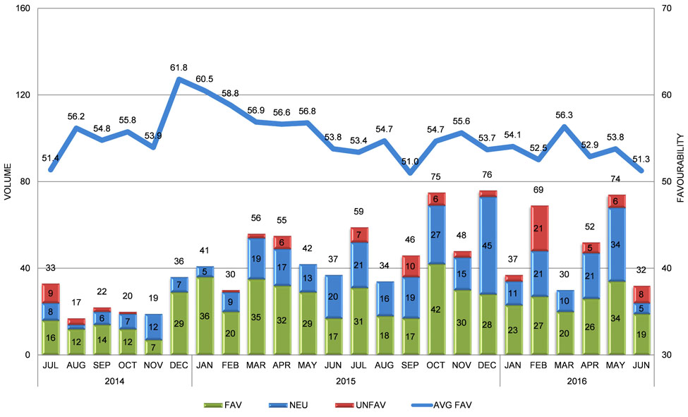

Stakeholders
Chart 2 Stakeholders: overall
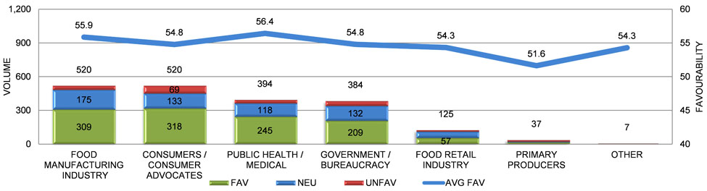
Chart 3 Stakeholders: press
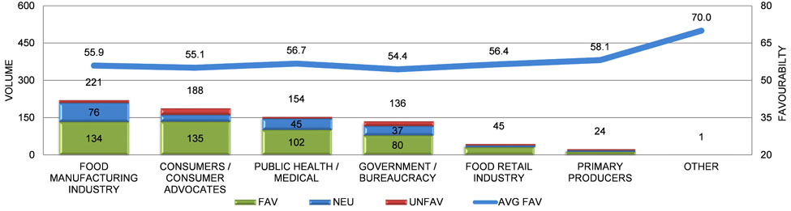

Chart 4 Stakeholders: radio
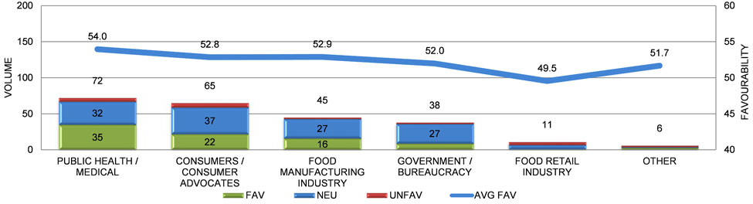
Chart 5 Stakeholders: television
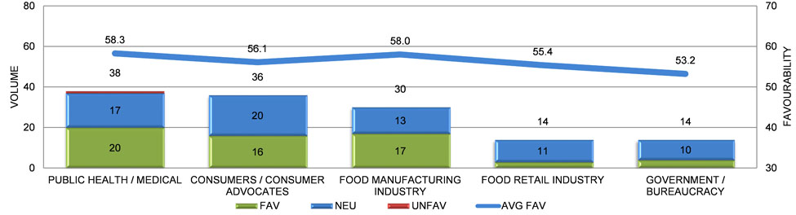

Chart 6 Stakeholders: internet
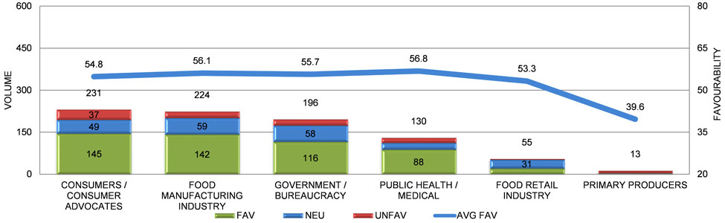

Leading Messages by Stakeholders

Overall
Chart 7 Favourable messages by stakeholders
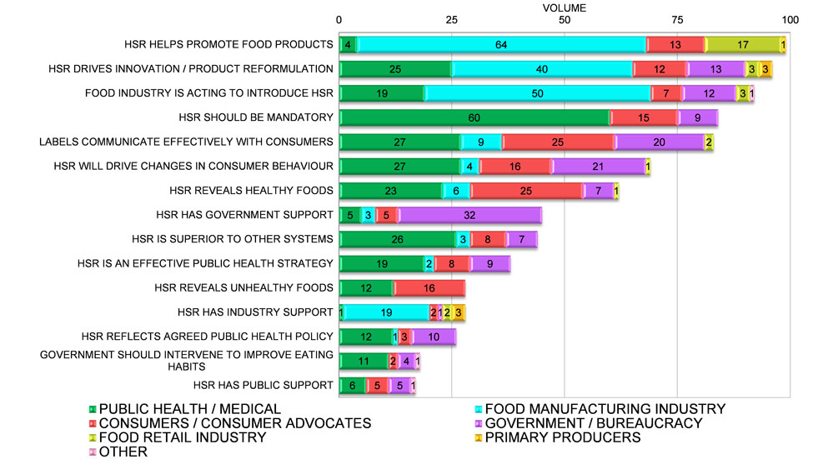

Chart 8 Unfavourable messages by stakeholders
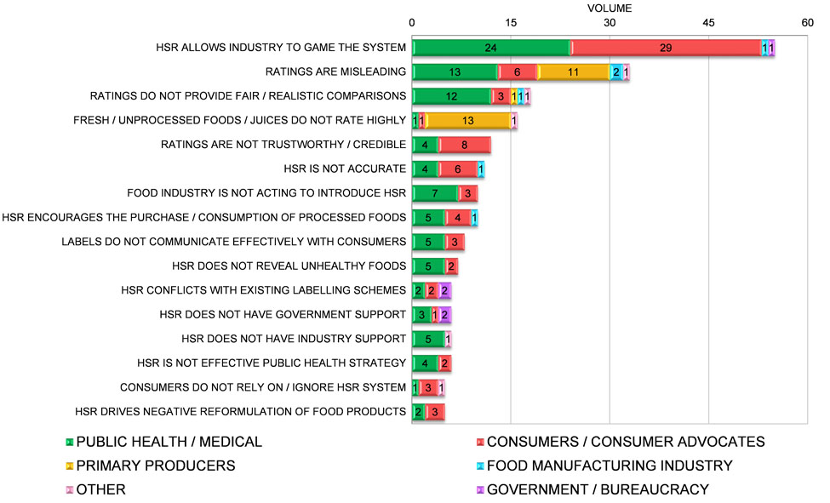

Public Health/Medical
Chart 9 Public health/medical messages in each time period
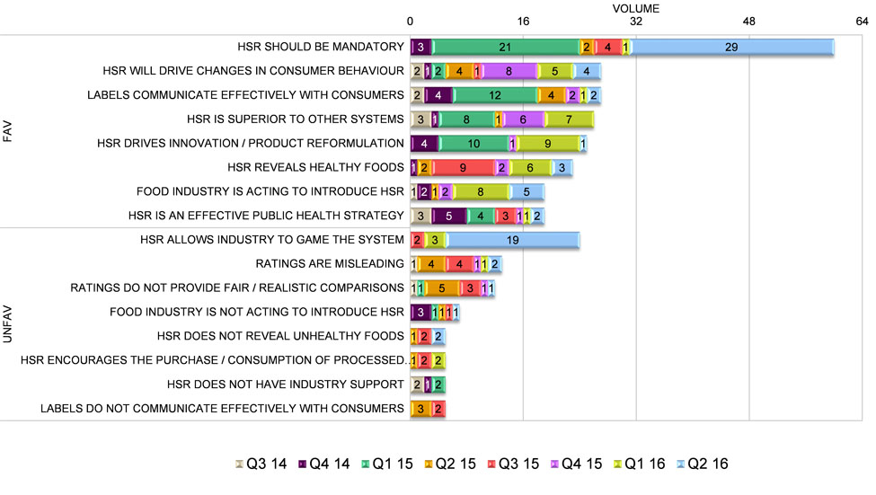

Consumers/Consumer Advocates
Chart 10 Consumers/consumer advocates messages in each time period
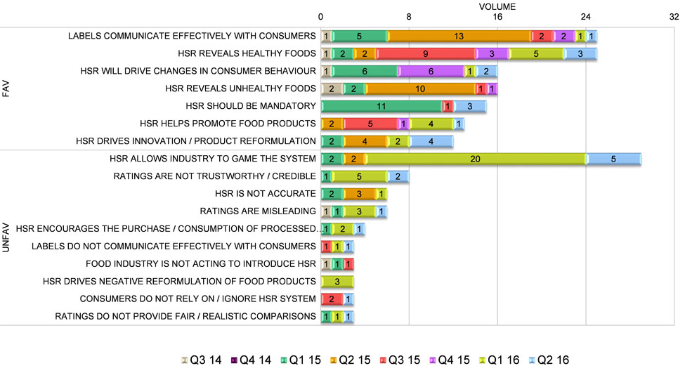

Food Manufacturing Industry
Chart 11 Food manufacturing industry messages in each time period
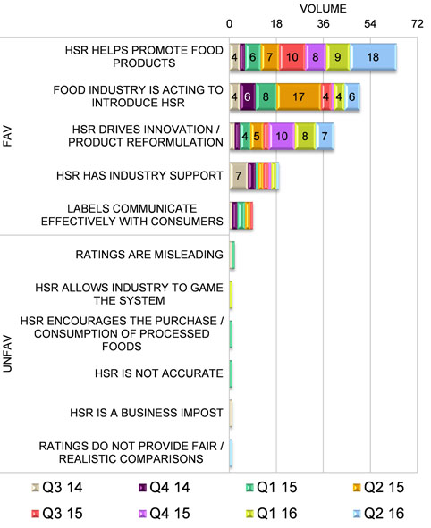

Government/Bureaucracy
Chart 12 Government/bureaucracy messages in each time period
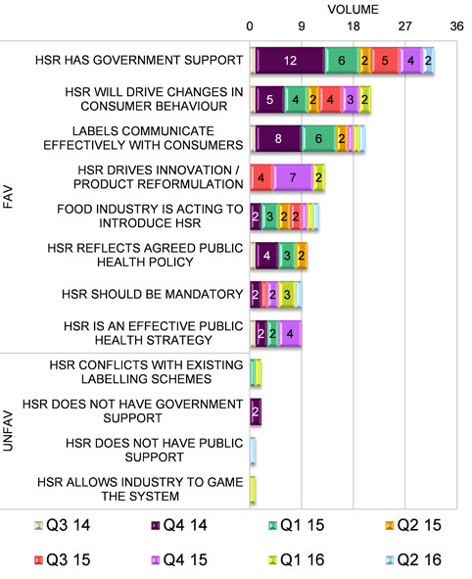

Food Retail Industry
Chart 13 Food retail industry messages in each time period
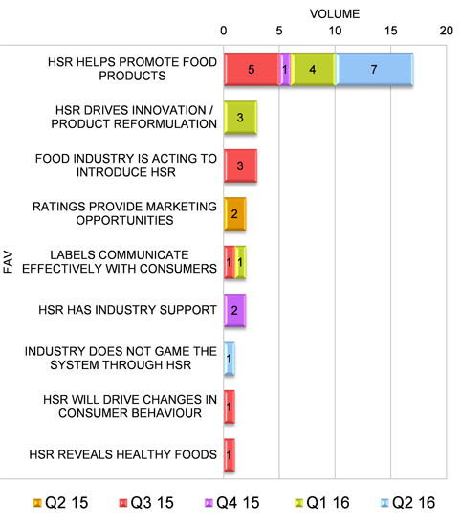

Primary Producers
Chart 14 Primary producers messages in each time period
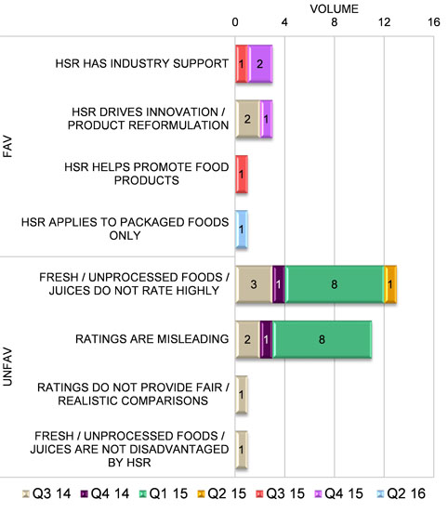

Other
Chart 15 Other messages in each time period
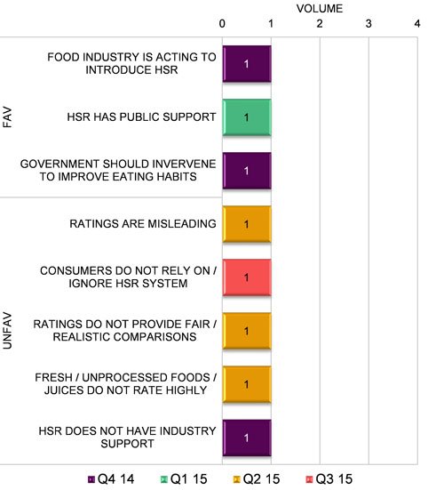

Leading Spokespeople
Chart 16 Leading spokespeople: overall
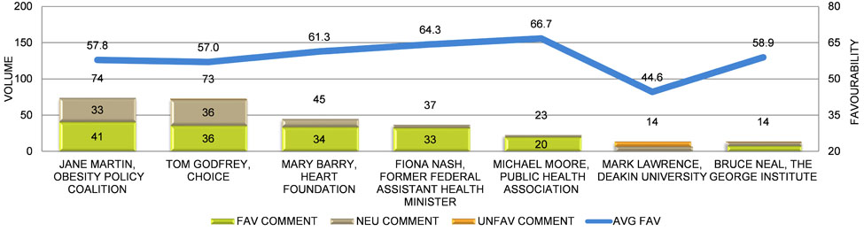

Quarterly Breakdown

Quarter 3 2014

Chart 17 Messages by stakeholders: Quarter 3 2014
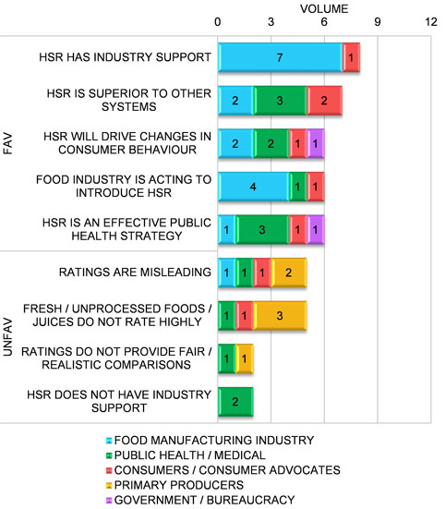
Table 2 Leading spokespeople: Quarter 3 2014
This table shows the most frequently cited spokespeople in Quarter 3 2014, the volume of reports in which they were cited, and the average favourability of this coverage.
Spokespeople | Vol | Avg Fav
Andrew White, Ausveg | 8 | 31.9
Gary Dawson, Food & Grocery Council | 7 | 60.7
Lisa Yates, Nuts for Life | 3 | 63.3
Trevor Lauman, Monster Health Food | 3 | 68.3
Jane Martin, Obesity Policy Coalition | 3 | 61.7

Chart 18 Stakeholders: Quarter 3 2014
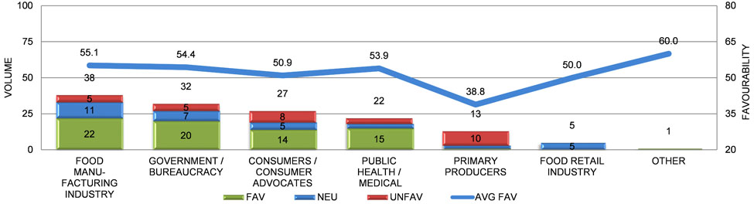

Quarter 4 2014

Chart 19 Messages by stakeholders: Quarter 4 2014
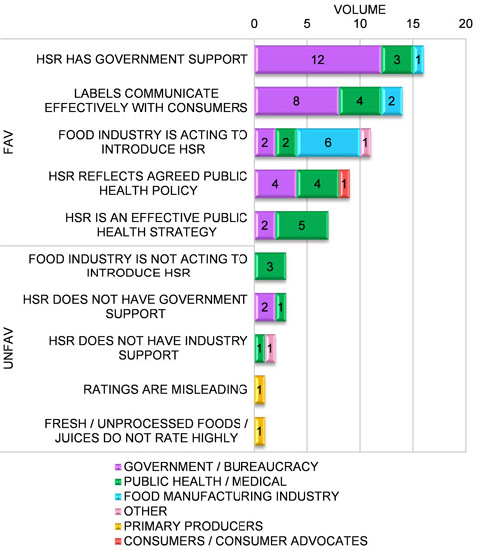
Table 3 Leading spokespeople: Quarter 4 2014
This table shows the most frequently cited spokespeople in Quarter 4 2014, the volume of reports in which they were cited, and the average favourability of this coverage.
Spokespeople | Vol | Avg Fav
Fiona Nash, Former Federal Assistant Health Minister | 16 | 65.6
Mary Barry, Heart Foundation | 14 | 66.1
Michael Moore, Public Health Association | 10 | 71.0
Bruce Neal, The George Institute | 3 | 65.0
Jane Martin, Obesity Policy Coalition | 3 | 70.0

Chart 20 Stakeholders: Quarter 4 2014
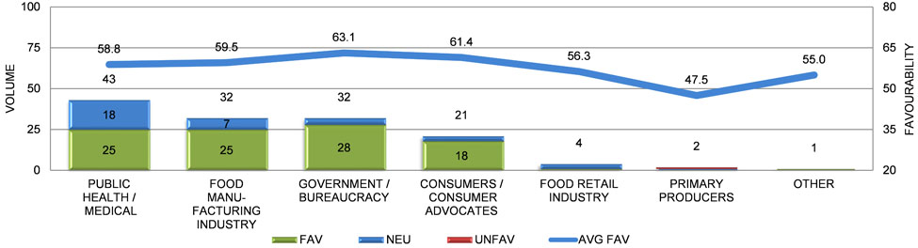

Quarter 1 2015

Chart 21 Messages by stakeholders: Quarter 1 2015
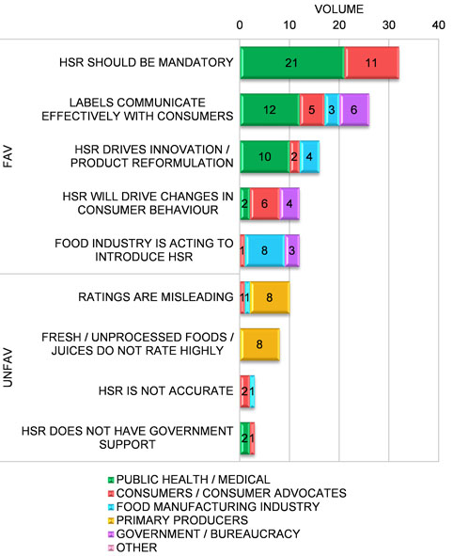
Table 4 Leading spokespeople: Quarter 1 2015
This table shows the most frequently cited spokespeople in Quarter 1 2015, the volume of reports in which they were cited, and the average favourability of this coverage.
Spokespeople | Vol | Avg Fav
Jane Martin, Obesity Policy Coalition | 14 | 62.9
Kara Landau, Dietician | 10 | 64.0
Tom Godfrey, CHOICE | 10 | 58.5
Rob McGavin, Cobram Estate & Boundary Bend | 9 | 67.8
Catherine Saxelby, Nutritionist & Food Commentator | 9 | 67.8

Chart 22 Stakeholders: Quarter 1 2015
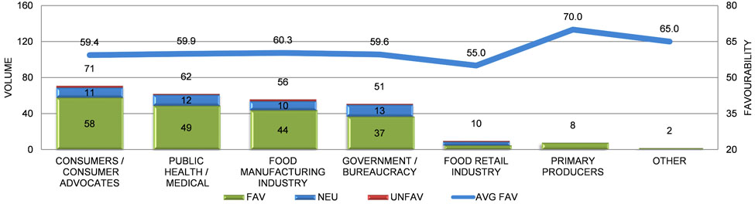

Quarter 2 2015

Chart 23 Messages by stakeholders: Quarter 2 2015
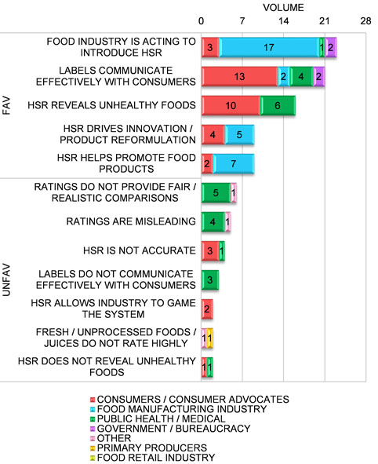
Table 5 Leading spokespeople: Quarter 2 2015
This table shows the most frequently cited spokespeople in Quarter 2 2015, the volume of reports in which they were cited, and the average favourability of this coverage.
Spokespeople | Vol | Avg Fav
Tom Godfrey, CHOICE | 24 | 62.5
Michelle Celander, Kellogg’s Dietician | 11 | 69.5
Jane Martin, Obesity Policy Coalition | 7 | 67.1
Joanna McMillan, Nutritionist | 4 | 60.0
Steph Wearne, Nutritionist | 4 | 46.3
Fiona Nash, Former Federal Assistant Health Minister | 4 | 65.0
Bruce Neal, The George Institute | 4 | 48.8

Chart 24 Stakeholders: Quarter 2 2015
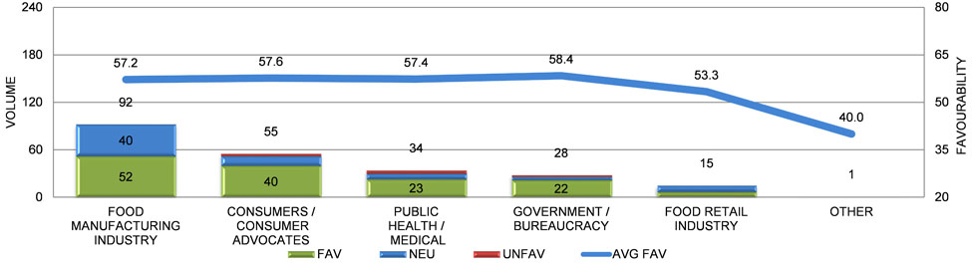

Quarter 3 2015

Chart 25 Messages by stakeholders: Quarter 3 2015
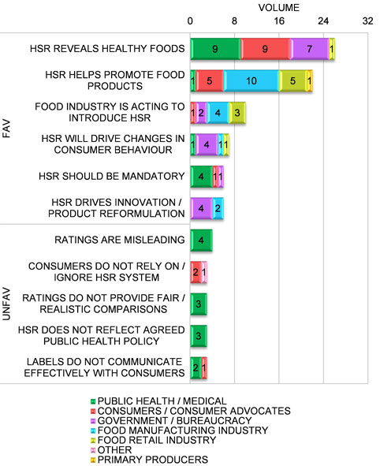
Table 6 Leading spokespeople: Quarter 3 2015
This table shows the most frequently cited spokespeople in Quarter 3 2015, the volume of reports in which they were cited, and the average favourability of this coverage.
Spokespeople | Vol | Avg Fav
Mark Lawrence, Deakin University | 6 | 50.8
Megan Doyle, Canstar Blue | 5 | 42.0
Tom Godfrey, CHOICE | 5 | 53.0
Fiona Nash, Former Federal Assistant Health Minister | 4 | 70.0

Chart 26 Stakeholders: Quarter 3 2015
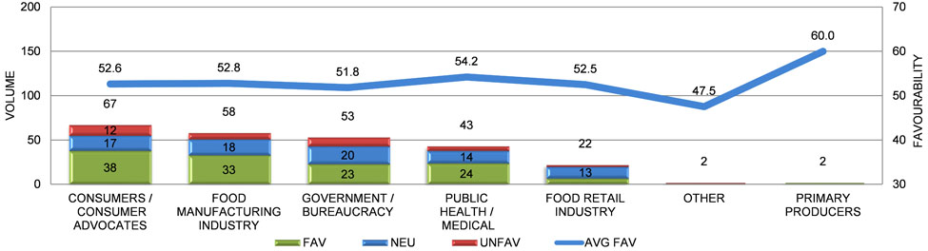

Quarter 4 2015

Chart 27 Messages by stakeholders: Quarter 4 2015
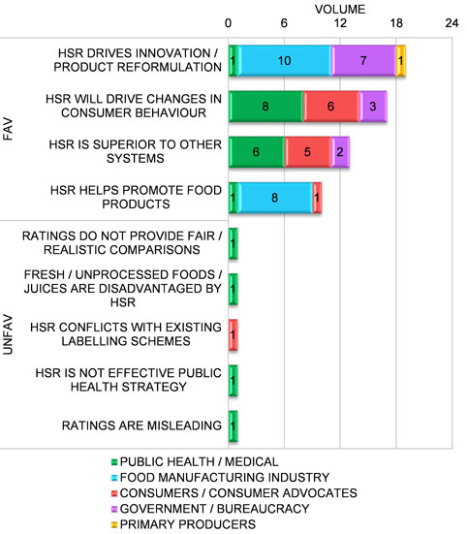
Table 7 Leading spokespeople: Quarter 4 2015
This table shows the most frequently cited spokespeople in Quarter 4 2015, the volume of reports in which they were cited, and the average favourability of this coverage.
Spokespeople | Vol | Avg Fav
Mary Barry, Heart Foundation | 15 | 55.0
Susan Kevork, Nestle Group Nutritionist | 13 | 51.9
Kristina Petersen, The George Institute | 11 | 50.0
Tom Godfrey, CHOICE | 10 | 60.5
Unnamed Source, Vox Pop | 9 | 50.0

Chart 28 Stakeholders: Quarter 4 2015
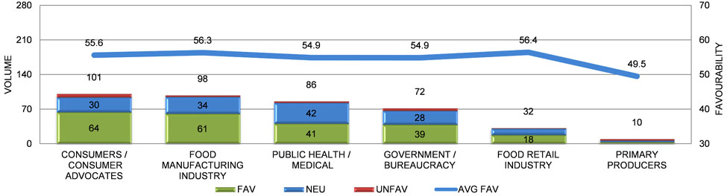

Quarter 1 2016

Chart 29 Messages by stakeholders: Quarter 1 2016
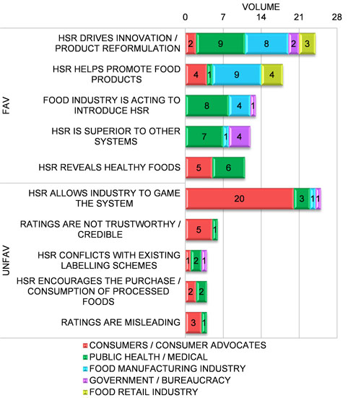
Table 8 Leading spokespeople: Quarter 1 2016
This table shows the most frequently cited spokespeople in Quarter 1 2016, the volume of reports in which they were cited, and the average favourability of this coverage.
Spokespeople | Vol | Avg Fav
Tom Godfrey, CHOICE | 22 | 49.1
Unnamed Source, Kellogg's | 11 | 47.7
Michael Moore, Public Health Association | 10 | 65.5
Kate Freeman, Nutritionist | 8 | 68.1
Mark Lawrence, Deakin University | 6 | 39.2

Chart 30 Stakeholders: Quarter 1 2016
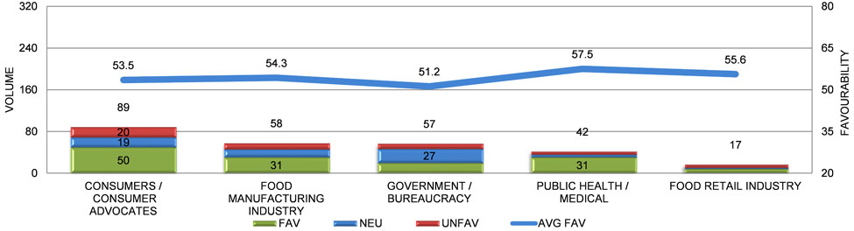

Quarter 2 2016

Chart 31 Messages by stakeholders: Quarter 2 2016
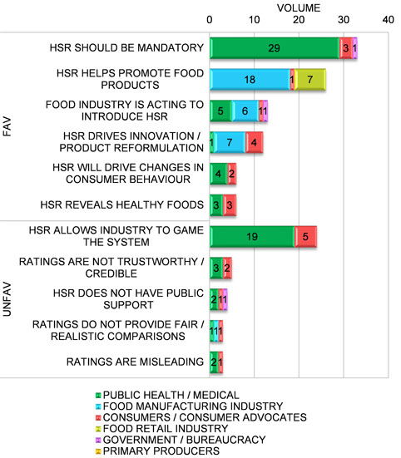
Table 9 Leading spokespeople: Quarter 2 2016
This table shows the most frequently cited spokespeople in Quarter 2 2016, the volume of reports in which they were cited, and the average favourability of this coverage.
Spokespeople | Vol | Avg Fav
Jane Martin, Obesity Policy Coalition | 41 | 53.9
Alison Ginn, Cancer Council Dietician | 8 | 55.6
Food Retail Industry Spokesperson | 8 | 57.5
Claire Deeks, Auckland Food Blogger | 7 | 32.1
Rosemary Stanton, HSR Technical Committee | 5 | 35.0
Fiona Nash, Former Federal Assistant Health Minister | 5 | 54.0
Unnamed Source, Kellogg's | 5 | 46.0

Chart 32 Stakeholders: Quarter 2 2016
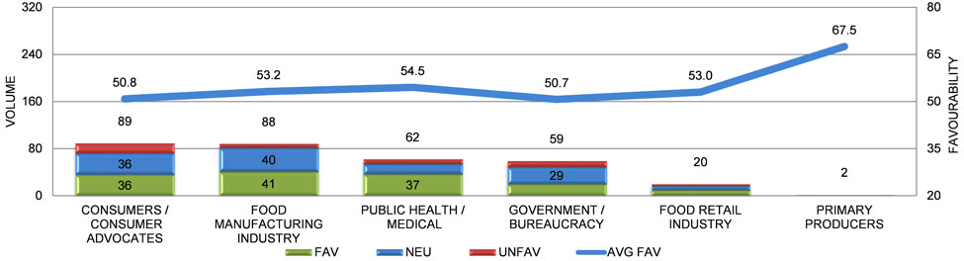

Leading Media

Chart 33 Leading media: press
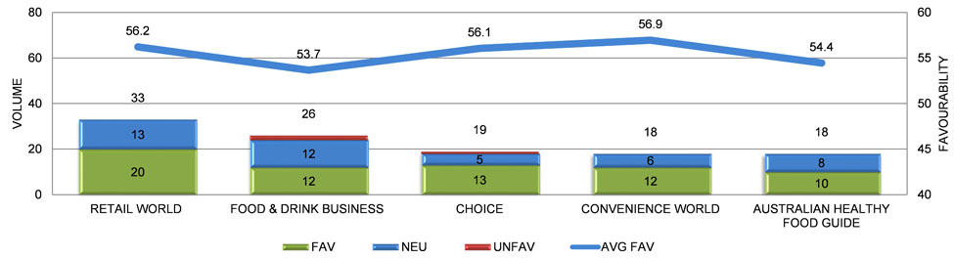
Chart 34 Leading media: radio
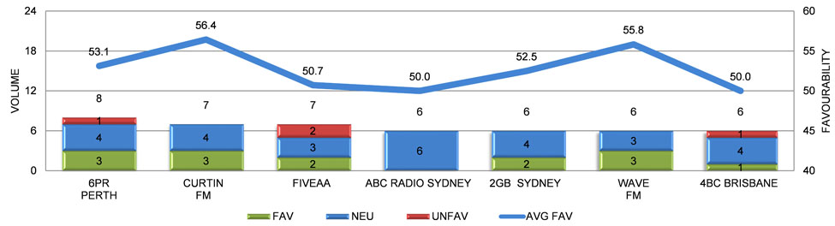

Chart 35 Leading media: television
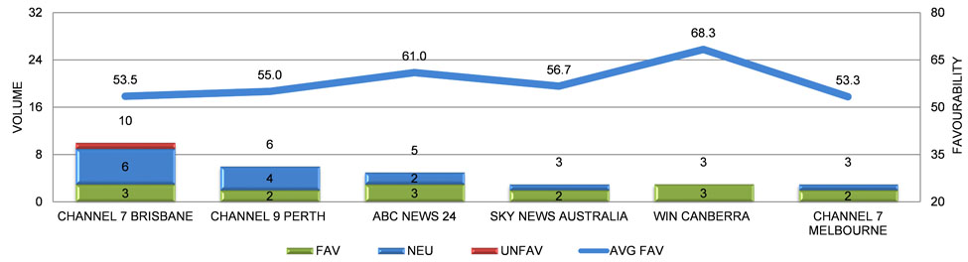
Chart 36 Leading media: internet
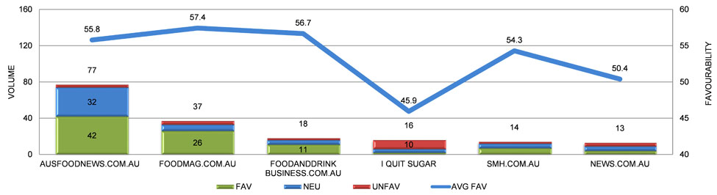

Leading Bylines/Comperes
Chart 37 Leading bylines: press
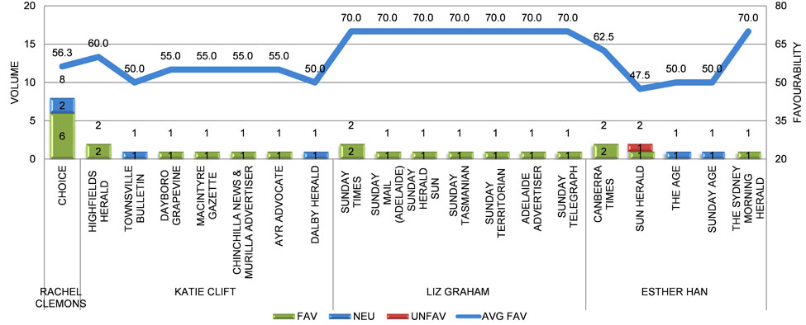

The following tables show the leading comperes and bylines in radio, television and internet coverage; a breakdown of their reports by favourability and outlet; and the average favourability of this coverage.
Table 10 Leading comperes: radio
Compere Name | Media Name | Fav | Neu | Unf | Vol | Avg Fav
Loretta Ryan |  | 2 | 0 | 0 | 2 | 62.5
 | ABC Southern Queensland | 1 | 0 | 0 | 1 | 60.0
 | ABC Sunshine & Cooloola Coasts | 1 | 0 | 0 | 1 | 65.0
Annie Gaffney |  | 2 | 0 | 0 | 2 | 65.0
 | ABC Sunshine & Cooloola Coasts | 2 | 0 | 0 | 2 | 65.0
Adam Shirley |  | 1 | 1 | 0 | 2 | 55.0
 | ABC Radio Canberra | 1 | 1 | 0 | 2 | 55.0
Gary Adshead |  | 1 | 1 | 0 | 2 | 60.0
 | 6PR Perth | 1 | 1 | 0 | 2 | 60.0
Leon Byner |  | 1 | 0 | 1 | 2 | 52.5
 | FIVEaa Adelaide | 1 | 0 | 1 | 2 | 52.5
Mark Colvin |  | 2 | 0 | 0 | 2 | 60.0
 | 666 ABC Canberra | 1 | 0 | 0 | 1 | 60.0
 | ABC Radio National | 1 | 0 | 0 | 1 | 60.0
Chris Smith |  | 1 | 1 | 0 | 2 | 55.0
 | 2GB Sydney | 1 | 1 | 0 | 2 | 55.0
Steve Austin |  | 1 | 1 | 0 | 2 | 55.0
 | ABC Radio Brisbane | 0 | 1 | 0 | 1 | 50.0
 | 612 ABC Brisbane | 1 | 0 | 0 | 1 | 60.0
Table 11 Leading comperes: television
Compere Name | Media Name | Fav | Neu | Unf | Vol | Avg Fav
Paul Lobb |  | 1 | 4 | 0 | 5 | 54.0
 | NBN Newcastle | 1 | 1 | 0 | 2 | 60.0
 | NBN Central Coast | 0 | 1 | 0 | 1 | 50.0
 | NBN Coffs Harbour | 0 | 1 | 0 | 1 | 50.0
 | NBN Lismore | 0 | 1 | 0 | 1 | 50.0
Natasha Beyersdorf |  | 0 | 4 | 0 | 4 | 50.0
 | NBN Coffs Harbour | 0 | 1 | 0 | 1 | 50.0
 | NBN Central Coast | 0 | 1 | 0 | 1 | 50.0
 | NBN Newcastle | 0 | 1 | 0 | 1 | 50.0
 | NBN Lismore | 0 | 1 | 0 | 1 | 50.0
Edwina Seselja |  | 3 | 0 | 0 | 3 | 75.0
 | WIN Gippsland | 1 | 0 | 0 | 1 | 75.0
 | WIN Wagga Wagga | 1 | 0 | 0 | 1 | 75.0
 | WIN Canberra | 1 | 0 | 0 | 1 | 75.0
Geoff Philips |  | 1 | 1 | 0 | 2 | 55.0
 | WIN Orange | 0 | 1 | 0 | 1 | 50.0
 | WIN Canberra | 1 | 0 | 0 | 1 | 60.0
Paul Kennedy |  | 1 | 1 | 0 | 2 | 57.5
 | ABC News 24 | 1 | 1 | 0 | 2 | 57.5
Jo Palmer |  | 1 | 1 | 0 | 2 | 52.5
 | Southern Cross TV Hobart | 0 | 1 | 0 | 1 | 50.0
 | Southern Cross Northern Tasmania | 1 | 0 | 0 | 1 | 55.0
Jackie Quist |  | 0 | 2 | 0 | 2 | 50.0
 | Channel 7 Brisbane | 0 | 1 | 0 | 1 | 50.0
 | Channel 7 Melbourne | 0 | 1 | 0 | 1 | 50.0
John Barron |  | 0 | 2 | 0 | 2 | 50.0
 | ABC News 24 | 0 | 2 | 0 | 2 | 50.0
Jennifer Keyte |  | 0 | 2 | 0 | 2 | 50.0
 | Channel 7 Brisbane | 0 | 2 | 0 | 2 | 50.0
Peter Mitchell |  | 2 | 0 | 0 | 2 | 55.0
 | Channel 7 Melbourne | 2 | 0 | 0 | 2 | 55.0
Tim McMillan |  | 1 | 1 | 0 | 2 | 60.0
 | Channel 9 Perth | 1 | 1 | 0 | 2 | 60.0

Table 12 Leading bylines: internet
Byline Name | Media Name | Fav | Neu | Unf | Vol | Avg Fav
Vanessa Brown |  | 5 | 3 | 0 | 8 | 55.0
 | news.com.au | 2 | 1 | 0 | 3 | 53.3
 | perthnow.com.au | 1 | 2 | 0 | 3 | 53.3
 | themercury.com.au | 1 | 0 | 0 | 1 | 65.0
 | dailytelegraph.com.au | 1 | 0 | 0 | 1 | 55.0
Esther Han |  | 5 | 0 | 0 | 5 | 63.0
 | smh.com.au | 2 | 0 | 0 | 2 | 70.0
 | canberratimes.com.au | 1 | 0 | 0 | 1 | 55.0
 | watoday.com.au | 1 | 0 | 0 | 1 | 65.0
 | farm weekly online | 1 | 0 | 0 | 1 | 55.0
Rachel O'Regan |  | 1 | 0 | 4 | 5 | 47.0
 | I Quit Sugar | 1 | 0 | 4 | 5 | 47.0
Andrea Hogan |  | 1 | 4 | 0 | 5 | 52.0
 | ausfoodnews.com.au | 1 | 4 | 0 | 5 | 52.0
Bevan Shields |  | 0 | 5 | 0 | 5 | 50.0
 | canberratimes.com.au | 0 | 1 | 0 | 1 | 50.0
 | brisbanetimes.com.au | 0 | 1 | 0 | 1 | 50.0
 | watoday.com.au | 0 | 1 | 0 | 1 | 50.0
 | theage.com.au | 0 | 1 | 0 | 1 | 50.0
 | smh.com.au | 0 | 1 | 0 | 1 | 50.0

Methodology

Best Practice Media Analysis

The media analysis methodology used by Isentia has a systematic approach to turn media content into meaningful data. This approach analyses media content both quantitatively and qualitatively.
Isentia uses the CARMA® media content analysis methodology, which is internationally recognised as one of the leading commercial systems available. CARMA® (Computer Aided Research and Media Analysis) uses advanced technology to quantify media content, and human intelligence to provide qualitative insight and analysis.
Isentia uses the CARMA® methodology to qualitatively analyse media coverage by taking into account multiple variables. These include the:
- Placement of media reports (front page or lead item in broadcast media and websites);
- Positioning of organisation discussion (headline, prominent mentions, passing mentions);
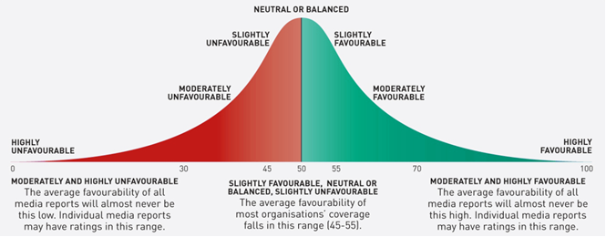
- Image (photos, illustrations, charts, cartoons, or the image content of video);
- Topics discussed in the media and their relative importance to the client organisation;
- Messages, both favourable and unfavourable, communicated in media reports;
- Sources quoted (both organisation representatives and other individuals who make relevant comments in the media); and
- Tone of content (extreme language, adjectives and adverbs, metaphors or similes and other figures of speech).
An aggregate score is calculated based on these multiple variables and presented on a 0–100 scale where 50 is neutral. This is an overall rating of the favourability of each media report towards the client organisation (and, if relevant, other organisations or competitors). This aggregate score is called the CARMA® Favourability Rating.
The average favourability is the aggregated rating of the media coverage analysed. This can identify the potential impact of media reporting, and can be used to identify trends and establish benchmarks for future data.
The criteria for analysis (such as topics and specific key messages) are set up uniquely for each individual client by a team of media analysis experts. These experts bring their industry knowledge to identify key issues and attitudes that appear in the media, answer clients’ key questions, and, where relevant, provide recommendations for further action.
The consistency of analysis is ensured in three key ways:
- Most of the variables analysed are objective criteria (such as media name, positioning, sources’ names);
- The somewhat more subjective topics and messages are identified by either exact phrasing or acceptable alternatives, provided to researchers before analysis begins; and
- Isentia uses multiple researchers on projects to minimise individual subjectivity.
The image below shows the scale of average favourability ratings on a bell curve.

