HEALTH STAR RATING SYSTEM:
CAMPAIGN EVALUATION REPORT
By
Garrett Parker
June 2017
Report prepared by:
Pollinate Research
Level 6, 8 Hill Street
Surry Hills, NSW 2010
www.pollinate.com.au

Table of Contents
KEY FINDINGS AND RESULTS - OVERVIEW 3
The Health Star Rating System 3
The Campaign 3
EXECUTIVE SUMMARY 4
Research background and methodology 4
HSR System evaluation 4
HSR campaign evaluation 5
RESEARCH BACKGROUND & OBJECTIVES 6
Background 6
Objectives 6
METHODOLOGY 7
Survey 7
Fieldwork dates 7
Sample 7
Reporting: 8
Research team: 8
AWARENESS AND UNDERSTANDING 9
Awareness of the Health Star Rating 9
Other influences on purchase choice 12
Understanding of the Health Star Rating 13
CAMPAIGN PERFORMANCE 16
Campaign recognition, branding and performance 16
Campaign elements 16
Pre-roll Video Ads 18
Out of Home (OOH) / Print advertisements 19
Online advertising 21
Campaign Message 21
Call to Action 23
Areas for improvement 23
Key Next Step 24
CAMPAIGN IMPACT ON KEY METRICS 25
Health Star Rating Awareness 25
Use of the Health Star Rating 25
Evaluation of the Health Star Rating - sentiment 28
Key Next Step 29
CONCLUSION 30

KEY FINDINGS AND RESULTS - OVERVIEW

The Health Star Rating System
Awareness of the Health Star Rating (HSR) has continued to increase
Awareness has reached 75%, a significant increase from 59% after the previous phase of campaign activity in June 2016.
The HSR is driving positive behaviour change
Of those aware of the HSR, 35% have bought a new product because it had a higher HSR than their usual product (20% among the total sample). This is significantly higher among those who are campaign recognisers at 60% (8% of the total sample).
…and driving lasting behaviour change
Of those who have bought a new product because it had a higher HSR than their usual product, 82% have continued to buy this new product with a higher HSR rating (17% of the total sample).
However, reported likelihood to use the HSR on a regular basis has decreased
Likelihood to ‘use HSR on a regular basis’ has declined, from 50% in June 2016, to 44% in April 2017.
… and the proportion of people wanting to see the HSR on ‘more’ or ‘all’ packaged foods has declined
A majority of grocery buyers (55%) state they would like the HSR on ‘more’ or ‘all’ packaged food products, however this has fallen (by 10%) since the previous wave of research.

The Campaign
1 in 5 Australians (18%) have seen the Government’s HSR campaign, a decrease from the previous campaign in June 2016 (25%)
Awareness levels are higher among 18-24-year-olds and lowest among 55-64-year-olds.
There has been a strong response to the campaign call to action
The majority (73%) of those who are campaign recognisers have carried out at least one of the behavioural objectives of the campaign: using the HSR in store and thinking more about nutrition when buying food at the supermarket are the strongest outcomes.

EXECUTIVE SUMMARY
The Australian Government Department of Health, in collaboration with the State and Territory Governments, food industry, public health and consumer groups, has developed the Health Star Rating (HSR) system. The HSR system is voluntary and is being rolled out across various packaged food products over a five-year period.

Research background and methodology
This survey was designed to track awareness and understanding of the HSR and evaluate the performance of Phase 4 of the HSR campaign, including campaign performance in terms of recognition, messaging and diagnostics; and what impact the campaign has had on key metrics relating to the success of the HSR.
Fieldwork was conducted in April 2017, with the survey including questions in common with the prior waves of HSR campaign evaluation survey (conducted in September 2014, 2015 and June 2016), and the HSR Consumer Use and Understanding survey (April 2015 and March 2016). Where relevant, results from the surveys have been compared.
The results are based on a nationally representative sample of 1052 main/joint grocery buyers (which entails a higher proportion of females to males), aged 18 years and older. The recruitment process ensured that the results would include representation from Culturally and Linguistically Diverse Australians and Aboriginal and Torres Strait Islander people.

HSR System evaluation
Awareness of the HSR has increased from 59% in June 2016 to 75% in April 2017. The strength of this result is underpinned by unprompted mention of 36% when respondents were asked to list any labelling on packaged foods to ‘help you decide how healthy it is’.
The results indicate that HSR continues to promote positive behaviour change among Australian grocery buyers, such as a third recalling buying a product they do not usually buy – rather than their habitual choice – because the new product had a higher HSR than their usual product.
The results also indicate that HSR continues to deliver lasting behaviour change. Among those grocery shoppers who said they have purchased a new product because it had a higher HSR than their habitual purchase, 82% (17% of the total population) have continued to buy this new product with a higher rating.
The HSR’s strength remains the clarity of the system, with high levels of agreement that the HSR, ‘makes it easier to identify the healthier option’ (67% agree) and that it is ‘easy to understand’ (70% agree).
However, a possible consequence of higher overall awareness is a higher proportion of people who are becoming aware of HSR who do not feel that it is relevant to them, such as those with a preference for using other guides to nutrition (e.g., nutrition information panel), those with low engagement with nutrition labelling when shopping, or those who are guided primarily by price. Encouragingly, levels of strong negativity in the survey results remain low.
There has been slight decrease in likelihood to ‘use the HSR on a regular basis’, with 44% of the sample agreeing they would be likely to do this, compared to 50% agreement in June 2016.
Similarly, there has been a decline in the desire to see the HSR on more products. When asked how many products people would like to see the HSR on, 55% stated they would like the HSR on more products than is currently the case. This is a decrease compared to all previous waves of research with 66% agreement in March 2016 and 62% in September 2015. It is worth noting that the desire to see HSR on less products did not increase significantly, but a higher proportion reported that they ’didn’t mind either way’. Three in ten respondents (30%) said they would like to see HSR on ‘all products’.
The level of understanding regarding how to use the HSR within the supermarket is strong at 68% of those surveyed agreeing the HSR makes it easier to compare products that are in the same section of the supermarket.

HSR campaign evaluation
The HSR campaign consisted of the following:
- five online pre-roll videos (played in full before YouTube videos, within catch-up TV etc.)
- five out of home (OOH) advertisements
- five print advertisements (in-store magazine only)
- a six-panel online ad
- a mobile-specific ad
- a taste.com.au Taste Health Hotline
The campaign achieved 18% recognition, performing below the June ‘16 campaign awareness levels at 25% recognition.
The campaign covers a broad target audience of Australian grocery shoppers aged over 18, and in line with this, recognition of the campaign was broadly similar across most population groups. Demographic breakdown of the results showed that 55-64-year-old, and regional respondents were less likely to be campaign recognisers (possibly reflecting less ‘opportunity to see’ in regional areas).
Most people accurately understand the objective of the advertising, which is to communicate that the HSR helps shoppers make healthier choices. However, there has been no decline in those who believe the campaign is advocating for purchasing of packaged food. Specifically, 16% agree that ads in this campaign communicate that you should buy packaged foods instead of unpackaged foods.
Overall, those who are campaign recognisers are more engaged with and positive toward the HSR than those who are not campaign recognisers across several measures, having a higher likelihood to use the HSR on a regular basis and higher awareness of the HSR system.

RESEARCH BACKGROUND & OBJECTIVES

Background
The HSR system was developed by the Australian Government Department of Health in collaboration with the State and Territory Governments, food industry, and public health and consumer groups. The purpose of the HSR is to provide clear, simple, interpretive nutrition information on the front of food packaging – with the potential to greatly assist in making healthier food purchases.
The HSR campaign launched in December 2014. The HSR is a voluntary system and is being rolled out across packaged food products over a five-year period.

Objectives
This research evaluates the 2017 HSR campaign activity as part of ongoing evaluation of the HSR campaign which contributes to the broader implementation of the HSR system.
This report addresses:
- Current awareness and understanding of the HSR system
- How the campaign has performed in terms of recognition, messaging and diagnostic metrics
- What impact the campaign has had on key metrics relating to the success of the HSR system.

METHODOLOGY
This wave of research was conducted in April 2017. The survey aligns with prior HSR campaign evaluation surveys (conducted in September 2014 (benchmark), September 2015 and June 2016), and shares common metrics with HSR Consumer Use and Understanding survey (April 2015 and March 2016).

Survey
The research was conducted using a 15-minute online survey, developed by Pollinate in conjunction with the Department of Health.

Fieldwork dates
Survey conducted: 6th of April to 12th April 2017.

Sample
The results are based on a nationally representative sample of 1052 main/joint grocery buyers (which skews towards females) aged 18 years and older across Australia with representation of Aboriginal and Torres Strait Islander people, Culturally and Linguistically Diverse (CALD) groups, and those of low socio-economic status (low SES). Where base sizes allow, results have been analysed by sub-groups.
Table 1 provides details of the sample.
Table 1 - Demographic information
Gender
Male | 35%
Female | 65%
Age
18 - 24 | 13%
25 - 34 | 28%
35 - 44 | 21%
45 - 54 | 19%
55- 64 | 14%
65 or over | 15%
Grocery buyer
Main grocery buyer | 72%
Joint grocery buyer | 28%
Language spoken
Only English | 77%
Mainly English | 17%
Mainly Language other than English (LOTE) | 6%
Location
Sydney metro | 20%
NSW (Not Sydney) | 13%
Melbourne metro | 18%
VIC (Not Melbourne) | 7%
Brisbane metro | 9%
QLD (Not Brisbane) | 11%
Adelaide metro | 6%
SA (Not Adelaide) | 2%
Perth metro | 7%
WA (Not Perth) | 2%
NT | 1%
TAS | 2%
Body Mass Index (BMI)
Not reported | 21%
Underweight | 3%
Normal | 35%
Overweight | 23%
Obese Class I | 11%
Obese Class II & III | 7%

Reporting:
Statistical significance is defined as a significant difference at a 95% confidence level throughout the report.

Research team:
Pollinate is an independent market research consultancy with expertise across a variety of government, not for profit and corporate clients.

AWARENESS AND UNDERSTANDING

Awareness of the Health Star Rating
Overall awareness of the HSR has significantly increased by 16% since June 2016, 75% of Australians now recognise the HSR.
Total spontaneous (unprompted) awareness of HSR is 36%. This is a significant increase from June 2016 (26%). Most of these mentions are ‘top of mind’ (first mention) by the respondent. Recognition of other labelling remained relatively stable across this period, the Daily Intake Guide Labelling was the only other label to increase from 53% in June 2016 to 67% in June 2016. This increase could have potentially been driven by awareness of the HSR, which features daily intake ‘thumbnail’ information similar to the Daily Intake Guide Labelling.
Details are in Figure 1below.
Figure 1 - Awareness of nutrition logos and labelling,
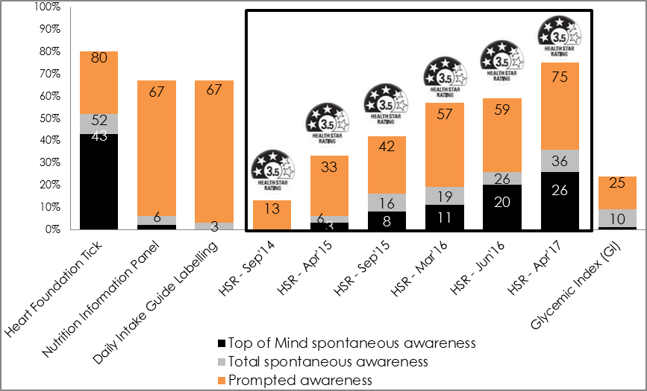
Base: All respondents (n=1052)
There have been largely consistent increases in prompted awareness from the benchmark measure across every age group. Awareness of the HSR remains highest among young people (86% for 18-24-year-old), and lowest among older people (66% for 65 and over), however this is a significant increase among the older age group, up from 39% in June 2016. The gaps in awareness between younger and older respondents have closed substantially since the last wave of research, as seen in Figure 2 below.
Figure 2 - Awareness of HSR by age
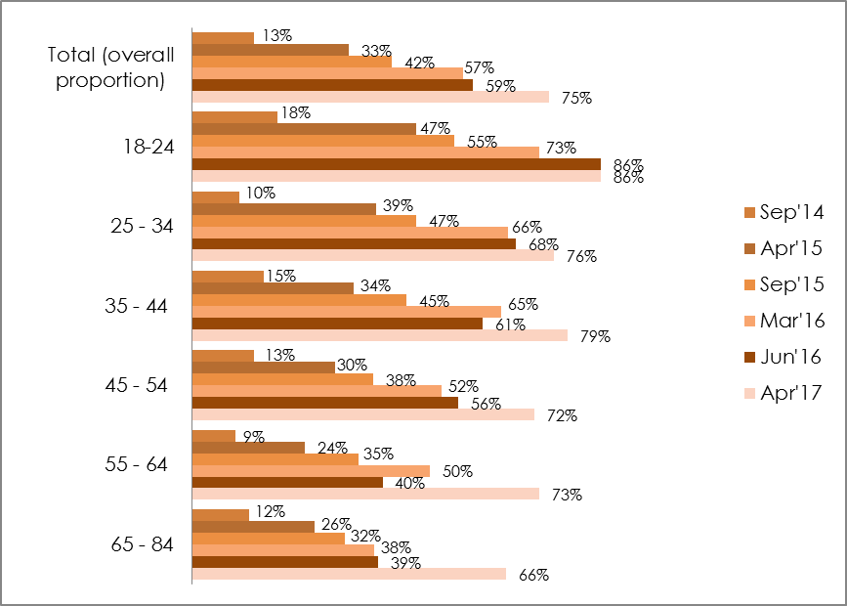
Base: All respondents Apr’17 {18-24 (n=128), 25 - 34 (n=172), 35 - 44 (n=208), 45 - 54 (n=197), 55 - 64 (n=168), 65 and over (n=179)}
Differences in prompted awareness can also be seen by Body Mass Index (BMI) groups. Those with a BMI within the healthy range have consistently had the higher awareness of HSR across all waves of research (currently at 81%) and those in the Obese Class II + III have lower awareness (77%), as shown in Figure 3.
Figure 3 – Prompted Awareness of HSR by Body Mass Index (BMI) groups
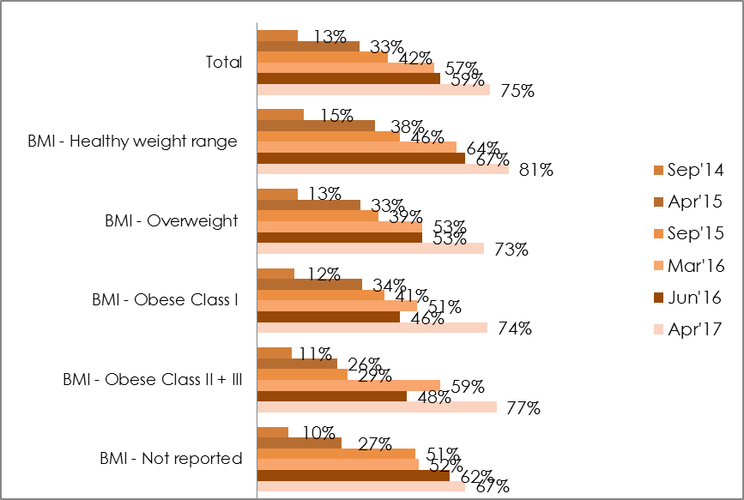
Base: All respondents {BMI: Healthy weight range (n=301), BMI - Overweight (n=180), BMI - Obese Class I (n=82), BMI - Obese Class II + III (n=53, BMI – Not reported (n=143}
As seen in previous waves of research, females have significantly higher awareness of HSR than males; 78% versus 70% among males.
Figure 4 – Prompted Awareness of HSR by Gender
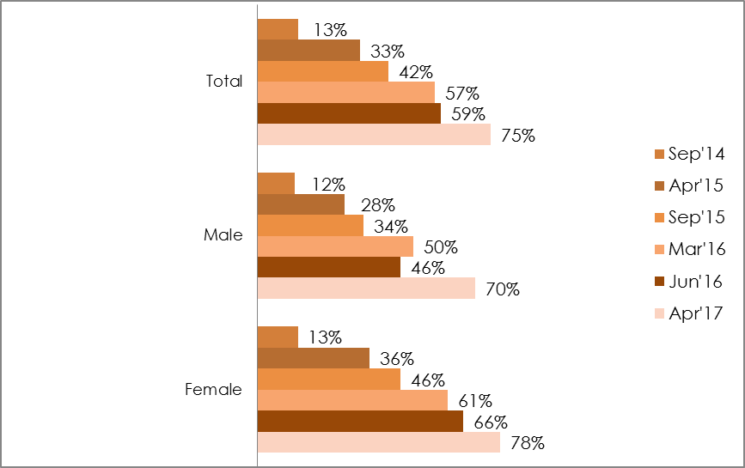
Base: All respondents {Gender: Male (approx. n=340 per wave), Female (approx. n=660 per wave)}
The proportion of those aware of HSR who recall buying a product with HSR on pack has fallen slightly in this wave of research, from 77% in June 2016 (representing 44% of the total sample) to 68% in April 2017, (58% of total sample).
Since September 2015, there has been a steady increase in those reporting that HSR is on products that they regularly buy. In this wave of research, 59% of respondents report that ‘some’ products that they regularly buy have the HSR, and 16% report that ‘most’ products they regularly buy display the rating. The increase over time is likely reflective of growing penetration of HSR, and indicates an increased opportunity to use HSR in a comparison context.
Figure 5 - How many products that you regularly buy have the Health Star Rating?
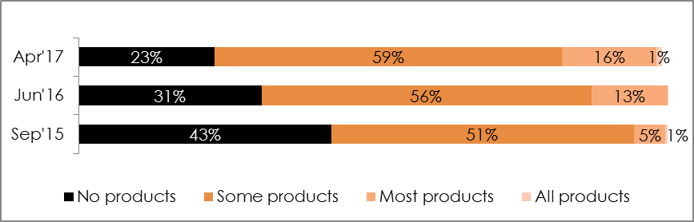
Base: All respondents Sep’15 (n=1000); Jun’16 (n=1007). Mar’17 (n=1052)
However, when asked about how many products they would like to see HSR on, just over half (54%) would like the HSR on more products, which is a decline from 65% in the previous wave. Respondents were less inclined to want to see it on ‘more’ products (24% vs 28% in June 2016) or ‘all’ products (30% vs 37% in June 2016). A third ‘don’t mind either way’ (37%), importantly negativity towards the HSR remains low at 8%. This result potentially reflects that the HSR is on more products than in the previous wave.
Figure 6 – How many products would you like to see the Health Star Rating on?
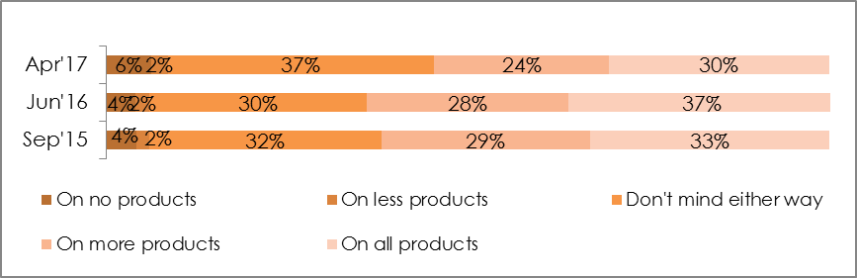Base: All respondents Sep’15 (n=1000); Jun’16 (n=1007); Apr’17 (n=1052).

Other influences on purchase choice
The research also aimed to quantify an aspect of shopping behaviour which will overlay consideration of HSR in choosing packaged foods, and should be noted. In this wave of research, around 3 in 10 respondents shop with specific dietary requirements/allergies in mind. For these shoppers, consideration of HSR in their purchase decision may be limited, or even invalidated, by these requirements.
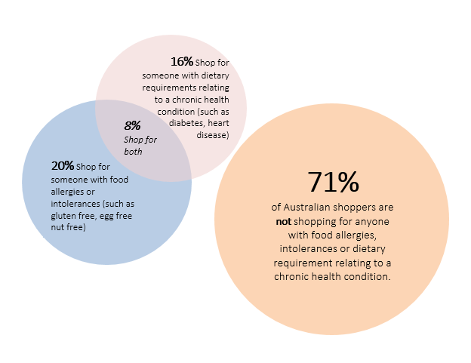

Understanding of the Health Star Rating
Figure 7 - Images used in the survey
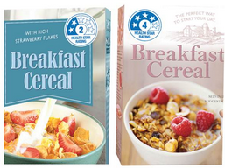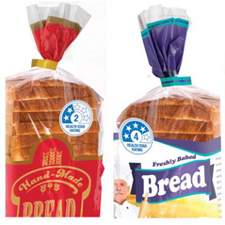
When shown images of HSR on mock products (as above in Figure 7) and asked, “how would you use the Health Star Rating?” just over half accurately describe correct usage of the HSR. The proportion of people who say they “don’t know” how to use HSR remains consistent with the past wave of research at around 1 in 3 (29% April17, 26% June 2016).
Table 3 – Coded responses to “How would you use the Health Star Rating?”
Responses | April  2017
NET accurate understanding of the HSR | 54%
More stars the better/Higher star rating the healthier/higher the better/Stars/star rating | 26%
Health rating/How healthy it is | 15%
Comparisons to other/similar products/brands | 10%
When deciding what to buy/which one to buy/ Whether I buy it or not | 6%
Help make healthier decisions/buy healthier options | 5%
Nutritional content/advice /Use as a guide/general advice | 5%
It’s good for you/better for you/more beneficial | 4%
Not interested/bothered/don’t/won’t use it | 6%
Ingredients/what’s in the products /Sugar content/Fat content/Salt content/Carbohydrates | 4%
Untrustworthy/unbelievable/ Misleading/unreliable/Food given too high/low rating | 2%
Easy to use/read/understand /Good | 2%
Price/cost | 2%
I’d look at it/consider it/use it | 2%
Other | 3%
None/Don't know | 29%
All respondents Apr’17 (n=1052)
Free text responses about how people say they use / would use the HSR included:
Statements indicating correct usage included:
‘If there were two types of a product I was interested in I would pick the option with the better health star rating, as long as it wasn't massively more expensive’
'I would think that the higher health star rating means the food is more healthy’
'It would help me pick the healthier option if I am pondering between products’
Other statements suggested correct usage in conjunction with other factors influencing purchase choice:
‘I would select the highest health star rating if there was a choice but checking also information regarding sugar and saturated fat content’
‘As a quick guide. I would still look at the nutrition panel to see how they compare’
‘Supposedly more stars are better but still seem to be some strange choices with lots of stars‘
‘If it is a product I buy, I would take note of the rating but it's not my top priority’
There was some evidence of misconceptions about HSR, although the nature of these varied:
'To see how much energy it would have’
‘You would have to check out the ingredients to find out why they are healthy’

CAMPAIGN PERFORMANCE

Campaign recognition, branding and performance

Campaign elements
This phase of the HSR campaign consisted of five online pre-roll video ads, five print ads (in-store magazines only), five OOH ads, one online ad, one mobile-specific ad, and the ‘Taste Health Hotline’ partnership with taste.com.au. It should be noted that media spend for this campaign was relatively modest when compared with other recent government and private media and marketing campaigns.
All respondents were shown the campaign ads in the survey, with this being the first time the majority (82%) had seen any of the campaign ads.
Snapshots of the suite of advertisements are shown below:
Figure 8 – Health Star Rating campaign advertising showing 5 online pre-roll (videos) still, 6 OOH/ print advertisements, an online ad, an in-store ad and 6 CALD ads.
Video ads (screenshot of each ad):
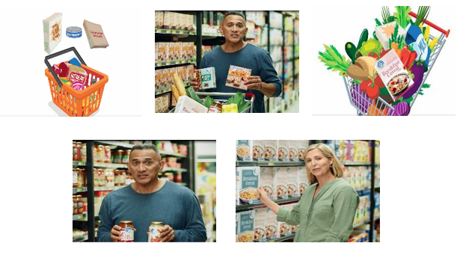
Print/OOH ads:
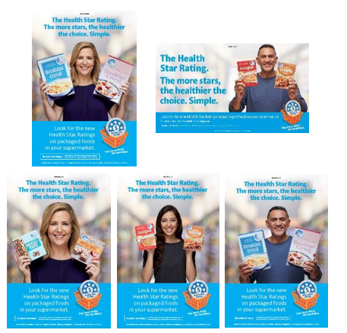
Online ad:
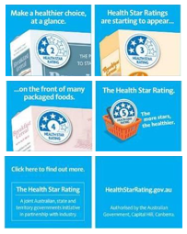
Mobile ad:
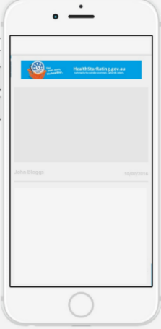
Taste.com.au Taste Health Hotline:
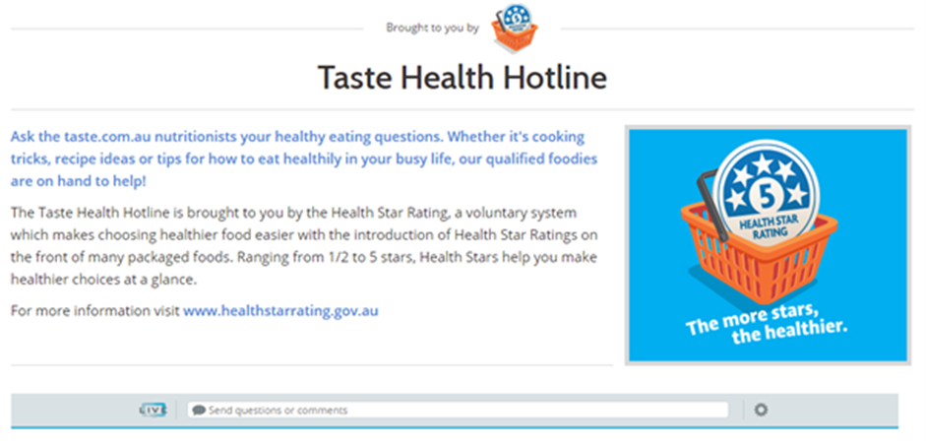Nearly 1 in 5 (18%) of those surveyed recalled seeing at least one element of the HSR campaign, which is a decline from 25% in the previous wave.
The few significant differences among respondents around campaign awareness were:
- Those aged 18-24 were more likely to recall seeing the campaign (36%) than those aged 55-64 (10%); and
- Metro respondents were more likely to recall seeing the campaign (21%) than regional respondents (14%). This may be partly due to increased ‘opportunity to see’ in metro areas.

Pre-roll Video Ads
Just over one in ten (11%) respondents stated that they had seen at least one of the HSR pre-roll video ads.
Overall the pre-roll video ads are regarded as easy to understand, informative and that they make their point in a straightforward way. For those who had seen the ad prior to the survey, the pre-roll video ads drive the impression of an informative campaign (54% vs 42% amongst total sample), as well as making people think about healthiness of food (47% vs 39%) and believability (38% vs 24%).
Although a smaller proportion agreed that the pre-roll ads were ‘attention grabbing’ (18%), encouragingly, agreement with negative statements ‘it is boring’ (6%) and ‘it is irritating’ (5%) remain very low.
Figure 9 - Which of these statements describe how you feel about the advertising? Pre-roll (video) Ad
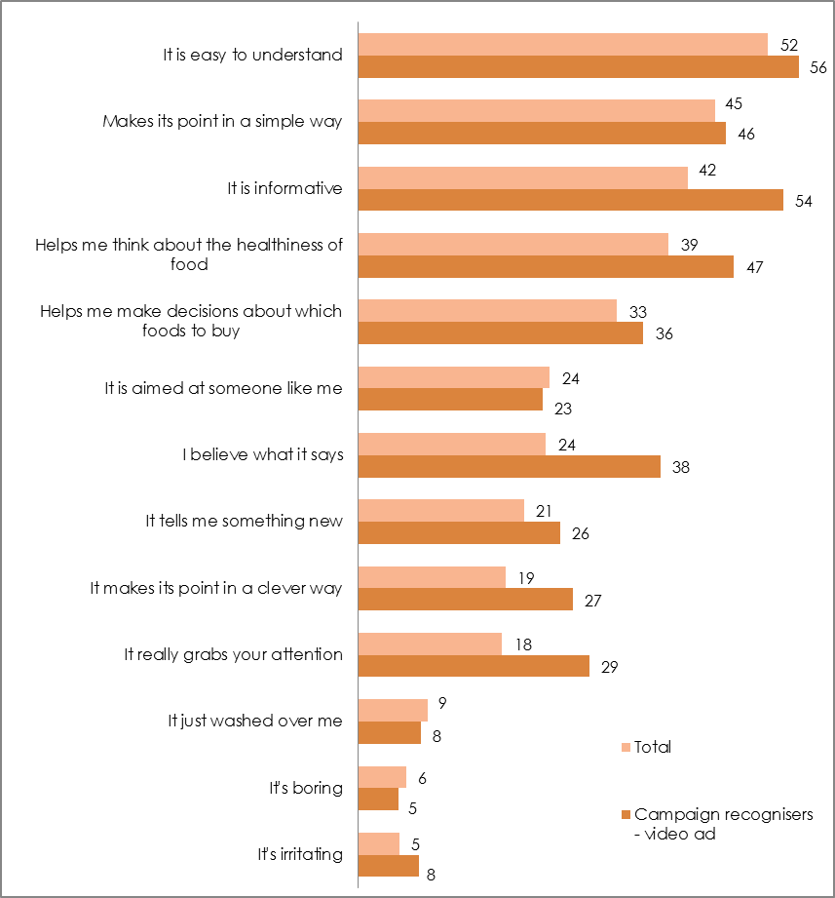
Base: All respondents (Total sample n=1052; Campaign recognisers – video ad n=155).

Out of Home (OOH) / Print advertisements
On par with the online video ads, 11% had seen at least one OOH/print ad. No single ad was recalled significantly more than others.
Figure 10 – Response to the question: “Have you seen any of these ads before?”
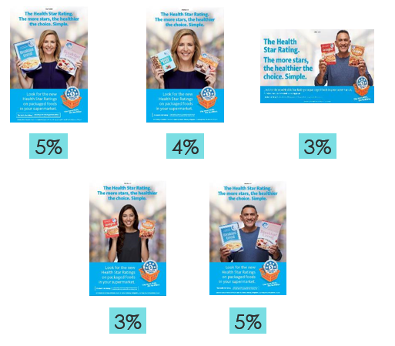
Base: All respondents (n=1052).
Despite no TV presence of the campaign, the main location reported for seeing these advertisements is ‘TV ad’ (27%). This may be explained by these advertisements looking similar to the video ads, and/or that people may have seen the HSR advertised on TV by product brands in commercial advertising. Second reported location to have seen the advertising is in catalogues (Woolworths, Coles, ALDI) (24%).
As seen with the pre-roll video ads, these advertisements are perceived as easy to understand, simple advertising, and informative. Those who saw at least one of the ads prior to exposure in the survey have significantly higher levels of agreement with believability (39% vs 24% among the total sample), ‘making its point in a clever way’ (33% vs 19%) and attention grabbing (35% vs 18%) when compared to the total sample.
Figure 11 - Which of these statements describe how you feel about the advertising? (Select all that apply) OOH/Print Advertisements
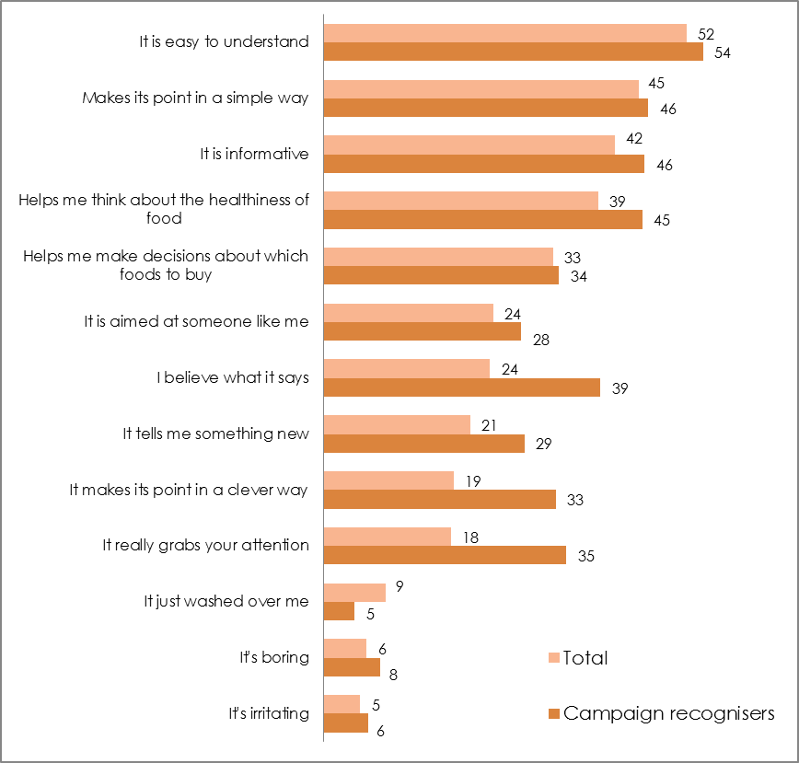
Base: All respondents (n=1052).

Online advertising
Few recall the online ads, with recognition of the ad at 5%. However, this result is not unexpected, as online advertising is geared more toward driving interest and research in a product/brand or system, rather than driving campaign recall.

Campaign Message
When asked what the campaign communicates consumers should do, 81% of respondents agreed the campaign communicates ‘you should compare the Health Star Rating on similar products’, and 79% agreed the campaign communicates ‘you should look out for the Health Star Rating if you are buying packaged foods’.
At a spontaneous level, the campaign message is on target; nearly three quarters (70%) replayed a correct understanding of the campaign message, with the strongest specific message being ‘will help you choose the healthier option/ make healthier choices’ (29%).
Table 5 details respondents’ understanding of the campaign messages.
Table 5 – Responses to the question, “What do you think these ads are trying to tell you? What is the message?” (Free text responses coded for analysis)
Responses | Total Sample | Campaign recognisers
NET Correct understanding | 70 | 67
Will help you choose healthier options/make healthier choices | 29 | 23
More stars the healthier/the higher stars the better | 16 | 16
Use the Health star rating/star rating | 13 | 10
Eat healthier | 9 | 12
Compare foods/helps compare products | 9 | 9
How healthy something is/healthy food | 6 | 7
Easy to decide/easy to use/makes things easier | 5 | 8
Buy healthier | 5 | 5
Use the rating system (no further information) | 4 | 2
Obesity issues/tackle weight issues | 3 | 1
Be healthy/have healthy lifestyle | 3 | 3
NET Other messages | 6 | 8
Inaccurate information/not all true/misleading | 1 | 2
Good/good system/good idea/helpful | 1 | 2
Nothing + Don’t know | 25 | 25
Base: All respondents (n=1052), Campaign recognisers (n=189).
Verbatim responses included:
‘The Health Star Rating is shown on the front of food packing so we can compare foods and make healthier choices.’
‘That the higher the number the better the product is for you.’
‘That there is now an easy way by which you can see how healthy or otherwise a product is and compare similar products.’
‘To make informed choices when purchasing products. The higher the rating, the healthier the choice.’
‘Be aware of these labels and trust them so that you can choose healthier products if you choose between two different brands of breads for example.’

Call to Action
The correlation of campaign awareness and respondents having performed one of the calls to action suggests that the campaign is driving HSR usage, encouraging healthier choices in the supermarket, and encouraging consideration of nutrition generally.
More than 7 in 10 respondents (73%) have performed at least one of the calls to action, such as ‘used the HSR in store’ (35%), ‘thought more about nutrition when buying food at the supermarket’ (30%) and ‘tried to eat healthier’ (28%). Only 27% of campaign recognisers stated they have done ‘none of these’. However, these results are not quite as strong as the June 2016 campaign, (77% reported performing at least one of the calls to action).
Responses to the calls to action are shown in Figure 12 below.
Figure 12 - After seeing this advertising, which of the below did you do? (Select all that apply)
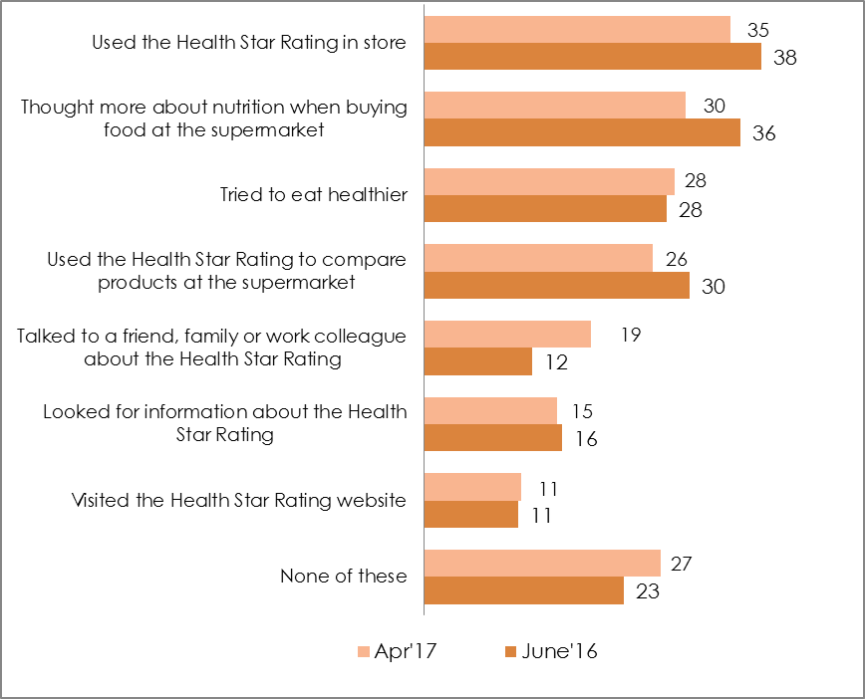
Base: Campaign recognisers April 17 (n=189) June 2016 (n=235).

Areas for improvement
There is a need to evolve the campaign messaging to now focus on how and when the HSR should be used: 35% agreed that the campaign suggested ‘you should only purchase food with a Health Star Rating’, 16% agreed the campaign communicates you should ‘buy packaged foods instead of unpackaged foods’.
In addition, there still exists some confusion regarding what the HSR can symbolise, as 41% agreed with the statement ‘food is healthy if it displays a HSR’ (perhaps suggesting the interpretation that a product has ‘earned’ the HSR for its nutritional value).

Key Next Step
Given the HSR has now reached a strong level of awareness (75% of grocery shoppers aware of the HSR), campaign messaging and communication no longer needs to focus on driving awareness as the primary criteria. Future marketing and communications (PR, social media, sponsored content) should focus on correct use of the HSR, and how the HSR can be used in everyday shopping.

CAMPAIGN IMPACT ON KEY METRICS

Health Star Rating Awareness
The campaign continues to drive awareness of the HSR. Prompted awareness increases among those who are campaign recognisers to 82% (compared to 75% across the total sample).
Although it must be noted that commercial advertising from foods carrying the HSR may be contributing, this research repeatedly finds significant differences in awareness of HSR among campaign recognisers compared to the total sample as seen in Figure 13.
Figure 13 – Comparison of awareness of HSR between those total sample and campaign recognisers
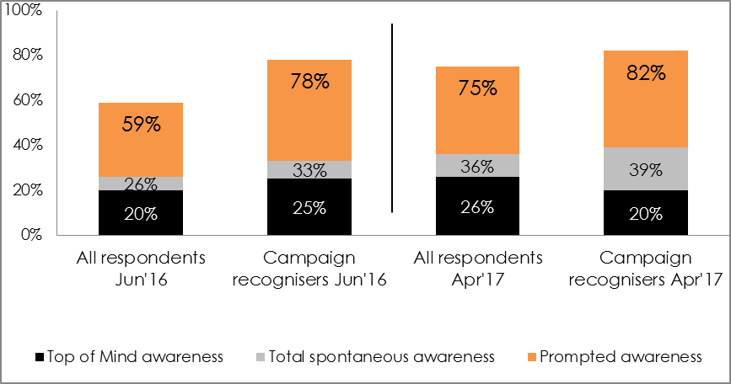
Base: All respondents (June’16 n=1007, April’17 n=1052).

Use of the Health Star Rating
Those who are campaign recognisers are significantly more likely to interact with the system. Noting that it is not possible to know from this research what level of prior use, attitudes or exposure to commercial advertising may have primed a response to the campaign, the results among those who are campaign recognisers are very positive.
Incremental increases are also evident since June 2016 regarding interaction with the system, with more people noticing the HSR on pack (58% vs 54%) and talking to others about the HSR (21% vs 19%).
These findings are detailed in Figure 14 below.
Figure 14 - Thinking about the Health Star Rating, have you:
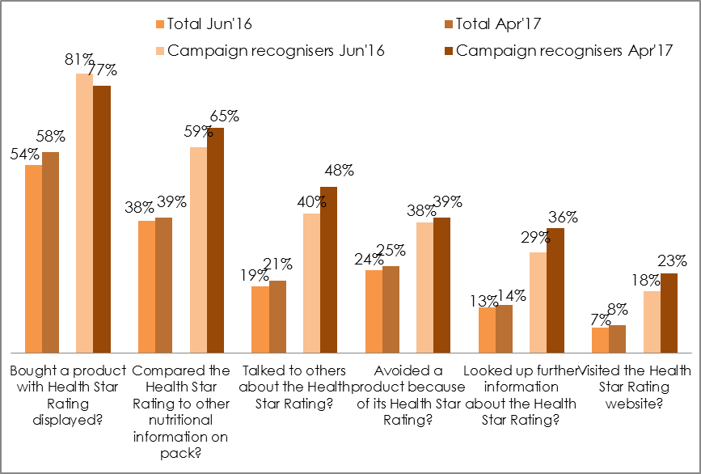
Base: Apr’17 (Total n=1052, Campaign recognisers n=189); Jun’16 (Total n=1007, Campaign recognisers n=235)
Among those who have bought a product with the HSR displayed (58% n=609), one third (35% n=215 or 20% of all respondents) stated they were influenced to buy the product due to the product having a higher HSR than their usual product. This impact is stronger among those who are campaign recognisers, with 60% (n=86, or 8% of all respondents) stating they bought a different product because it had a higher HSR rating. This indicates that the HSR is driving positive behaviour change when it comes to making healthy food choices, and exposure to the campaign may be reinforcing this behaviour change.
As described above, there is a clear relationship between exposure to the HSR campaign and holding a more positive perception of the HSR, however, this research cannot confirm causality or the direction of this relationship. While it is likely the HSR campaign has contributed to the positive perceptions, it is also possible that people with positive perceptions of the HSR have been more likely to notice the HSR campaign.
Figure 15 – Influence of Health Star Rating on purchase decision: “Did the Health Star Rating influence your choice to purchase this [new] product?”
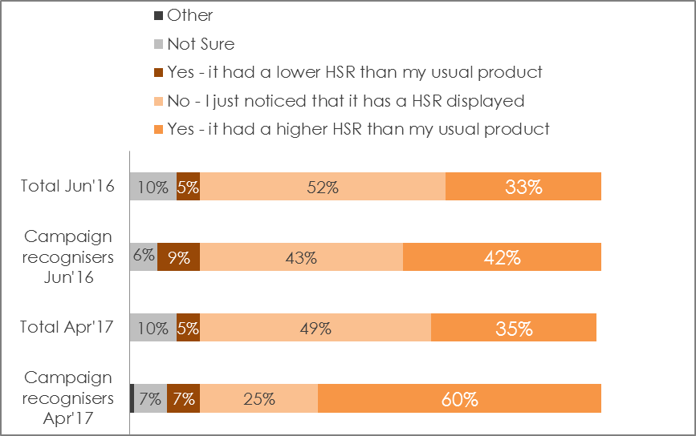
Base: Those who bought a product with HSR Apr’17 (n=609); Jun’16 (n=534)
Importantly, of those who stated they were influenced to choose a product due to the product having a higher HSR than their usual product (as above - 35%, n=215 or 20% of all respondents) the HSR continues to have a lasting impact, with 82% (17% at a total level) continuing to buy the product with the higher rating.
Reported likelihood to use the HSR has declined in April 2017, down 6% from June 2016 to 44%. Those who are campaign recognisers have also declined at a similar rate down 7% to 54%. However, overall there continues to be very low levels of negativity toward the HSR; people are generally either positive or ambivalent towards HSR. These results are detailed in Figure 16.
Figure 16 – Likelihood to use the HSR on a regular basis: “If the Health Star Rating was on most packaged foods in your supermarket, how likely would you be to use it on a regular basis?”
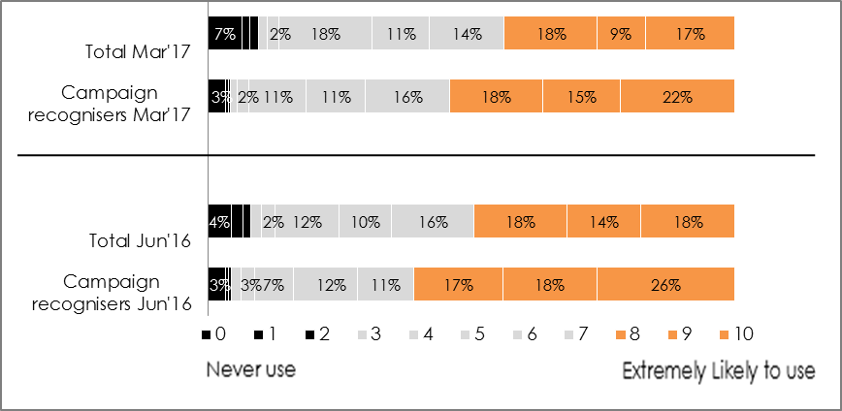
Base: Apr’17 (Total n=1052, Campaign recognisers n=189); Jun’16 (Total n=1007, Campaign recognisers n=235)

Evaluation of the Health Star Rating - sentiment
In line with the previous research, agreement with the statement that HSR is easy to understand is 70% (69% in June 2016). This is higher among those who are campaign recognisers at 80% (81% in June 2016).
Similarly, those who are campaign recognisers are significantly more likely to say the HSR ‘Is informative’, at 75% compared to 66% overall.
Making it easier to compare products (67%), and to identify and choose a healthier option (67%) all remain positive, and strengths of the system.
Trust has increased at a total level (48% in April 2017, compared to 44% in June 2016) and among campaign recognisers level (69% vs 60%). Perceptions of the HSR as independent have also increased at a total level (40% vs 36% in June 2016) and among campaign recognisers (56% vs 53%).
However, there is some evidence that as awareness of the system grows, so does the perception for some that the HSR is ‘just another thing on a pack that makes shopping more confusing’ which has increased from 19% in June 2016 to 26% in April 2017.
The perception of the HSR as ‘irritating’ has also shown a significant increase since the last wave of research among the total sample (April 2017 16% vs June 2016 12%) and campaign recognisers (24% vs 16%). This suggests that the campaign is displaying signs of ‘wear out’, perhaps in line with growth of HSR awareness and, subsequently, a larger proportion of those who are less engaged with health and nutrition.
These results are detailed in Table 9 below.
Table 9 – Perception of the HSR: agreement with statements
The Health Star Rating | Total | Campaign recognisers
 | Apr’17 (Jun’16)
Is easy to use | 70% (71%) | 76% (82%)
Is easy to understand | 70% (69%) | 80% (81%)
Is informative | 66% (65%) | 75% (75%)
It stands out on the pack | 61% (58%) | 75% (71%)
It tells me something new | 58% (59%) | 68% (68%)
It really grabs my attention | 45% (44%) | 59% (63%)
Is confusing | 18% (14%) | 23% (15%)
Using the Health Star Rating | Total | Campaign recognisers
Makes it easier for me to identify the healthier option | 67% (68%) | 80% (77%)
Makes it easier for me to compare products that are in the same section of the supermarket | 68% (70%) | 72% (81%)
Is easy to use | 70% (71%) | 76% (82%)
Helps me make decisions about which foods to buy | 60% (60%) | 71% (71%)
Makes choosing foods easier | 59% (61%) | 71% (73%)
Makes it easier for me to compare products that are in different sections of the supermarket | 48% (50%) | 65% (63%)
It's just another thing on a pack that makes shopping more confusing | 26% (19%) | 32% (18%)
Is irritating | 16% (12%) | 24% (16%)
Influence of the Health Star Rating | Total | Campaign recognisers
Helps me think about the healthiness of food | 67% (68%) | 74%(81%)
Makes me want to buy healthier products | 59%(58%) | 73%(67%)
It is aimed at someone like me | 55%(54%) | 67%(66%)
It is believable | 54%(52%) | 69%(66%)
Is a system I trust | 48%(44%) | 69%(60%)
Is independent | 40%(36%) | 55%(53%)
It is not relevant to me | 21%(19%) | 31%(22%)
Base: All respondents (n=1052), campaign recognisers (n=179).

Key Next Step
The HSR campaign has been an effective vehicle for driving awareness of the system from its infancy in 2014 to 2016, with 75% of grocery buyers now aware of HSR: next steps could shift communication strategy to clarify correct use of HSR, and work to resolve existing confusion and misconceptions. As more become aware of the system, there is a greater need to ensure it is clear how the system was designed to be used, to ensure a positive user experience.

CONCLUSION
Results in this report are from the HSR campaign evaluation survey conducted in April 2017. The survey included questions in common with earlier surveys. Where relevant, results from the surveys have been compared.
- Just under 1 in 5 (18%) Australians recall seeing the HSR campaign, a lower result than the June 2016 campaign (25%) with similar media placement. This is a potential indication of creative wear out.
- Respondents still report that the campaign advertisements are easy to understand, make their point in a clever way, and are informative: over the past three years this campaign has effectively help to drive awareness of the HSR.
- Overall impact of the campaign has been positive with significantly higher awareness, likelihood to use, and reported use of HSR, as well as a significantly higher likelihood to swap a usual product for a product with a higher HSR among campaign recognisers.
- The campaign has helped drive positive lasting behaviour change, with 60% of those who saw the campaign buying a product with a higher HSR than their usual product, and 82% of people continuing to buy this new product. Given the HSR is not on all items in supermarkets, this level of uptake strongly suggests the HSR is creating positive behaviour change among Australian grocery buyers.
- With awareness of HSR now at 75%, this campaign has been effective at helping to drive awareness of the HSR, and future communication does not need to have driving awareness as the primary objective.
- Given there is confusion around correct use of the system, and how a product receives its rating, the next stage of the campaign should shift the focus from awareness to understanding: communicating how to use the HSR system correctly, and potentially going further to explain how the stars are determined.
- Ideally, future campaigns should focus on addressing confusion around the system. This confusion is apparent in that: 41% agree the ads in the campaign communicate that ‘food is healthy if it displays a HSR’, 35% agree the ads communicate you should only purchase food with a Health Star Rating, and nearly half (48%) continue to agree with the statement that the HSR ‘makes it easier for me to compare products that are in different sections of the supermarket’.

Body Mass Index (BMI) is a person's weight in kilograms divided by the square of height in meters. BMI can be used as a screening tool for weight categories that may indicate higher risk of some health conditions, but is not diagnostic of the health of an individual. The proportion of respondents reporting BMI in the normal weight range is significantly higher than ABS BMI data.
“Top of mind” means that HSR was the ‘first mention’ of a respondent.” “Other spontaneous” means other unprompted mention. “Total spontaneous” mentions are top of mind and other spontaneous mentions combined
Respondents were asked: Apart from brand names, can you think of any nutrition logos or labelling that you have seen on food packaging to help you decide how healthy it is? If so, what was it that you saw? The following question was; which of the following nutrition logos or labelling on food packaging have you heard of? with a bank of images/logos to select from.
Body Mass Index is a person's weight in kilograms divided by the square of height in meters. BMI can be used as a screening tool for weight categories that may indicate higher risk of some health conditions, but is not diagnostic of the health of an individual. Reported BMI is significantly higher in the normal weight range compared to ABS BMI data.
Note: n=215 of the most recent sample have not reported their BMI. Awareness of the HSR is lowest (67%) among this group)
NET accurate understanding of the HSR is the combined percentage of the following responses, respondents could provide more than one answer: NET includes - More stars the better/Higher star rating the healthier/higher the better/Stars/star rating/Health rating/How healthy it is/ Comparisons to other/similar products/brands/ Help make healthier decisions/buy healthier options/It’s good for you/better for you/more beneficial/Nutritional content/advice/Use as a guide/general advice

