Health Star Rating system
Implementation Guide
Version 9

Legal Considerations and Disclaimer

Use of the Health Star Rating (HSR) system does not negate any legal obligations imposed by the Australia New Zealand Food Standards Code (the Code) or other relevant legislation at the Commonwealth or state or territory level in Australia, or in New Zealand. Users should ensure they are fully aware of the labelling requirements of the Code and other legislation and seek legal advice.
This Guide and its provisions are intended as a guide only, to provide industry best practice and consistency in utilising the HSR system and meeting the relevant requirements of the Code.
The information in this Guide should not be relied upon as legal advice or used as a substitute for legal advice. Businesses need to apply their own skills and knowledge in determining compliance with the labelling requirements of the Code. Businesses should consider obtaining independent legal advice or undertaking appropriate training in labelling requirements.
In using this Guide, users acknowledge that neither the Commonwealth of Australia or the Government of New Zealand, its employees or agents are responsible for any action taken on the basis of information provided, or any errors or omissions, and expressly disclaim all liability in this regard, including any liability for any loss, injury or damage as a result of product being labelled according to this Guide.

Contact Information

Any questions relating to the use of the HSR system, including interpretation of this Guide, should be directed to the HSR Unit.
HSR Unit
Food and Nutrition Policy Section
MDP 570, Department of Health, Disability and Ageing
GPO Box 9848
CANBERRA ACT 2601

Email: hsr@health.gov.au
Phone: 1800 099 658
www.healthstarrating.gov.au

Contents
Legal Considerations and Disclaimer 2
Contact Information 2
Glossary and Definition of Terms 6
Purpose of this Guide 7
Section 1. Overview 7
Section 2 Application of the Health Star Rating system 8
2.1 Foods intended to display the HSR graphic 8
2.2 Foods that may display the HSR graphic 8
2.3 Foods that must not display the HSR graphic 9
2.4 Imported Foods 9
2.5 Foods not sold in Australia and/or New Zealand 9
Section 3 The Health Star Rating Calculator 10
Section 4 Assessing the Health Star Rating of a Product 11
4.1 Automatic Health Star Ratings 11
4.2 Form of the food (as prepared or as sold) 12
4.3 Health Star Rating categories 13
4.4 Fruit, vegetable, nut and legume (FVNL) content 15
Section 5 On Pack presentation of the Health Star Rating system 17
5.1 HSR system graphic elements 17
5.2 Design principles 18
5.3 Health Star Rating graphic 19
5.4 Energy and Nutrient Icons 19
5.5 Nominated Reference Measure 22
5.6 Industry Agreed Standardised Serve Sizes 23
5.7 Multipacks 23
Section 6 Hierarchy of Health Star Rating system presentation 25
Section 7 Display of additional Health Star Rating information 27
Section 8 The Daily Intake Guide, Health Logos and certification schemes 27
Section 9 Digital and other off-pack use of the HSR system 27
Appendix 1: Calculator Guide 28
Appendix 2: Possible configurations of the Health Star Rating system graphic 38
Appendix 3: Calculating Percentage Daily Intake values for the energy Icon 39
Appendix 4: References to the Food Standards Code 40
Appendix 5: Document Changes 41

Glossary and Definition of Terms

Term | Definition
The Code | Australia New Zealand Food Standards Code
Dietary guidelines | Unless otherwise specified, references to the dietary guidelines refer to the Australian Dietary Guidelines and the New Zealand Eating and Activity Guidelines
FoPL | Front-of-Pack Labelling
Foods | Unless otherwise specified, the term ‘food’ is inclusive of beverages.
FVNL | Fruits, vegetables, nuts and/or legumes
General purpose foods | All foods - except Special Purpose Foods in Part 2.9 of the Code.  Note: General purpose foods are subject to the requirements for health claims set out in Standard 1.2.7, Schedule 4 and Schedule 5 of the Code.
HSR | Health Star Rating
HSR Advisory Committee (HSRAC) | A group of representatives from government, industry, public health and consumer sectors responsible for governance support to the continued implementation of the HSR system across Australia and New Zealand.  The Terms of Reference for the HSR Advisory Committee are available on the HSR website.
Intended product | Foods intended to display a HSR as defined at section 2.1 of this Guide.
NIP | Nutrition Information Panel referred to in Standard 1.2.8 of the Code.
NPSC | Nutrient Profiling Scoring Criterion, referred to in Standard 1.2.7 of the Code and detailed in Schedule 5 of the Code.
%DI | Percentage daily intake

Purpose of this Guide

This Guide is intended to provide guidance on the full and correct use of the Health Star Rating (HSR) system and has been designed primarily for use by those within the food industry.
It outlines overarching principles of the HSR system, steps required to determine a HSR score and assign a rating to a food or beverage, and the presentation of the HSR system graphic on food/beverage packages.

Section 1 Overview
The fundamental purpose of the HSR system is:
‘To provide convenient, relevant and readily understood nutrition information and/or guidance on food packs to assist consumers to make informed food purchases and healthier eating choices.’
The system is designed for use as a front-of-pack labelling scheme on foods for retail sale in Australia and/or New Zealand.
The HSR system is not designed to give information on the quantity of each product to be consumed in a healthy diet. This information is provided in the Australian Guide to Healthy Eating and the Eating and Activity Guidelines for New Zealand Adults. The HSR system is used by consumers to compare similar products which are displayed in similar parts of the shop, for example yoghurts should only be compared to other yoghurts, and not to different types of foods, like breads.
The HSR system complements the NIP by providing front-of-pack interpretive information on packaged foods. The HSR system is based on an algorithm that awards a rating based on the quantity of specific components in the food. These components can include energy, saturated fat, total sugars, sodium, protein, dietary fibre, and ‘fruit, vegetable, nut and legume (FVNL) content’, depending on certain criteria.
Use of the HSR system is voluntary; however, businesses that choose to adopt the HSR system are encouraged to do so consistently across their full product range, and within all (intended) product categories. Uptake of the HSR is monitored against targets set by Food Ministers (2023-2025). These targets and reports on progress can be found on the HSR website.
The HSR system artwork is trademarked and therefore use of the artwork requires compliance with this guidance. Copyright approval may be required for the use of the HSR graphic other than for food labelling purposes (for example reproduction in textbooks). Further information can be obtained from the HSR Unit (hsr@health.gov.au).
While there is some flexibility in relation to how the HSR is presented on the label, the final presentation should conform to the principles and details outlined in Sections 5 and 6 of this Guide.

Section 2 Application of the Health Star Rating system

The HSR system is designed for application on the physical front of most packaged food products presented for retail sale through supermarkets and other food retail outlets. It can also be used in digital formats (see Section 9 of this Guide).
Foods intended to display the HSR graphic, foods that may display the HSR graphic, and foods that must not display the HSR graphic are described below.
If in doubt about the application of the HSR system, businesses can seek guidance prior to label changes from the HSR Unit (see page 2 for contact details).

2.1 Foods intended to display the HSR graphic
The HSR graphic is intended to be displayed on packaged foods and beverages:
- required by the Code to have a NIP; and
- that can vary in nutrient composition, including:
  - multi-ingredient packaged foods for which the composition can be altered, and
  - some single ingredient foods such as flours, milks, edible oils and canned fruits and vegetables where the composition may vary between similar foods; and
- that are not prevented from using the HSR, in line with the criteria in Section 2.3 below.

2.2 Foods that may display the HSR graphic
While the HSR system is not intended to be used on some foods, the system may still be used if the manufacturer chooses to do so (other than for the foods described in section 2.3 of this Guide). For example:
- unpackaged foods
- foods not required to display a NIP
- products for which composition does not vary significantly across products (such as eggs, sugar and baking powder), even though they are required to display a NIP
- packaged fresh and minimally processed fruit and vegetables that have only been peeled, cut, surface treated, blanched or frozen (ie products eligible for an automatic 5 star rating); and
- packaged plain water.
Products not required to display a NIP
Some packaged foods are exempt from bearing a label and therefore a NIP (Standard 1.2.1—6 of the Code). These include foods such as those packaged in the presence of the purchaser (eg food in bulk bins or salads from deli counters) or those made and packaged on the same premise from which they are sold (eg in-store bakery products). Some other packaged foods are exempt from bearing a NIP (subsection 1.2.8-5(2) of the Code) such as some packaged fruits, vegetables, meat, poultry, pre-packaged rolls and sandwiches and foods in small packages (less than 100 cm²). While the HSR may be displayed in relation to such foods, there is no expectation they do so.
However, the HSR system is generally not appropriate for use on packaged products not required to display a NIP (Standard 1.2.8—5 of the Code). For example, products inherently low in nutritional value such as herbs, spices, vinegar, salt, pepper, tea, coffee, herbal infusions, gelatine and setting compounds.
Fruit and vegetables, and water
Fresh and minimally processed fruits and vegetables and water are both eligible to display a 5 star rating. This the result of policy decisions intended to encourage consumption of these foods, and in recognition that for water and some fruits/vegetables, if the HSR calculator was used the rating calculated may not align with recommendations in the dietary guidelines. While the display of an HSR on these products may assist consumers, for monitoring purposes these products are not considered ‘intended’ products.

2.3 Foods that must not display the HSR graphic
The HSR graphic must not be displayed on:
- foods regulated under certain Standards in Part 2.9 of the Code:
- infant formula products (Standard 2.9.1 of the Code)
- food for infants (Standard 2.9.2 of the Code)
- formulated supplementary foods for young children (Division 4 of Standard 2.9.3 of the Code) (including toddler milks and formulated supplementary foods for young children).
- formulated supplementary sports foods (Standard 2.9.4 of the Code)
- food for special medical purposes (Standard 2.9.5 of the Code)
- products containing more than 0.5% alcohol by volume
- beverages containing less than or equal to 0.5% alcohol by volume that resemble an alcoholic beverage (e.g. in look and/or taste) and are marketed as a non-alcoholic variant or brand extension of an alcoholic beverage. This includes, but is not limited to, beverages labelled and advertised as ‘alcohol-free’, ‘non-alcoholic’, ‘zero alcohol’, ‘de-alcoholised’ and ‘alcohol removed’.
- alcohol kits. This includes non-alcoholic drinks intended to be used to make up an alcoholic drink, for example cocktail mixes/kits and home brew beer or spirits.
- kava
In addition, the HSR graphic should not be displayed on foods that are:
- intended for further processing, packaging or labelling prior to retail sale
- delivered to a vulnerable person by a delivered meal organisation
- other than in a package, provided to a patient in a hospital or a medical institution.

2.4 Imported Foods
The intent of the HSR system is that it applies equally to domestically manufactured and imported foods. Importers of packaged foods into Australia and/or New Zealand are strongly encouraged to adopt the HSR system for intended foods.

2.5 Foods not sold in Australia and/or New Zealand
The display of HSRs in relation to products that are not intended to be marketed or sold in Australia and New Zealand is not encouraged. The HSR provides a tool for comparison between products (see Section 1), and as such, the display of an HSR in markets where the system is not widely adopted does not provide useful information to consumers.

Section 3 The Health Star Rating Calculator

Background
The HSR Calculator was developed for use by businesses to determine a rating for products.
The HSR Calculator was originally developed as an adaptation of the Nutrient Profiling Scoring Criterion (NPSC), which was developed by Food Standards Australia New Zealand (FSANZ) for the regulation of health claims in Australia and New Zealand. The NPSC is prescribed in Schedule 5 of the Code.
The selection of nutrients and ingredients in the nutrient profiling system used in the HSR Calculator are consistent with the 2013 Australian Dietary Guidelines and 2015 Eating and Activity Guidelines for New Zealand Adults.
The HSR Calculator can be found on the HSR website (as an Excel document and web form). If required, Appendix 1 provides a guide to manually determine a rating for foods. The manual guide allows users to see where the points are attributed and how the rating is determined. It can also be useful to provide information to support product reformulation.
How the calculator works
There are six categories of products. These are:
1. Non-dairy beverages, jellies and water-based ice confections
1D. Milk and Dairy beverages (and alternatives)
2. Foods (not in any of the other categories)
2D. Dairy foods (and alternatives)
3. Oils and oil-based spreads
3D. Cheese
See Section 4.3 of this Guide for full details around eligibility for each category.
In all categories (except Category 1 Non-dairy beverages, jellies and water-based ice confections) the HSR Calculator takes into account four components of the product associated with increasing the risk factors for chronic diseases:
- energy,
- saturated fat,
- sodium,
- total sugars
It also considers certain ‘positive’ components of a product such as fruit, vegetable, nut and legume (FVNL) content, and in some categories, dietary fibre and protein content. Taking these components into account, points are allocated based on the composition per 100 g or 100 mL of the product.
For these categories ‘HSR baseline points’ are assigned for the energy, saturated fat, total sugars and sodium content of the product. ‘HSR modifying points’ can then be calculated for the percentage of the product that is made up of FVNL ingredient. These are known as ‘HSR V points’. Some foods can score further HSR modifying points for the protein and dietary fibre content in the product. These are known as ‘protein’ or ‘HSR P points’ and ‘fibre’ or ‘HSR F points’, respectively.
For Category 1 (Non-dairy beverages, jellies and water-based ice confections), the system calculates HSR points using only:
- baseline points using energy, total sugars; and
- HSR V modifying points
A final HSR score is calculated by subtracting the HSR modifying points (HSR V, P and F points) from the HSR baseline points.
The HSR score is then assigned a rating specific to its HSR category.
Points tables are provided at Appendix 1.

Section 4 Assessing the Health Star Rating of a Product

There are several steps that must be completed to obtain a Health Star Rating for a product. In summary, the following process is used:
- Determine whether the product is eligible for an automatic HSR (see Section 4.1)
- Determine the form of the product for the HSR (see Section 4.2)
- Determine the category of the product (see Section 4.3)
- Determine FVNL eligibility for HSR V points (see Section 4.4)
- Calculate the rating of the product, using the HSR calculator online or using the points tables.

4.1 Automatic Health Star Ratings
There are some products for which an automatic rating is applied, as outlined below. The Calculator should not be used to determine the rating for these products.
Product type | Automatic Health Star Rating | Criteria/definition
Plain water |  | Packaged water as defined in Standard 2.6.2 of the Code (which sets out composition and chemical limits for packaged water).
Unsweetened flavoured water | 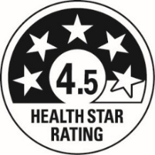 | Packaged beverages similar in nutritional profile to water that may contain only:  - carbon dioxide, whether added or naturally occurring;  - permitted flavouring substances (as defined by Standard 1.1.2-2 of the Code)  - mineral salts at Good Manufacturing Practice (GMP) (Schedule 16 of the Code)  - additives that provide a specific safety or stability function at GMP (Schedule 16 of the Code)  and must not contain:  - added sugars, sweeteners, colours, sodium, caffeine, quinine, or any other ingredient that contains energy and is not expressly permitted above (e.g. protein).
Fresh and minimally processed fruit and vegetables |  | All whole fresh fruit (except coconut) and vegetables, fungi and legumes (except peanuts) as sold with no processing, plus these same products that have only been peeled, cut and/or surface treated and/or blanched and/or frozen (not dried), or canned without the addition of fat, sugars/sweeteners or salt.  The above definition of fresh and minimally processed fruit and vegetables excludes dried products, and canned or fermented fruit and vegetables in juice and brine. The addition of these liquids provides an additional source of sugar and/or salt which should be reflected in its HSR and is not permitted under the definition of minimally processed fruit and vegetables.

Businesses may choose to use the full HSR system graphic on these foods in accordance with the hierarchy of presentation described under Section 6 of this Guide.
Displaying 5 star ratings for unpackaged fruits and vegetables
Fresh fruit and vegetables do not require packaging to display a HSR of 5, and businesses are encouraged to avoid packaging unprocessed fruit and vegetables unless it is necessary.
For fruit and vegetables not sold in packaging, businesses may choose to display the HSR as the 5-star icon and/or words to the effect that fresh fruit and vegetables receives a HSR of 5 stars.
For example, this could occur in any of the following ways:
  - Banners or floor stickers at the entry to or in the fresh food section.
  - HSR stickers or shelf wobblers near the price tags/stickers for individual fresh fruit or vegetables.
  - Statements on businesses websites.
  - Posters displayed at checkouts.
  - Posters on/in shopping trolleys and baskets.
  - Any further marketing activities that businesses deem suitable to promote the automatic HSR of 5 stars for fresh and minimally processed fruit and vegetables.

4.2 Form of the food (as prepared or as sold)
In most cases the HSR should be calculated and displayed on the basis of the product as it appears on the shelf (i.e. as sold).
You can only calculate your product’s rating as prepared if it must be rehydrated, diluted, or mixed with water; or drained of water or brine before it is consumed and the label clearly specifies these directions for that preparation.
Examples of foods where HSR can be calculated as prepared are:
- Rehydrated - dehydrated peas, plain milk powder
- Diluted - condensed soups, cordial
- Mixed/diluted with water - powdered stock, powdered gravy, powdered soups, jelly crystals
- Drained of water - canned tuna
- Drained of brine - canned tuna, canned beans, canned vegetables

For all other products, such as products to be drained of oil or mixed with milk, the rating should be calculated as sold
Examples of products that are NOT permitted to calculate the HSR based on ‘as prepared’ include (but are not limited to):
- Drinking chocolate or other powdered drinks where the preparation specifies the addition of milk;
- Canned tuna in oil;
- Canned fruit in syrup;
- Cake mixes that specify preparation with milk, eggs and oil; and
- Recipe bases that specify the addition of anything other than water (eg meat, vegetables, milk, fruit etc).

The HSR must not be calculated ‘as drained’ for products drained of anything other than water or brine (eg drained of water or syrup). This applies even when products state on the label they should be drained before consumption and display their NIP values on the basis of the drained product, as required by Standard 1.2.8—12 of the Code. In these cases, the HSR cannot be calculated using the information in the NIP. For these products only the star graphic should be displayed (Figure 4.4 in Section 6 of this Guide). A statement to the effect of ‘HSR calculated undrained’ should be included on packaging where possible.

4.3 Health Star Rating categories

Category | Eligibility criteria | Examples (not exhaustive)
Category 1 -Non-dairy beverages, jellies, and water-based ice-confections | All beverages that do not qualify for category 1D or an automatic HSR.  Includes:  - all non-dairy drinkable products  - jellies, and  - water-based ice confections including frozen juices.  This category includes dairy-based beverages and alternatives that do not meet the criteria for category 1D. | Includes: Fruit juice (including frozen juice), soft drink, cordial, ice blocks, jelly (including jelly crystals), dairy alternative drinks that do not contain >75% dairy/dairy alternative* ingredients.  Does NOT include: soup, stock or broth; plant-based dairy alternatives such as soy or oat milk that meet the requirements for category 1D.
Category 1D - Milk | Milk (defined in Standard 2.5.1 of the Code), dairy beverages and dairy alternative beverages that meet the below criteria:  - Dairy beverages that contain:  - ≥ 80mg calcium per serving; AND  - ≥75% dairy or permitted dairy alternative ingredients.  - Legume-based dairy alternatives that contain:  - no less than 3%m/m protein from legumes, AND  - ≥100mg calcium per 100mL, AND  - ≥75% permitted dairy alternative ingredients*  - Dairy alternatives derived from seeds, nuts and/or cereals that contain:  - no less than 0.3%m/m protein from those sources, AND  - ≥100mg calcium⁵ per 100mL, AND  - ≥75% permitted alternative ingredients*. | Includes: Plain or flavoured milk, fortified plant-based products, protein shakes (if calcium requirements are met, and not including Formulated Supplementary Sports Foods).  Does NOT include: evaporated or condensed milk (these are category 2D), plant-based milks with <100mg calcium; any Formulated Supplementary Sports Foods or non-milk like drinks that are fortified with protein, eg protein water
Category 2- Foods | All other foods that do not fit within any other category. | Includes: Chips, nuts, bread, breakfast cereal, muesli bars, pasta, sauces, stocks, ready meals, jams, nut butters, ice-cream.  Does NOT include: beverages, most dairy food (unless not captured in categories 1D, 2D or 3D)

Category 2D - other dairy foods | Non-frozen dairy foods not included in HSR Categories 1D or 3D, provided they contain ≥75% dairy or permitted dairy-alternative ingredients*.  Includes the following dairy alternatives:  - Legume-derived cheese alternatives that contain no less than 15% m/m protein derived from legumes and contain ≤320 mg/100 g calcium.  - Legume-derived yoghurt/dairy dessert alternatives that contain no less than 3.1% m/m protein derived from legumes. | Includes: Yoghurt, cheeses that contain ≤320 mg/100g calcium, ricotta, cottage cheese, cream cheese, fermented dairy products, cream, dairy desserts (such as custards), condensed or evaporated milk, and other chilled (but not frozen) dairy products.  Does NOT include: frozen dairy products such as ice cream, gelato, ice-confection or frozen yoghurt; cheeses that are eligible for category 3D, non-dairy cheeses that are not legume-based.

Category 3 – Oils and oil-based spreads | Edible oils, edible oil spreads, margarine and butter.  These products must fall into one of the following categories within the Food Standards Code:  - Edible oil, as defined in Standard 2.4.1  - Edible oil spread, as defined in Standard 2.4.2  - Margarine, as defined in Standard 2.4.2  - Butter, as defined in Standard 2.5.5 | Includes: Olive oil, canola oil, peanut oil, margarine and other edible oil spreads, butter.  Does NOT include: nut butters or other similar spreads, jams, cheese spread, pate, or mayonnaise.
Category 3D – Cheeses | Cheese (including surface ripened cheeses) and processed cheese, as defined in Standard 2.5.4 of the Code, with a calcium content >320 mg/100 g. Must consist of ≥75% dairy ingredients.  Cheese alternatives derived from legumes that contain no less than 15% m/m protein derived from legumes AND have a calcium content >320 mg/100 g AND contain >75% permitted dairy-alternative ingredients (see below). | Includes: hard cheese, brie cheese, legume-based cheese alternatives  Does NOT include: plant-based cheeses not derived from legumes (Category 2); ricotta, cream cheese, cottage cheese (Category 2D).

*Permitted dairy-alternative ingredients

For the purposes of Categories 1D, 2D and 3D ‘permitted dairy-alternative ingredients’ are those that are permitted by the Code and would otherwise be expected to be found as an ingredient in a ‘dairy-alternative’ product. Examples include water, oil, acidity regulators, stabilisers, emulsifiers, and thickening agents. These ingredients do not include substances added for flavouring (eg chocolate powder).

4.4 Fruit, vegetable, nut and legume (FVNL) content

HSR V points
HSR modifying points (points allocated to beneficial food components within the HSR calculation) may be scored for the amount of fruits, vegetables, nuts and legumes (FVNL) in a product. These modifying points are referred to as ‘HSR V points’.

Food eligible to score HSR V points
Variations of FVNL that are eligible for HSR V points include:
- FVNL that are fresh, cooked, frozen, canned, pickled, preserved, peeled, diced or cut (or otherwise reduced in size), puréed or dried.
- Fruit or vegetable juice, as standardised in the Code, and concentrated juices and purees
- Water in the centre of the coconut and coconut flesh that has been juiced, dried or desiccated.
- Flours derived from vegetables and legumes, with vegetable flours scoring V points as a concentrated vegetable and legume flours (other than flours where the legume has been partially de-fatted) scoring HSR V points as non-concentrated FVNL.

Food ineligible to score HSR V points
HSR V points may not be scored for:
- A constituent, extract or isolate of a food;
  - These are products where the whole food has been broken down into components, often using methods that require commercial equipment. Examples include peanut/olive oil, fruit pectin, and pea protein.
- Processed coconut products (such as coconut milk, cream, or oil);
- Cacao/cocoa beans, coffee beans, carob;
- Cereal grains (other than sweet corns). This includes–but is not limited to–those listed at item 3 in the table to subsection Schedule 22—5(7)of the Code (as below):
Sub-group | Commodities
Wheat, similar grains, and pseudocereals without husks | Amaranth, grain; Chia; Psyllium; Quinoa; Rye; Triticale; Wheat
Barley, similar grains, and pseudocereals with husks | Barley; Buckwheat; Oats
Rice Cereals | Rice; Wild rice
Sorghum Grain and Millet | Millet; Sorghum, grain
Maize Cereals | Maize (not including sweet corn); Popcorn

Concentrated FVNL
The HSR calculator treats concentrated and non-concentrated FVNL differently. Fruits and vegetables can be considered concentrated if they have had the moisture removed or have been dehydrated or desiccated, for example dried fruit or tomato paste. Only fruit and vegetables count as concentrated, and not nuts, legumes, spices, herbs, fungi, seeds, algae or coconut. Examples include concentrated fruit or vegetable juice, tomato paste, and dried fruit.

Form of Food (see also section 4.2)
The percentage of FVNL should be based on the form of the product for which the HSR is to be calculated,
i.e., For most products the form of the food will be ‘As Sold’, which is the product as it appears on the shelf.
For foods that must be rehydrated, diluted or mixed with water, or drained of water or brine before being consumed the form of the food will be the product ‘As Prepared’, which is the final product once it has had water added or water or brine removed.
Businesses are encouraged to list any ingredients contributing to FVNL content as a percentage in the ingredients list or to keep records of FVNL content to support transparency in the HSR system. Note also the requirements in division 7 of Standard 1.2.7 of the Code, that if a product scores V points it may be required to list the percentages of FVNL ingredients.

Specific FVNL examples
Note: this is not an exhaustive list.
Eligible for FVNL  (non-concentrated) | Eligible for concentrated FVNL | Not eligible for FVNL/concentrated FVNL
Sweet corns  Coconut flour/powder (100% coconut), coconut water, coconut flesh including desiccated coconut  Canned vegetables and legumes  Seeds (and seed meals) – chia, hemp, flaxseeds/linseeds, poppy, mustard, pumpkin, sesame, sunflower, fenugreek, cumin  Shelled nuts (and nut meals), including roasted nuts  Low-moisture products – potato crisps, sweet potato crisps, vege crisps  Olives  Fruit and vegetable juice, including reconstituted juice from fruit and vegetable juice concentrate  Dried legumes (including legume flours), other than peanut flour (as it has been de-fatted)  Tofu (soy content only)  Seaweed/nori | Dates – packaged, dried, specified  Dried fruits and vegetables eg. sultanas, sundried tomato, dried potato or onion flakes, dried fruit peel (other than low-moisture products like potato crisps)  Tomato paste  Fruit and vegetable juice concentrate (if not reconstituted)  Dehydrated sweet corn (but not maize)  Dried ginger, tumeric  Dried mushrooms | Agave syrup  Coconut milk, coconut cream, coconut oil  Oils derived from seeds, nuts, vegetables/herbs  Fruit pectin  Micoprotein, pea protein  Psyllium husk  Cane juice  Corn as a cereal – eg cornflour, cornflakes, corn chips, popcorn  Cacao beans  Coffee beans  Carob  Quinoa  Defatted legume flours (eg peanut flour)  Fruit fibres/gums (guar, agar, locust bean gum)  Deionised / clarified juices  Cereal flours eg wheat, spelt, bulghur, cañihua, cornflour, buckwheat, maize, barley, millet, oats, sorghum, rice

Section 5 On Pack presentation of the Health Star Rating system
There are several design options for the HSR system. The following information is provided to aid your choice of display options. If the online Calculator is used to calculate the HSR, the artwork file in the format of a layered vector file will be generated, including all options described below. This file can be edited to show your choice of display options. The artwork file will not be populated with the details of the individual product. The details of the product will need to be manually entered.

5.1 HSR system graphic elements
The HSR system graphic comprises three main elements (see Figure 1):
- Health Star Rating (stars element)
An overall evaluation of the product based on its nutrient profile (per 100g or 100mL), presented as a star rating graphic and numerically;
- Energy Declaration (energy element)
The average energy content of the product on a per 100g or 100mL basis, or per pack when presented as a single portion intended for consumption in a single sitting, or per [reference portion] when presented as part of a multipack (refer to Section 5.7 of this Guide), or per serve when presented in the context of any industry agreed standardised serve sizes (Section 5.6 of this Guide); and
- Nutrient Content Declarations (nutrients element)
Individual icons indicating the average quantity of prescribed nutrients (saturated fat, sugars and sodium) per 100g or 100mL, or per pack when presented as a single portion or per [reference portion] when presented as part of a multipack (refer to Section 5.7 of this Guide), or per serve when presented in the context of any industry agreed standardised serve sizes. A single ‘positive’ nutrient may also be included alongside these nutrients, where eligible, but not alone.
The stars element must always be used if the HSR system is adopted. The the energy decleration and nutrient content declarations are optional additions.
HSR optional positive nutrient icons are considered a nutrition content claim.
Where an optional positive nutrient icon is displayed as part of the HSR system graphic, this is considered a nutrition content claim under Standard 1.2.7 of the Code. If businesses choose to display an optional nutrient, it must therefore be present in levels consistent with Schedule 4 Nutrition, health and related claims of the Code. This also means use of a positive nutrient icon would trigger the need to include NIP labelling if it is used in relation to a food that otherwise would be exempt from NIP requirements, or require the inclusion of additional information in the NIP.

Figure 1: The HSR system graphic – main elements
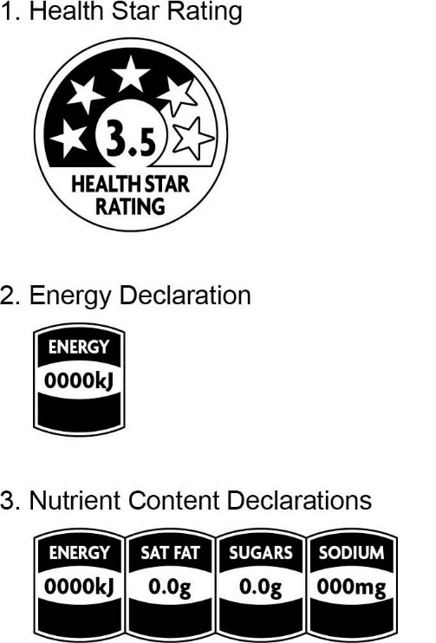

5.2 Design principles
- The HSR system is designed as a front-of-pack labelling tool and so should be displayed on the front label of the product (as displayed in the supermarket if applicable). However, where products are generally displayed with an alternative visible facing side (such as some products displayed in a chest freezer where a side facing may be visible to the shopper), the HSR system graphic may be placed on the commonly visible facing side.
  - For products in cylindrical packaging the HSR system graphic should be placed on the part of the container most likely to be considered the front-of-pack (i.e. showing a prominent brand and net weight/volume). There is no requirement to duplicate the HSR system graphic on a secondary facing.
  - If the HSR system graphic is duplicated on a secondary facing, the rating must be the same as on the front of the product and not an example of a lower or higher HSR.
- Businesses are encouraged to use as many elements of the HSR system graphic as possible, consistent with the hierarchy outlined in Section 6 of this Guide.
- All HSR elements must be presented exactly as shown in Figure 1. All stars must be visible, with shading behind the appropriate number of stars to indicate the rating of the product. The style of the energy and nutrient icon elements must be as per Figure 1, noting the HSR energy icon is not permitted in isolation (i.e. without the stars element of the HSR system graphic).
- The stars element of the HSR system graphic should be larger than the energy and nutrient elements (when they are used within the HSR system graphic).
- Stylised versions of HSR elements are not permitted.
- Businesses are responsible for choosing the colour and size of the graphic. The HSR system graphic should be presented in a colour that meets legibility requirements and provides good contrast to the background to maximise legibility (legibility requirements are detailed in Section 1.2.1—24 of the Code). Where the HSR system graphic may not be legible due to background images or colour, a white or contrasting colour panel can be used behind the HSR system graphic to further aid legibility. The HSR system graphic can be scaled according to the package size, provided that all elements used remain legible.

5.3 Health Star Rating graphic
As illustrated in Figure 1, the HSR system graphic comprises:
- A rating from ½ to 5 stars (in ½ star increments) represented by shading behind the stars with all stars displayed clearly on the graphic;
- The same rating displayed numerically; and
- The words “Health Star Rating” displayed prominently below the stars.
The stars element of the HSR system graphic is designed to be more prominent than the energy and nutrient elements. The stars element of the HSR system graphic must be used on all products using the HSR system.

5.4 Energy and Nutrient Icons
The nutrition content declarations, when they are used, should include:
- ‘Energy’;
- The nutrient name;
- The average energy content or average quantity of nutrients in the nominated reference measure with appropriate units i.e. kilojoules (kJ) for energy, grams (g) or milligrams (mg) or millilitres (mL) for nutrients.
The order of the icons in the HSR system graphic should reflect their order in the NIP, i.e. reading from left to right: energy, prescribed nutrients (saturated fat, sugars, sodium), optional nutrient.
Individual values within each icon should:
- In most cases (where the NIP is calculated as sold rather than as prepared) be consistent with values shown in the NIP*;
- in the case of energy, be reported as a whole number of kilojoules (e.g. 452.4 presented as 452kJ);
- be reported to one decimal place if the units are grams (e.g. 4.5g) (unless the decimal is a 0, in which case a whole number can be used); and
- be reported as a whole number if the units are milligrams (e.g. 450mg).
The energy and nutrient icons cannot be used in isolation. They must be displayed in conjunction with the HSR stars graphic.
The energy and nutrient composition of product ingredients can vary significantly. Businesses need to be aware of this variation, and its potential magnitude, when estimating average values. Energy and nutrient values should generally reflect those stated in the NIP* (i.e. if values in the NIP change, the energy and nutrient values displayed as part of the HSR system graphic should be updated).
Sufficient space has been provided in the design to accommodate nutrient names and values in a clear and legible way.
- For the declaration of saturated fat content in the nutrient icon, ‘sat fat’ is permitted; and
- For a declaration of dietary fibre, ‘fibre’ is permitted.
If it is necessary to use an abbreviation for positive nutrients with long names to maintain legibility, please seek advice from the HSR Unit.
* Products for which the NIP is calculated “as prepared” but which do not meet the requirements for the HSR to be calculated “as prepared”, should display the HSR icon alone, without additional energy or nutrient icons. See Section 4.2 of this Guide for further information.

Figure 2: Elements of the Energy and Nutrient icons
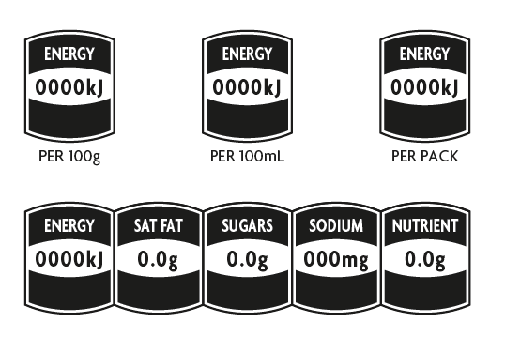
Rounding of figures
Australian and New Zealand consumer law legislation is also relevant and requires that claims and representations are not false or misleading. It may therefore be inappropriate to round a number that reflects the presence of a number to zero (e.g. rounding 0.021mg to zero), as this would imply an absence of the nutrient. In this instance rounding to two decimal places is permitted.

5.4.1 Energy icon
The energy icon may be used in conjunction with other HSR system graphic elements. If the energy icon is used with only the stars element of the HSR system graphic, the energy icon should be placed to the right-hand side of HSR system graphic (as illustrated in Figure 4.3). If required, the energy icon may be placed below the HSR system graphic, (see options for configuration at Appendix 2, Figure 5).
A %DI value may be included within the energy icon for ‘per pack’ values (i.e. when presented as a single serve pack intended for consumption in a single sitting) or ‘per [serve size]’ values (when displayed in accordance with Section 5 of this Guide). %DI cannot be used for reference measurements of per 100g/100mL (example is at Figure 4.1).
The %DI value should be:
- based on the energy content per pack (for single serve packs intended for consumption in a single sitting) or per [serve size] (when displayed in accordance with Section 5.5 of this Guide);
- expressed as a percentage of the total DI reference value for energy as listed in Standard 1.2.8 of the Code;
- expressed as a whole number through standard rounding (unless < 1). Values above 1 with a following decimal below 0.5 should be rounded down and values above 1 with a following decimal of 0.5 or above should be rounded up to the next whole number; and
- presented as %DI*, with the asterisk (*) to refer to a back of pack message about the average daily adult kilojoule intake.
When %DI is used on the energy icon, it triggers the full use of %DI column in the NIP, i.e. energy plus 6 nutrients and a statement about the average daily adult diet of 8700 kJ (refer to Standard 1.2.8—8 of the Code).
Details on calculating %DI values are provided in Appendix 3.

5.4.2 Nutrient Icons
If the prescribed nutrient icons are displayed (saturated fat, sugars, sodium) they should all be displayed, in conjunction with the energy icon and stars.
A single optional nutrient may be presented, in addition to the prescribed nutrient icons, and the energy icon. Businesses may choose, with consideration of the following, which (single) optional nutrient to present within the HSR system graphic:
- Optional nutrients are defined as ‘property of food’ Standard 1.1.2—3 of the Code and referred to Standard 1.2.7—12 of the Code in the context of nutrition content claims
- The nutrient must be present at a level consistent with the requirements of Schedule 4 and be included in the NIP in accordance with the requirements of Standard 1.2.8 of the Code.
- The purpose of the nutrient icons is to provide nutritional information only. They are not to be used to provide advice on the levels of food components which may have other health implications - for example gluten content, lactose content, glycaemic index, etc.
The words ‘low’ and ‘high’ may be used within the nutrient icons (except for the energy icon) to highlight the content of individual nutrients in the food product, in line with the table below: (example is at Figure 3 below).

Use of the words “low” or “high”
Term | Nutrient icon | Conditions
Low | Energy | May not be used
Low | Prescribed nutrients:  - Saturated fat  - Sugars  - Sodium | May only be used when the nutrient level meets Schedule 4 of the Code requirements for a "low" nutrition content claim.
High | Optional positive nutrient  (e.g., vitamins, minerals) | May only be used when the nutrient level meets Schedule 4 of the Code requirements for a "good source" or "excellent source" nutrition content claim.

The use of the following will constitute a nutrition content claim under Standard 1.2.7 of the Code, and must therefore comply with the requirements of that Standard:
- The optional positive nutrient icon (for example, fibre, calcium) (with or without the descriptor ‘high’)
- ‘Low’ descriptors used in conjunction with prescribed nutrient icons for saturated fat, sugars and sodium.

Figure 3: Use of %DI, ‘low’ and ‘high’ and nominated reference value
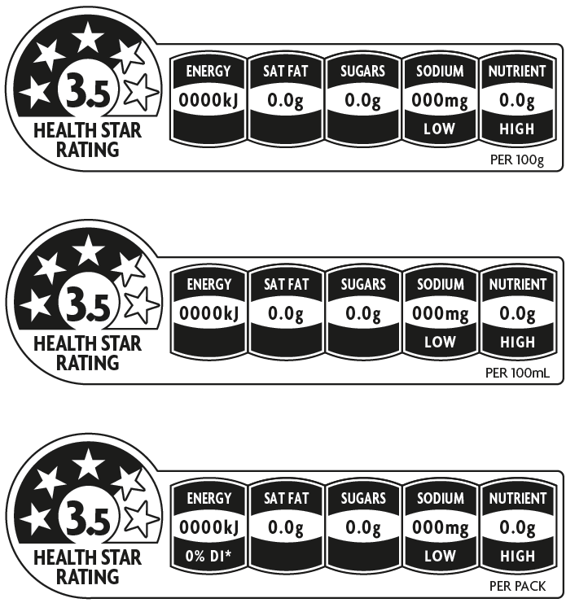

5.5 Nominated Reference Measure
Energy and nutrient information may be presented on a ‘per 100g or 100mL’ basis, ‘per pack’ (when presented as a single portion), or ‘per [reference portion]’ (when presented as a multipack with individual pre-portioned units intended for consumption in a single sitting), or ‘per [serve size]’ according to the following guidance.
- All products may use the ‘per 100g’ or ‘per 100mL’ reference, which should be placed to the right-hand side of the graphic.
- Products presented in single serve packages (e.g. an individual lasagne intended for consumption in a single sitting by a single person) may use the:
- ‘per 100g’ or ‘per 100mL’ reference; or
- ‘per pack’ reference.
The nominated reference measure should be placed to the bottom right-hand side of the graphic, as shown in Figure 3.
- Products presented as multipacks with multiple individually pre-packaged units (Section 5.7 of this Guide) may use the:
- ‘per 100g or 100mL’ reference; or
- ‘per [reference portion]’ reference.
- Products for which an industry agreed standardised serve size applies (Section 5.6 of this Guide) may use the ‘per [serve size]’ reference (see Table 8).
If a serve size is used, it should be consistent with the NIP.
- Products for which the energy and nutrient information is calculated ‘as prepared’, reference weight should include the text ‘as prepared’ after the nominated reference measure.

Percentage daily intake (%DI) information can only be used on the energy icon of a ‘per pack’ or ‘per [serve size]’ representation. To comply with Standard 1.2.8 of the Code, %DI should not appear on products when nutrient information is presented on a ‘per 100g or 100mL’ basis. See Section 5.6 of this Guide for confectionary packs displayed on a per ‘reference portion’ reference.

5.6 Industry Agreed Standardised Serve Sizes
Where there is an industry agreed standardised serve size for products listed in Table 8, this may be used as the nominated reference value on packs and with corresponding nutrient values in the nutrient information elements of the HSR system graphic. The star rating element will still be calculated per 100g/100mL. Industry agreed standardised serve sizes are listed in Table 8 below. Only those categories listed in Table 8 should use the standardised serve size as the nominated reference measure.
Other industry agreed standardised serve sizes may be considered by the HSR Advisory Committee for inclusion in Table 8 and use in the HSR system once they have been agreed by industry through formal processes.
Table 8: Industry agreed standardised serve size
Category | Standardised serve size | Notes
Beverages | Product less than or equal to 600mL – serve size is the entire product  Products greater than 600mL – serve size is 250mL
Chocolate / Sugar confectionery | 25g +/- 5g  The nominated reference measure (e.g. per row for share pack of chocolate / per 3 snakes etc.) can be used when the nominated reference amount equals 25g +/-5g | Pack should specify what the actual confectionery serve size is, e.g. 23g

5.7 Multipacks
Multipacks are packs that contain individual pre-portioned units intended for consumption as single portions and not intended for individual sale. Examples include individual packets of potato crisps in a multipack; individual packs of yoghurt in a 4-serve multipack; individual bottles (600 mL or under) in a 6-pack of soft drinks. It also includes multi-component foods, like individually portioned cheese and crackers.
For multipacks with individually pre-portioned units, ‘per [reference portion]’ may be used on the HSR system graphic. The reference portion may be presented as appropriate (e.g. ‘per inner pack’ or ‘per single pack’ or ‘per bottle’) and should be clearly visible to the shopper at the point of sale.
For confectionery products only, the %DI can be shown on the energy icon for individual packs in a multipack, even when the pre-portioned piece size is not the industry agreed standardised serve size (see Section 5.6 of this Guide). However, in order to be consistent with the Code, the pre-portioned piece size should be consistent with the serve size specified in the NIP.
For multi-component foods, the HSR may be calculated either for individual components (eg an HSR calculated and displayed for each component), or a single HSR may be calculated for the combined product. If a single HSR is calculated, the category must reflect the combined product – for example, cheese and crackers would fall under category 2.
For multipacks that display more than one NIP on the outer pack, the preferred display option for the HSR system is one HSR system graphic to represent each NIP or product in the pack.
Where businesses choose to display only one HSR system graphic, then an average HSR which represents the average nutrient content of all of the products within the outer pack (rather than an average of all HSRs) should be displayed. Alternatively, businesses may choose to display the lowest HSR and indicate that the products within the multipack are either equivalent to the displayed HSR or higher. In either case the company should include a statement on how the HSR was derived (e.g. ‘average of nutrient content of all varieties’ or ‘minimum star rating of varieties’).

Section 6 Hierarchy of Health Star Rating system presentation

The HSR system graphic includes:
- the Health Star Rating,
- energy icon,
- three (3) prescribed nutrient icons
- an optional nutrient icon (if appropriate),
together with the further optional interpretive terms ‘high’ and ‘low’ with respect of the nutrient icons, and the %DI of energy (for the ‘per pack’ or ‘per [serve size]’ presentation) (Figure 4).
Therefore, businesses are encouraged to use as many elements of the HSR system graphic as possible, consistent with the hierarchy shown below. Some products may not be able to display all the elements of the HSR system graphic due to pack or label size or other considerations. In these cases there is a hierarchy of options for the elements to be displayed:
- Health Star Rating + energy icon + 3 prescribed nutrient icons + 1 optional nutrient icon.
- Health Star Rating + energy icon + 3 prescribed nutrient icons.
- Health Star Rating + energy icon.
- Health Star Rating (e.g. when pack size does not accommodate all elements).
It is the responsibility of businesses to determine which presentation format is most suitable for their products, based on the above hierarchy, available pack size and label space.
The different options for displaying the HSR system graphic are shown below (Figure 4).

Figure 4 – all options for HSR display (note that these options can also be vertically displayed on pack).
Figure 4.1: Health Star Rating + energy icon + 3 prescribed nutrient icons + 1 optional nutrient icon (plus the two optional elements: with or without the use of the terms High / Low and %DI)
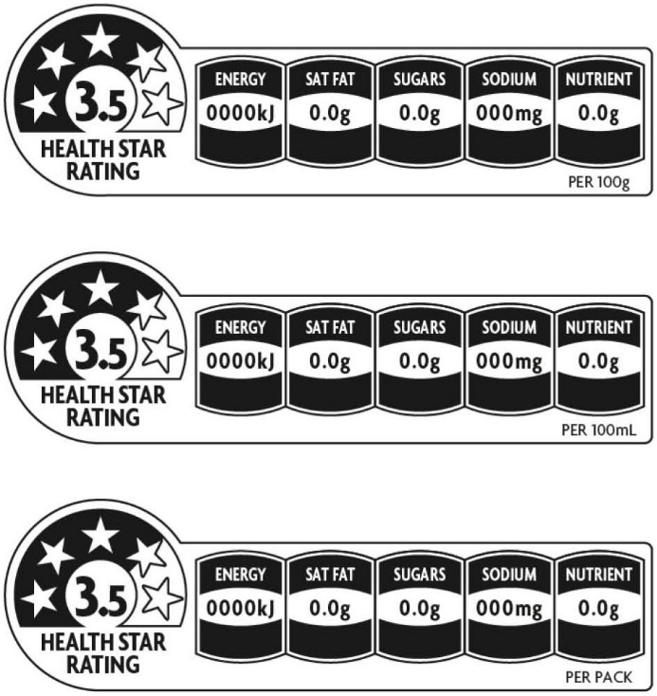

Figure 4.2: Health Star Rating + energy icon + 3 prescribed nutrient icons
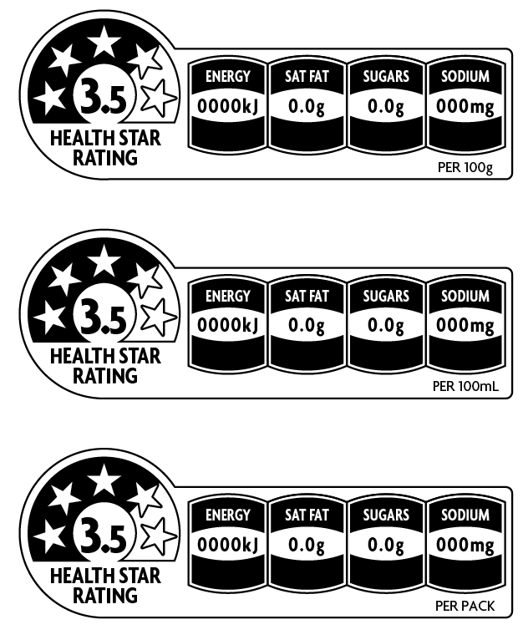

Figure 4.3: Health Star Rating + energy icon
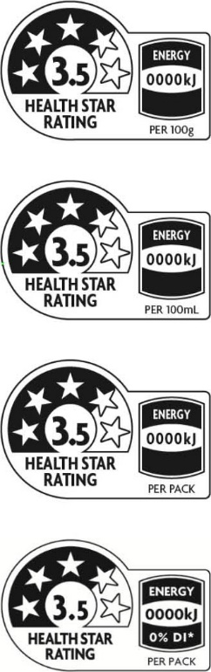

Figure 4.4: Health Star Rating
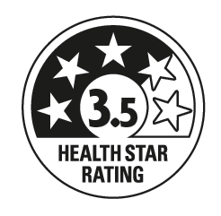

Section 7 Display of additional Health Star Rating information

Where businesses choose to display additional information on the HSR system on their product packages, any HSR system graphic displayed in this context should be a duplicate of the HSR system graphic displayed on the front of the pack i.e. if a product displays a HSR of 3.5, any additional information given on the label must be consistent with this rating.
Where additional information is displayed and if space permits, businesses are encouraged to display an HSR Quick Response (QR) Code that directs consumers to the HSR website when scanned. A QR Code is available for download on the HSR website.

Section 8 The Daily Intake Guide, Health Logos and certification schemes

The Daily Intake Guide (DIG) and health logos and certification schemes that provide nutritional guidance to consumers are used widely in Australia and New Zealand. In line with guidance from Codex and the World Health Organization, it is recommended that businesses only use one front-of-pack nutrition labelling system. However, the DIG, health logos, other industry initiatives and certification schemes may coexist with the HSR system graphic.
Where the HSR system graphic and DIG are used on the same pack care should be taken to ensure they do not lead consumers to believe they are linked or are two parts of a single system.

Section 9 Digital and other off-pack use of the HSR system

The display of the HSR on the physical front of packaged food products is encouraged on all intended products.
For products where the HSR is displayed on-pack, the digital and other off-pack display of the HSR system is encouraged. It is also permitted where the HSR is not displayed on pack, in line with the principles below. Examples of off-pack use of the system include display on online shopping platforms, consumer facing phone applications, business websites, in-store signage and through advertising and/or marketing. Where possible, businesses are encouraged to ensure the HSR is available at the point of purchase (ie in store or online).
Digital and off-pack application without the use on labels will not be counted towards HSR uptake figures.
Retailers, brand owners, manufacturers and other users may choose to digitally or otherwise display the HSR for a product that does not display the HSR on its physical label, or to complement the physical label. When the HSR is displayed by a third party for commercial purposes (eg by a retailer) and is not displayed on pack, express permission must be granted by the manufacturer/brand owner to display the rating and the rating must be confirmed by the brand owner/manufacturer prior to display. The brand owner/manufacturer is not required to provide calculation details for this confirmation. It is recommended a record is kept of this confirmation.
Although it is best practice, the requirement to confirm the rating with the brand owner/manufacturer is not required where the HSR is not associated with commercial use, for example (including but not limited to) government, public health, research, database or similar use. Best efforts should be made to ensure the accuracy of the HSR calculation and there should be pathways in place for brand owners/manufacturers to query the HSR rating or inform of changes to the HSR.
All displays of the HSR system must be aligned with the design principles for on pack display where applicable. It is the responsibility of the third party to amend and regularly update any Health Star Rating. Should a rating be queried by the brand owner/manufacturer, the third party must cease all off-pack use of the HSR for the product in question until the rating can be confirmed by the brand owner/manufacturer. If the matter cannot be resolved between the brand owner/manufacturer and third party, the HSR unit should be contacted (hsr@health.gov.au).

Appendix 1 – Calculator Guide

Calculator Guide
The following information is provided to enable users to manually calculate a Health Star Rating (HSR), and to see the cut-off points for each rating. This may assist industry in reformulating products to achieve a better HSR.
Please note that a calculator application is available at the HSR website which provides a quick and easy way to calculate ratings.

Health Star Rating Calculator guide
This information is provided to enable users to manually calculate a Health Star Rating (HSR), and to see the cut-off points for each rating. This may assist industry in reformulating products to achieve a higher HSR. You will need to have determined the category of your product before calculating the rating (see section 4.3).
Please note that a calculator application is available at the HSR website which provides a quick and easy way to calculate ratings.
How to calculate a star rating
- Calculate the total baseline points by summing the baseline points for each applicable nutrient
- Baseline points for all categories other than category 1 (non-dairy beverages) are assigned for:
  - Energy (kilojoules) per 100g
  - Saturated fat (grams) per 100g
  - Total sugars (grams) per 100g
  - Sodium (milligrams) per 100g
- Baseline points for category 1 (non-dairy beverages) are awarded for energy and total sugars only.
Refer to the appropriate table below to calculate baseline points:
- Table 1: HSR baseline points for Category 1D, 2 and 2D products
- Table 2: HSR baseline points for Category 3 and 3D Foods
- Table 3: HSR baseline points for Category 1

- Calculate modifying points
- Modifying points may be scored for the amount of fruits, vegetables, nuts and legumes (FVNL) in the product, and for protein and dietary fibre.
FVNL (V) points
- Refer to Section 4.4 of this Guide for eligibility for HSR V points. Products must contain either non-concentrated FVNL sources or concentrated fruits or vegetables, or a mixture of both to be eligible for points.

Category 1 | can score up to 10 points
Categories 1D, 2, 2D, 3 and 3D | can score up to 8 points

Protein (P) points
Category 1 | Not eligible for HSR P points
Categories 1D, 2, 2D, 3 and 3D | if HSR baseline points are < 13, can score up to 15 P points  if HSR baseline points are ≥ 13, can score P points only if the HSR V points are ≥ 5

Fibre (F) points
- The prescribed methods of analysis to determine total dietary fibre are outlined in Schedule 11 of the Code.

Category 1 and 1D | Not eligible for HSR F points
Categories 2, 2D, 3 and 3D | can score up to 15 F points

Refer to the appropriate table to calculate modifying points:
- Table 4: HSR V points for Categories 1D, 2, 2D, 3 and 3D
- Table 5: HSR V Points for Category 1
- Table 6: HSR Protein (P) and Fibre (F) Points

- Calculate the final HSR score
- The final HSR score is calculated by subtracting the HSR modifying points (HSR V, P and/or F points) from the HSR baseline points (see Tables 1 - 6) using the following formula:
Final HSR score
= HSR baseline points – (HSR V points) – (HSR P points if eligible) – (HSR F points if eligible)

- Convert the HSR score to a rating
- Refer to table 7 to find the final rating.

Table 1: HSR baseline points for Categories 1D, 2 and 2D
Baseline points | Energy (kJ)  per 100 g or 100 mL | Saturated fat (g)  per 100 g or 100 mL | Total sugars (g)  per 100 g or 100 mL | Sodium (mg)  per 100 g or 100 mL
0 | ≤335 | ≤1.0 | ≤5.0 | ≤90
1 | >335 | >1.0 | >5.0 | >90
2 | >670 | >2.0 | >8.9 | >180
3 | >1005 | >3.0 | >12.8 | >270
4 | >1340 | >4.0 | >16.8 | >360
5 | >1675 | >5.0 | >20.7 | >450
6 | >2010 | >6.0 | >24.6 | >540
7 | >2345 | >7.0 | >28.5 | >630
8 | >2680 | >8.0 | >32.4 | >720
9 | >3015 | >9.0 | >36.3 | >810
10 | >3350 | >10.0 | >40.3 | >900
11 | >3685 | >11.2 | >44.2 | >990
12 |  | >12.5 | >48.1 | >1080
13 |  | >13.9 | >52.0 | >1170
14 |  | >15.5 | >55.9 | >1260
15 |  | >17.3 | >59.8 | >1350
16 |  | >19.3 | >63.8 | >1440
17 |  | >21.6 | >67.7 | >1530
18 |  | >24.1 | >71.6 | >1620
19 |  | >26.9 | >75.5 | >1710
20 |  | >30.0 | >79.4 | >1800
21 |  | >33.5 | >83.3 | >1890
22 |  | >37.4 | >87.3 | >1980
23 |  | >41.7 | >91.2 | >2070
24 |  | >46.6 | >95.1 | >2160
25 |  | >52.0 | >99.0 | >2250
26 |  | >58.0 |  | >2340
27 |  | >64.7 |  | >2430
28 |  | >72.3 |  | >2520
29 |  | >80.6 |  | >2610
30 |  | >90 |  | >2700

Table 2: HSR baseline points for Categories 3 and 3D
Baseline points | Energy (kJ)  per 100 g or 100 mL | Saturated fat (g)  per 100 g or 100 mL | Total sugars (g) per 100 g or 100 mL | Sodium (mg)  per 100 g or 100 mL
0 | ≤ 335 | ≤1.0 | ≤ 5.0 | ≤ 90
1 | >335 | >1.0 | >5.0 | >90
2 | >670 | >2.0 | >9.0 | >180
3 | >1005 | >3.0 | >13.5 | >270
4 | >1340 | >4.0 | >18.0 | >360
5 | >1675 | >5.0 | >22.5 | >450
6 | >2010 | >6.0 | >27.0 | >540
7 | >2345 | >7.0 | >31.0 | >630
8 | >2680 | >8.0 | >36.0 | >720
9 | >3015 | >9.0 | >40.0 | >810
10 | >3350 | >10.0 | >45.0 | >900
11 | >3685 | >11.0 |  | >990
12 |  | >12.0 |  | >1080
13 |  | >13.0 |  | >1170
14 |  | >14.0 |  | >1260
15 |  | >15.0 |  | >1350
16 |  | >16.0 |  | >1440
17 |  | >17.0 |  | >1530
18 |  | >18.0 |  | >1620
19 |  | >19.0 |  | >1710
20 |  | >20.0 |  | >1800
21 |  | >21.0 |  | >1890
22 |  | >22.0 |  | >1980
23 |  | >23.0 |  | >2070
24 |  | >24.0 |  | >2160
25 |  | >25.0 |  | >2250
26 |  | >26.0 |  | >2340
27 |  | >27.0 |  | >2430
28 |  | >28.0 |  | >2520
29 |  | >29.0 |  | >2610
30 |  | >30.0 |  | >2700

Table 3: HSR baseline points for Category 1
Baseline points | Energy (kJ)  per 100mL | Total sugars (g)  per 100mL
0 | - | ≤ 0.1
1 | ≤31 | > 0.1
2 | > 31 | > 1.6
3 | > 61 | > 3.1
4 | > 91 | > 4.6
5 | > 121 | > 6.1
6 | > 151 | > 7.6
7 | > 181 | > 9.1
8 | > 211 | > 10.6
9 | > 241 | > 12.1
10 | > 271 | > 13.6

Table 4: HSR V points for Categories 1D, 2, 2D, 3 and 3D
Points | Column 1  % concentrated fruits or vegetables | Column 2  % non-concentrated fvnl
0 | <25 | ≤40
1 | ≥25 | >40
2 | ≥43 | >60
3 | ≥52 | >67
4 | ≥63 | >75
5 | ≥67 | >80
6 | ≥80 | >90
7 | ≥90 | >95
8 | =100 | =100

If the food product contains a mixture of concentrated fruits or vegetables and non-concentrated FVNL sources, the percentage of total FVNL must be worked out as follows:
where:
%non-concentrated FVNL/concentrated fruits or vegetables means the percentage of FVNL in the food determined using the appropriate calculation methods.
Notes to Table 4
- Use column 1 if the product only contains concentrated (dried) fruits and/or vegetables.
- Use Column 2 of Table 4 if:
- There are no concentrated (dried) fruits or vegetables in the product; or
- The percentages of all concentrated ingredients are calculated based on the ingredient when reconstituted (according to subsection 1.2.10—4(3) and 1.2.10—4(4) of the Code); or
- The product contains a mixture of concentrated fruits or vegetables and non-concentrated FVNL sources (after following the formula given above).

Table 5: HSR V Points for Category 1
Points | (%FVNL)
0 | < 25
1 | ≥ 25
2 | ≥ 33
3 | ≥ 41
4 | ≥ 49
5 | ≥ 57
6 | ≥ 65
7 | ≥ 73
8 | ≥ 81
9 | ≥ 89
10 | ≥ 96

Table 6: HSR Protein (P) and Fibre (F) Points
Points | Protein (g)  per 100 g or 100 mL | Dietary fibre (g)  per 100 g or 100 mL
0 | ≤1.6 | ≤0.9
1 | >1.6 | >0.9
2 | ≥3.2 | >1.9
3 | >4.8 | >2.8
4 | >6.4 | >3.7
5 | >8.0 | >4.7
6 | >9.6 | >5.4
7 | >11.6 | >6.3
8 | >13.9 | >7.3
9 | >16.7 | >8.4
10 | >20.0 | >9.7
11 | >24.0 | >11.2
12 | >28.9 | >13.0
13 | >34.7 | >15.0
14 | >41.6 | >17.3
15 | >50.0 | >20.0

The prescribed methods of analysis to determine total dietary fibre are outlined in Schedule 11 of the Code.

Table 7: HSR scores by category, with final Heath Star Rating
HSR rating | Cat. 1 | Cat. 1D | Cat. 2 | Cat. 2D | Cat. 3 | Cat. 3D
5 | Water | ≤-2 | Eligible fruits and vegetables  ≤-11 | ≤-2 | ≤13 | ≤24
4.5 | Unsweetened  Flavoured water | -1 | -10 – -7 | -1 – 0 | 14 – 16 | 25 – 26
4 | ≤0 | 0 | -6 – -2 | 1 – 2 | 17 – 20 | 27 – 28
3.5 | 1 | 1 | -1 – 2 | 3 | 21 – 23 | 29 – 30
3 | 2 – 3 | 2 | 3 – 6 | 4 – 5 | 24 – 27 | 31
2.5 | 4 – 5 | 3 | 7 – 11 | 6 – 7 | 28 – 30 | 32 – 33
2 | 6 – 7 | 4 | 12 – 15 | 8 | 31 – 34 | 34 – 35
1.5 | 8 – 9 | 5 | 16 – 20 | 9 – 10 | 35 – 37 | 36 – 37
1 | 10 – 11 | 6 | 21 – 24 | 11 – 12 | 38 – 41 | 38 – 39
0.5 | ≥12 | ≥7 | ≥25 | ≥13 | ≥42 | ≥40

Appendix 2:
Possible configurations of the Health Star Rating system graphic

Note: Images shown here as left facing may be presented as right facing, retaining the order of the nutrients as displayed below.

Figure 5: Configuration options for display of the HSR system graphic on pack

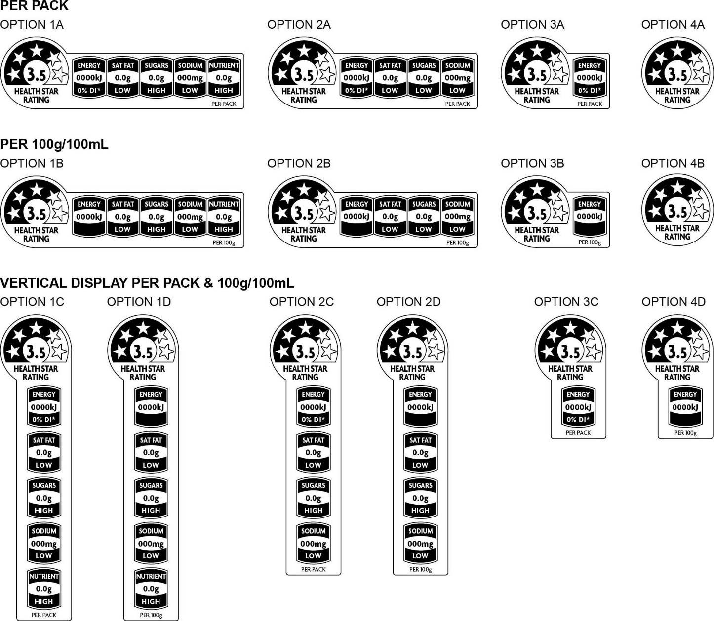

Appendix 3:
Calculating Percentage Daily Intake values for the energy Icon

For ‘per pack’ (when presented as a single portion package) or ‘per [serve size]’ (when displayed as described in Section 5.6 of this Guide) representation of the energy icon, %DI values should be calculated as follows:

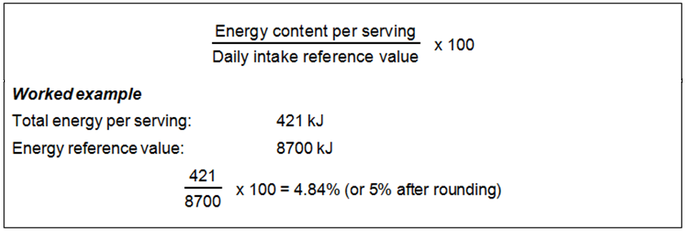

As per requirements of Standard 1.2.8 of the Code, the Daily Intake reference value for Energy is 8700kJ.
When %DI is used on the energy icon, the following is required:
- The %DI for energy must also be included in the NIP
- Under Standard 1.2.8 of the Code the percentage daily intake (%DI) for fat, saturated fat, carbohydrate, sugars, protein and sodium (per serving) must also be included in the NIP
- either of the following statements must be included under the NIP
‘*based on an average adult diet of 8700 kJ’; or
‘Percentage daily intakes are based on an average adult diet of 8700 kJ’.

Appendix 4: References to the Food Standards Code

Standards and Schedules within the Australia New Zealand Food Standards Code (the Code) referred to in this Guide are listed below. Online access to current versions of these Standards and Schedules in the Code is at: www.foodstandards.gov.au/code. A full compilation version of the Code can also be downloaded here.
Standards - General
- 1.1.2 Definitions used throughout the Code
- 1.2.1 Requirements to have labels or otherwise provide information
- 1.2.7 Nutrition, health and related claims
- 1.2.8 Nutrition information requirements
- 1.2.10 Information requirements - characterising ingredients and components of food
- 1.3.2 Vitamins and minerals
- 1.4.2 Agvet chemicals (applies to Australia Only)

Standards - General Purpose Foods
- 2.4.1 Edible oils
- 2.4.2 Edible oil spreads
- 2.5.1 Milk
- 2.5.4 Cheese
- 2.5.5 Butter
- 2.6.1 Fruit juice and vegetable juice
- 2.6.2 Non-alcoholic beverages and brewed soft drinks

Standards - Special Purpose Foods
- 2.9.1 Infant formula products
- 2.9.2 Food for infants
- 2.9.3 Formulated meal replacements and formulated supplementary foods
- 2.9.4 Formulated supplementary sports foods
- 2.9.5 Food for special medical purposes

Schedules
- Schedule 1 RDIs and ESADDIs
- Schedule 4 Nutrition, health and related claims
- Schedule 5 Nutrient profiling scoring method
- Schedule 11 Calculation of values for nutrition information panel
- Schedule 16 Types of substances that may be used as food additives
- Schedule 17 Vitamins and minerals
- Schedule 22 Foods and classes of foods

Appendix 5: Document Changes

Version | Location | Change | Date
2 | Glossary and page 14 | Definition for ‘unsweetened flavoured water’ updated. | 15 November 2020
3 | Glossary and page 14 | Definition for ‘fresh and minimally processed fruits and vegetables’ updated. | 27 November 2020
4 | Section 2 and page 10 | Definition of a small package corrected ‘less than 100cm^{2’.} | 29 June 2021
4 | Section 4, Step 4 and page 20 | Table 3 (the first two rows of values the Energy column only) have been updated to reflect the changes in values in the NDB Calculator, and therefore allow for a maximum rating of 3.5 stars for diet soft drinks when using the guide to manually calculate the rating. | 29 June 2021
4 | Section 5.6 and page 29 | Reference to ‘Table 8’ has changed to ‘Section 5.7’ to correct an error made in the previous version. | 29 June 2021
5 | Section 4, Step 3 and page 18 | Additional guidance on form of the food for products drained of substances other than water or brine added. | 19 October 2021
6 | Section 2, 2a and page 10 | Additional guidance that non-alcoholic variants or brand extensions of alcoholic beverages must not use the HSR system added. | 1 July 2022
7 | Section 2, 2a and page 10 | Additional guidance that all beverages with above 0.5% alcohol by volume are excluded from applying the HSR system added. | 15 March 2023
8 | Section 4, step 5.1, page 21  Page 33, new Section 9 | Clarification on sweet corns being eligible for FVNL points subsequent to their classification in Schedule 22 of the Australia New Zealand Food Standards Code  New section added on digital and other off-pack use of the HSR | 21 September 2023
9 | All | Document has been restructured and revised for clarity. It has also been renamed “Implementation Guide” (formerly “Calculator and Style Guide”). No policy changes have been made. Contact hsr@health.gov.au if you would like further detail on the changes. | 10 December 2025

Front-of -Pack Labelling (FoPL) Project Committee: Objectives and principles for the development of a FoPL scheme. 2012.
Available at: https://www.healthstarrating.gov.au/monitoring-and-reviews
Note that the HSR may be displayed on foods regulated under Division 2 (Formulated meal replacements) and Division 3 (Formulated supplementary foods) of Standard 2.9.3 of the Code (see Section 2.3 below for guidance about other standards in Part 2.9 of the Code). See excluded foods under Section 2.3 of this Guide.
This equates to sufficient calcium to meet the requirements for a ‘source of calcium’ claim under Standard 1.2.7 of the Code
The requirement for dairy beverage alternatives to contain at least 100mg calcium per 100mL aligns with the recommendation of the Australian Dietary Guidelines to select milk and dairy beverages alternatives with at least 100mg of added calcium per 100mL.
The types of products permitted to be considered ‘dairy alternatives’ align with those that are considered analogues and are permitted to be fortified with calcium in accordance with Schedule 17 of the Code, eg the Code does not provide for fortification of analogues of cheeses derived from nuts, and consequently these types of products are treated as Category 2 – food, and not category 2D – dairy food.
https://www.foodstandards.gov.au/food-standards-code/legislation#compilation

